**COURSE 101. QUIZ ANSWER GUIDE**

**Purpose**

**There are two ways that as a moderator you can use the 101. Quiz Answer Guide**

1. **After the participants have taken the quiz you can use this answer guide and take them through the answers**
2. **Print a copy for each participant a give them a copy after they have taken the quiz**

**This should be done in conjunction the playing with playing the flash card set**



**101. QUIZ No. 1 Questions and Answers**

Q1.

Using the following information calculate the Cap Rate

Net Operating Income (NOI): $200,000 per year

Sale Price: $4,000,000

*Start by writing down the formula for calculating the Cap Rate*

Answer

Cap Rate = Net Operating Income (NOI) x 100

Sale Price

= $200,000 x 100

$4,000,000

= 5.00%

**Q2.**

Put an “X” against the expenses that should be removed from the

Income & Expense Statement when using the Cap Rate to determine

the property value.

Insurance

**Property taxes**

Upgrading the elevator

Elevator service contract

Landscaping service contract

Mortgage Interest costs

Security services

Painting 40% of the building exterior

Property management

Answer

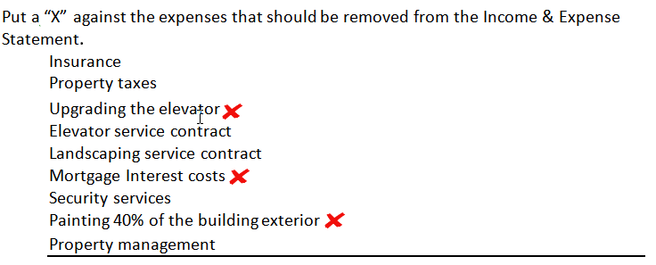**Q3**

Calculate the Return on Equity (ROE) or Cash on Cash Return using the following information

Net Operating Income (NOI): $125,000 per year

Debt Service: $75,000 per year

Purchase Price: $1,700,000?

Mortgage: $1,000,000

*Start by writing down the formula*

Answer

Return on Equity (ROE) = (NOI – Debt Service) x 100

(Price – Mortgage)

= Cash Flow before Tax

Cash invested

= Cash on Cash

= ($125,000 – 75,000) x 100

($1,700,000 – 1,000,000)

= 7.14% Return on Equity

**Q4.**

From a BUYERS perspective which do they prefer?

A high or a lower Cap Rate?

***Circle your selection***

Answer

From a BUYERS perspective which do they prefer?

A high or a lower Cap Rate?

***Circle your selection***

**Buyers like a high Cap Rate because this means they pay less for the property compared to a low Cap Rate**

**Q5.**

Using the following information calculate the:

1. Loan to Value Ratio(LTV)
2. Debt Service Coverage Ratio (DSCR)

Purchase Price: $2,500,000

First Mortgage: $1,500,000

Net Operating Income (NOI): $130,000 per Yr.

Debt Service: $100,000 per Yr. Annual (P +I) payment

Sta*rt by writing down the formulas*

Answer

Loan to Value Ratio = First Mortgage Amount

Purchase Price

= 1,500,000

2,500,000

= 60%

Debt Coverage Ratio = Net Operating Income

Debt Service

= 130,000 = 1.30

100,000

**Q6.**

Calculate the Base Rent per Sq. Ft per Yr. for an office building using the following information:

Base Rent: $200,000 per Yr. based on the “Rentable Area”

Usable Area: 9,000 Sq. Ft. This is the area occupied by the tenant.

**Add on Factor or Gross Up Factor: 15%**

Answer

Rentable Area = Usable Area x Add on Factor

= 9,000 Sq. Ft x 9,000 x 15%

Or 9,000 Sq. Ft x 1.15

= 10,350 Sq. Ft

Base Rent = $200,000

10,350 Sq. Ft

=$19.32 per Sq. Ft per Yr

**Q7.**

**The lower the Cap Rate the higher or lower the property value?**

***Circle you selection***

**The lower the Cap Rate the higher or lower the property value?**

***Circle you answer***

**A low Cap Rate creates a higher property value than a low Cap rate**

**which is illustrated in the example below.**

**Net Operating Income: $100,000**

**Value = Net Operating Income x 100**

**Cap Rate**

**$100,000 x 100 = $2,000,000 $100,000 x 100 = $1,000,000**

**5% 10%**

**Q8.**

**The Cap Rate is an excellent approach to valuing Property A below which has the following lease arrangement. True or False?**

***Circle your selection***

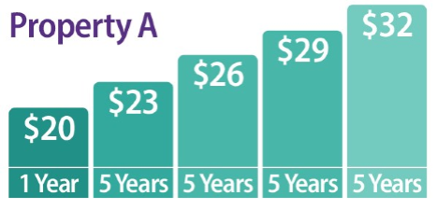

Answer

**The Cap Rate is an excellent approach to valuing Property A which has the**

**following lease arrangement. True or False**

**The Cap Rate is not a good way to value an income property where the lease increases in steps like Property A.**

**The best approach is to use discounted cash flow analysis which take into account the changing income over time.**



**Q9.**

**A tenant is entering into a Triple Net Rent (NNN) and has offered the tenant three months free rent.**

**The tenant interprets this to mean that during the Free Rent period of three months that there are no payments made to the landlord.**

**Based on the typical arrangements for free rent is the tenant’s assumption correct?**

**Yes or No**

***Circle your answer***

Answer

**With a Triple Net lease if the landlord offers a free rent period**

**the free rent refers only to the Base Rent. The landlord wants to get**

**paid for the “Additional Rent” to cover the operating expenses**

**such as taxes, insurance and maintenance as defined in the lease.**

**Q10**  
**When calculating the Cap Rate for a commercial building leasing fees should be excluded from the Income & Expenses statement when using a Cap Rate to determine the value.**

**True False**

Answer

**When calculating the Cap Rate for a commercial building leasing**

**fees should be excluded from the Income & Expenses statement**

**when using a Cap Rate to determine the property value.**

**True False**

**Non recurring expenses such as one off leasing fees should be excluded**

**from the the calculation of the Net Operating Income (NOI) when using a**

**Cap Rate to calulate the value of the property**

**Q11**  
**You are considering buying a building which has a Net Operating Income (NOI) of $240,000  
   
If you wish to buy the property for a 6.00% Cap Rate, how much would you pay for the property?**

Answer

**Purchase Price = Net Operating Income (NOI)**

**Cap Rate (%)**

**= $240,000 x 100**

**6.00%**

**= $4,000,000**

**Q12  
The Loan to Value Ratio (LTV):**

**a) __ Always determines the loan amount**

**b) __ Determines the maximum loan subject to the Debt Service or Coverage Ratio**

**c) __ Is never used by a commercial lender because they always use the Debt Service or Coverage Ratio to determine the loan amount to determine the loan amount**

***Tick your answer***

**The Loan to Value Ratio (LTV):**

**a) __ Always determines the loan amount**

**b)**  **Determines the maximum loan subject to the Debt Service Coverage Ratio**

**c) __ Is never used by a commercial lender because they always use the Debt Service or Coverage Ratio to determine the loan amount**

**The Loan to Value Ratio sets the maximum loan amount but lenders will use**

**the Debt Service Coverage Ratio if it produces a loan amount that is less than the amount determined by the Loan to Value Ratio (LTV).**

**Q13.  
Which Debt Service Coverage Ratio provides the highest loan amount?**

**a) 1.19**

**b) 1.25**

**c) 1.3**

***Tick the correct answer*  a)__ b)__ c)__**

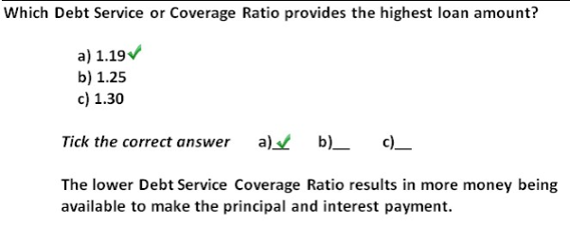

**Q14.**

**Which Debt Service Coverage Ratio potentially indicates the highest financial risk?**

**a) 1.31**

**b) 1.07**

**c) 1.15**

**d) 1.20**

***Tick the correct answer* a)__ b)__ c)__ d)__**

Answer

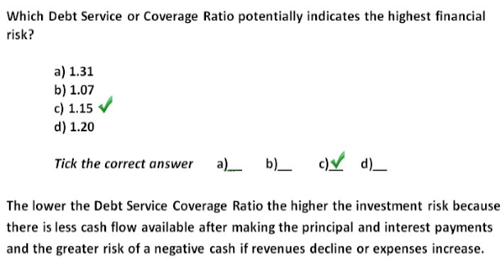

**Q15.**  
**A "Triple Net (NNN)" lease means that the tenant pays all of the landlords operating expenses.**

**True False**

***Circle your answer***

Answer

**A "Triple Net (NNN)" lease means that the tenant pays all of the landlords operating expenses. True False**

**The term Triple Net Lease generally means that the tenant pays the landlord’s operating expense such as taxes,insurance and maintenance. However you need to READ the LEASE carefully to see what operating expenses are paid by the tenant and which are paid by the landlord. The term “Triple Net (NNN)” can be misleading.**

**Q16.**

**In a multi-tenant office building the landlord usually calculates the rent based on the Usable Area because this is the area occupied by the tenant.**

**True False**

***Circle your answer***

Answer

**In a multi-tenant office building the landlord usually calculates**

**the rent based on the Usable Area because this is the area occupied**

**by the tenant.**

**True False**

**The statement is false because office building landlords want the**

**tenant to pay rent for the space they occupy plus pay their proportional share of common area costs and such as the lobby, corridors, common area bathrooms etc.**

**Q17.**

**How much would you pay for $130,000 per year forever if wanted a 10% return?**

**a) __ $1,300,000**

**b) __ $130,000**

**c) __ $13,000,000**

**d) __ None of these**

**e) __ $13,000**

***Tick the correct answer***

Answer

**How much would you pay for $130,000 per year forever if wanted a 10% return?**

**a)**  **$1,300,000**

**b) __ $130,000**

**c) __ $13,000,000**

**d) __ None of these**

**e) __ $13,000**

**$130,000 = $1,300,000**

**10%**

**The 10% is the Cap Rate**

**Q18*.*Which would you rather have?**

**a) Receive $750,000 today**

**b) Receive $750,000 in 5 years time**

***Tick the correct answer* a)__ b)__**

Answer

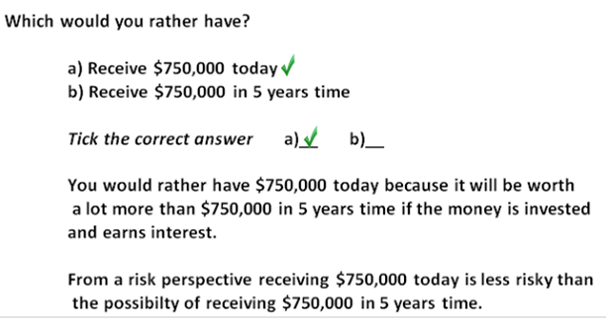

,

**Q19.**  
**The diagram below shows the projected lease rates and renewals**

**for two comparable properties. Which is the most valuable property?**

**a) Property A**

**b) Property B**

***Tick the correct answer a)__ b)__***

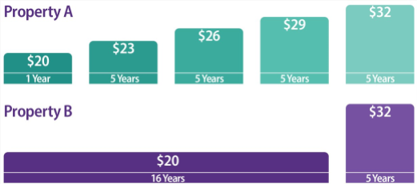

Answer

**The diagram below shows the projected lease rates and renewals**

**for two comparable properties. Which is the most valuable property?**

**a) Property A**

**b) Property B**

***Tick the correct answer a)__ b)__***



Answer

**Property A will provide the highest return (IRR) and is less risky because the cash flow is increasing at a faster rate because of the rent increases every 5 years after the first year. Sooner is better than later.**

**Q20.**  
**From a financial perspective which investment provides the:**

1. **Highest Return (IRR) Investment A or Investment B**
2. **Highest Risk Investment A or Investment B**

***Circle your answers*  
   
 ** ____________________________________________________________

Answer

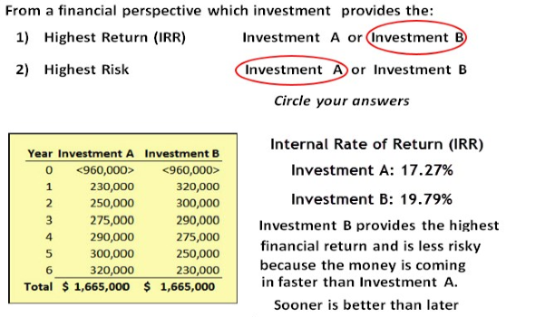  
 

**Q21.**  
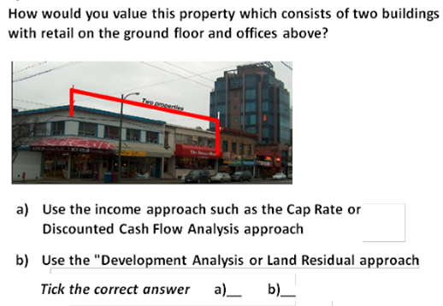

Answer 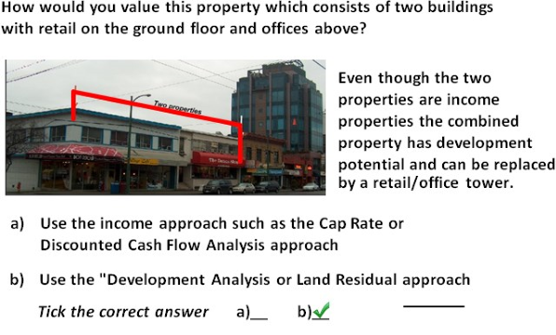

**END**