Raising Your Commercial IQ
________________________________________________________________________________________________________________________

How to Analyze & Value Income Properties

____________________________________________________________________________________________________________
Neil Osborne M.B.A.
DL. (604) 988-9964
nosborne@investitsoftware.com
Investit Software Inc.
Toll free 877-878-1828
North Vancouver BC
Canada
investit@investitsoftware.com
www.investitsoftware.com
Copyright 2019 Neil Osborne
All rights reserved

Table of Contents

Objectives & Topics 4
Financial Measures. Overview 5
Gross Income Multiplier (GIM) 5
Two ways to calculate the Gross Income Multiplier 6
Bad Debt Allowance or Credit Loss Allowance 6
Capitalization Rate. The Cap Rate 7
Calculating the Cap Rate from a sale 7
Calculating the value of a property using the Cap Rate from comparables 7
Calculating the Net Operating Income (NOI) 8
Operating Costs 8
How do you find comparable Cap Rates? 9
Capitalization Assumptions 11
Don’t Trust the Cap Rate 11
Understanding Cap Rates 13
Cap Rates and Property Values 13
Risk 13
Cap Rate and Equity or the Down Payment 13
Cap Rates and House Prices 14
Lowest Cap Rates 14
Sensitivity Analysis 16
The Cap Rate 16
Rent levels 16
Return on Equity (ROE) or Cash on Cash 17
Major difficulties with the Return on Equity 18
Financing Ratios 19
Loan to Value Ratio 19
Debt Coverage Ratio 19
Operating Expense Ratio (OER) 20
Default Ratio or Breakeven Point 21
Other measures used by buyers and sellers 22
Which financial measure should you use to value a building? 22
Steps in Analyzing Rental Apartment Building 23
Tips for analyzing Income & Expense Statements 24
Remove all non recurring expenses like partial painting of the building 24
Case Study. 79 Unit Rental Apartment Building 25
Revenue from the Owner 25
Expenses from the Owner 25
Financial Analysis of the Owner’s Statement 26
Expense Adjustments 27
Revised Financial Measures Report 28
How much would you pay for the property to get an 8.00% Cap Rate? 29
Revised Income & Expense Statement 30
Income Distribution Chart 31
Future Capital Expenditures 34
The importance of a professional engineering inspection 36
Valuing commercial properties 40
Introduction 40
Income & Expense Statement. Commercial 40
Types of Leases 41
Gross Lease 41
Gross Lease with escalation clause 41
Triple Net Rent (NNN) 41
Types of Rent 42
Base Rent 42
Additional Rent 42
Free Rent 42
Percentage Rent (Shopping Centers) 42
Rentable Area 43
Measuring Space 43
Tips for reading a lease 44
Case Study. Screening an investment opportunity 48
Long term real estate investment analysis 50
Two main approaches to determining the value of income properties 50
Discounted cash flow analysis 50
Two financial measures 51
The big picture. The “Net Cash Flow report 51
Application of discounted cash flow analysis 51
Introduction to long term real estate investment analysis 52
Apparent Cap Rate versus the True Cap Rate 52
Factors that distort the Cap Rate. Examples 52
Developing the Net Cash Flow 55
Calculating the Net Cash Flows before Tax 55
Internal Rate of Return 56
The building blocks of real estate investment analysis 57
Introductory Case Study. Real Estate Investment Analysis 61
Valuing income properties that have development potential 66
Introduction to Development Analysis and Valuing Land 66
Development Analysis. The Residual or Back Door approach 70
Condominium Development Example 70
Identifying development potential 71
APPENDICES 73
Real Estate Investment Analysis Formulas with Examples 73
TIPS for Analyzing Income & Expense Statements 81
Information Sources and web sites 83

Objectives & Topics

- To provide a good understanding of the basic financial measures used to value a building with an emphasis on the using the Cap Rate to determine the sale price.

- How to analyze Income statements. How to adjust the income & expenses to more realistically reflect the future financial performance of the building.

- Assess financing potential and potential investment risk.

- How to quickly screen investments and identify poor or risky investments.

- How to determine the value of income properties.

- Create awareness of the importance of professional engineering inspections.

- Analyzing commercial buildings.

- How to read a lease and important leasing terms.

- Measuring space and issues related to space measurement.

- Introduction to long term real estate investment analysis.

- The importance of financial leverage.

- Valuing properties with development potential.

- Introduction to development analysis and valuing land.

NOTE: USA versus Canadian calculations

The examples provided in the manual are for the USA where the default mortgage setting for the “Compounding Period” is monthly.

For Canada, the entries are the same, but the default setting for mortgages for the “Compounding Period” is semi-annually.

Financial Measures. Overview

Gross Income Multiplier (GIM)
Also called the Gross Rent Multiplier (GRM)

Gross Income Multiplier = Sale Price____
Gross Income

Sale Price = Gross Income x Gross Income Multiplier (GIM)

Example: Gross Income: $56,000

GIM from comparables: 11 (Note: The Gross Income Multiplier is a number not a %)

Sale Price = 11 x $56,000

= $616,000

Gross Income Multiplier ignores “Operating Expenses”, ‘Financing” and “Capital Appreciation

The Gross Income Multiplier is mostly used when the operating expenses are unknown, suspect or hard to determine such as small revenue properties, rooming houses etc.

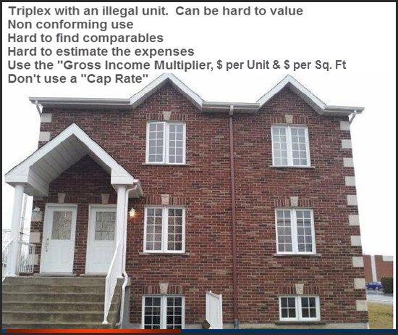

Two ways to calculate the Gross Income Multiplier

- Using Potential Gross Income

(Ignores Vacancy & Bad Debt Allowance)

Called the Potential Gross Income Multiplier (PGIM)

- Using Effective Gross Income

(Takes into account Vacancy & Bad Debt Allowance)

Called the Effective Gross Income Multiplier (EGIM)

If you are given the GIM you need to ask if the Vacancy & Bad Debt Allowance has been deducted or not.

i.e. Is it the PGIM or EGIM?

Bad Debt Allowance or Credit Loss Allowance

The unit was rented but the check bounced and the rent was lost for the month.

Capitalization Rate. The Cap Rate

Purpose:

- To determine the value of a property

- Is this a good investment compared to other investment opportunities?

- Turns an income stream into an investment or capital value

How much would you pay for $120,000 per year for ever, if you wanted a 10% annual return?

Multiple choice

- $12,000
- $120,000
- $1,200,000
- $12,000,000

Answer is ____________

$__________ = $____________
%

Calculating the Cap Rate from a sale

Cap Rate = Net Operating Income (NOI) x 100
Sale Price

= $120,000 x 100
$1,500,000

= 8.00%

Calculating the value of a property using the Cap Rate from comparables

Sale Price = Net Operating Income x 100
Cap Rate

= $120,000 x 100 or $120,000
8.00 8.00%

= $1,500,000

Calculating the Net Operating Income (NOI)

Potential Gross Income (PGI) $784,500
Less: Vacancy and Bad Debt Allowance (5%) 39,225

Effective Gross Income $745,275

Less: Operating Expenses 335,373 (45%)

Net Operating Income (NOI) $409,902

Operating Costs

All costs involved in the direct operations of the building such as:

- Property taxes
- Insurance
- Maintenance
- Utilities
- Property management
- Resident manager or caretaker
- Bookkeeping
- Supplies

When using Cap Rates exclude the following expenses from the Net Operating Income:

- Interest payments on the mortgages or other forms of financing or working capital loans

- Expenses that provide long term benefits or are non recurring expenses such as:

Replacing some or all of the appliances

Replacing carpets

Major repairs to the roof

Painting a portion or all of the building

Structural repairs etc.

How do you find comparable Cap Rates?

With a great deal of difficulty and hard work. There is little published information on Cap Rates

Cap Rates come from comparable sales but;

It’s hard to get the information or know what adjustments were negotiated between the seller and the buyer

Example:

The buyer had a professional engineering inspection done and deducted $360,000 to allow for the immediate replacement the roof and the boiler

A major tenant was moving out in 9 months

Read newspapers like the Wall Street, USA Today and major local papers. Often a sale is reported together with the sales price, price per sq. ft and sometimes the Cap Rate is quoted

Commercial realtors and appraisers may or may not be helpful

Major commercial firms provide research reports by area and property type, cap rate range etc. Visit their web sites

Your best source for accurate, current Cap Rates ___________________________

Caution: Because of the current economic situation where property prices are volatile and falling, it is hard to get a fix on Cap Rates.

Sometimes the Sale Price per Sq. Ft is a better comparable than a Cap Rate when the market is volatile.

Other sources of cap rates, lease and vacancy rates, economic trends etc.

Real estate research organizations
www.REISreports.com
www.costar.com

Commercial real estate research organizations where you can purchase comprehensive reports on specific types of commercial real estate by geographical area.

News Letters
Both REIS reports and Costar have excellent free news letters that help you keep up-to-date on the commercial real estate market.

National and local new papers
Many newspapers have a weekly commercial real estate page, including the Wall Street Journal which can help you get abreast to the commercial markets, trends etc. Newspapers often report the sales of a building providing details such as the cap rate, price per Sq. Ft, lease rates etc.

Don’t’ forget to ‘Google” to look for the information you need.

Capitalization Assumptions

- The Net Operating Income (NOI) is constant and goes on for ever

Year 1 2 etc.

Net Operating Income $120,000 $`120,000 forever

- The property is never sold.

Why would you buy at a 5% Cap Rate and finance with a first mortgage at 7.00%?

Called “Negative financial leverage”

Answer: ____________________________

Don’t Trust the Cap Rate

Are the income and expenses realistic?

Have the expenses been manipulated to justify the Cap Rate and the Sale price?

Expenses may be understated

What has been left out from the expenses? Example: The Resident Manager’s salary

When using Cap Rates make sure the Income and Expense Statement doesn’t include;

- Depreciation

- Non recurring expenses such as;

- Minor capital expenditures E.g., Replacing 10% of the carpets for $12,000

Drop in value = $12,000 = $150,000
8.00% Cap Rate

The Capitalization assumption:

Year 1 $12,000 is spent on carpets. Year 2 $12,000 Year 3 $12,000 forever

- Financing

- Expenses unrelated to the operations of the building

E.g., Travel expenses to the Apartments Owners convention

- Higher than normal owner’s compensation

- Maintenance reserves

Use next year’s income & Expense projection

When calculating the sale price use next years Income & Expenses. This is what the buyer, appraiser and lender will do

Understanding Cap Rates

Cap Rates and Property Values

The higher the Cap Rate the ______________ the property value

The lower the Cap Rate the _______________ the property value

If Net Operating Income (NOI) = $100,000

Sale Price = $100,000 x 100
5.00% Cap Rate

= $______________

Sale Price = $100,000 x 100
10.00% Cap Rate

= $______________

Buyers want a high Cap Rate which means a lower purchase price

Sellers want a low Cap Rate because it results in a higher price

Risk

The higher the risk, the ____________ the Cap Rate

Buyers and Sellers perception of long term capital appreciation.

The higher the anticipated capital appreciation the __________ the Cap Rate

Cap Rate and Equity or the Down Payment

Low Cap Rate
Generates a high price and requires a hefty down payment or equity
Example: 3.5 % Cap. Equity or down payment might be 60% or more

High Cap Rate
Generates a low price and requires a lower down payment or equity
Example: 8.00 % Cap. Equity or down payment might be as low as 25%

Cap Rates and House Prices

Very high house prices very ____________Cap Rates

Very low house prices very ____________Cap Rates

Lowest Cap Rates

Generally prime rental apartment buildings

Why. Vacancy risk is lower than office buildings, industrial and retail.

_______________________________________________

_______________________________________________

Locations with very low Cap Rates of _____________%

- Very limited supply & strong demand
- Dynamic cities
- High levels of gentrification

_______________________________________________

_______________________________________________

Cap Rates depend on the Property Type
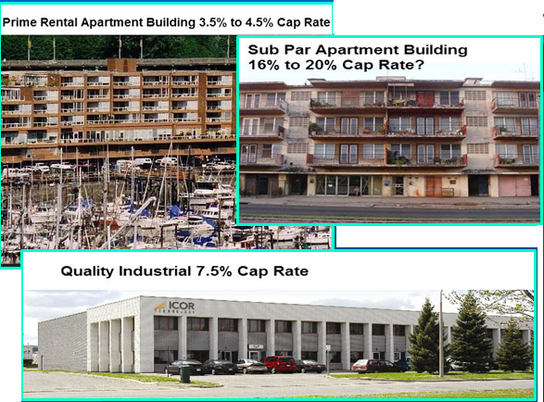

As well as the location, quality of tenant and future cash flows and expenditures

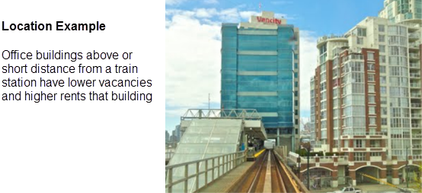

A large influence on the Cap Rate is the economy

Factors like unemployment, growth potential affect the Cap Rates. Some general observations;
- Large cities have lower Cap Rates than small towns
- Large seaport cities generally have lower Cap Rates than large inland cities

Sensitivity Analysis
Sensitivity analysis helps identify which numbers have the largest impact on the sale price?

The Cap Rate

A small change in the Cap Rate creates a large change in value.

If the Cap Rate goes from 8.00% to 9.00%, the value of the property drops by 1/8 or 12.5%

A small increase in the Cap Rate causes a large drop in the property value

Rent levels

The value of a property is very sensitive to rent levels.

Example: 50 Suite building
Planned rent increase: $50 per unit per month.
Cap Rate: 8.5%

Increase in value by raising the rents $50 per unit per month

= Change in the Net Operating
Cap Rate

= 50 suites x $50 x 12* x 100
8.5

= $352,941

An indicator that rents can possibly be increased subject to rent controls

Return on Equity (ROE) or Cash on Cash
Also called the Equity Dividend Rate (EDR) The term used by appraisers

Purpose: What is the return I am getting on the money I invest?

Equity is the down payment

How does this return compare with other investment opportunities?

Takes into account financing

Return on Equity (ROE) = (NOI – Debt Service) x 100
(Price – Mortgage)

= Cash Flow before Tax
Cash invested

= Cash on Cash

= ($130,000 – 93,000) x 100
($1,625,000 – 1,252,000)

= 9.92% Return on Equity

Note: Debt Service is the annual payment of “Principle plus Interest”

Case Study. Using the Return on Equity to choose between two investments

An investor has been offered two comparable rental apartment investment opportunities offering the following returns;

- Property A . Return on Equity or Cash on Cash is 15%

- Realtor B. Return on Equity or Cash on Cash is 28%

Which is the best investment for the investor from a financial perspective?

Answer. ___________________________________________________

Property A.
The mortgage has a 15 year amortized period which
means a large a annual mortgage payment and low cash on
cash return (15.00%)

Property b.
The mortgage has a 25 year amortized period which
means a lower annual mortgage payment and a higher cash on
cash return (28.00%)

Major difficulties with the Return on Equity

Mostly used by investors who buy smaller apartment buildings

Very volatile measure

Highly sensitive to interest rates, the amortization period and the amount of financing.
Very easy to manipulate to create a misleading return on investment

Example:

An analysis of a typical apartment building shows the sensitivity of the Return on Equity

- A 10% increase in rents increases the Return on Equity by 40%

- A 10% increase in the mortgage interest rate lowers the Return on Equity by 9%

- Changing from a 30 year to 15 year amortization period drops the ROE by 40%

The Return on Equity (ROE) is useful for looking at a specific property, but not for comparing the return against other properties because of the impact of financing.

To compare properties using the Return on Equity you need the same:

Loan to Value Ratio - Interest Rate - Amortization Period

Financing Ratios
- Loan to Value Ratio

- Debt Coverage Ratio or Debt Service Ratio

Used by lenders to determine loan amounts

Loan to Value Ratio
determines the maximum loan amount

Debt Coverage Ratio
determines the loan amount based on the Net Operating Income and the Debt Coverage Ratio

Debt Coverage Ratio = Net Operating Income
Debt Service

= $120,000 Net Operating Income
$80,000 Debt Service

= 1.50

The Debt Coverage Ratio is the Lender’s margin of safety.

A Debt Coverage Ratio of 1.50 means that the Net Operating Income could drop by approximately 33% before there is negative cash flow.

The lender calculates the loan amount based on the;

- Loan to Value Ratio

- Debt Coverage Ratio or Debt Service Ratio

- Then chooses the method that produces the lower loan amount.

The Debt Coverage Ratio and Loan to Value Ratio are helpful in determining whether and when the property can be refinanced.

Example:

A Debt Coverage Ratio of 1.50 would suggest that;

- the property could be refinanced by reducing the Debt Service Ratio to say 1.25 subject to a maximum loan amount based on a 65% Loan to Value Ratio.

Today lenders have lowered the Loan to Value Ratio from 75% to 65% to 60% or lower

On a typical rental apartment building;
Operating Expense Ratio: 45.00%
Cap Rate 7.00%
65% Loan to Value Ratio

The Debt Service Ratio would be approximately 1.26

Operating Expense Ratio (OER)

Often the financial statements provided by the owner of a rental apartment building are inaccurate and expenses are understated.

The Operating Expense Ratio (OER) is used to check if the expenses are realistic or not.

Operating Expense Ratio (OER) = Operating Expenses x 100
Gross Income

Typical Operating Expense Ratio. Rental Apartment Buildings.

Operating Expense Ratio (OER): 35% to 45%+ including property management

Another check is the Maintenance Costs per Unit per Year.

Range: $450 to $650+ per Unit per Year

Motels: 55% to 65% Operating Expense Ratio
Public Storage: 35% to 45% Operating Expense Ratio

Motels: 55% to 65% Operating Expense Ratio
Public Storage: 35% to 45% Operating Expense Ratio

Typical Operating Expense Ratio. Commercial Buildings

Office: 40% to 50%+ Incl. Pty Management
Industrial: 30% to 35%+ Incl. Pty Management
Retail: 45% to 50%+ Incl. Pty Management

The most common measure for commercial buildings for is “$ per Sq. Ft per Yr (or Month)”

Default Ratio or Breakeven Point

Measures the degree of risk and is also helpful in determining if additional financing can be added.

Default Ratio = (Operating Expenses + Debt Service ) x 100
Effective Gross Income

Example: Operating Expenses: $60,000

Debt Service: $100,000

Effective Gross Income: $196,000

Default Ratio = (60,000 + 100,000) x 100
196,000

= 82%

Can the first mortgage be increased?

The magic figure is around 85%

Once the Default Ratio or Breakeven Point is 85% or more, there is little room left to increase the first mortgage.

As an example, a Default Ratio (Breakeven Point) of 60% suggests that the first mortgage can be increased until the default Ratio is around 85%

The Default Ratio is very useful to assess the investment risk and the potential for refinancing the property.

Other measures used by buyers and sellers

Price per Unit or Door

Price per Sq. Foot

Rent per Sq. Foot per Month is used for checking apartment rents

Which financial measure should you use to value a building?

Use the financial measure that best predicts the value of the building and represents the approaches used by buyers and sellers to determine value

Example: Valuing a single family home

Cap Rates are not used by home buyers to figure out what they are prepared to offer and therefore are not helpful in determining the value of a home

Steps in Analyzing Rental Apartment Building

- Ignore the Cap Rate

- Are the rents reasonable? If not adjust

- Review the Vacancy Allowance. Is it representative of local conditions?

- Calculate the Operating Expense Ratio. Is it realistic?

- If the Operating Expense Ratio is incorrect, review and adjust the expenses.

Generally use next year’s revenue and expense if you are trying to determine the value of the property

Remember that property taxes may go up after the sale

If possible, verify costs such as insurance, elevator servicing, garbage collection, property taxes etc.

Make sure that minor capital expenditures or nonrecurring expenses such as replacing appliances, carpets etc., are not included in calculating the Net Operating Income

Remove non-operating expenses E.g., Travel expenses

Are any expenses missing? E.g., Property Management, Resident Caretaker

- Recalculate the operating cost. Is it within an acceptable range?

- Determine the Sale Price to provide the desired Cap Rate

- Make sure the Cap Rate being used is accurate because small changes in the Cap Rates creates large changes in value.

A good source of Cap Rates is commercial lenders and mortgage brokers

Tips for analyzing Income & Expense Statements

Rental Apartment Buildings
Revenues: Express as $ per Unit per month
Laundry: $9.00 per Unit per Mo
Parking: $30.00 per Space per Month

Expenses: Express as $ per Unit per Mo or Year

E.g. Maintenance $5,000 is not very helpful.
If there are 45 units the maintenance cost is $111 per unit which is too low
Range is $350 to $650 per Unit per Yr

Expense verification. Certain expenses can be quickly verified by calling the companies providing the services, such as;

- Elevator service contracts
- Garbage collection
- Insurance

Calculate the Operating Expense Ratio 35% to 50%+ ?

Remove all non recurring expenses like partial painting of the building

Commercial Buildings

Use $ per Sq. Ft per year or month

Case Study. 79 Unit Rental Apartment Building

Asking Price $8,000,000
Cap Rate for comparable properties is 8.00%
6 Studios
58 One Bedroom Units
11Two Bedroom Units
4 Three bedrooms
81 Parking Spaces
Financing
Interest Rate: 7.00%
Loan Amount: $4,300,000
Amortization: 25 years Compounding Frequency. Monthly

Question. What is the value of the property if the Cap Rate from comparables is 8.00%?

Revenue from the Owner
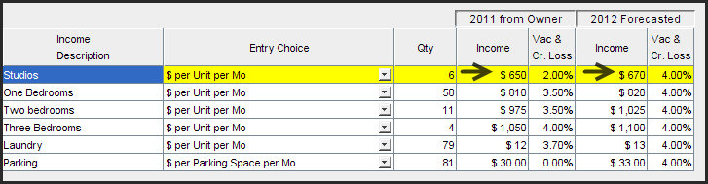

Expenses from the Owner
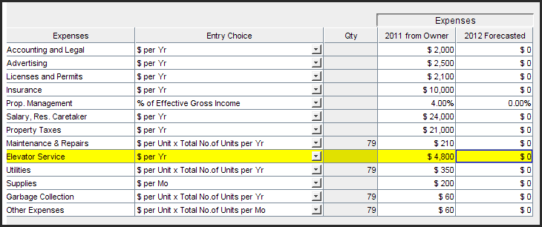

Financial Analysis of the Owner’s Statement

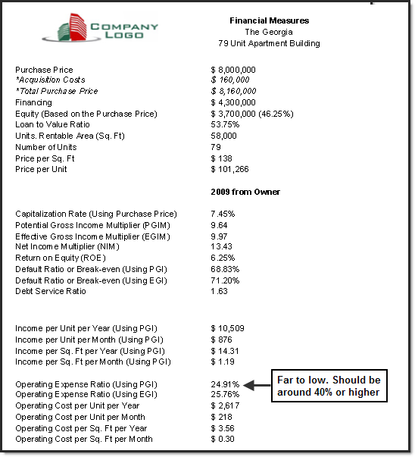

Expense Adjustments
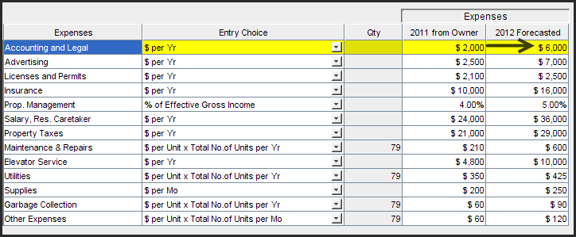

Revised Financial Measures Report
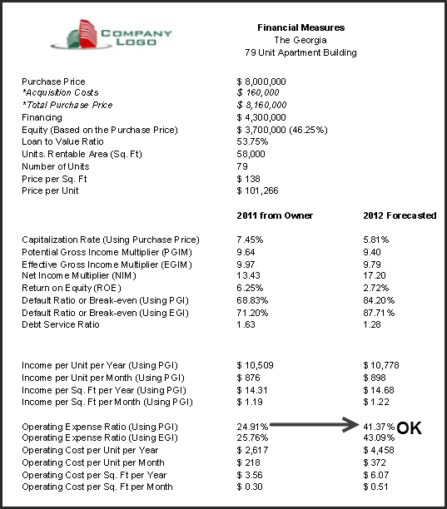

How much would you pay for the property to get an 8.00% Cap Rate?
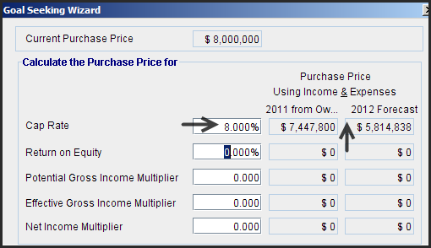

Answer: $5,814,838
Asking Price: $8,000,000
Need to drop the price by $2,185,162 or 27%

Note: The Net Income Multiplier (NIM) is the inverse of the Cap Rate and produces the same value of $5,814,838

Revised Income & Expense Statement

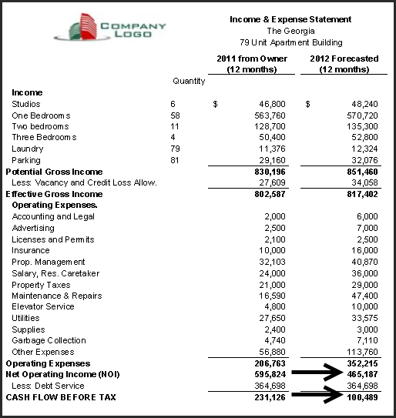

Income Distribution Chart
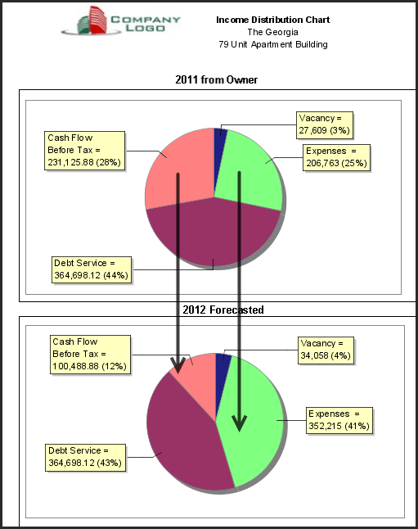
Potential to Re-finance and Risk Assessment
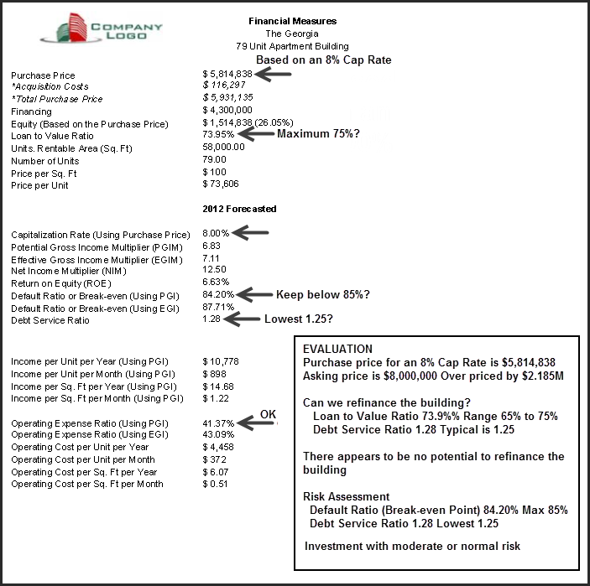

Review & Summary
Following is a summary of the analysis we carried out on the 79 unit apartment building.
Asking price: $8,000,000
Existing Financing: Interest Rate 7.00%, Loan Amount $4,300,000, Amortization 25 years
Desired Cap Rate: 8.00%
Questions
- What price should we offer to get an 8.00% Cap Rate?
- Is there potential to increase the financing and lower the equity requirements?
- How risky is the investment?
Steps
- Adjusted the rents and vacancy allowances for next year
- Calculated the Operating Expense Ratio (OER)
OER = Operating Expenses = 24.91% Too low. Should be over 40%
Gross Income
- Reviewed and adjusted the Owner’s expenses using more realistic for expenses such as
maintenance and elevator service contracts

- Re-calculated the Operating Expense Ratio (OER)
OER = Operating Expenses = 41.37% which is a more realistic figure
Gross Income
- Using the revised Net Operating Income calculated the value based on an 8.00% Cap Rate
Value = Net Operating Income x 100 = $5,814,838 Asking Price $8,000,000
Cap Rate
Questions
- What price should we offer to get an 8.00% Cap Rate?
Using the revised Net Operating Income calculated the value based on an 8.00% Cap Rate
Value = Net Operating Income x 100 = $5,814,838 Asking Price $8,000,000
Cap Rate
- Is there potential to increase the financing and lower the equity requirements?
Loan to Value Ratio: 73.95% Debt Service Ratio: 1.28
No potential for increasing the first mortgage
- How risky is the investment?
Default Ratio (Breakeven Point): 84.20%
Debt Service Ratio: 1.28
Conclusion. Investment with moderate risk with no potential for increasing the first mortgage

Future Capital Expenditures
In determining the value of the building the investor should have a professional engineering inspection to determine:

- Immediate major repairs
- Future capital expenditures and repairs

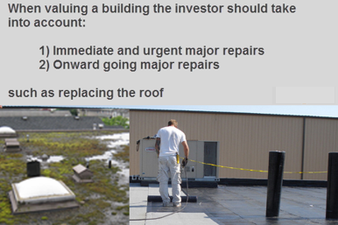

Immediate major repairs
These are urgent expenditures that need to be made by the buyer shortly after taking ownership of the building such as replacing a leaking roof.

Example:
Prior to buying the building, the buyer engaged a professional engineering firm to inspect the building and they found the following remedial needed to be done:

Resurfacing the roof $220,000
Upgrade the aging and unreliable elevator $110,000

Total Cost: $330,000

A prudent buyer would deduct $330,000 or more for the urgent major repairs that need to be completed after taking ownership.

Future capital expenditures and repairs

As the building ages there are many capital expenditures that need to be made to maintain the building in good working order. These expenditures are nonrecurring and are in addition to the regular operating expenses and are often developed on behalf of the owner by architects, engineers of professionals specializing in conducting building assessments.

Following is an example of a cash flow projection for a 40 year old 100 unit rental apartment building.

The annual capital expenditures range from $202 to $$571 per unit per year or from 2.72% to 8.52% of potential gross income.

Investors often set up a replacement reserve fund which they contribute to on a regular basis to ensure that funds are available to carry out the needed capital expenditures. As an example, in 2020 $60,000 is needed to replace the asphalt parking area and the total capital expenditures in 2020 is $80,500.

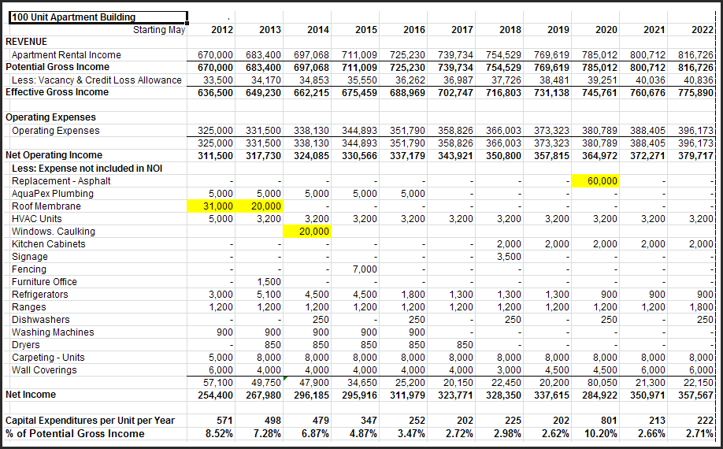

The importance of a professional engineering inspection

A building is a complex system which may have hidden, serious problems that are costly for a buyer to fix. Some examples are;

- Concrete rot or cancer
- Salt corrosion causing deterioration of reinforcing steel and the integrity of the floor slab
- Failure of post tension systems
- Thin wall copper pipe

Concrete Rot and the deterioration of concrete structural systems

There are a variety of conditions that can cause serious problems with concrete structures and slabs and affect the useful life of the building including:

Chemicals, called admixes, that are mixed in concrete to enable the concrete to be poured during very hot or cold weather which may cause the concrete to slowly self destruct. Sometimes called concrete rot or cancer.

Deterioration of the reinforcing steel caused by water borne chloride ions seeping into the concrete, causing the reinforcing steel to rust. A Common cause is the use of de-icing salts in cold climates to melt snow and ice and water borne environmental contaminants.

Continual exposure to water can create serious problems if the concrete was not poured properly and contains air pockets allowing water to penetrate the concrete. This can be aggravated if there is freezing and thawing taking place.

When purchasing a building the buyer should have a professional engineer to check the structure for
structural defects and identify if costly repairs are needed and ascertain whether the useful life of the
building has been affected by structural problems such as concrete rot or cancer or the deterioration of
the reinforcing steel caused by exposure to a variety of chemicals.

Examples of serious structural concrete problems

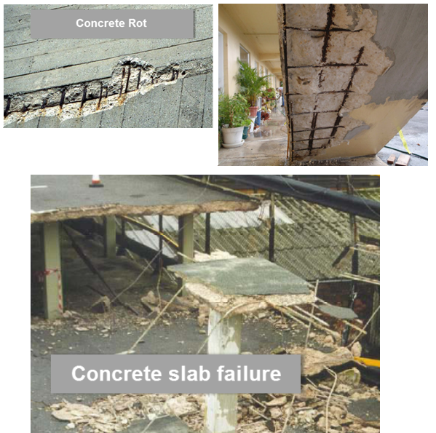

Failure of post tensioning floor slab systems

Un-bonded post-tensioned (PT) systems are popular with developers of multi-storey office and residential buildings as they reduce costs by allowing thinner slabs and faster construction. In many of these buildings, some only ten years old, expensive repairs have been necessary because of premature corrosion of the tendons. This corrosion can occur and continue without any visible signs of deterioration.
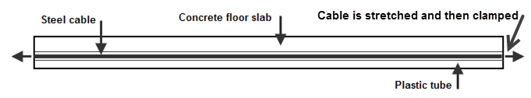

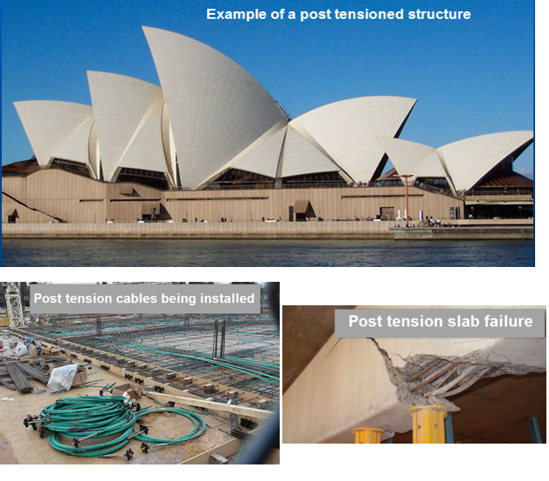

Other examples

Failure of thin wall copper pipe which requires constant expenditures on pipe repairs and water damage.

At some point it becomes necessary to replace the copper piping in the building. A very costly process and a major inconvenience to the tenants.

As an example, if it costs $3,000 per unit to replace the copper piping, the cost for re-piping a 100 unit building is $300,000.

Recommendation. Encourage your buyer to have an inspection carried out by professional engineers.

Valuing commercial properties

Introduction

The issue of misleading expenses is generally less an issue with commercial properties compared to rental apartment buildings. Most commercial space uses some variation of “Triple Net Rent with the tenant paying for property taxes, insurance and maintenance. This is called ‘Additional Rent” or ‘Recoverable Expenses

This means that you can use the “Additional Rent” currently being paid by the tenants as get a good estimate of the current operating expenses.

An investor still has to have a realistic figure for the operating costs per sq. ft because the landlord will pay the operating expenses for any vacant space.

The terms and conditions in the lease can affect the value of a commercial building

- Following is the correct layout for the Income & Expense Statement for a commercial building.

Income & Expense Statement. Commercial

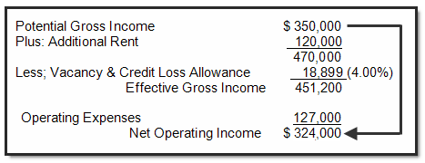
- Incorrect Approach
To ignore the operating expenses because with a Triple Net lease the tenant pays the expenses. This is a poor assumption and can result in an incorrect valuation.
- The landlord pays the expenses on the vacant space
- There may be operating expenses not recovered by the landlord from the tenant

Types of Leases

Gross Lease
Tenant pays rent and their utilities. Landlord pays the operating Expenses

Gross Lease with escalation clause
The rent increases each year based the increase in the CPI (Often used by governments)

Triple Net Rent (NNN)
May mean that the tenant pays the landlord for their share of Taxes, Insurance & Maintenance (TIM’s)

Under a Triple Net Lease does the tenant pay;

- Property management?.

- Depreciation of mechanical equipment?

- Administration fees?

Answer: _____________________________________________________

Types of Rent

Base Rent
The rent paid E.g., $20 per Sq Ft per Year

Additional Rent
Payment for expenses incurred by the landlord as agreed to in the lease. Also be called;

Recoverable Expenses
Reimbursable Expenses
Pass Through
TIM’s (Taxes, Insurance & Maintenance) or TMI’s
CAM’s (Common Area Maintenance)

Free Rent
Generally free rent only applies to the “Base Rent” not to the “Additional Rent”

Example: Four months free rent

Generally free rent will be spread over several years. It’s unlikely that the tenant will get the first four months free as this is too risky a proposition for the landlord

Free Rent example
Lease Term: 3 years
Three months spread over three year
Applied to the “Base Rent” only
Tenant pays the “Additional Rent”
Free Rent: June Years 1, 2 & 3
Tenant pays the “Additional Rent (TMI’s)”

Percentage Rent (Shopping Centers)

Tenant pays the Base Rent or % Rent, whichever is the larger

Example

Base Rent: $500,000 per year

% Rent: 4.00% of sales

Sales $14,000,000 per year

% Rent 4.00% x $14,000,000 = $560,000

Tenant pays $560,000

Rentable Area

The area used to calculate the rent.

Industrial. Rentable Area. The area occupied by the tenant

Retail. Gross Leaseable Area The area occupied by the tenant
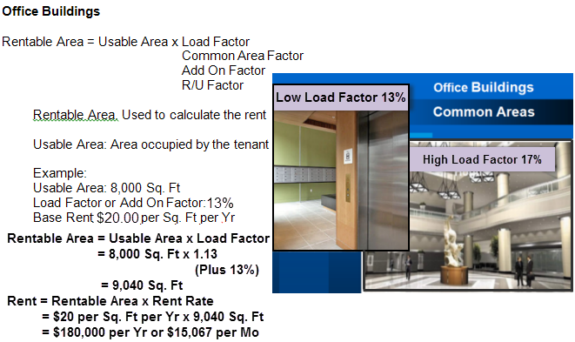

Measuring Space

Can be very difficult. Which area do we use? and how do we measure the space?

If the rent is quoted as a $per Sq. Ft or Mo the:
- Area has to be defined- Rentable or Usable? 2. How will the space will be measured?
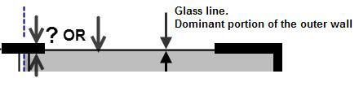
The BOMA Standards for measuring space in office, retail, industrial and flex buildings are the most
Commonly used standards.

TIP: Quote rents as a “$ per Month or Year” to avoid all the problems of measuring the space.

Example: The rent is $21.00 per Sq. Ft per Yr. which is $110,400 per year

Tips for reading a lease

Key clauses are often buried in the middle of the lease

e.g. Demolition Clause

What’s the value of a small business if there is a demolition clause in the lease and the property is ripe for redevelopment?

Key Items

- Who pays what?

What expenses are paid by the landlord and what expenses are paid by the tenant? Called;

Recoverable Expenses
TIM’s or TMI’s (Taxes , Maintenance & Insurance)
Additional Rent (Legal term used in leases)

Be careful of the term Triple Net or NNN as it is highly ambiguous

The expenses paid by the tenant to the landlord will be defined in the lease

- Demolition clause
The right to terminate the tenancy on the issuance of a rezoning, development or building permit from the City.

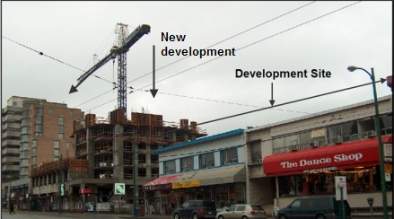

- Under what terms and conditions can the tenant assign or sublease their space?

Won’t be unreasonable withheld by the landlord

Tenant has to pay landlord a penalty upon subleasing

Can’t assign or sublease

_______________________________________________

- Lease terms, options to renew and rent increases (Called “Steps” or “Bumps”)

At the end of the lease does the tenant have to option
to renew and if so, how long?

How will the renewal rate be determined?

Renewals versus Steps or Bumps

Renewals occurring at the end of the term of the lease

Lease Terms

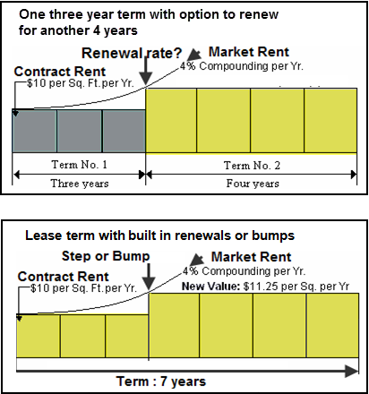
- How are renewal rates are or bumps in the lease determined?

Standard lease has “Steps” or “Bumps” or “Renewals”

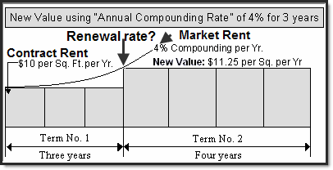

- Lease may specify. Example: The renewal rate Feb 2011 is $12.00 per Sq. Ft per Yr
- At market
- Based on a percentage increase in the CPI (Need to specify which CPI)

Indexed lease or Escalating Lease
The lease rate increase each year which may be based on the increase in the Consumer Price Index (CPI) or the increase or new rate may be specified in the lease

Governments tend to use Indexed Leases

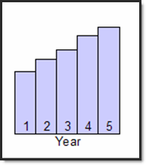

6. Read a lease in several settings
Leases are complex documents and need to be read very carefully

7. Read with a purpose. Have a question in mind.

Is there a demolition clause? If this is important to the buyer
Who pays what?
When will the renewals take place?
How is the renewal rate determined?

8. Need to look at all leases in the building as they may vary

- Look at the timing of the lease renewals. Are they spread out?
Example of risk management

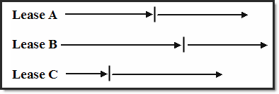

Having all the leases come up for renewal at the same time is risky and can affect the value and the ability to finance the building

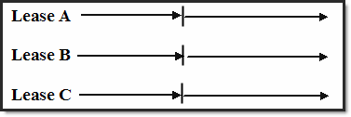

Case Study. Screening an investment opportunity

An investor is considering buying the following building and asked my opinion.

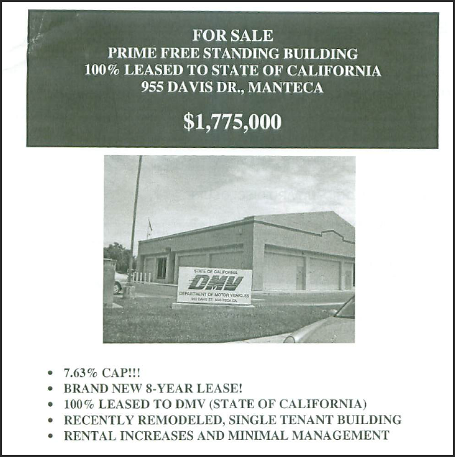

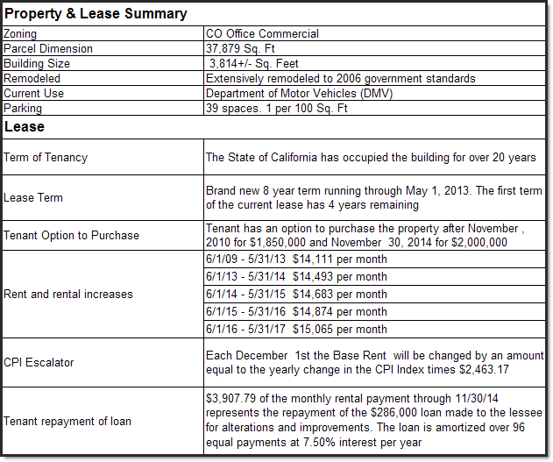

This is a hybrid lease. A Gross Indexed Lease with a very modest escalation clause.

Base Rent: $44.40 Very high. What if they move out? Appears to included the amortization of leasehold improvements

A major issue;

If there are increases in property taxes, insurance and maintenance only a very small portion of the increases can be passed on to the tenant.

The Net Operating Income (NOI) will decline over time if the increase in property taxes, insurance and maintenance exceeds the increase in the CPI.

Long term real estate investment analysis

Two main approaches to determining the value of income properties

- Long term real estate investment analysis or Discounted cash flow analysis
- Cap Rate approach

Value = Net Operating Income
Cap Rate

Issues related to the Cap Rate approach

The Cap Rate approach is simple and quick but ignores:

- Long term capital appreciation
- The impact of financing on the return on investment
- Changing cash flows over time
- Future capital expenditures such as replacing the roof for $300,000 in 5 years’ time

Cash flow projections
This is an example of an operating cash flow projection.

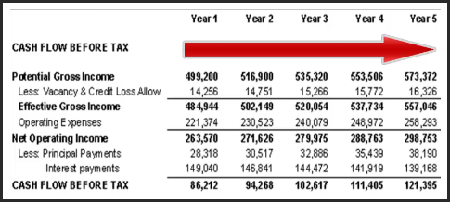

Discounted cash flow analysis

Which would you rather have?

- $1,000,000 today or 2) $1,000,000 in 10 years’ time?

Answer. $1,000,000 today because I can invest the $1,000,000 and earn interest for the next 10 years

In choosing the $1,000,000 today you intuitively carried out ‘Discounted cash flow analysis” and recognized the “Time Value of Money”

Two financial measures

- Internal Rate of Return (IRR)
Example: 10.61%

- Net Present Value (NPV
Example: Net Present Value at 13% ($296,501)

The big picture. The “Net Cash Flow report

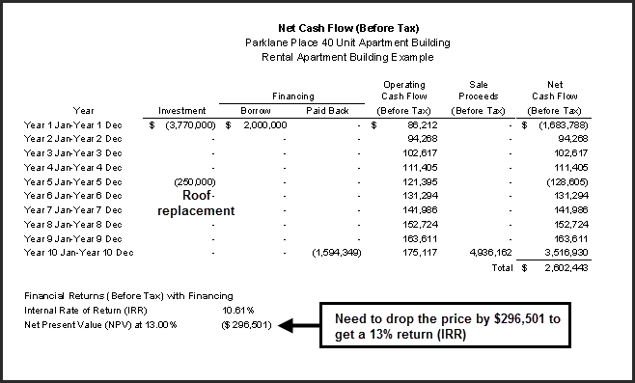

Application of discounted cash flow analysis

Discounted cash flow analysis can be used to carry out many different types of analyses including:

- Long term real estate investment analysis
- Buy versus lease analysis
- Hold versus sell analysis
- Lease and lease comparison analysis form a landlord and tenant perspective
…even valuing a land lease

Introduction to long term real estate investment analysis
Issues related to using the Cap Rate
Using the sale price and the Net Operating Income to calculate the Cap Rate can result in an incorrect Cap Rate because of factors that you were not aware of that influenced the price.

Apparent Cap Rate versus the True Cap Rate
The “Cap Rate” is just the tip of the iceberg

Factors that distort the Cap Rate. Examples

The impact of “urgent major repairs” on the Sale Price

Sale Price: $3,200,000 Net Operating Income: $275,000 per year

“Apparent Cap Rate” = $275,000 x100 = 8.59%
$3,200,000

BUT… the buyer deducted $425,000 because the roof had to be replaced, the elevator upgraded
Sale Price based on “Normal” building = $3,200,000 + $425,000 = $3,625,000

“True Cap Rate” = $275,000 x100 = 7.59%
$3,625,000

True Cap Rate is 7.59% Apparent Cap Rate” of 8.59% A 12.00% difference
Impact of the timing of lease renewal on cash flows and the property value

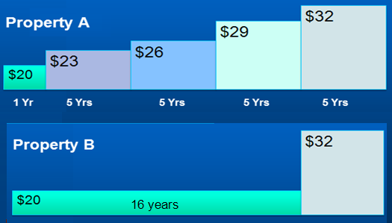

Question: What is the difference in value between Property A and Property B?

The rentable area is 20,000 Sq. Ft

Present Value Property A at 13.00% is $3,514,593
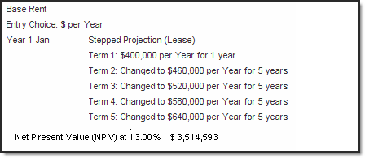

Present Value Property B at 13.00% is $2,960,062
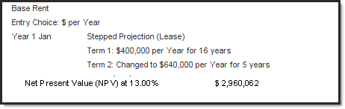
NPV at a 13% Discount Rate Property A: $3,514,593
NPV at a 13% Discount Rate Property B: 2,960,062
Difference $ 554,531 (16%)
Cap Rates. Summary

Using a Cap Rate to determine the value of an income property is a very simplistic approach fraught with difficulties.

A more realistic approach is “Discounted Cash Flow Analysis”, which projects the cash flow over time and takes into account the “Time Value of Money”

Comparing Case A with Case B above was an example of “Discounted Cash Flow Analysis”, and the use of Net Present Value

Developing the Net Cash Flow

You have a choice to invest in either Property A and B. Each property will generate the following net cash flows. Which one would provide you with the best overall financial return?
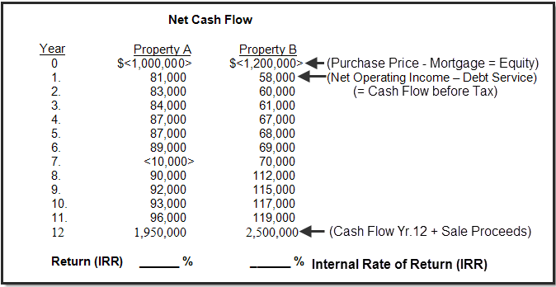

Calculating the Net Cash Flows before Tax
Analysis Time Period
In the example above the “Analysis Period” or the “Holding Period” is 12 years. The property will be sold at the end of the “Analysis Period”.
Acquisition (Net Cash Flow)
The purchase is made at “Time Period Zero” and the Net Cash Flow is:
Purchase Price
Less: Mortgage
Equity = (Net Cash Flow. Time Period zero)
Note that the Net Cash Flow or Equity, which is the cash invested shown as a negative. For Property A, it is minus $1,000,000 because this is an outflow of cash. In contrast, revenue would be shown as a positive number because revenue is an inflow of cash.
Yearly Cash Flows
The calculation of the yearly cash flow is:
Potential Gross Income
Less: Vacancy Loss
Effective Gross Income
Less: Operating Expenses
Net Operating Income
Less: Debt Service (Principal & Interest Payments)
Cash Flow before tax
Cash Flow in the Last Year
At the end of the last year of the “Analysis Period” the building is sold and we calculate the “Sale Proceeds” as follows:
Sale Price
Less: Real Estate & legal fees
Repayment of the outstanding mortgage balance
Sale Proceeds

The Net Cash Flow in the last year is:

Net Cash Flow = Operating Cash Flow + Sale Proceeds

Internal Rate of Return

The Internal Rate of Return (IRR) is the return we use when we are analyzing uneven cash flows.

Think compound interest
An Internal Rate of Return of Return (IRR) of 13% can be compared against a second mortgage rate of 8.00%
Generally, we would expect to get a higher return (Internal Rate of Return) than the second mortgage rate for the property because of the additional risks associated with ownership compared to being a second mortgage lender for the same kind of property.

Calculating the Internal Rate of Return (IRR)
Financial calculators, Excel and investment analysis software such as Investit Pro all calculate the Internal Rate of Return (IRR).

The building blocks of real estate investment analysis

Following are the steps involved in carrying out long term investment analysis
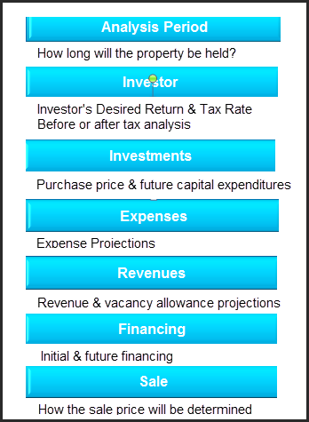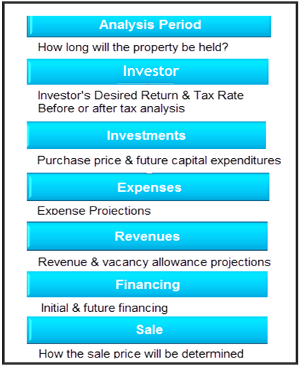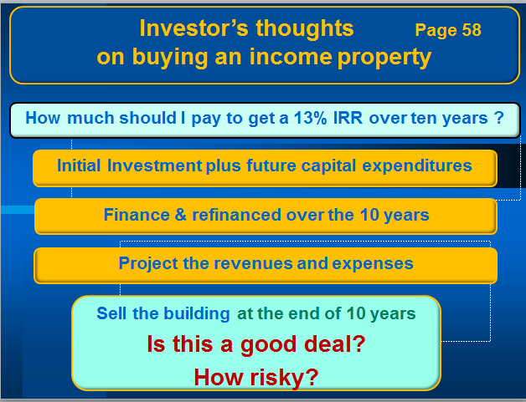

Introductory Case Study. Real Estate Investment Analysis
Showing the importance of financial leverage
Office building
Capital Plaza
8,400 Sq. Ft

The case study explores the following financial arrangements on return (Internal Rate of Return)

- Zero financing
- 45% LTV $1,395,000 25 years 4.50%
- 75% LTV $2,350,000 25 years 4.50%

Zero Financing
Without financing the Internal Rate of Return (IRR) is 8.29%
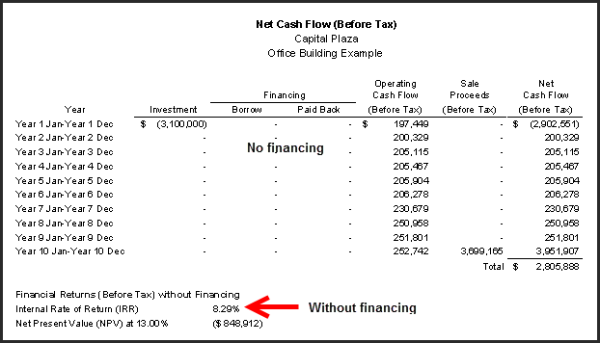

With Financing: 45% LTV $1,395,000 25 years 4.50% interest rate

Adding financing using a 45% loan to value ratio, 25 year amortization and 4.50% interest rate changes the return from 8.29% without financing to 10.65% which is a 29% increase in the return.

Can the financing be increased?
In year 1 the Loan to Value Ratio is around 44%. The ceiling is generally around 75%
The Debt Service Ratio is 2.12. The Ratio can go down to 1.25 or lower.

Both measures suggest that the first mortgage can be increased.

How risky is the investment?
The two measures of risk are:

Debt Service Ratio 2.12 The Ratio can go down to 1.25 or lower
Default Ratio or the Breakeven Point 60.22%. Generally shouldn’t exceed 85%

The Debt Service Ratio and the Default Ratio suggest low risk.

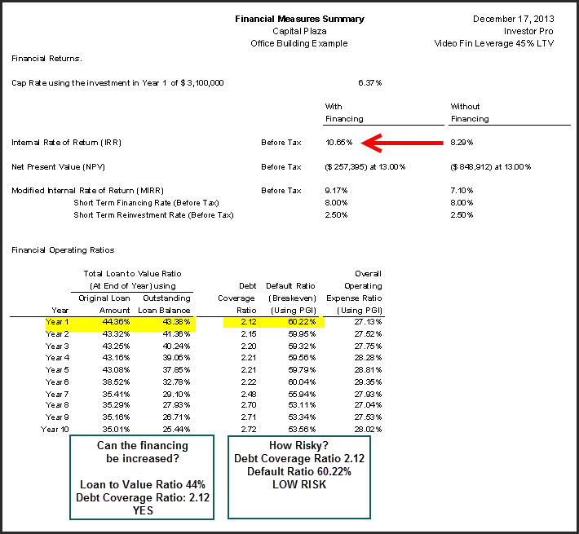.
With Financing: 75% LTV $2,350,000, 25 years 4.50%

Adding financing using a 75% loan to value ratio, 25 year amortization and 4.50% interest rate changes the return from 8.29% without financing to 15.24% which is an 84% increase.

Can the financing be increased?
In year 1 the Loan to Value Ratio is around 74%. The ceiling is generally around 75%
The Debt Service Ratio is 1.27. The Ratio can go down to 1.25 or lower.

Both measures suggest that the there is little room to increase the first mortgage.

How risky is the investment?
The two measures of risk are:

Debt Service Ratio 1.27 The Ratio can go down to 1.25 or lower
Default Ratio or the Breakeven Point 82.28%. Generally shouldn’t exceed 85%

The Debt Service Ratio and the Default Ratio suggest moderate to higher risk
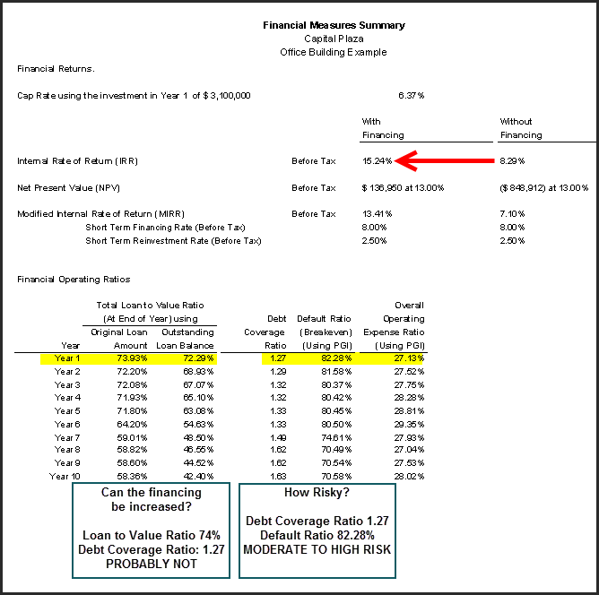

Summary. The impact of financial leverage
With no financing the Internal Rate of Return (IRR) is 8.29%. If a mortgage is added using a 45% Loan to Value Ratio the Internal Rate of Return (IRR) changes from 8.29% without financing to 10.65% which is an increase of 29%.

If a mortgage is added using a 75% Loan to Value Ratio the Internal Rate of Return (IRR) changes from 8.29% without financing to 15.24% which is an increase of 84%.

The use of financial leverage generally increases the return (IRR) but it also increases the investment risk.

In this example the Debt Coverage Ratio has gone from 2.12 with a 45% Loan to Value Ratio down to 1.27 using a 75% Loan to Value Ratio indicating increased investment risk.

The Default Ratio (Breakeven Point) has gone from 60.22% with a 45% Loan to Value Ratio up to 82.28% using a 75% Loan to Value Ratio.

A healthy balance is needed between the investment return and associated financing and risk.

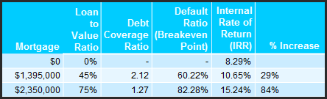
The above example looks how the use of financing increases the return on investment for a specific investment but there is more.

The use of financing allows the investor to buy a much larger property than buying a property using cash.

Conclusion
The cautious use of financial leverage results in:
- the acquisition of a much larger property. $20,000,000 versus $6,000,000 purchase price
- a significant increase in the return on investment (IRR). 16.65% versus 9.70%
- accumulated wealth over a 10 year period of $15,578,970 versus $$6,385,933
- A relatively safe investment. Debt Coverage Ratio is 1.48 and the Default Ratio (Breakeven Point) is 67.73% which points to a safe investment depending on the quality of the tenants and potential for vacancies

Valuing income properties that have development potential
How to identify whether an income property has development potential
Brief introduction to development analysis and valuing land
Income properties that are poor investments because they lack future development potential

Introduction to Development Analysis and Valuing Land

How do you value this property?
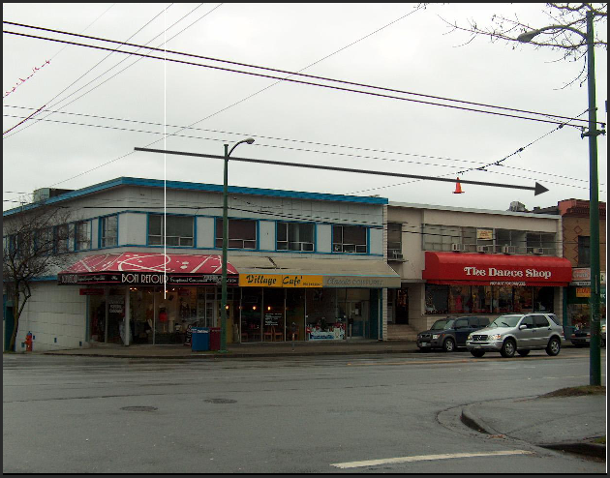

Two approaches to value
- Income approach
- Land residual or back door approach
One day these old buildings will be demolished and replaced with a high rise building.

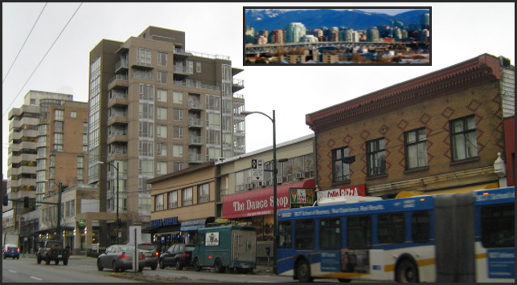

Development analysis versus the income approach

While the property is operating as an income property, the value is determined by the development potential, not the income. The property is not at its “Highest and best use”
Sometimes it is hard to determine whether to use the “Development Analysis” or the “Income” approach to valuation.
TIP
Ask this question: If the property was destroyed, what would replace it?
If the answer is:
A similar but new building. Use the Income approach
A very different building. Use the Development analysis or land residual approach to value.
In this case, it would be replaced with a high rise building with retail on the ground floor and likely condominiums and perhaps some office space depending on the zoning regulations and demand for office space in the area.

Income approach examples
Following are examples of buildings that would be valued by the income approach
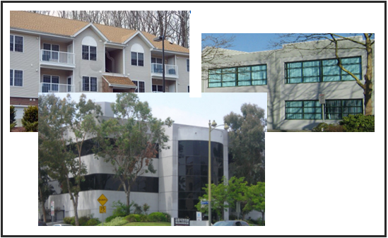

Development potential examples
Following are examples of income properties that have development and assembly potential which would be valued using land residual or backdoor approach to determine the value.
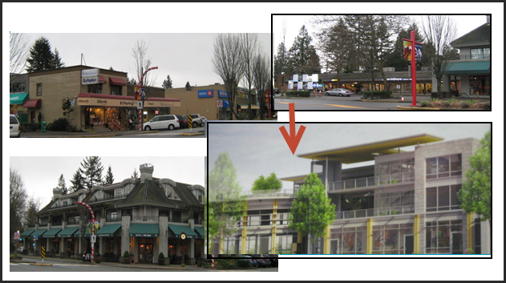

A current trend in large cities where there is a shortage of land is to replace aging super markets with hi-rise condominium towers and retail space on the ground level.
These sites would be valued using the land residual or backdoor approach to determining the value.
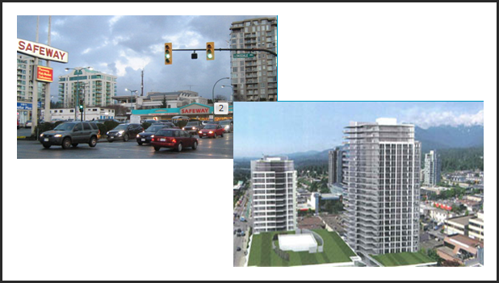

Look at the property tax assessment value.
If the Cap Rate based on the asking price is very low, look at the property tax assessed value. As an example, if the Cap Rate for a shopping center is 2.00% based on the asking price and the current net operating income, then the value is likely based on the value as a development site not as an income property.
You may be able be to confirm this by looking at the assessed value for property tax purposes.

Development Analysis. The Residual or Back Door approach

Following is an example of the Back Door or Land Residual Approach for valuing land where we work backwards to calculate the land value.

Condominium Development Example
Market Value. 30 units x $350,000 $10,500,000
Less: Development Costs
Site clearing and preparation
Construction
Financing
Professional fees
City permits and fees
Miscellaneous 6,575,000
Real estate fees 525,000
Developer’s Profit 1,900,000
Land Value (Residual) $ 1,500,000

Identifying development potential

In deciding whether to value the property using the income approach or the development analysis or land residual approach you need to check if it is possible to construct a new building on the site.
As an example, the property may not be wide enough to construct a building under the current zoning regulations or would require the acquisition of adjacent properties in order to obtain a site that is large enough to profitably develop.
Take a look at the properties on either side of the property that you are valuing. Is there assembly potential and potential for future development?
Under normal circumstances the value of this old, obsolete rental apartment building shown below would be influenced by the development potential. If the building was destroyed it would normally be replaced by a three or four story condominium project with underground parking similar to the newer property next door to the left of the building.

This site is very difficult to develop because it is a small corner site requiring setbacks from both streets. The site is not very wide and it would be difficult to create sufficient underground parking which would be required to meet the city’s parking requirements.

The current use is non-conforming with insufficient parking. If the building was destroyed by a fire it could not be replaced with a similar building. This rental building is a very risky investment and will remain an apartment building for a long time even though there are many condominium developments in the area.

Example of a property with no development potential
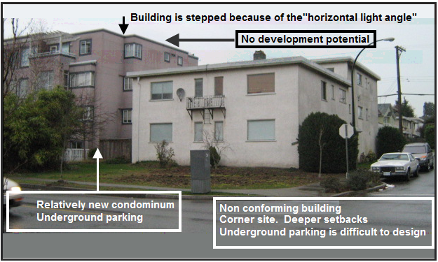

Good assembly potential
Any one of these three buildings had good long term development and assembly potential by acquiring the adjacent building creating a much wider and larger development.
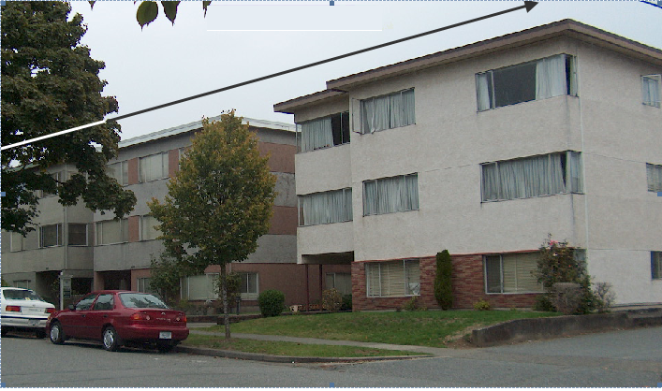

Which property would you buy?

Which is the best property to buy. Property A, B or C?
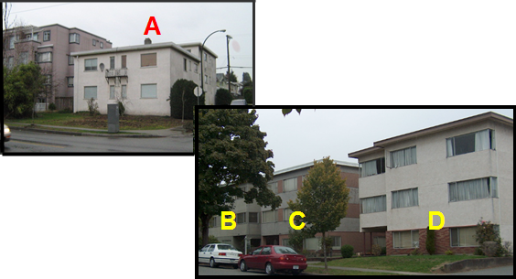

Answer.
Property A has no development potential whereas properties B, C and D have development and assembly potential. The best choice is property C because of potential assembly potential on either side of property C.

APPENDICES

Real Estate Investment Analysis Formulas with Examples

Income and Expense Statement

Income
Potential Gross Income (PG1) $__________
Less: Vacancy and Bad Debt Allowance __________
Equals: Effective Gross Income (EGI) $__________
Operating Expenses
Exclude: Depreciation
Mortgage Payments
Non-Operating Expenses. E.G Directors Salaries
Capital Expenditures $__________
Net Operating Income (NO1) __________
Less: Debt Service (P + I) __________
Cash Flow Before Tax (CFBT) __________
Less: Income Taxes __________
Equals Cash Flow After Tax (CFAT) $__________

FINANCIAL MEASURES used to determine the value and performance of income properties

Potential Gross Income Multiplier (PGIM)
Also called Potential Gross Rent Multiplier(PGRM)

PGIM = Market Value or Market Value = Potential Gross Income x PGIM
Potential Gross Income

= MV MV = PGI x EGIM
PGI

Effective Gross Income Multiplier (EGIM)
Also called Effective Gross Rent Multiplier(EGRM)

EGIM = Market Value or Market Value = Effective Gross Income x EGIM
Effective Gross Income
MV = EGI x EGIM
= MV
PGI

Net Income Multiplier (NIM)

NIM = Market Value or Market Value = Net Operating Income x NIM
Net Operating Income
MV = NOI x NIM
= MV
NOI

Capitalization Rate (Cap Rate)
Also called Broker’s Yield

Cap Rate(%) =Net Operating Income x 100 or Market Value = Operating Income x 100
Market Value Cap Rate(%)

= NOI x 100 MV = NOI x 100
MV Cap Rate(%)

Return on Equity (ROE)
Also called: Equity Dividend Rate (EDR) or Cash on Cash

ROE(%) = (Net Operating Income – Debt Service) x 100
Equity

Where: Equity = Market Value – Mortgage
Debt Service = Principal & Interest Payment or MV = (NOI-DS) x 100 + Mortgage
ROE(%)
ROE(%) = Cash Flow Before Tax x 100
Equity

ROE(%) = (NOI–DS) x 100
(MV–Mtge.)

Default Ratio (Break-even) (%)

Using Potential Gross Income Using Effective Gross Income

= (Operating Expenses + Debt Service) x 100 = (Operating Expenses + Debt Service) x 100
Potential Gross Income Effective Gross Income

FINANCE MEASURES used by lenders to determine loan amounts

Debt Service Ratio (DSR) Loan to Value Ratio (%)
Debt Coverage Ratio (DCR)

= Net Operating Income = Loan Amount x 100
Debt Service Market Value

GENERAL MEASURES

Rental Apartment Building Measures.

1. Price Per Suite
2. Price Per Sq. Foot (Using suite areas)
3. Rents Per Sq. Foot per month
4. Operating Costs
a. Operating Costs Per Suite Per Year
b. Operating Cost per Sq. Foot per Year
5. Operating Expense Ratio (OER) = Operating Expense x 100 used to check if the expenses are realistic
Effective Gross Income

Commercial Real Estate Formulas with Sample Calculations

The following examples illustrate how to use the real estate formulas. In Example No.1 the information is obtained for the property and the financial measures calculated. In Example No. 2 the financial measures such as the Cap Rate are obtained for comparable sales and are used to calculate the Market Value for the subject property.

Example No. 1

Sale Price (Market Value) $3,165,000
Potential Gross Income: $306,000
Vacancy & Bad Debt Allowance: 4.5%
Operating Expenses $58,000
Mortgage $2,056,000
Mortgage Payment (P+i) $180,538
Number of Suites 30
Total Rentable Area 24,000 Square feet

Note: All figures are annual

Calculate: Potential Gross Income Multiplier (PGIM)
Effective Gross Income Multiplier (EGIM)
Net Income Multiplier (NIM)
Capitalization Rate (Cap Rate)
Return on Equity (ROE)
Default Ratio (Break even) based on:
Potential Gross Income
Effective Gross Income
Debt Service Ratio (DSR)
Loan to Value Ratio
Price per Suite
Price per Square Foot
Rent per Square Foot per Month
Operating Cost per Suite per Year
Operating Cost per Square Foot per Year
Operating Expense Ratio (OER) based on:
Potential Gross Income
Effective Gross Income

1. Construct the Annual Income and Expense Statement

Potential Gross Income $306,000
Less Vacancy & Bad Debt Allowance (4.5%) 13,770

Effective Gross Income $292,230

Operating Expenses 58,000

Net Operating Income $234,230

Less; Debt Service (P+i) 180,538

Cash Flow Before Tax $ 53,692

2. Calculate the Financial Measures

Potential Gross Income Multiplier (PGIM):

PGIM = MV = 3,165,000
PGI 306,000

= 10.34

Effective Gross Income Multiplier (EGIM):

EGIM = MV = 3,165,000
EGI 292,230

= 10.83

Net Income Multiplier (NIM):

NIM = MV = 3,165,000
NOI 234,230

= 13.51

Capitalization Rate (Cap Rate):

Cap Rate = NOI = 234,230 x 100
MV 3,165,000

= 7.40%

Return on Equity (ROE):

ROE = (NOI – DS) x100 = Cash Flow Before Tax x 100
EGI Equity

= 53,692 x 100
(3,165,000 - 2,056,000)

= 4.84%

Default Ratio (Breakeven):

Based on Potential Gross Income:

Default Ratio = (Operating Expenses + Debt Service) x 100
Potential Gross Income

= (58,000 + 180,538) x 100
306,000

= 77.95%

Default Ratio (Breakeven) cont.

Based on Effective Gross Income:

Default Ratio = (Operating Expenses + Debt Service) x 100
Effective Gross Income

= (58,000 + 180,538) x 100
292,230

= 81.63%

Debt Service Ratio (DSR) = Net Operating Income
Debt Coverage Ratio (DCR) Debt Service

= 234,230
180,538

= 1.30

Loan to Value Ratio % = Loan Amount x 100
Market Value

= 2,056,000 x 100
3,165,000

= 64.96%

Price Per Suite = 3,165,000
30

= $105,500

Price per Square foot = 3,165,000
24,000

= $131.88

Rent Per Sq. Foot per Mo. = 306,000
24,000 x 12

= $1.06

Operating Costs Per Suite Per Year

= 58,000
30

= $1,933

Operating Cost per Square Foot per Year

= 58,000
24,000

= $2.42
Operating Expense Ratio (OER)

Based on Potential Gross Income:

= Operating Expenses x 100
Potential Gross Income

= 58,000 x 100
306,000

= 18.95%

Based on Effective Gross Income:

= Operating Expenses x 100
Effective Gross Income

= 58,000 x 100
292,230

= 19.85%

Summary.

Potential Gross Income Multiplier (EGIM): 10.83
Potential Gross Income Multiplier (EGIM): 10.83
Net Income Multiplier (NIM): 13.51
Capitalization Rate (Cap Rate) 7.40%
Return on Equity (ROE) 4.84%
Default Ratio (Break even) based on:
Potential Gross Income 77.95%
Effective Gross Income 1.63%
Debt Service Ratio (DSR) 1.30
Loan to Value Ratio 64.96%
Price per Suite $105,000
Price per Square Foot $131.88
Rent per Square foot per month $1.06
Operating Cost per Suite per Year $1,933
Operating Cost per Square Foot per Year $2.42
Operating Expense Ratio (OER) based on:
Potential Gross Income 18.96%
Effective Gross Income 19.85%

Example No 2.

Potential Gross Income: $244,800
Vacancy & Bad Debt Allowance: 5.0%
Operating Expenses $49,300
Mortgage $1,685,000
Mortgage Payment (P+i) $147,500
Number of Units or Suites 24
Total Rentable Area 18,720 Square feet

Note: All figures are annual

Calculate the Market Value using the following financial measures

Effective Gross Income Multiplier (EGIM): 9.30
Net Income Multiplier (NIM): 12.50
Capitalization Rate (Cap Rate): 8.00%
Return on Equity (ROE): 5.57%

1. Start by constructing the Annual Income and Expense Statement

Potential Gross Income $244,800
Less Vacancy & Bad Debt Allowance (5.0%) 12,240

Effective Gross Income $232,560

Operating Expenses 49,300

Net Operating Income $183,260

Less; Debt Service (P+i) 147,500

Cash Flow Before Tax $ 35,760

2. Calculate the Market Value based on the:

Effective Gross Income Multiplier (EGIM):

MV = Effective Gross Income x EGIM

= 232,560 x 9.30

= $2,162,808

Net Income Multiplier (NIM):

MV = Net Operating x NIM

= 183,260 x 12.50

= $2,290,750

Capitalization Rate (Cap Rate):

MV = Net Operating Income x 100
Cap Rate

= 183,260 x 100
8.0

= $2,290,750

Return on Equity (ROE):

MV = (NOI - DS) x 100 + Mortgage
ROE

= (183,260 - 147,500) + 1,685,000
5.57

= $2,327,011

TIPS for Analyzing Income & Expense Statements

- Certain revenues such as laundry, parking etc, are easier to understand if expressed as a $ per Unit per Mo.

Examples: Parking $35 per Space per Mo. Laundry: $13 per Unit per Mo
.
- Expense verification.
Certain expenses can be quickly verified by calling the companies providing the services, such as;

Elevator service contracts
Garbage collection
Insurance
Property taxes

- Analyzing expense. It is helpful to express some expenses as “$ per Unit or Sq. Ft per Mo” or “$ per Unit or Sq. Ft per Yr”.

- As an example, Maintenance of $24,000 has little meaning. Calculate the $ per Unit cost

Number of Units 120 units
Maintenance: $24,000 per year
Maintenance cost per Unit: $200 which is too low. The range is $350 to $650 plus

Operating Expense
Operating expenses are the expenses involved directly in the operation of the building.

Non recurring or minor capital expenses such as partial painting of the building, replacement of some or all of the appliances and other non recurring expenses etc., should be removed from the Income and Expense Statement when using the Cap Rate to establish the value.

Example: The owner included in the Income & Expense Statement $20,000 for replacing 20% of the appliances which is a non recurring expense. If the Cap Rate is 8.00%

Drop in Value = $20,000 = $250,000
8.00%

Partial replacement of equipment, carpets, painting etc., often appear on Income Statements because they are considered expenses for tax purposes but need to be removed when using Cap Rates to establish the value of the property.

Rental apartment buildings. Often the seller understates the operating expenses in order to justify the asking price based on the market Cap Rate for comparable properties. The seller;

- is usually aware of the Cap Rate for comparable properties
- is aware that rents can be quickly verified by the seller doing a quick survey of rents in the area
- has a price in mind. I bought the building for $1,600,000 and want to sell it for $2,100,000
- manipulates the expenses to justify the price based on the market Cap Rate

If a seller knows she is going to sell the building in say 6 months, maintenance may be postponed. This creates deferred maintenance expenditures for the buyers

Commercial buildings. Most commercial building have some form of Triple Net Rent where the tenant pays the landlords expense such as property taxes, insurance and maintenance (TIM’s) depending on the terms in the lease.

The building expenses paid by the tenant such as property taxes are called “Recoverable Expenses” or “Additional Rent” The expenses can be verified by finding out the recoverable expenses currently being paid by the tenant.

Even though the tenant is paying most of the landlords operating expenses, it is important to know the operating expenses because the buyer will have to pay these expenses for any vacant spaces.

A mistake when analyzing commercial properties is to assume that because the lease is Triple Net lease, the building operating expenses can be ignored because the tenant is paying the operating expenses.

There are several problems with this approach;

Triple Net is an ambiguous term. What counts is what the lease specifies as ‘Recoverable Expenses” or “Additional Rent”

Depending on the lease the tenant may or may not pay;

Property Management. If so, at what rate?
Depreciation of equipment
Administration fees

Financial Measures
The following financial measures are helpful in evaluating a building

Expense analysis

Operating Expense Ratio = Potential Gross Income x 100 or Effective Gross Income x 100
Operating Expenses Operating Expenses

Operating Costs per Unit & Sq. Ft per Mo. and Yr.

Financing
The following measures are helpful in ascertaining whether the financing can be increased or if the building is over financed.

Loan to Value Ratio. For the first mortgage, generally 65% to 75%

Debt Coverage Ratio = Net Operating Income Typically 1.25 and higher
Debt Service

E.g., A Debt Coverage Ratio of 1.43 may indicate potential to increase the financing

Risk Assessment

Default Ratio (Breakeven Point) = (Operating Expenses + Debt Service) x 100
Potential or Effective Gross Income

Debt Coverage Ratio = Net Operating Income
Debt Service

Show how much the Net Operating Income exceeds the Debt Service (P+i)

A Debt Coverage Ratio of 1.60 indicates low risk while 1.05 may indicate high risk

Information Sources and web sites

www.investitpro.com Visit the Online Learning Center for educational resources, articles etc.
www.investitacademy.com Online commercial education video series
www.youtube.com/user/investitacademy

The following organizations provide information on income and operating expenses.

Institute of Real Estate Management (IREM)
www.irem.org
Tel: (312) 329-6000
Income/Expense Analysis. Office Buildings
Income/Expense Analysis. Shopping Centers
Income/Expense Analysis. Conventional Apartments
Income/Expense Analysis. Federally Assisted Apartments
Income/Expense Analysis. Condominiums, Co-ops & PUDs

Building Owners and Managers Assoc. (BOMA)
www.boma.org
Tel: 1-800-426-6292 Office building expenses. Experience Exchange Report

International Council of Shopping Centers (ICSC) www.icsc.org Tel: (646) 728-3800

Appraisal Institute www.appraisalInstitute.org
Excellent books on analyzing many kinds of properties including Hotel and Motels, Mobile Home & RV Parks, Apartment Buildings, Nursing Homes, Land Subdivisions, Golf Courses, Marinas , Convenience Stores & Retail Facilities, Shopping Centers, Religious Facilities, Rural Properties, Industrial Properties etc

A variety of reports on sales, operating expense and percentage by type of shopping center, location etc.

Commercial Listing services called CIE’s (Commercial Information Exchanges)
www.Loopnet.com USA & Canada
www.icx.ca Canada CREA
www.clslink BC Canada
www.ICIWorld.ca Canada

www.costar.com www.REISReport.com http://www.thenewsfunnel.com/
Excellent free newsletters and blogs on commercial real estate markets

CCIM Institute. www.CCIM.com or CCIM.NET CCIM.STDB (Site to do business)
Construction costs: www.rsmeans.com
Snagit Screen Capture program www.techsmith.com Great productivity tool

