Raising Your Commercial IQ
_____________________________________________________________________________________________________________________

102 Real Estate Investment Analysis

In-house Training Program
Instructor Guide, Agenda and Timetable

Neil Osborne M.B.A.
DL. (604) 988-9964
nosborne@investitsoftware.com
Investit Software Inc.
Toll free 877-878-1828
North Vancouver BC
Canada V7R 3N4
investit@investitsoftware.com
www.investitacademy.com
www.investitpro.com
Copyright

Table of Contents

102. INSTRUCTOR GUIDE 2
Class hours 2
Content choices 2
Teaching process 2
LEARNING OBJECTIVES 3
AGENDA TIME TABLE 5
PRACTICE QUIZ and 102 COURSE EXAM 7
FLASH CARDS. QUESTIONS and ANSWERS 8
Cap Rates. Issues 8
Introduction to Investment Analysis 12
IRR, NPV & MIRR Introduction 15
Cash Flow & Investment Analysis 25
Financial Leverage 36
Risk Analysis 41
Real estate taxation 47

102. INSTRUCTOR GUIDE

Class hours
Allow approximately 16 hours of class time. For example, four, four-hour sessions meeting once per week.

Content choices
In some cases, you may not want to present all the course material. For example, if the class consists of residential realtors or rookie commercial interested in learning more about commercial real estate, some topics may be too advanced. If this is the case, skip the topic.

Teaching process
The teaching process consists of alternating between playing the:

- micro videos
- flashcards, answering the flashcard questions, and class discussions

by following the “Agenda Time Table” below.

The micro videos provide an introduction to the topic. The flash cards actively involve the student in the learning process and reinforce the material presented in the micro videos.
Flash cards
A great way to learn the basics. The Participant Guide contains:

- Question
- Space for the participant to write the answer
- The answer is on the flip side of the flashcard.

Teaching using flashcards.
Allow the participants time to complete the flashcard questions and then:

Review each flashcard question and answer and encourage questions and discussions. Enliven with your own experience and local examples.
This approach provides the opportunity for active class involvement.

- Questions, answers, and lively in-depth discussions
- Provides the instructor with an opportunity to provide local examples and personal experiences.

Example.
Soil conditions can impact the development costs and lower the landlord. Explain the various types of soil and how the soil impacts the land value.

LEARNING OBJECTIVES
Learning objectives.
The overall objective of the video is to provide an understanding of how to carry out in-depth real estate analysis investment and lease analysis, and how to apply investment analysis techniques to different types of properties or types of real estate decisions. How to use investment analysis to create deals.
Topics
- The significant weaknesses in using Cap Rates to make real estate investment decisions compared to the discounted cash flow approach. Examples illustrating the weakness of the Cap Rate approach to establishing value

- Time value of money concepts. The Internal Rate of Return (IRR) and Net Present Value financial measures
- Steps involved in carrying out long term real estate investment analysis and discounted cash flow analysis

- Real estate analysis. Tips and tricks

- The importance of financial leverage and accumulated wealth

- Real estate taxation

- Properties that are hard to sell because of taxes

- Seller financing. Tax issues

- Sale. Impact of mortgage restrictions

- How to use real estate analysis techniques to help list, sell or lease a property during challenging times

The knowledge and skills developed will improve your ability to value, list, sell or lease income properties and use investment analysis techniques to put deals together, make you money and help your client make wise financial decisions.
Skills and benefits obtained from the Video
How to:
- carry out and apply in-depth real estate analysis to different types of income properties
- determine the value of an income property using the discounted cash flow analysis approach
- assess risk
- develop presentation packages and executive summaries
- financially structure a real estate transaction using creative financing
- perform lease comparison analysis from a landlord or tenant perspective
- evaluate Buy versus Lease opportunities and Hold versus sell decisions
The knowledge and skills developed will improve your abilty to value, list, sell or lease income properties and how to use investment analysis techniques to put deals together and make you money.

AGENDA TIME TABLE

REAL ESTATE INVESTMENT & DISCOUNTED CASH FLOW ANALYSIS
Line  number | Play Micro Video | Manual  Page Number | Play Flash Card Set | Participant Package  Page number
1 | Apparent versus True Cap Rate (2 min) | 4
2 | Factors the effect Cap Rates (5 min) | 4
4 | Introduction to Discounted Cash Flow Analysis (7 min) | 7
5 | The Internal Rate of Return (IRR) (5 min) | 10
6 | Financial Calculators (2 min) | 13
7 | The Net Present Value (NPV)  (6 min) | 13
8 | The Modified Internal Rate of Return (MIRR) (2min) | 15
9 |  |  | Cap Rate. Issues | 7
10 |  |  | Intro. Investment analysis | 10
11 |  |  | IRR, NPV & MIRR Intro | 13
12 | The Building Blocks of Investment Analysis (5 min) | 16
13 | Investment Analysis. Case study (47 min) | 17
14 | Review. Building blocks of Investment Analysis (2 min) | 33
15 | Cap Rate versus IRR (19 min) | 39
16 | Timing and Sign convention  (10 min)
17 | What does “Return” mean? (3 min) | 46
18 |  |  | Cash Flow and Investment Analysis | 22
19 |  |  | Financial leverage | 33
20 |  |  | Risk analysis | 37

Line  number | Play Micro Video | Manual  Page Number | Play Flash Card Set | Participant Package  Page number
21 | Real estate analysis. Tips and tricks (28 min) | 55
22 | The importance of Financial Leverage and Accumulated Wealth (22 min) | 56
23 | Real estate investment analysis. Summary (6 min)

SELLING A PROPERTY. & POTENTIAL CHALLENGES
Line  number | Play Micro Video | Manual  Page Number | Play Flash Card Set | Participant Package  Page number
24 | Real estate taxation (21 min) | 47
25 | Properties that are hard to sell because of taxes (4 min) | 53
26 | Seller financing. Tax issues (1 min) | 53
27 | Sale. Impact of mortgage restrictions (4 min) | 54
28 |  |  | Real Estate Taxation | 43

PRACTICE QUIZ and 102 COURSE EXAM

Suggest the participants take the 102 Practice Quiz to test their knowledge and measure their progress.

They can take the test many times, and the grade will be recorded and can be reviewed

The quiz results are confidential and cannot be viewed by anyone else.

102. Course Exam.
Encourage the students to take the 102 course exam which is set up by a manager or office administrator.

FLASH CARDS. QUESTIONS and ANSWERS

Cap Rates. Issues
Q1.
The Cap Rate takes into account the "Time Value of Money"
True or False?
Your answer
False.

The Cap Rate is calculated using the:

Net Operating Income and Sale Price

and does not take into account the time value of money

Q2.
The "Internal Rate of Return (IRR)" takes into account the time value of money.

True or False?
Your answer
True.

In calculating the Internal Rate of Return (IRR) the fact that $1 dollar today is worth more than $1 in the future is taken into account.

The process is called "Discounted Cash Flow Analysis (DCF)”

Q3
The calculation of the Cap Rate assumes:

a) the property is never sold and

b) the Net Operating Income (NOI) is constant and goes on forever.

True or False?
Your answer
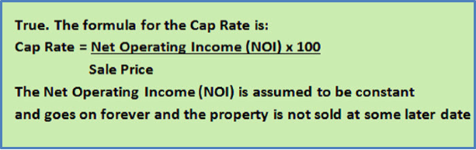

Q4.
Think of an example of when the Cap Rate approach to determining the value would not yield a good estimate of the value because of the way the cash flows change over time.

Flip to see an example
Your answer
Would the Cap Rate approach be a good way to value these two investment?

No. because the yearly cash flows are changing over time.

Instead use “Discounted Cash Flow Analysis” and the Internal Rate of Return (IRR)
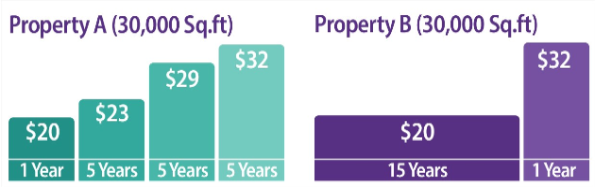
Q5
Is the Cap Rate calculated using the:

Net Operating Income (NOI) and Sale Price
always correct?

Your answer
No. If the buyer deducted $450,000 from the purchase price to replace the roof, and this was not known, then the calculated Cap Rate is incorrect. We call this Apparent Cap Rate".

The "True Cap Rate" would reflect the $450,000 adjustment to the purchase price for replacing the roof.

Q6
Purchase Price: $3,000,000

Net Operating Income (NOI): $195,000
The Buyer deducted $450,000 for urgent major repairs to the roof and the boiler.

Calculate the "Apparent Cap Rate" and the "True Cap Rate”
Your answer
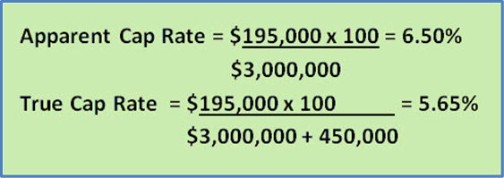

Q7
The "Apparent Cap Rate" ignores the hidden factors that may have influenced the price such as the buyer discovering that $350,000 has to be spent immediately on replacing the roof and major repairs to the HVAC system.
True or False?
Your answer
True
The "Apparent Cap Rate" uses the known purchase price and does not take into account factors that have influenced the purchase price such as the buyer discovering that $350,000 has to be spent on replacing the roof and major repairs to the HVAC system
The "True Cap Rate" would take into account the $350,000 that was deducted from the purchase price to cover the urgent major repairs.

Q8
If the Sale Price was $1,650,000 and the Net Operating Income $124,000 and the buyer deducted $300,000 for urgent major repairs.

Calculate the True Cap Rate.
Your answer
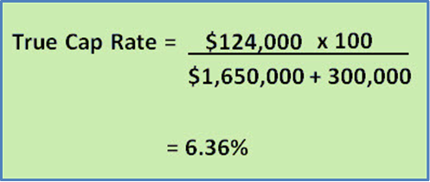

Q9
If the Cap Rate is calculated using the "Sale Price" and next years "Net Operating Income (NOI)" which one of the following statements is most correct?
- The calculation of the Cap Rate is always correct
b) The calculation of the Cap Rate is incorrect because the future value of the property has not been included

c) Using the Sale Price and the Net Operating Income (NOI) can result in an incorrect Cap Rate because of factors that you may not be aware of such as the cost of urgent major repairs that may have influenced the purchase price

Your answer
Answer c)
Using the Sale Price and the Net Operating Income (NOI) can result in an incorrect Cap Rate because of factors that you may not be aware of such as the cost of urgent major repairs that have influenced the purchase price

END OF SET

Introduction to Investment Analysis
Q1.
Which would you rather have?

1) $1,000,000 today or

2) $1,000,000 in 10 years’ time?
Your answer

$1,000,000 today because you can invest the $1,000,000 and earn interest for the next 10 years.
In choosing the $1,000,000 today you intuitively carried out “Discounted Cash Flow Analysis” and recognized the “Time Value of Money”
This is called Discounted Cash Flow (DCF) analysis and is used to carry out real estate investment analysis.

Q2.
You are going to loan me $10,000 and I’m offering the following two repayment plans. The annual payment is paid at the end of the year.

Which would you prefer as a lender Plan A or Plan B?

From your perspective as a lender which is the more risky option Plan A or Plan ?
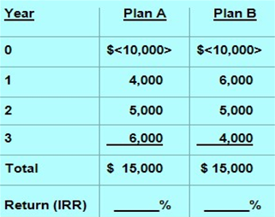
Your answer
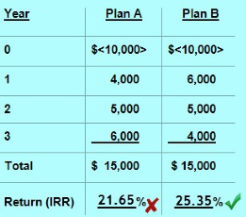
Plan B provides the highest return which is 25.35% compared to the Plan A return of 21.65%
If you chose Plan B you intuitively applied “Discounted Cash Flow Analysis” and took into account the “Time Value of Money”

Always balance “Risk”and Reward” Which is less risky Plan A or Plan B?

Plan B because your receive the money back faster.
Sooner is better than later.
Q3
What is the Internal Rate of Return (IRR)?
How do you calculate the Internal Rate of Return?
Your answer
The Net Cash Flow report shows the cash flow from the time the property is acquired until it is sold allowing us to calculated the Internal Rate of Return (IRR)
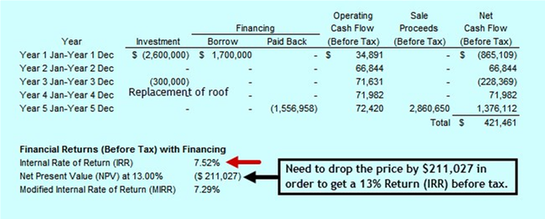

Q4.
What are the steps involved in carrying out real estate investment analysis?
Your answer
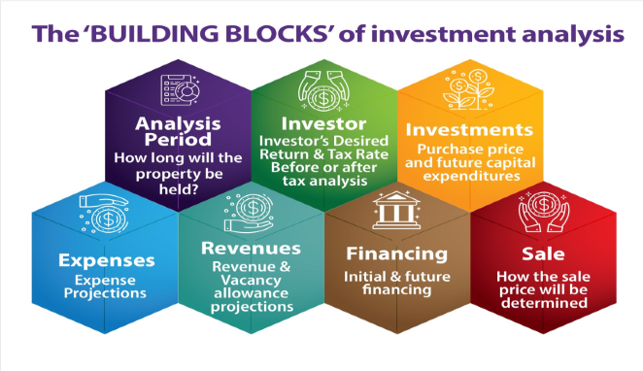
Q5
How to developing the Net Cash flows and Internal Rate of Return (IRR).

Example on the flip side.
Your answer
You have a choice to invest in either Property A and B. Each property will generate the following net cash flows. Which one would provide you with the best overall financial return?

Property A because the Internal Rate of Return (IRR) is 11.62% compared to 10.88% for Property B
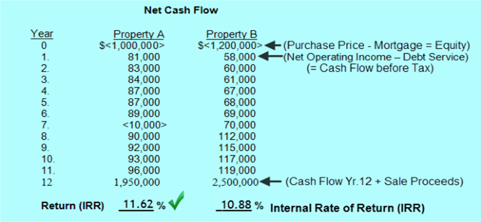

END OF SET

IRR, NPV & MIRR Introduction
Q1.
The IRR, NPV, MIRR, DCF and NCF are abbreviations for?
Your answer
IRR = Internal Rate of Return

NPV = Net Present Value

MIRR = Modified Internal Rate of Return

DCF = Discounted cash flow

NCF = Net Cash Flow

Q2.
Which investment option would you rather have and which option is less risky?
a) $300,000 today
b) $300,000 in five years time
Your answer
Answer

Option a) because the $300,000 received today can be reinvested and will be worth more the $300,000 in five years time
Option a) is also the less risky option.

Investment choices involve taking into account the "Time Value of Money" and the investment risk.
Q3
Which of the following are true?

Discounted cash flow analysis considers the:
1) Time value of money

2) The impact of financial leverage

3) Changing revenues and expenses over time

4) Uses the IRR and NPV

5) The sale at the end of the Analysis Period

6) The above items are ignored when using the Cap Rate
Your answer
Answer. All these statements are true.

Discounted cash flow takes into account:

1) Time value of money

2) The impact of financial leverage

3) Considers changing revenues and expenses over time

4) Calculates the IRR and NPV

5) Sale at the end of the Analysis Period

6) The Cap Rate approach ignores all of the above and uses the Net Operating Income (NOI) and the Cap Rate to value the property

Q4.
In carrying out long term real estate investment or discounted cash flow analysis the "Analysis Period" refers to:
Your answer
The time period in years used to carryout the investment analysis.
It is the time in years from when the investment is acquired until it is sold which is called the “Analysis Period” or the “Holding Period”

Q5
What is the generally recommended analysis period for:
a) Rental apartment buildings

b) Commercial buildings
Your answer
a) Rental apartment buildings
Five years but maybe 10 years
b) Commercial buildings.
Because of the lease renewals it is probably wise to use an "Analysis Period" of 10 years or more in order to reflect the impact of lease renewals and tenants moving out and the costs associated with re-leasing space

Q6
The Cap Rate and Internal Rate of Return (IRR) create the same estimate of value because they are both a 'Return on Investment"
True or False?
Your answer
False. The Cap Rate and the IRR likely result in different estimates of value.
The Cap Rate is a very simple measure using the Net Operating Income (NOI) and the Cap Rate to establish the value.
The Internal Rate of Return (IRR) is a more comprehensive approach that considers the "Time Value of Money", changing cash flows, the impact of financial leverage and the eventual sale of the property

Q7
The Cap Rate approach is the best method for valuing an investment that has the following lease arrangement over the next 16 years.
Yr 1. $21 psf. per Yr.
Yrs 2- 6 $23 psf. per Yr.
Yrs 7-11 $26 psf. per Yr.
Yrs 12 -16 $29 psf. per Yr.

TRUE or FALSE?
Your answer
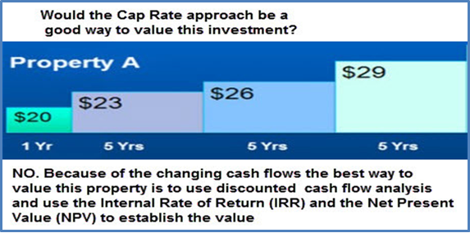

Q8
Can you use a standard mortgage calculator to calculate the return on investment (the interest rate) for this cash flow?
Year 0. <$600,000>
Year 1. 200,000
Year 2. 250,000
Year 3. 310,000
Your answer

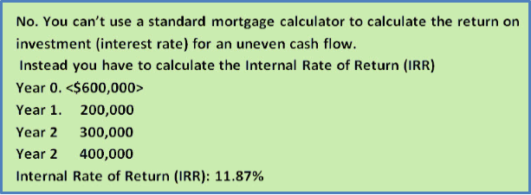

Q9
Which statement is correct?
a) If the Net Present Value (NPV) is positive the return is greater than the investment's discount rate or desired return
b) If the Net Present Value (NPV) is negative the return is greater than the investor's discount rate or desired return
Your answer
a)If the Net Present Value (NPV) is positive the return is greater than the Investor’s discount rate or desired return

Q10
If the Net Present Value (NPV) at the Investor's discount rate or desired return is negative the return on investment (IRR) is:
a) greater than
b) less than
the Investor's desired return or discount rate.
Your answer
Correct answer is b)
If the Net Present Value (NPV) at the Investor's discount rate or desired return is negative the return on investment (IRR) is less than the Investor's desired return or discount rate.

Q11
Which statement is correct?

The Investor's discount rate or desired return is used to calculate the:
a) Cap Rate
b) Internal Rate of Return (IRR)
c) Net Present Value (NPV)
d) Cash on Cash or Return on Equity
e) None of these
Your answer
c) The Investor's discount rate or desired return is used to calculate the Net Present Value (NPV)
Example
Net Present Value (NPV) at 13% is $235,000

Note. When quoting the NPV you always need to state the discount rate being used to calculate the NPV

Q12
When carrying out real estate investment analysis you look at the financial "Reward" such as the Internal Rate of Return (IRR) and the Net Present Value (NPV) PLUS......?
Your answer
the RISK.
Always balance the Risk and the REWARD.
The higher the risk the higher the desired return on investment (IRR)

Q13
If the investor's discount rate or desired return is 11% and the Net Present Value (NPV) is $<329,000> how much does the purchase price have to be reduced to get a return of 11%?

Your answer
The price has to be reduced by $329,000
The Internal Rate of Return (IRR) will then be 11% which is the investor's desired return.

Q14
Which items are not included when calculating the yearly cash flows from an investment in an income property?
a. Potential Gross Income
b. Vacancy Loss
c. Operating Expenses
d. Principal Payments
e. Interest Payments
f. Future Sale Price
g. Cap Rate
h. Major capital expenditures
Your answer
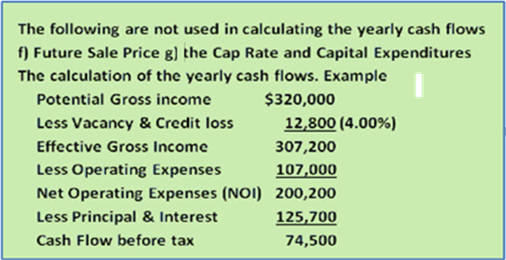

Q15
Which of the following financial measures does not take into account the "Time Value of Money"?
a) Debt Service Ratio
b) Cap Rate
c) Internal Rate of Return (IRR)
d) Return on Equity (Cash on Cash)
e) Net Present Value (NPV)
f) Modified Internal Rate of Return (MIRR)
Your answer
The following calculations do not involve the "Time Value of Money"
a) Debt Service Ratio
b) Cap Rate
d) Return on Equity (Cash on Cash)
These calculations use the "Time Value of Money"
c) Internal Rate of Return (IRR)
e) Net Present Value (NPV)
f) Modified Internal Rate of Return (MIRR)
Q16
If the Investor's "discount rate" or "desired return on investment: is 13% and the Net Present Value (NPV) of a potential investment is $283,000 what does this tell you?

Your answer
1) The return is higher than 13%
2) If the investor paid $283,000 more for the property they would get a 13% return (IRR)

Q17
What does the term "Capital Expenditure" mean?
Your answer
A capital expenditure is a major, one off expenditure such as replacing the roof or a major upgrade to the building or the interior and generally depreciated for tax purposes.
Capital expenditures are not treated as an operating expense because they provide benefits greater than one year.
Q18
What does the 'Re-investment assumption" refer to when calculating the Internal Rate of Return (IRR)?
Your answer
The re-investment assumption refers to how positive and negative (losses) cash flows are re-invested.
If the Internal Rate of Return (IRR) is 14% the re-investment assumption used when calculating the IRR assumes that positive cash flows are re-invested at 14% and cost of funds borrowed to cover losses is 14%.
Q19
If you received the following cash flow and calculated the Interest Rate the answer is 9.70%
Yr
0 <400,000
1 160,000
2.160,000
3.160,000
What is the Internal Rate of Return (IRR)?

Your answer
The Internal Rate of Return (IRR) is also 9.70%. For an even cash flow the interest rate and the Internal Rate of Return (IRR) are the same.
For uneven cash flows you have to calculate the IRR and can't use a standard mortgage calculator.

Q20
Can you calculate the return on investment or interest rate for the following investment using a standard mortgage calculator
Year
0 <730,000>
1 350,000
2 400,000
3 150,000...This is an uneven cash flow
Your answer
Answer is no.
You cannot use a standard mortgage calculator to calculate the interest rate or return on investment for an uneven cash flow.

You have to use a financial calculator or computer program that calculates the Internal Rate of Return (IRR)

Q21
Which statement is correct?
a) If the Net Present Value (NPV) is positive the return is greater than the investment's discount rate or desired return
b) If the Net Present Value (NPV) is negative the return is greater than the investor's discount rate or desired return

Your answer
Answer a)
If the Net Present Value (NPV) is positive the return is greater than the Investor's discount rate or desired return.
If the NPV is negative the return is less than the Investor's discount rate or desired return on investment

Q22
The Investor's discount rate is used to calculate the:
a) Cap Rate
b) Internal Rate of Return (IRR)
c) Net Present Value (NPV)
d) Cash on Cash or Return on Equity
e) None of these
Your answer
c) The Net Present Value (NPV)

Q23
Which one of the following might be a good reference point in deciding on the "Discount Rate" or "Desired Return" when calculating the Net Present Value (NPV)?
a) A conservative second mortgage rate for the same kind of property
b) The Cap Rate from comparable properties
c) Government bond rate
d) The average return for a large REIT (Real Estate Investment Trust)
Your answer
We like to use a discount rate that:

a) Uses published data

c) Where the investments have similar risks and characteristics.
A good choice is....
a) A conservative second mortgage rate for the same kind of property
Q24
The analysis of an investment property shows the following results:
Financial Returns (Before tax) with financing
Internal Rate of Return (IRR): 7.95%
Net Present Value (NPV) at 11%: $<319,118>
a) How much does the price have to be reduced to get the desired return of 11%?
b) If the price is reduced by this amount what is the IRR and the Net Present Value at 11%?
Your answer
Answers

a) The price has to be reduced by $319,118 to get the desired return of 11%
b) If the price is reduced by $319,118 the IRR will be 11% and the NPV will be zero
Q25
The reinvestment assumption used when calculating the Internal Rate of Return (IRR)
a) Can cause the Internal Rate of Return (IRR) to be overstated

b) Has no impact on the Internal Rate of Return (IRR)
Your answer
Answer is a)
If the Internal Rate of Return on an investment is 17% the reinvestment assumptions assumes that positive cash flows will be reinvested at 17%.
Investing the positive cash flows on a short term basis at 17% is highly unlikely.
This means that the IRR will overstate the true return which will be less than the IRR of 17%

Q26
If the Internal Rate of Return (IRR) is 16.17% when calculating the Internal Rate of Return (IRR) losses are borrowed at:
a) 0%
b) The interest rate used for the first mortgage
c) 16.17%
d) 15%
Your answer
Answer is c) 16.17%
When calculating the IRR the reinvestment assumption assumes losses are borrowed at the IRR which in this case is 16.17%
While this is not realistic it's the way the calculation of the IRR works
There is another measure called the Modified Internal Rate of Return (MIRR) which utilizes a short term reinvestment and borrowing rate but is not widely used compared to the IRR.
Q27
The Cap Rate and the Internal Rate of Return (IRR) are similar measures and therefore can be compared.
True or False?
Your answer
FALSE. The Cap Rate and Internal Rate of Return (IRR) are very different financial measures or returns on investment

The Cap rate is a very simple measure using the Net Operating Income, ignoring changing cash flows over time, the impact of financing and the eventual sale of the property.

The IRR takes these factors into account.

Generally the IRR is higher than the Cap Rate.
As an example, why would you invest at a Cap Rate of 4% and finance at 6%?

One reason is capital appreciation which is ignored when calculating the Cap Rate but taken into account when calculating the IRR.
Q28
The Internal Rate of Return (IRR) is generally "Higher" or "Lower" than the Cap Rate?
Your answer
Under normal circumstances the Internal Rate of Return (IRR) is higher than the Cap Rate.
As an example, if the Cap Rate is around 7% to 8% the IRR will be around 12% to 14% for typical income properties.

Q29
The results of an investment analysis of an office building are:
Internal Rate of Return (IRR): 8.27%
Net Present Value (NPV) at 13%: $<680,000>
If the purchase price is reduced by $680,000 the Internal Rate of Return (IRR) will change from 8.27% to ...?% and the Net Present Value (NPV) will be $...?
Your answer
Dropping the purchase price by $680,000 will result in an Internal Rate of Return (IRR) changing from 8.27% to 13.00%.
The Net Present Value at 13% will change from $<680,000> to $0

Q30
Under what conditions does the Cap Rate come close to being equal to the Internal Rate of Return (IRR)?
Your answer
Under the following conditions:
1) The Net Operating Income (NOI) is constant for many years such as 50 years or more
2) The property is never sold
3) There is no financing or financing is removed from the calculation of the yearly cash flows

END OF SET

Cash Flow & Investment Analysis
Q1.
What are the components of the

"Operating Cash Flow (Before tax)"?
Your answer
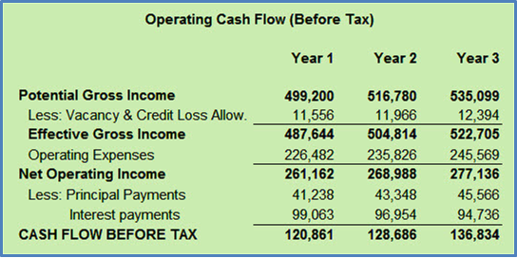

Q2.
How is the after tax cash flow calculated?
Your answer
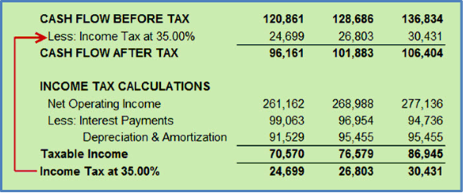

Q3
Investment analysis can be broken down into basic steps or building blocks.
The "Building Blocks of Investment Analysis" are shown on the flip side
Your answer
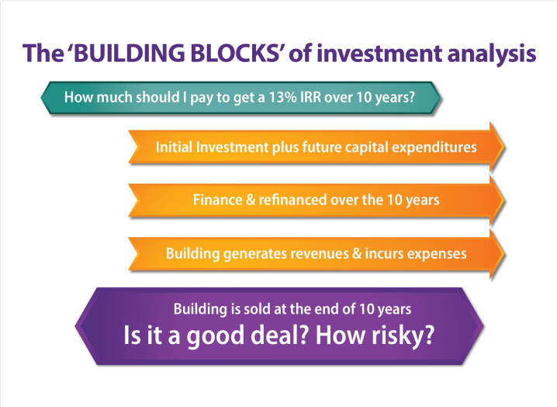

Q4.
A good starting point when carrying out investment analysis is to decide on the questions you want answered.

Examples are shown on the flip side
Your answer
How much to pay for the property to get the investor's desired return of say 13% before tax?
2. Is there potential for increasing the financing now or in the future?
3. How risky is the investment?
TIP. Before starting the analysis think carefully as to what questions you want to answer.

Q5
On the flip side is a summary of the steps involved in carrying out long term real estate investment analysis.
Also called "Discounted Cash Flow Analysis"
Your answer
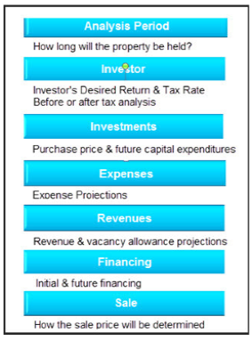

Q6
Capital Investment and capital expenditures refers to?
Your answer
The purchase price of the property is referred to as the "Capital Investment"
"Capital Expenditures" also refer to major future expenditures such as replacing the roof for $359,000 in 3 years or upgrading the interior.

Q7
What are "Operating Expenses?
Operating Expenses are regularly recurring expenses involved in maintaining and running the building.

For examples of “Operating Expenses” see the flip side
Your answer
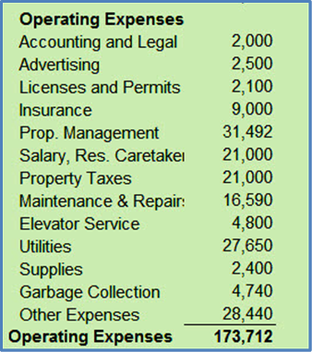

Q8
What are "Non Recurring Expenses"?
Non Recurring Expenses are smaller "one off" expenditures that are being treated as an expense rather than as a capital expenditure such as a leasing agent's fee for leasing the space or painting a portion of the exterior of the building.

Non recurring expenses should not be included in calculating the Net Operating Income (NOI) when using a Cap rate to determine the value of an income property.

See the flip side for examples.
Your answer
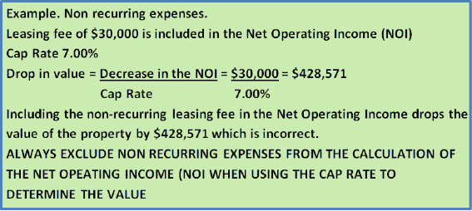

Q9
Non recurring expenses such as a leasing fee should never be included in the Net Operating Income (NOI) when using a Cap Rate to establish the value.

How do you show non-recurring expenses in an Income & Expense Statement?
Your answer
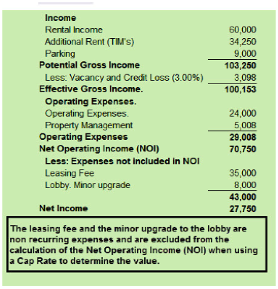

Q10.
What's the difference between:
1) Capital investment
2) Capital Expenditure or Capital Improvements
3) Expense
4) Non recurring expense
Your answer
A "Capital Investment" and a "Capital Expenditures or Improvements" are essentially the same. They both involve large "one off" investments that provide benefits over many years.
Expenses occur every year on a regular basis such as building maintenance, utilities etc.

Non recurring expense are "one off" expenses such as a leasing fee.

Q11.
How do you calculate the "Cash Flow from Sale" before and after tax?
Your answer
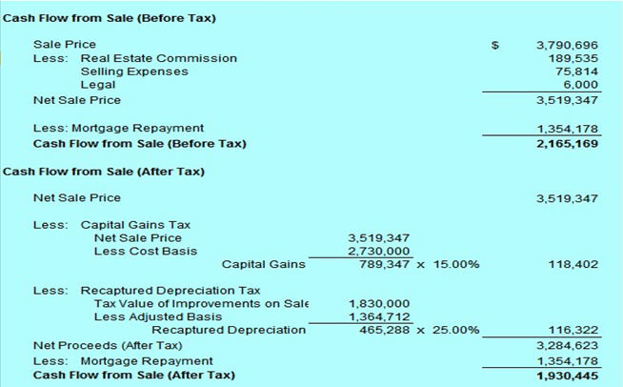

Q12.
What is the best investment analysis report that shows the big picture and the financial results and is easy to understand?
Your answer
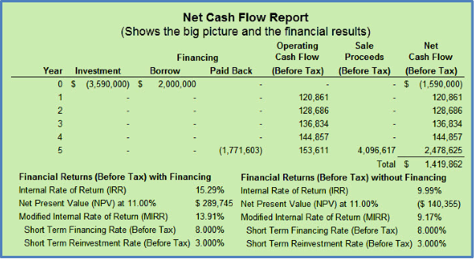

Q13.
The “Overall Cash Flow” report is an excellent report for seeing the "big picture" and the financial results all on one easy to understand report.

See example on the flip side
Your answer
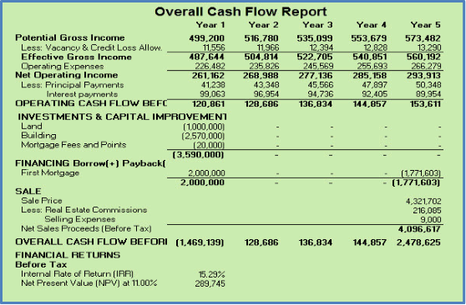

Q14.
What is 'Extra-ordinary Revenue" or "Non Recurring Revenue" and how do we treat them in cash flow analysis ?
Your answer
"Extra-ordinary Revenue" or "Non Recurring Revenue" are "one off" sources of revenue and need to be excluded from the Net Operating Income (NOI) when using the Cap Rate to establish the value.

Examples could be revenue from short term sign rental for 3 months or other forms of temporary revenue.

Q15.
How would you show the following on an Income and Expense Statement?
Temporary sign rental $17,000 year 1

Leasing fee $30,000 & Minor building upgrades $21,000 both in year 2

Capital expenditure. Roof $450,000 year 3
Your answer
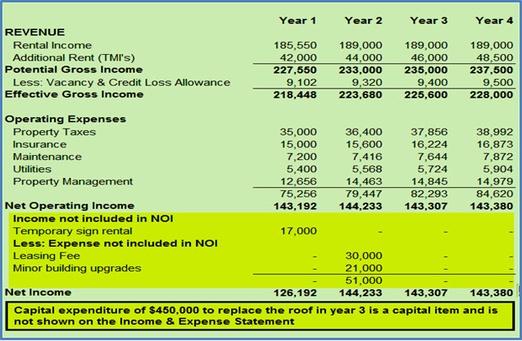

Q16.
How do you determine the Sale Price at the end of the "Analysis Period" (Also called the "Holding Period")?
Your answer
The most common approach is to take the "Net Operating Income (NOI)" for the year following the sale and divide by the Cap Rate.
If the Analysis Period was 10 years you would use the Net Operating Income" in year 11.

Q17.
In real estate investment analysis what does the "Analysis Period" or the "Holding Period" refer to?
Your answer
The "Analysis Period" refers to the time period in years that the analysis covers.

It is the time from when the property is acquired until it is sold.

Q18.
Should the projection of revenues and expenses be done on a yearly or monthly basis?
Your answer
Yearly projections are usually fine for rental apartment buildings because the revenues and expenses tend to increase gradually overtime.
For commercial buildings such as office, retail and industrial buildings the revenue and expense projections should be done on a monthly basis in order to reflect rent renewals and changes in rent rates which occur during the year.

Q19.
What are the different ways for projecting revenues and expenses?
Your answer
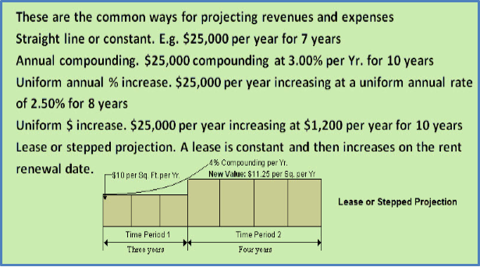

Q20.
When carrying out investment analysis don't forget to consider...
Your answer
Future capital expenditures and major repairs

Potential for future refinancing

For new commercial tenants.
Free rent periods
Cost of tenant improvements (TI's) paid by the landlord Cost of tenant inducements, Leasing and legal fees.

If the tenant is vacating the space how long will it take to lease the space?

Q21.
An important aspect of real estate analysis is investigating the impact of financing on the financial return (IRR).

Financing generally increases the return (IRR) but increases the investment risk.

Always check to see if the financing can be increased now or some time in the future and if so, when?

See the impact of financial leverage on the flip side
Your answer
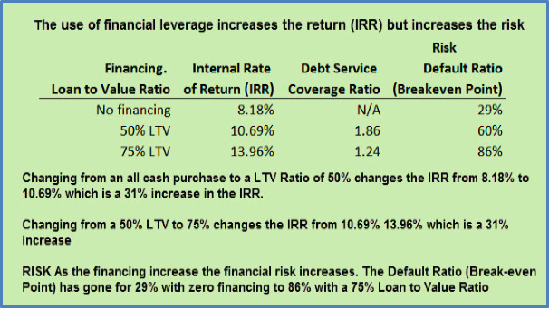

Q22.
When carrying investment analysis always check to see if the financing can be increased now or in the future and if so when?
The goal is to reduce the amount of equity required to buy the property and increase the return (IRR) through financial leverage balanced by risk considerations.

See examples showing how to determine if the financing can be increased on the flip side.
Your answer
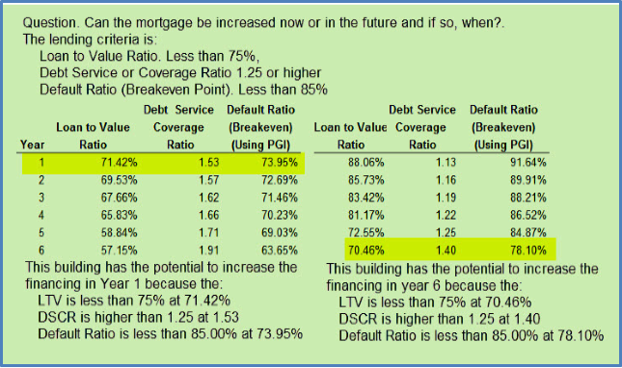

END OF SET

Financial Leverage
Q1.
What are the two financial measures commonly used by lenders to determine mortgage loan amounts.
Your answer
1) Debt Service or Coverage Ratio (DSCR)

2) Loan to Value Ratio (LTV)

Lender is conservative. They use both ratios and then choose the ratio that provides the lowest loan amount.
Typical figures for a first mortgage
DSCR 1.20 to 1.25
LTV 70% to 75%

Q2.
Calculate the Debt Service or Coverage Ratio (DSCR) using the following information:
Net Operating Income (NOI): $200,000
Debt Service (p+i): $160,000
Note. Debt Service is the annual mortgage payment of principal and interest
Your answer
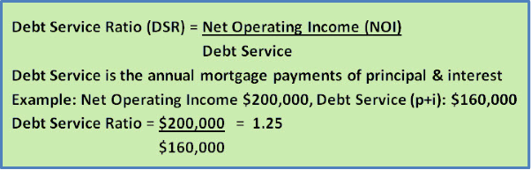

Q3
If the Debt Service or Coverage Ratio (DSCR) is 1.25 and the Loan to Value Ratio (LTV) is 75% determine the loan amount for the following mortgage:
Appraised value: $3,500,000
Net Operating Income (NOI): $245,000
Interest Rate: 5.00% compounded monthly.
Amortization: 25 years
Your answer
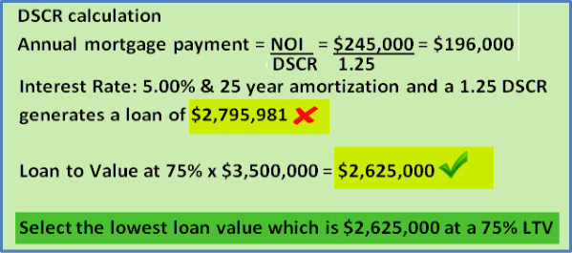

Q4.
If financing is increased from a 50% Loan to Value Ratio (LTV) to a 75% LTV what happens to the:

Return on Investment (IRR)?

Financial risk?
Your answer
If the financing increases from 50% to 75% LTV the Internal Rate of Return (IRR) will generally increase but the financial risk will increase.
Increased use of financial leverage generally increases the return (IRR) but increases the financial risk.

Q5
In carrying out investment analysis always check to see if the financing can be increased "Now" or some time in the future and if so "When"

Flip side. If the lender is using a Debt Service or Coverage Ratio of 1.18 in what year could the building be refinanced and the mortgage increased?
Your answer
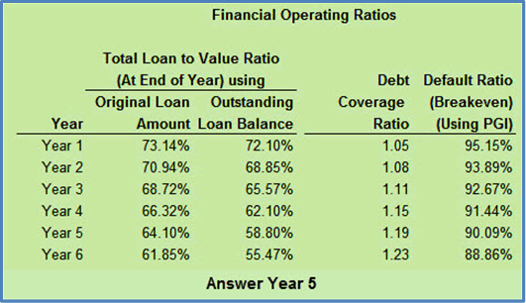

Q6
What does a Debt Service or Coverage Ratio (DSCR) of 1.25 mean from a lender's perspective
Your answer
...It means that the Net Operating Income (NOI) could drop by approximately 25% from 1.25 to 1.00 before the building would experience a negative cash flow.
The DSCR is the lender's margin of safety. The higher the DSCR the lower the financial risk.

Q7
Increasing the financing increases the return on investment (IRR) but increases the risk.

This is illustrated on the flip side which shows the return on investment (IRR) with and without financing and shows the impact on the DSCR and the Default Ratio (Breakeven Point)
Your answer
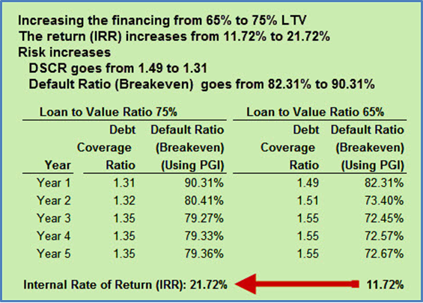

Q8
What is financial leverage?
Financial leverage refers to using finance or other people's money to purchase real estate.

Hopefully the use of financial leverage will increase the return on investment but it also increases the risk.
See example on the flip side.
Your answer
Example of using financial leverage

You have $1,000,000 to invest. and your options are:

1) Buy a building for $1,000,000 paying all cash

2) Buy a $4,000,000 building using a 75% LTV and an equity of $1,000,000

If the values increase 10%

Option 1) Profit is 10% x $1,000,000 = $100,000 with no financial leverage

Option 2) Profit is 10% x $4,000,000 = $400,000 using financial leverage

Using financial leverage the profit went from $100,000 to $400,000 but the financial risk increased. If the values went down 10% you would lose $400,000 if you used financing instead of $100,000 if you paid cash.
Q9
What might prevent you from increasing the first mortgage or arranging a second mortgage with the seller in order to reduce the amount of equity required to buy the property and increase the return on investment (IRR)?

Your answer
You need to check the mortgage document or talk to the lender to see if the mortgage can be paid off or increased. Mortgages often have a number of restrictions such as:
1) The mortgage can't be paid off
2) The mortgage can be paid off but there is a very large penalty
3) The loan amount can be increased but the interest rate will increase
4) The first mortgage prohibits placing a second mortgage on the property

END OF SET

Risk Analysis
Q1.
The "Higher" the risk the "Higher" or "Lower" the desired return on investment?
Your answer
The higher the risk the higher the desired return on investment.
Investor's will often accept a higher risk but will look for a higher return on investment.

Q2.
What creates risk?
Identify some strategies that are used to reduce risk
Your answer
Risk is created by uncertainty and the inability to accurately predict outcomes.
One strategy is to shift or share the risk.

Examples.
Taking out fire and flood insurance.
Use a "Triple Net Lease" to transfer increases in operating costs to the tenant.
Form a joint venture to spread the risk between the participants

Q3
One way to identify risk is to look at the timing of the cash flows. The faster the money flows back the less risky the investment. Sooner is better than later.

This is illustrated on the flip side.
Your answer

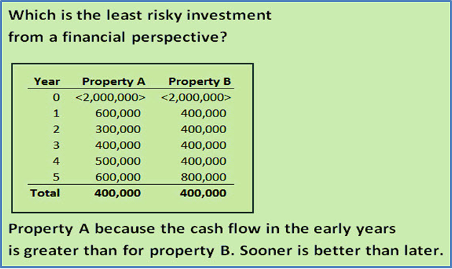

Q4.
When carrying out investment analysis which are the best financial measures for assessing the potential investment risk?
Your answer
The primary financial measures used to measure risk are:
a) Debt Service or Coverage Ratio (DSCR)
b) Default Ratio (Breakeven Point)

Q5
One of the best measures for evaluating risk is the Debt Service or Coverage Ratio (DSCR)

Calculate the Debt Service or Coverage Ratio based on the following

Net Operating Income (NOI): $239,000

Debt Service (p+i): $190,000
Your answer
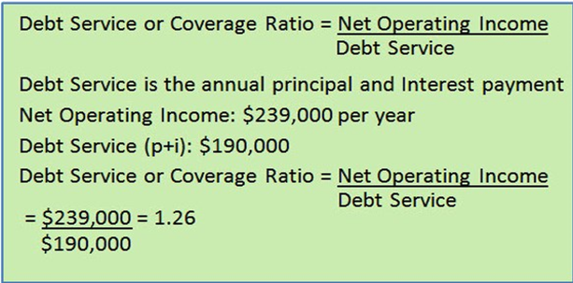

Q6
How can you use the Debt Service or Coverage Ratio (DSCR) to evaluate the financial risk?
Your answer
A DSCR of 1.26 tells you that the Net Operating Income (NOI) can drop by approximately 26% before the operating cash flow becomes negative. It's the lender's margin of safety.
The higher the DSCR the safer the investment from a cash flow perspective.

Q7
Another really good measure of financial risk is the “Default Ratio (Breakeven Point)” which is the point where the revenue covers the operating expenses and the mortgage payments.

Using the following information calculate the
Default Ratio (Breakeven Point)

Operating Expenses: $58,000

Debt Service (p+i): $180,538
Effective Gross Income (EGI): $292,230
Your answer
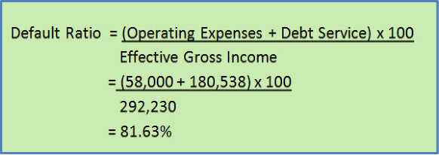

Q8
How can you use the Default Ratio (Breakeven Point) to evaluate the investment risk?
Your answer
The Default Ratio (Breakeven Point) shows you the percent of revenue needed to breakeven where the revenue covers the operating expenses and the debt service or mortgage payments.
A high Default Ratio (Breakeven Point) tends to suggest high risk depending on the quality of the tenants.

Q9
Which investment would you consider to be less risky?
Investment A:
Default Ratio (Breakeven Point): 90%
Debt Service or Coverage Ratio: 1.13
Investment B
Default Ratio (Breakeven Point): 81%
Your answer
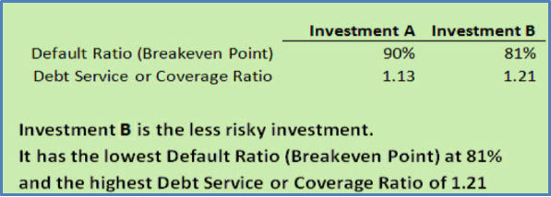

Q10
Increasing the financing on a building will increase the financial risk but will generally increase the return on investment or the Internal Rate of Return (IRR)
This is illustrated on the flip side where increasing the Loan to Value Ratio from 65% to 75% increases the Internal rate of Return(IRR) from 11.72% to 21.72% but increases the financial risk.
Your answer
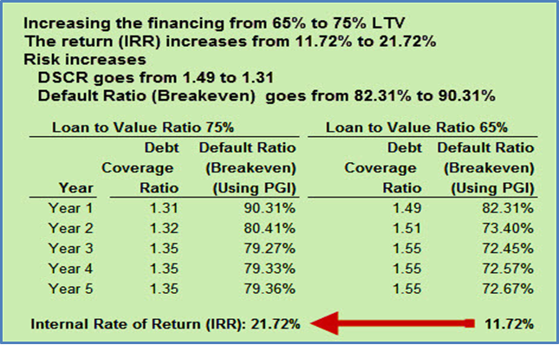

Q11
When using the Default Ratio (Breakeven Point) a high Default Ratio (Breakeven Point) such as 92% may indicate high risk but it depends on the predictability of the cash flows which may depend on the quality of the tenants.
The example on the flip side illustrates this.
Your answer
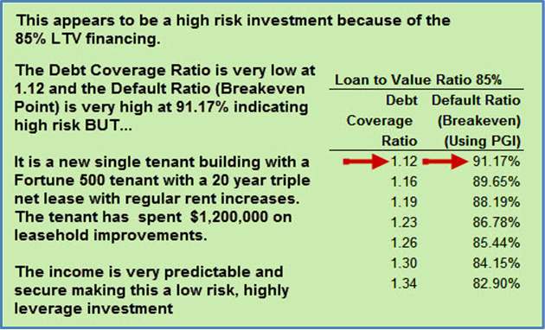

Q12
Increasing the financing generally increases the return on investment (IRR) but increases the risk.
The example on the flip side show the impact of using financial leverage.
Your answer
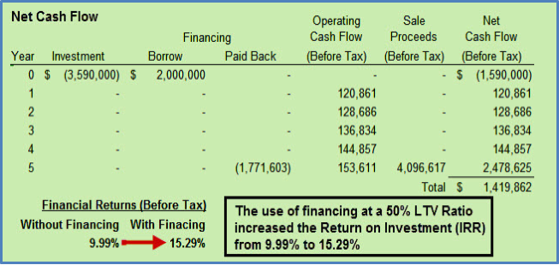

Q13
The example on the flip side shows prudent financial ratios for a safe versus a more risky investment.
Your answer
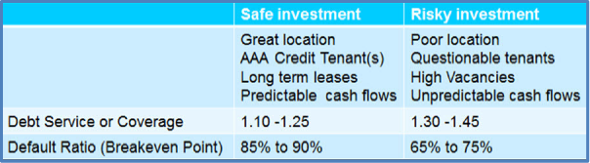

END OF SET

Real estate taxation
Q1.
When calculating taxes which of the following are “EXPENSED” and which are expensed by claiming “DEPRECIATION”?

Maintenance Expense Depreciate
Improvements Expense Depreciate
Utilities Expense Depreciate
Insurance Expense Depreciate
Roof replacement Expense Depreciate
Circle your answer

Q2.
When an investor buys a commercial property, the value of the land is claimed over time using depreciation.
True False
Circle your answer

Land cannot be depreciated or expensed for tax purposes.

Q3.
Recaptured depreciation tax paid by the seller because:

- The value of the improvements on sale is greater than on acquisition or..

- The value of the improvements on sale is less than on acquisition
Circle your answer
The value of the improvements on sale is less than on acquisition
If the value of the improvements on sale is greater than on acquisition, the value of the improvements has “appreciated”, not “depreciated”, and the seller will face recaptured depreciation tax which is generally taxed at the seller’s income tax rate.

Q4.
When a property is sold, why is it important that the buyer and seller agree on the allocation of the purchase price between “Land” and “Improvements”?

BUYER
Wants the value of the improvements to be “HIGH” or “LOW”

SELLER
Wants the value of the improvements to be “HIGH” or “LOW”
Circle your answers

BUYER
Wants the value of the improvements to be “HIGH” or “LOW”

The “Buyer” wants the value of the improvements on sale to be as high as possible, to maximize the yearly depreciation claim and reduce income taxes.

SELLER
The “seller Wants the value of the improvements to be “HIGH” or “LOW”

The “Seller” wants the value of the improvements on sale to be as low as possible, to minimize the amount of recaptured depreciation tax that has to be paid.

Q5.
What is a “Capital Gain”?
Your answer
A “Capital Gain” is created when the value of the property increases.

Example
A buyer bought the property for $2,000,000 and sold it for $3,500,000 five years later.

The capital gain is;

$3,500,000 - $2,00,000 = $1,500,000 which will be subject to a capital gains tax.

Q6.
A “Capital Gain” is taxed at the Investor’s income tax rate.

True False
Circle your answer
The “Capital Gain” is taxed at the capital gain tax rate which is different from the income tax rate and is lower than the income tax rate.

Q7.
Your getting a listing to sell an income property.

The Investor has owned the property for many years, and it’s gone up a lot in value.

Why is it important for the Investor to check with her accountant before selling the property?
Your answer
The investor needs to know the tax implication associated with the sale and how much money she will receive after paying:
Capital gains tax
Depreciation recaptured tax
Paying off the outstanding balance of the mortgage plus any penalties
Real estate commission and closing costs

If the building has been refinanced and has a large mortgage it’s possible that the seller will receive little money from the sale and walk away from the deal.

Best to know this before you put a lot of effort into listing and trying to sell the property.

Q8.
What are the characteristics of income properties that are hard to sell because of the impact of taxes?
Your answer
Properties that are hard to sell because of the tax implications.

Characteristics
1. Owned for a long period of time
2. Gone up a lot in value
3. Heavily depreciated
AND THERE IS A LARGE MORTGAGE ON THE PROPERTY
When the owner sells:
Large Capital Gain tax to pay
Large Recaptured Depreciation tax to pay
Real estate commissions and closing costs
……and a large mortgage to pay off.

THE RESULT
The is little money left over from the sale
When the owner realizes this, the deal collapses
Q9.
Can a full depreciation claim be made in the year of acquisition?

Yes No

Circle your answer
In the first year the allowable depreciation claim is reduced based on the tax rules for the country and the asset class.

In Canada 50% of the asset value is used to calculate the first year depreciation.

USA uses a more complex system using mid month, mid quarter and mid year rule depending on the asset class.

Q10.
What is the difference between “Amortization” and “Depreciation”
Your answer

Depreciation is used for expensing the cost of tangible assets for tax purposes such as a building or the cost of replacing a roof.

Amortization is used to expense the cost of intangible assets for tax purposes such as a fee paid to the realtor for leasing space or cash paid by the landlord to the tenant to entice a tenant to lease space in the building.

Q11.
When listing and selling a property, why is it important to review the mortgage document?
Your answer
The mortgage(s) may have restrictions that make it difficult to sell the property such as:
1. The mortgage can’t be paid off until the end of the term
2. The interest penalty for paying off the mortgage is very high
3. The seller is willing to provide a second mortgage to the buyer to facilitate the sale, but the buyer’s first mortgage lender prohibits a second mortgage being placed on the property killing the deal

Q12.
A CAUTION
Flip side
Taxation is complex and depends on the type of real estate and the legal entity used to own the real estate, such as a partnership or corporation and many other factors.

It is very important to get legal and accounting advice before acquiring or selling a property.

