Raising Your Commercial IQ
_____________________________________________________________________________________________________________________

103 Development Analysis
and Valuing Land

In-house Training Program
Instructor Guide, Agenda and Time Table

Neil Osborne MBA
DL. (604) 988-9964
nosborne@investitsoftware.com
Investit Software Inc.
Toll free 877-878-1828
North Vancouver BC
Canada V7R 3N4
www.investitacademy.com
investit@investitsoftware.com
www.investitpro.com
Copyright

Table of Contents
103. INSTRUCTOR GUIDE 3
Calculator 4
AGENDA TIME TABLE 5
PRACTICE QUIZ and 103 COURSE EXAM 9
FLASH CARDS. QUESTIONS & ANSWERS 10
Introduction to development analysis valuing land 10
Impact of soil conditions on development cost and land and value 18
Impact of excavation and foundation costs on land value 29
Impact of zoning regulations on land value 35
Market and design considerations 49
Construction financing 56
Profitability measures 67
Development analysis. Unit projects 70
Development analysis. Income properties 79
Development analysis. Monthly cash flow method 92
Analyzing “Mixed Use” developments 95
Sensitivity Analysis 97
Tips for creating an offer 104
Land assemblies 116

103. INSTRUCTOR GUIDE

Class hours
Allow approximately 16 hours of class time. For example, four, four-hour sessions meeting once per week.

Content choices
In some cases, you may not want to present all the course material. For example, if the class consists of residential realtors or rookie commercial interested in learning more about commercial real estate, some topics may be too advanced. If this is the case, skip the topic.

Teaching process
The teaching process consists of alternating between playing the:

- micro videos
- flashcards, answering the flashcard questions, and class discussions

by following the “Agenda Time Table” below.

The micro videos provide an introduction to the topic. The flash cards actively involve the student in the learning process and reinforce the material presented in the micro videos.

Flash cards
A great way to learn the basics. The Participant Guide contains:

- Question
- Space for the participant to write the answer
- The answer is on the flip side of the flashcard.

Teaching using flashcards.
Allow the participants time to complete the flashcard questions and then:

Review each flashcard question and answer and encourage questions and discussions. Enliven with your own experience and local examples.
This approach provides the opportunity for active class involvement.

- Questions, answers, and lively in-depth discussions
- Provides the instructor with an opportunity to provide local examples and personal experiences.

Examples.
Soil conditions can impact the development costs and lower the land value. Explain the various types of soil and how the soil impacts the land value.

Provide local examples showing how zoning and building regulations affect land value

LEARNING OBJECTIVES
The overall objective of the video is to provide an understanding of:
- how to carry out development analysis to determine land values for unit projects such as land subdivisions and condominium projects, and for income properties such as office buildings
- the issues and difficulties associated with determining land value
Topics
- Issues related to using simplistic approaches, such as $ per Acre or Sq. Ft to value land
- The backdoor or land residual approach to valuing land
- Factors that affect land values. Examples are illustrated using photographs
- Soil conditions
- Architectural, design & zoning constraints
- Development Analysis Case Study. Condominium development
- Development Analysis Case Study. Retail center development
- Sensitivity & Risk analysis. What numbers have the biggest impact on the development profit?
- Analyzing a “Mixed” unit and income property development.
- Income property development. Sell or hold analysis
- Renovation analysis
- Profitability analysis and ratios & assessing the development risks
- Quick Proforma approach versus detailed monthly cash flow development analysis
- Construction loan requirements
- Offer to Purchase versus Options. Pros & cons.
- Tips for creating an offer
- Keeping the offer together
- Land assembly and analyzing sites with assembly potential
Skills and benefits obtained from the video
- How to analyze development sites and determine land values using the development analysis approach
- Appreciate the difficulties and uncertainties in determining land value
The knowledge and skills developed during the video will improve your ability to value, list and sell development sites or develop successful projects.

Calculator
You will need to bring a calculator. In can be any kind of calculator. It doesn’t have to be a financial calculator.

AGENDA TIME TABLE

Line  number | Play Micro Video | Manual  Page Number | Play Flash Card Set | Participant Guide  Page number
1 | Introduction to valuing land  (3 min) | 2
2 | Check for a demolition clause  (2 min) | 4
3 | Two approaches to valuing land (4 min) | 4
4 | Land residual (11 min) | 5
5 | Total Development Cost  (2 min) | 9
6 |  |  | Introduction to development analysis and valuing land | 9

FACTORS THAT AFFECT LAND VALUE
Line  number | Play Micro Video | Manual  Page Number | Play Flash Card Set | Participant Guide  Page number
7 | Impact of soil conditions on land value (28 min) | 10
8 | Examples of factors that affect land values (5 min) | 24
9 |  |  | Impact of soil conditions on development costs and land and value | 15
10 |  |  | Impact of excavation and foundation costs on land value | 23
11 | Zoning regulations. Impact on land values (3min) | 27
12 | Building envelopes and light angles (6 min) | 28
13 | Be wary of long narrow sites (10 min) | 32
14 | Parking requirements (10 min) | 35
15 | Underground vs. surface parking. Case study (6 min) | 36
16 | Example. Highest and most stupid use (4 min) | 37
17 | Market and design considerations (6 min) | 39
18 | How to select an architect  (3 min) | 43
19 |  |  | Impact of zoning regulations on land value | 28
20 |  |  | Market and design considerations | 38

CONSTRUCTION FINANCING
Line number | Play Micro Video | Manual  Page Number | Play Flash Card Set | Participant Guide  Page number
21 |  |  | Construction financing | 45

CREATING AN OFFER
Line  number | Play Micro Video | Manual  Page Number | Play Flash Card Set | Participant Guide  Page number
22 | Tips for making an offer  (4 min) | 42
23 | Using development timelines  (8 min) | 43
24 | Purchase versus an Option (6 min) | 44
25 | Deposits and payments (1 min) | 46
26 | Potential subject clauses (1 min) | 46
27 | Built-in extensions (1 min) | 47
28 | Waiving “Subject to” clauses  (1 min) | 47
29 | Offers on land assemblies (1 min) | 47
30 | Tips for creating offers (4 min) | 48
31 | Keeping an offer together (6 min) | 49

DEVELOPMENT ANALYSIS and CASE STUDIES
Line number | Play Micro Video | Manual  Page Number | Play Flash Card Set | Participant Guide  Page number
32 | Introduction to development analysis and valuing land (9 min) | 51
33 |  |  | Profitability measures | 53
34 | Condominium development. Case study (35 min) | 54
35 | Condominium development. Sensitivity analysis (7 min) | 64
36 | Development Risks. A story  (11 min) | 65
37 | Determining the Sales Price. Challenges (1 min) | 66
38 | Realtors becoming developers. Beware (3 min) | 66
39 | Retail development. Case study (15 min) | 67
40 | Sensitivity analysis. Income property Development (13 min) | 79
41 |  |  | Development analysis.  Unit projects | 57
42 |  |  | Development analysis.  Income properties | 66
43 | Build and Sell or Keep (15 min) | 83
44 | How to analyze “Mixed Use” developments (3 min) | 89
45 | Two approaches to development analysis (8 min) | 90
46 | Lender requirements (3 min) | 93
47 | Renovation analysis (1 min) | 94
48 |  |  | Development analysis.  Monthly Cash Flow Method | 79
49 |  |  | Analyzing Mixed Use developments | 83
50 |  |  | Sensitivity analysis | 85

CREATING AN OFFER
Line  number | Play Micro Video | Manual  Page Number | Play Flash Card Set | Participant Guide  Page number
51 |  |  | Tips for creating an offer | 91

LAND ASSEMBLIES
Line  number | Play Micro Video | Manual  Page Number | Play Flash Card Set | Participant Guide  Page number
52 | Land assembly. Case study (9 min) | 95
53 | Analyzing a potential land assembly (5 min) | 102
54 |  |  | Land assemblies | 104

PRACTICE QUIZ and 103 COURSE EXAM

Suggest the participants take the 103 Practice Quiz to test their knowledge and measure their progress.

They can take the test many times, and the grade will be recorded and can be reviewed
The quiz results are confidential and cannot be viewed by anyone else.

103. Course Exam.
Take the 103 course exam which is set up by your manager or office administrator.

FLASH CARDS. QUESTIONS & ANSWERS

Introduction to development analysis valuing land
Q1.
How do you go about valuing land?

Your Answer
The best approach is to use the “Land Residual” or “Back Door Approach” to establish the land value.

Q2.
How does the “Land Residual” of “Back Door” approach to valuing land work?
Your Answer
Following is an example of the “Back Door” or “Land Residual” approach for valuing land where we work backward to calculate the land value.

We calculate the market value and then deduct all the development costs, real estate fees and closings costs, and the desired development profit to give us the land value.

Condominium Development Example
Market Value. 30 units x $350,000 $10,500,000 $10,500,000

Less: Development Costs
Site clearing and preparation
Construction
Financing
Professional fees
City permits and fees
Miscellaneous 6,575,000
Real estate fees 25,000
Developer’s Profit 1,900,000
Land Value (The Land Residual) $1,500,000

Residual means “What’s left over”

Q3
Why is it called the “Land Residual.”
Your Answer
Because the value of the land is what’s left over after deducting all development costs, financing, real estate fees and the developer’s profit from the sale of the development.

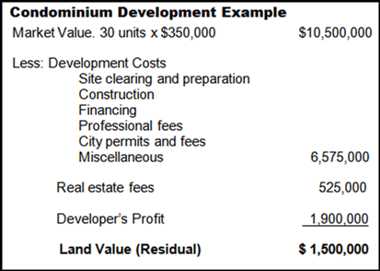

Q4.
Can the “Land Residual” or “Back Door” approach to determining land value be used on a site where there’s an existing older building?
Your Answer
This is an example of an older shopping center site that’s ready to be replaced by a new development. It’s a site with development potential.

The property value is based on the development potential, not on the income being generated from the existing retail buildings.

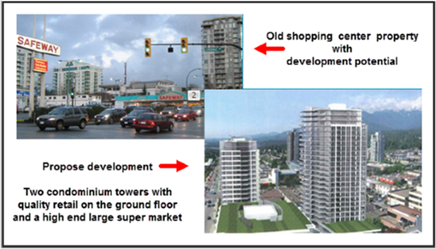

Q5.
How can we tell if a site with existing buildings has development potential?
Your Answer
There are several ways to tell if a site with an existing building has development potential

1. Is the property at its highest and best use? If not, it may have development potential

2. If the property was destroyed, what would replace it?
- a similar building. Use the income approach to establish the value
- a very different building. Use the land residual approach to value

3. Look at the Property Tax assessment value

If the Cap Rate based on the asking price is very low, look at the property tax assessed value. For example, if the Cap Rate for a shopping center is 2.00% based on the asking price and the current net operating income, then the value is likely based on the value as a development site, not as an income property.

Q6.
Does an old obsolete income property always have development potential?
Your Answer
This property looks like it has development potential but does it?

It would be very difficult to redeveloped this site and build condominium or rental units because of the city regulations that would require:
1. Front yard and side yard set backs
2. Underground parking
This would be a risky investment. If the building burnt down it would be very difficult to replace the building because of the zoning and building codes. It’s called a non conforming property.

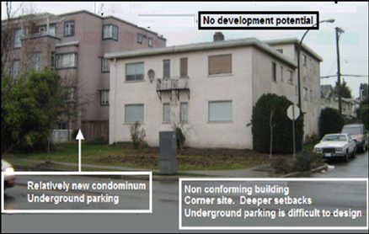

Q7.
The development potential of an old building on a narrow lot often depends on a land assembly.

It’s very difficult and costly to develop a building on a narrow site, 50 feet or less if underground parking is required.

See the flip side for an example.
Flip side
The area where buildings A, B, and C are located is zoned for hi-rise development with retail on the ground floor with offices and condominiums above, which will have a spectacular view of the mountains and downtown area.

On their own, it’s not possible to economically develop individually sites A, B, or C because they are narrow sites.

It requires and assembly of either buildings A & B or B & C or A, B, and C to effectively develop these obsolete rental properties.

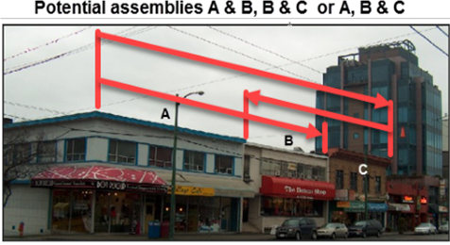

Q8.
Beware of long narrow sites. Why?
Your Answer
Long narrow sites are challenging and costly to develop if the building and zoning regulations require underground parking.

The income rental property shown, which is located in a nice neighborhood, appears to have development potential, and there are medium-rise rental and apartment buildings in the area.

It isn’t easy to develop this site because it’s very narrow. 45 feet wide.

To build a three storey rental or condominium building with underground parking on this narrow site, is difficult.

Unfortunately, there is no land assembly potential.

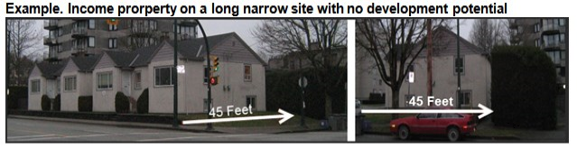

Q9.
A good starting point in carrying out development analysis to determine the land value is the have an architect develop sketch plans.
WHY?
Your Answer
Architectural sketch plans give you some idea as to what can be built on the property. In developing the sketch plans, the architect takes into account zoning regulations such as parking requirements, side yard set setbacks, height floor restrictions, and allowable site coverage, etc.

The architect might come back with;

You can build 15 one bedroom units, 5 two bedroom units with underground parking for 25 cars.

This information can then be used to carry out preliminary development analyses to determine land value.

A good starting point in carrying out development analysis to determine the land value is the have an architect develop sketch plans.
Architectural sketch plans give you some idea as to what can be built on the property. In developing the sketch plans, the architect takes into account zoning regulations such as parking requirements, side yard set setbacks, height floor restrictions, and allowable site coverage, etc.

Q10.
What do architectural sketch plans look like?
Your Answer
Architectural sketch plans can be rough and simple or more detailed, as shown in the two examples below.
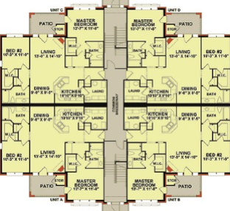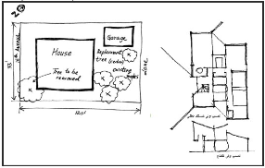

Q11.
How does a developer determine an acceptable development profit?
Your Answer
The desired development profit will depend on the development time and risk.

For a medium-risk project, the developer might look for a development profit for a two-year project of 20% to 25% of “Total Development Costs.”

“Total Development Costs” are all costs ready to start selling or leasing, which includes:

Land and acquisition costs
Site clearing and preparation
Construction costs
Financing costs
City permits and fees
Miscellaneous costs
Contingency allowance for unknowns

Q12.
.Are there circumstances where a developer might accept a lower development profit, such as 12% of Total Development Costs?
Your Answer
Yes. This example is based on a real case.

The developer owns industrial land
Providing a build to suit building to a prime national tenant
Has negotiated a building contract with a reputable builder
Building permits are in place
The lease has been negotiated
Long term financing has been secured
The developer is bidding against several other well know developers

This is a low-risk development because most of the uncertainties and risks associated with development have been removed.

The developer might accept a lower development profit, such as 12% of Total Development Costs because most of the development risks have been removed.

In addition, the developer is submitting a competing bid and needs to keep his numbers sharp in order to outbid the competitors.

END
.

Impact of soil conditions on development cost and land and value

Q1.
It is very difficult to value land. WHY?
Your Answer
Establishing the value of land is very challenging because there are so many factors that influence the value of land such as:

Soil conditions
Excavation and foundation costs
Complex zoning and building regulations
Location (Not being discussed)
The next flash cards illustrate using examples, factors that influence land value.

Q2.
Soil conditions can have major impact on foundation and construction costs.
Provide some examples of soil condition that would impact the value of land
Your Answer
Soil conditions vary widely and depend on the location. Some examples are;

Rock and shale. Costly to excavate
Expandable clay. Increases the excavation and foundation costs
Collapsible soil and sand
Organic or spongy soil
Peat moss
Sink holes
Water and drainage problems
Sites near water often require costly pilings

At some point during the due diligence the developer will have a soil test done by a Geoscientist.

Q3.
How are soil tests done?
Your Answer
Various soils test are conducted on-site and laboratory analysis caries out to decide the quality of soil for building construction purposes which help the architect and structural engineers design the building.

On-site drilling using a drilling rig, as shown in the photo, is a standard method for carrying out a soil test.

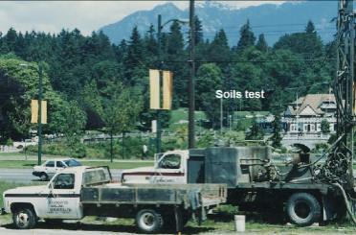
A soil test is carried out before the design of a condominium building with underground parking.

A wonderful location.

Q4.
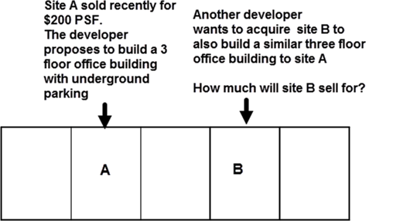

Your Answer
The temptation is to say that site B will sell for the same price as site A which is $200 per sq. ft because they are comparables.

Soil conditions that influence construction cost can vary from one site to another. For site A the excavation for the underground parking is easy because of the organic soil, which is easy to remove.

Site B has some organic soil but is mostly rock which will cost $175,000 to remove to create the underground parking. This means that site B should sell for $175,000 less than site A

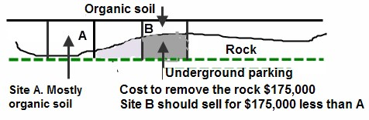

Q 5.
What is expandable clay?
Your Answer
Expandable clay is a nasty clay that expands when wet, and shrinks when dry, and can cause considerable damage to a building.

Expandable clay can be found in most areas of North America.

Dealing with expandable clay when developing a building can be very costly and lowers the land value.

Q6.
On the flip side are some examples of the damage to buildings created by expandable clay.
Flip side
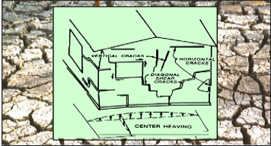

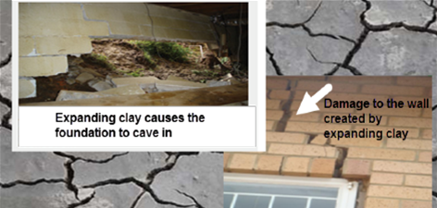

Q7.
What are some of the ways architects and engineers use to deal with expandable clay to prevent building damage?
Your Answer

Techniques for dealing with expandable clay

Remove and replace the expandable soil with stable fill
Keep water away from the building
Slope the soil away from the building
Install a waterproof apron or moisture barrier around the building
Use pilings to support the structure
Design flexibility into the structure (See examples below)
Separate paved areas and slabs from the main structure
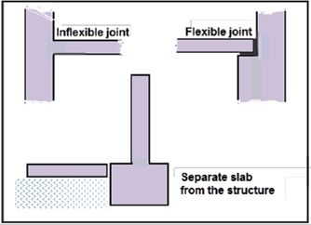
Examples of flexible versus inflexible structural design used to prevent building damage caused by expandable clay

Q8.
What is organic soil?
Your Answer
Organic soils are unstable soils that consist of soil and decayed organic material such as buried trees and branches and, in some cases, buried construction debris such as lumber and drywall scrapes, etc.

Buildings cannot be constructed on organics soils because the weight of the building would cause the structure to settle unevenly, causing damage to the building.

Organic material has to be removed and replaced with stable, compacted fill, and pilings may be required to support the building, which increases the construction cost and lowers the land value.

Q9.
For examples of organic soils see the flip side
Flip side
Examples of organic soil, buried materials and rubbish.

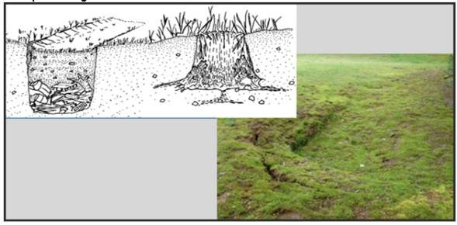

Q10.
What are sink holes, and how do sink holes develop?
Your Answer
Sink holes are hidden cavities in the ground that occur naturally or are man-made, and can range in size from minor cavities to vary large and dangerous pits. Sink holes can occur anywhere in North America. Costly to deal with and lowers land value.

Man-made changes to the natural water patterns through drainage and pumping systems and dams can create sink holes.

. A landowner may clear the land by removing trees or tree stumps and then burying the stumps and branches on the site.

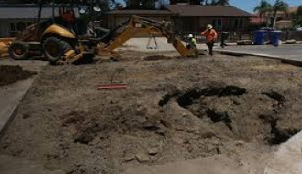

Q11.
When I first got involved in development, I was looking for an industrial site to develop an industrial building. I found a large site where the price per acre seemed cheap compared to similar sites elsewhere.

Why was the price per acre so cheap?
Answer
When I told the senior partner he replied: That’s on river road where:
a) A large amount of fill has to be bought in to bring the ground level with the road
b) The organic soil and peat moss has to be removed and replaced with compacted fill
c) Expensive pilings have to be used to support the foundation and structure

The cost to develop this industrial site is very high hence the low price per acre. Not such a great deal after all.

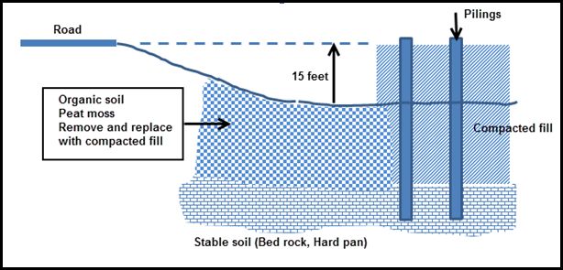

Q12.
Building on unstable soil may require pilings driven into the ground to support the foundation and building.

Pile driving is a costly and time-consuming process that lowers the land value.
Flip side

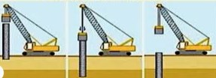

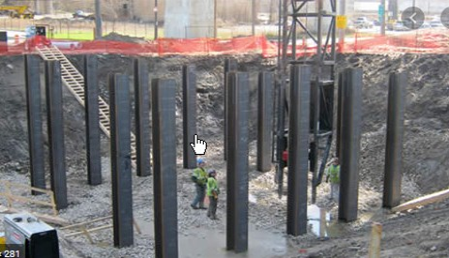

Q13.
What is “Pre-loading”?
Your Answer
Site Preloading
If the land is soft and spongy and needs to be compacted, the site is pre-loaded with sand to compact the soil. This is common for sites near the ocean or waterways.

The sand may sit on the site for several years before being removed. A preloaded site is worth a lot more than a non-preloaded site.

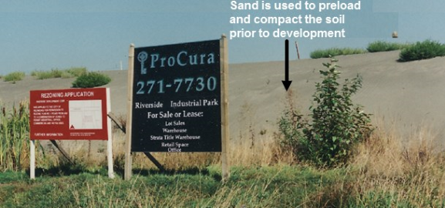

Q14.
What is dynamic compaction?
Your Answer
Dynamic compaction increases the density of the soil by dropping a heavyweight at regular interval intervals over the site to compact the soil.
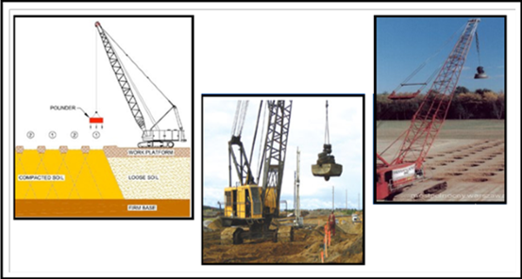

Q15.
How does the developer reduce the risks associated with soil conditions on construction costs, development profit, and land value?
Your Answer
When making the offer for the land, the developer will make to offer subject to:

Carrying out a soil test by a specified date
The seller to allow access to the site to carry out the soil test.

The developer may reduce the offering price if the soil test indicates that developing the land is more costly than anticipated because of the soil conditions.

Q16.
Can the impact of soil conditions on construction costs kill a project?
Your Answer

A client had an accepted offer to by a site which had the building permit for a three storey apartment building.

The profit determined by the development analysis suggested it was acceptable but a bit low.

My question was “Has there been a soils test done?”

Answer. The soil test is being carried out.

Result. The soil test indicated that to develop the site required pilings at a cost of $525,000 which killed the deal.

It’s very important for a developer to make an offer subject to a soils test.

Q17

It looks like the “Geoscientist” and “Engineers” didn’t get it right.
Answer

END

Impact of excavation and foundation costs on land value

Q1.
How do excavation and foundation costs impact land value?
Your Answer
The nearness of adjacent buildings can affect land values because of the increase in the excavation and foundation costs and the need to underpin adjacent buildings, which is costly.

The building on the left is protected during the excavation phase by:

Underpinning to support the building. The soil is prevented from collapsing into the site by the installation of mesh, which is then sprayed with a concrete substance called gunite or shotcrete, which is held in place by anchors.

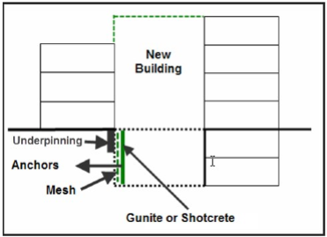

Q2.
What is underpinning?
Your Answer

In this case, the building’s foundation has to protected when excavating near the property line to prevent soil collapsing, causing damage to the existing building.

A temporary foundation is needed to support the building while excavating up to the property line. This may involve complex and costly encroachment agreements with the adjacent property owners.
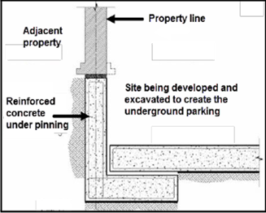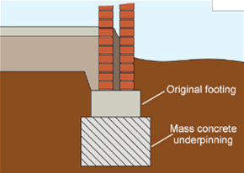

Q3
Show me an example of:
1. Underpinning
2. What can happen to adjacent buildings if not underpinned during excavation?
Flip side. Example
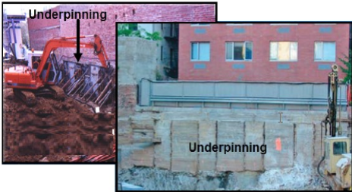

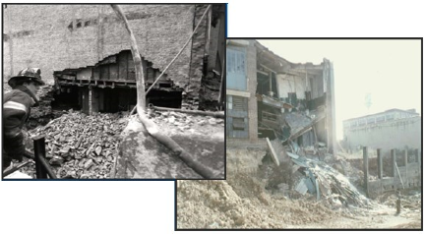
Failure caused by inadequate or no underpinning of the adjacent property

Q4.
What is “Shotcrete” or “Gunite?
Your Answer

Shotcrete or gunite refers to a process in which compressed air forces mortar or concrete through a hose and nozzle onto a surface at a high velocity.

The process is used during excavation to prevent soil from collapsing into the excavated hole. It’s the same system that is used to create swimming pools.
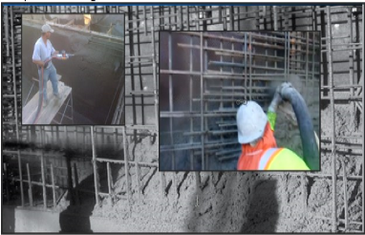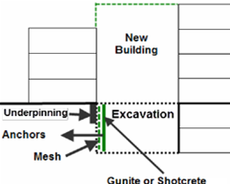

Q5.
Example of protecting the building adjacent to the site being excavated to develop a hotel and condominium tower on the flip side.

Flip side
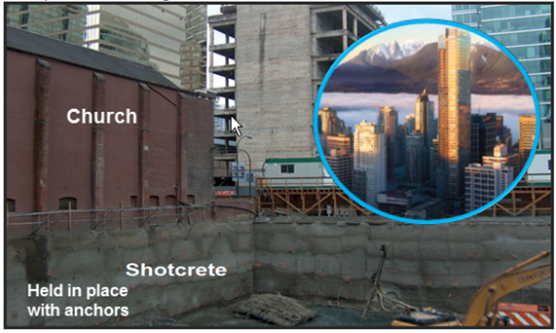

Q6.
A client had a piece of land in Brooklyn, NY, in a neighborhood that was being gentrified.

He proposed building a three storey condominium development.

The adjacent buildings bordered on the property line. I.e., there were no side yard setbacks.

He asked me what he had to look out for related to construction?

1. What questions would you ask him?

2. What should he worry about?

Your Answer
First question. How wide is the site?
Answer. 75 feet which provides adequate underground parking for a three storey condominium building.

What should he be concerned about? What are the major unknowns?

1. Soil conditions. The developer needs to have a soil test done to determine if costly pilings and foundations are required.

2. The cost of underpinning the adjacent buildings

The remainder of the development cost can be determined by getting a quote or estimate from a building contractor.

Q7.
True case.

When excavating against an existing building, even though the excavation is shallow, E.g., 3 to 4 feet, there will likely be a need to underpin to protect the adjacent building from damage.

What can happen if the foundation of the adjacent building is not underpinned?
Flip side
The structural engineer and the City required the developer of a warehouse facility to underpin the foundation of the adjacent warehouse.

The developer didn’t provide the specified underpinning to save money, and the side concrete block wall collapsed into the hole.

A very costly and dangerous decision, including a lawsuit and damages.

Flip side
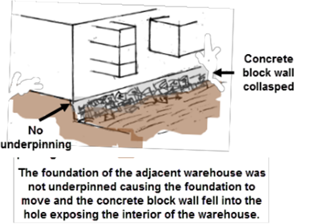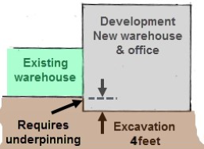

END

Impact of zoning regulations on land value
Q1.
A large number of architectural, design, and building code regulations reduce the buildable area, increase the construction cost, and reduce the land value.

Write down some examples.
Your Answer
Some examples of zoning regulations that influence the size, shape, buildable area, and land value such as:

Front, side yard, and rear yard setbacks
Site Coverage Ratio (FCR)
Floor Space Ratio (FSR)
Height limitations or the number of floors allowed
Parking requirements which often depend on the type of use
The shape of the land
Vertical and horizontal light angles

Zoning regulations are numerous and complex.

Q2.
How is the maximum buildable area calculated?

What are some of the dangers of using the buildable area to determine what can be built on the site?
Your Answer
You have found a site that is zoned for condominiums and want to determine how many one bedroom units can be built on the site.

Floor Area Ratio (FAR): 2.5 (specified in the zoning regulations)
Site Size: 125 feet x 120 feet

The objective is to build large one bedroom units for the first time home buyer market

Average Suite size: 800 Sq. feet
Common Area: 100 Sq. feet per unit
Gross Area: 900 Sq. feet

Buildable Area: FAR x Site Area = 2.5 x 125 x 120 = 37,500 Sq. Ft

Number of one bedroom units
= Buildable area = 37,500 = 41 Units
Gross area per unit 900

This answer is nonsense. Why? See next flash card

Q3
Why is this calculation incorrect?
Number of one bedroom units

= Buildable Area
Gross Area per Unit

= 37,500 = 41 One bedroom units
900
Flip side
Why is this calculation nonsense?
Buildable Area: FAR x Site Area = 2.5 x 125 x 120 = 37,500 Sq. Ft
Number of one bedroom units:
= Buildable area = 37,500 = 41 Units
Gross Area per Unit 900

The calculation provides us the maximum buildable area.

There are many factors that reduce the maximum buildable area including:

Zoning and building regulations such as building envelopes
Design & market considerations

Q4.
What are building envelopes?
Your Answer
Building envelopes influence the overall shape and volume of the building.

A “Sky Exposure Plane” or “Vertical Light Angle” are used to provide sunlight at the street level.
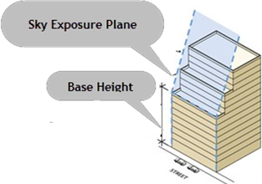

Sky Exposure Plane

Is a virtual sloping plane that begins at a specified height. The building may not penetrate the sky exposure plane, designed to provide light and air at the street level, and is used in medium and high density districts.

Also called “Vertical Light Angles.”

The impact is to reduce the buildable area, increase construction cost, and lower land value.

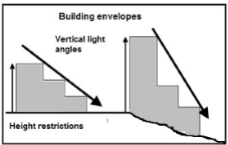

Q5.
Some examples of vertical light angles
Flip side
The shape and size of this office building is influenced by the building envelope and the vertical light angles, which reduces the building area, increases construction cost, results in an interesting design, and lowers the land value.
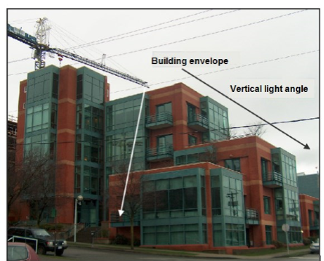

Q6.
Example. Fort Lauder beaches

Another example of using vertical light angles to allow sunlight into the street using vertical light angles.
Flip side
This example is located in Fort Lauder. Earlier buildings did not incorporate vertical light angles, which prevented sunlight from reaching the popular beach walk and shading a portion of the beach in the late afternoon.

The shading problem was solved by the City using vertical light angles to allow sunlight into the street.

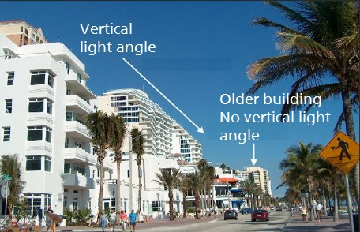

Q7.
An interesting and unusual example of shadow prevention.
Your Answer

No building can cast a shadow on the Alamo.

Nearby downtown buildings are limited to 12 floors and can’t cast a shadow on the Alamo, a historical building in San Antonio, Texas.

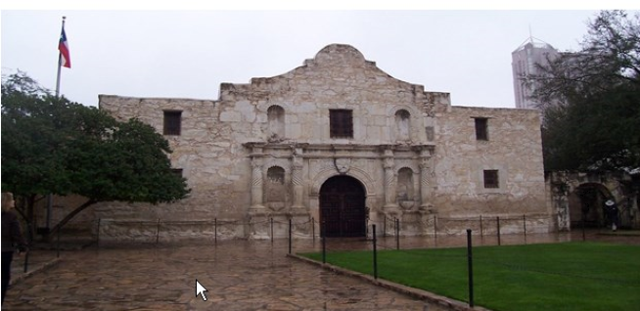

Q8.
What are “Horizontal Light Angles”?
Your Answer
Horizontal light angles protect the view or sightline from the corner windows of the adjacent building.

In the example below, the corner of the new building is stepped because of the horizontal light angle that protects the view line from the corner windows of the adjacent building.

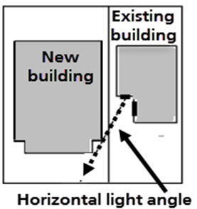
This is a simple example
of horizontal light angles.

Horizontal light angles specified in the zoning by laws can be very complex and requires interpretation and application by an architect.

Q9.
An example of the impact on a buildings shape created by horizontal light angles.

Flip side
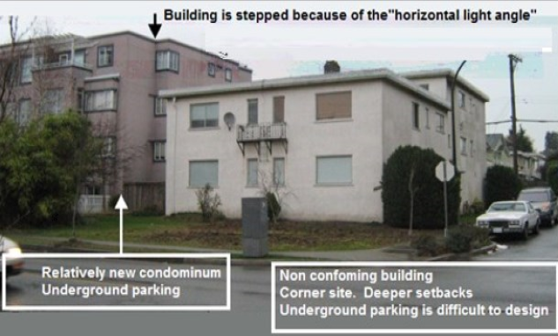

Q10.
What’s a “Traffic View Angle.
Your Answer
On corner sites, there may be a need to step the corner of the building to provide a sight line for drivers.

That is the reason the building below is stepped on the corner because of the cross street intersection. Reduces buildable and increases construction costs. Creates an interesting design.
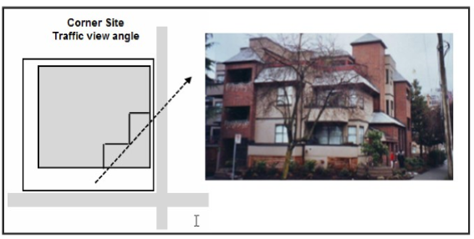

Q11.
What’s a corner or double set back?
Your Answer
Where a building is situated on a cross street like building “A” below the zoning regulations may require a “Double side yard setback” reducing the buildable area and land value.
The purpose is to provide more visibility for drivers at the intersection.

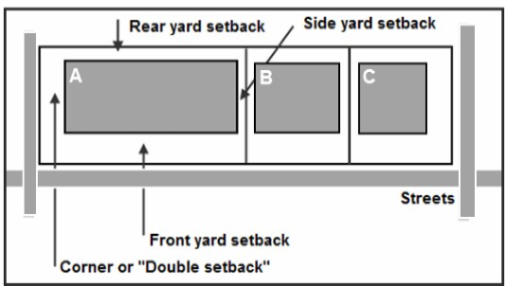

Q12.
The size and the shape of the lot and the intended use influence the size and shape of the building and land value.

See the example on the flip side.

Two industrial sites with the same area of 150,0000 Sq. Ft but different shapes.

Site a has a 38% site coverage. Site B is narrower but a longer site than Site B with a 19% site coverage. Provision has the be made for maneuvering the semi- trailers into the loading docks which requires 88 to120 feet.

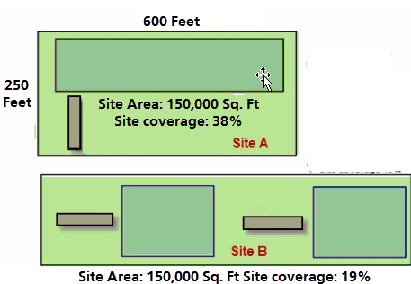

Q13.
If site A sold recently for $3,000,000 or $25 per Sq. Ft what will site B sell for?
Your Answer
If site A sold recently for $3,000,000 or $25 per Sq. Ft what will site B sell for?

The temptation is to say $300,000 or $25 per Sq. Ft because the area of both sites is the same but site B is worth a lot less than Site A because the site coverage is 19% compared to 38% for Site A.

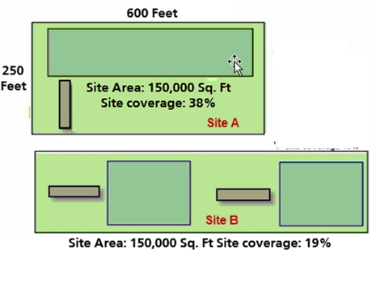

Q14.
Underground parking design.

A site width of 50 feet versus 75 feet is more difficult to design efficient underground parking. Why?
Your Answer
With narrow sites like “B” the parking spaces are limited to one row
which significantly reduces the number of parking spaces.

In contrast, “A” the wider site can have two rows of cars.

In both cases, there is a need for a stairwell, electrical room (and perhaps an elevator), which occupies a greater percentage of the parking area for the narrow site B.

You can get a lot more cars per square foot of parking area on a 75 feet wide site compared to a 50 foot wide site.

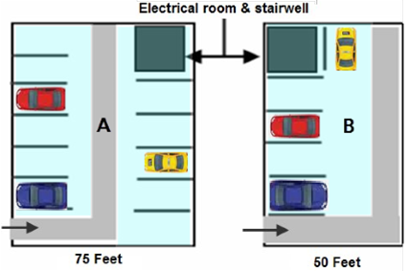

Q15.
On the flip side is an example of the underground parking for a 45 foot wide site.
Flip side
This examples shows how difficult and costly it is to create underground parking on a narrow site.
The ramp to the underground parking is curved
There is only space for four cars after providing the stairwell and electrical room.

Very costly. The cost per parking space is very high.

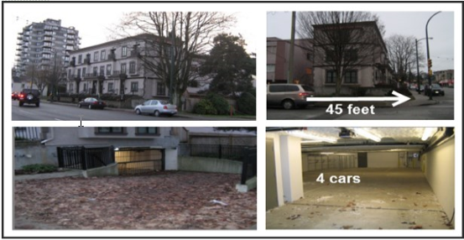

Q16.
An architectural engineering firm acquired a site to build a building where the firm would occupy around 3,000 Sq. Ft.
The zoning allows:
1. Wood frame. Three floors with surface parking at the rear and around 9,000 Sq. Ft
2. Wood frame. Three floors with one level of underground parking for 15,000 Sq. Ft
3. Concrete building. Two floors of underground and five floors for 25,000 Sq. Ft
The question is “What should they build?
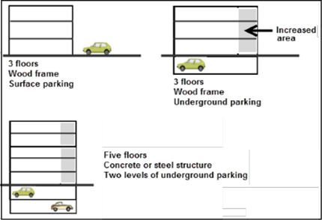
Flip side
The large concrete building with two levels of underground parking and five floors was quickly eliminated. The cost per Sq. Ft was much higher and couldn’t be supported by the local rent rates. The location was close to downtown but it was questionable if the area could absorb 25,000 Sq. Ft of office space. Required a lot of equity. High cost , high risk.

The three floor, wood-frame building with surface parking, was chosen as the safest investment for this local area. The economics of a three floor wood-frame building with underground parking couldn’t be justified.

The decision was made using development analysis to compare the three development options. The result was choosing the lowest cost, lowest risk option.

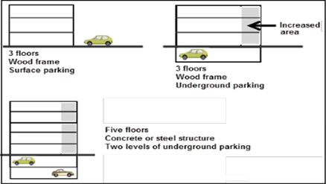
The building was completely leased before construction was completed to a government agency.

A photo of the completed building is on the next flash card

Q17.
On the flip side is a photo of the completed building.
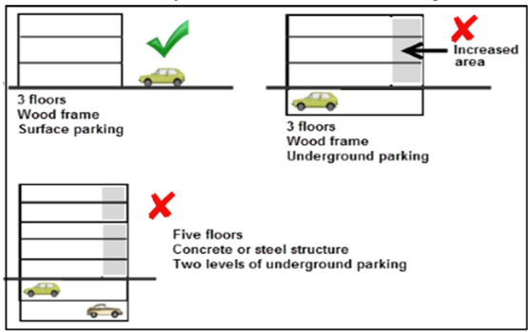
Flip side
The completed and fully rented three floor wood frame office building with surface parking at the rear of the building.

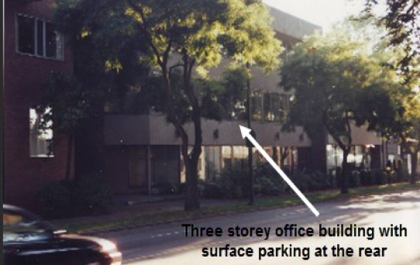

Q18.
What is the “Concept of highest and most stupid use.”?
Your Answer
The Concept of Highest and most Stupid use. Example.
It’s tempting for a developer to build the largest building possible on the site. In the warehouse development below, the developer built two buildings on the site, but the semi trailers have to cross, creating frustrated tenants and semi trailer drivers, lower rent, and high tenant turnover. A mess.

In showing this photo to a lender, he said they wouldn’t fund a property like this. It would be difficult to sell this property.
What works is tenants whose shipping needs are met using smaller trucks and vans, not semi trailers.
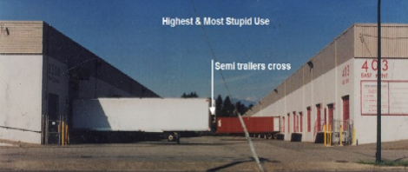

Q19.
Can a developer always build one large building on the site?
Your Answer
The city may require a large building to be split into several buildings to provide green space as illustrated below.

The impact is to:
1. Reduce the buildable area
2. Increase construction cost caused by:
Two extra end walls
Second electrical room etc.

The result is less buildable area, increased building costs, and lower land value.
____________________________________________________________________
Q20
What are retention ponds or storm water basins, and how do they impact land value?
Your Answer
Retention ponds or storm water basins delay storm water from overloading the storm water drainage system. The objective is to prevent flooding from heavy rain and storms.

Providing land for the retention pond reduces the land available for building, making the land less valuable and increases the development costs. Retention ponds are often designed as part of the landscape.
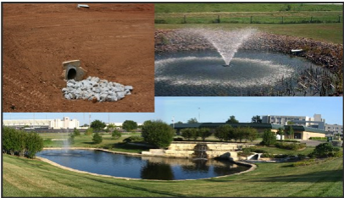

END

Market and design considerations

Q1.
The last flash card set explored the impact of zoning and building regulations that reduces the buildable area and lowers the land value.

We will now explore the impact of design and market considerations on the buildable area and land value.

Example
A developer targeting the one bedroom room condominium market has instructed the architect to design the floor plans using only one bedroom units. Can this be done?

Building size: 150 feet x 54 feet deep.

Typical unit sizes
One bedroom units: 22 feet wide x 25 feet deep. 550 Sq. feet
Studio units: 18 feet wide x 25 feet deep. 450 Sq. Feet
Flip side
No. The architect cannot do a layout that has all one bedroom units.

The layout below shows why this is not possible

Each floor can have 12 one bedroom units and two studio units except for the ground floor because of the space taken up by the lobby.

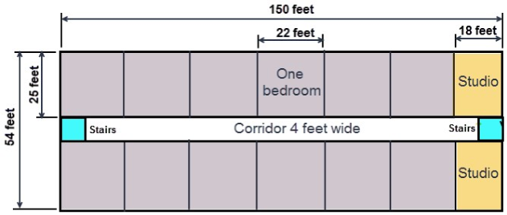

Q2.
The floor plan suite layout is much more complex than the previous flash card example.

In designing the floor plan, the architect has to include in the design:

- A firewall, which is located near the center of the building, which prevents fire from spreading from one side of the building to the other side.

- An elevator

- Laundry room

- A lobby on the ground floor

Flip side
The architect needs to provide the firewall in the center of the building plus an elevator and laundry rooms which complicates the floor layout.

The final result would be a combination studio and one bedroom units, possibly including some two bedroom units.

Achieving a floor plan with all one bedroom units is not be possible.

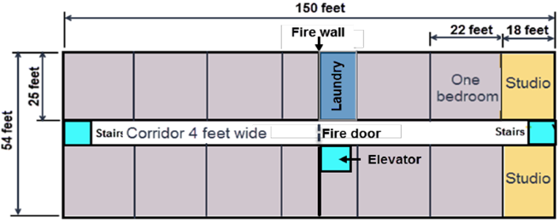

Q3
Can you think of retail examples where you wouldn’t build the maximum space allowed for the site because of the tenant’s space needs?
Your Answer
Examples

STRIP RETAIL. Typical retail space for mom and pop tenants is around 20 feet wide by approximately 50 feet deep and 1,000 Sq. Ft. A 20 foot x 125 foot site would allow a much larger building than 1,000 Sq. But it would result in a long narrow space that retail tenants don’t like.

Retail space that is long and narrow is hard to police and to rent.

7-11 STORE. The typical size is 3,500 Sq. Ft 68 feet wide by 52 feet deep. A long narrow space wouldn’t work for 7-11.

CASE STUDY. A developer of a strip retail center provided 4,000 Sq. Ft for a restaurant, but restaurants interested in the space needed a minimum of 5,000 Sq. Ft. The space remained empty for many years.

Q4.
What are some of the design challenge facing architects when designing rental or condominium units?
Flip side
When laying out the units, the living room and bedrooms have to have windows, which complicate the layout.

The images below show the typical layout and dimensions for one and two bedroom units.
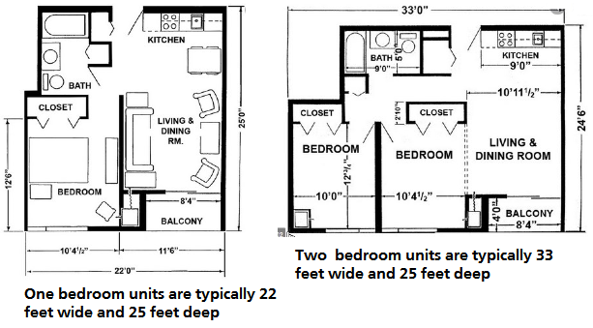

Q5.
Due to the Covid virus there may be less need for office space as more employees work from home.

What are the design and construction challenges in converting and office building to rental or condominium units?
Your Answer
There are geometric differences between what works architecturally for an office building and a condominium or rental apartment building.

Office floor plates are typically large and deep, with sizable dimensions between the exterior wall and high ceilings, which works well for apartments.

Apartment buildings tend to be 60 to 65 feet deep. The living room and bedrooms require windows.

Because of the difference in size and shape of apartment buildings compared to office buildings, converting an office building to an apartment building is difficult and very costly, involving structural, HVAC, new plumbing, and upgrading to current fire standards, etc.

What might work is an office building with a similar shape to an apartment building and is 50 to 60 feet deep.

Q6.
Beside market and design considerations can you think of other things and architect may have to consider when designing a building?
Your Answer
Depending on the location, the size of the development, the architect may have to take into account the following when designing the building:

Fire truck access
Garbage truck access
Handicap access
Bike storage and lockers
Highway access. Usually involves the department of highways
EV charging facilities for electric cars and hybrids etc.

The City may require:

Certain trees to be retained and protected
Set backs from rivers and streams

Q7.
A developer was considering buying an old retail property, demolishing the building and developing a three storey building with retail on the ground floor and offices on the second and third floor.

There was large cedar tree on the site which the City wanted protected because it was a neighborhood landmark.

Protecting the tree would result in less rentable area and reduce the value of the property.

Calculate the drop in value based on:

Lost rentable area: 25 feet x 25 feet x 3 floors = 1,875 Sq. Ft
Average rent rate: $27 psf per yr.
Cap Rate : 7.50%
Your Answer
Drop in value calculation
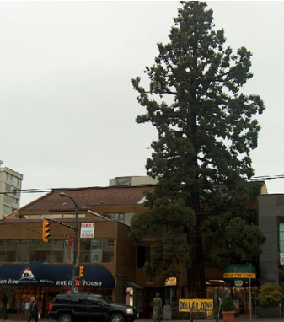
Drop in value

Lost rentable area: 1,875 Sq. Ft
Rent Rate: $27 per Sq. Ft per Yr
Cap Rate: 7.50%

Drop in value

=1,875 x $27
7.50%

= $675,000

Plus the increase in the construction costs created by protecting the tree.

Q8.
How can an industrial building be built on slopping land? and what’s the impact on the land value and development costs?
Your Answer
By using retaining walls which are costly, increases the construction costs and lowers the land value, and reduces the rental area because two buildings have to be built instead of one building.This adds additional costs for two extra end walls and second electrical room.

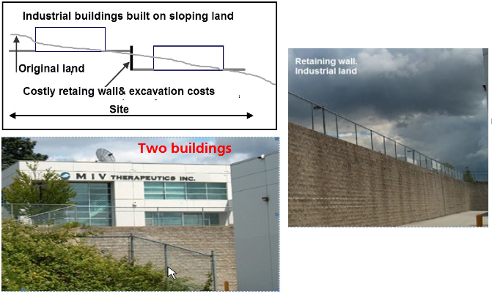

Q9.
If Your Answer going to be involved in land sales you need to get to know some architects. WHY?
Your Answer
Architects will often do preliminary sketch plans for free because they hope to be engaged by the developer who buys the site to design the building.

The sketch plans give you a general idea of what can be built on the site, which can be presented to developers to interest them in the site.

Q10.
True case
Having an architect develop sketch plans for free to market a potential development site.
Flip side
A realtor was aware of a large site that consisted of two side-by-side properties owned by the same owner, each with a different low-density zoning.

He asked an architect to develop some sketch plans for the site.

The architect suggested consolidating the two sites and then have the consolidated site rezoned for four storey condominium development.

The two properties had been on the market for some time at around $1,000,00 but had not sold.

The idea of consolidating the two properties and rezoning to a higher density was presented to a developer, and the site sold for around $1,300,000, which is $300,000 over the original asking price of $1,000,000.

END

Construction financing

Q1.
What the difference between a construction loan and a conventional mortgage?
Your Answer
Difference between a Construction Loan & Conventional Mortgage

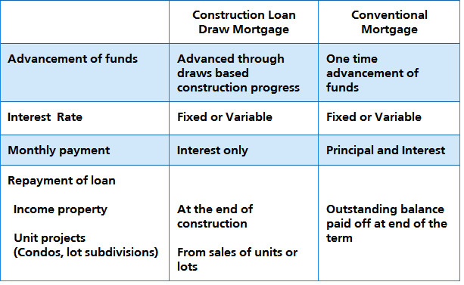

Q2.
How does Construction or Draw Mortgages work?
Your Answer
The Construction Loan Agreement will specify how the construction draws work and vary depending on the lender.

There are two general approaches used:

1. Funds, less the lien holdback, are released monthly to the developer based on the cost to complete the construction as determined by an architect representing the lender.

2. Funds are released, less the lien holdback, as certain construction milestones are met.

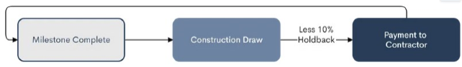

Q3
What does a construction draw schedule based on reaching specified milestones look like?

Develop an example.
Your Answer
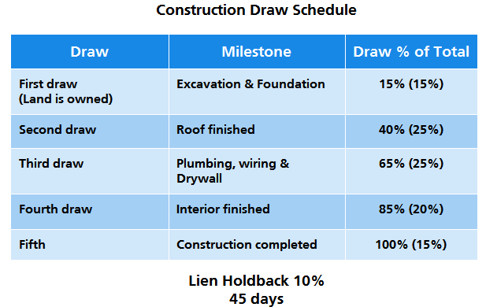

Q4.
What is a “Builders Lien” or Lien Holdback?
Your Answer
A ‘Lien Holdback” provides a form of security to contractors, subcontractors, workers, and suppliers who work on a building that is under construction to help ensure that they get paid.

The Lien process is governed by State or Provincial laws.

The lien holdback requires the developer to hold back between 10 to 15 percent of loan monies advanced on new construction for a specified period.

The time for retaining the holdback is usually between 40 to 55 days and varies by State or Province.

Q5.
Assume you are a construction lender and offering the following construction loan on a condominium development:

Development cost: $5,000,000
Construction loan 75% of development costs: $3,750,000
Developer’s equity 25%: $1,250,000

What would be two important conditions of the loan agreement that reduce the risk for the lender?
Your Answer
Development cost is $5,000,000
Construction loan 75% of development costs: $3,750,000
Developer’s equity 25%: $1,250,000

What would be the two major conditions of the loan agreement to reduce the risk for the lender?

1. The developer has to have pre-sold 70% of the units before starting construction, evidenced by enforceable contracts of sale and a non-refundable deposit of 5.00% of the sale price of the unit.

In calculating the pre-sale percentage, the lender may use a percentage rate that generates enough money to pay off the construction loan.

2. The developer has to pay construction costs of $1,250,000 before the lender advances any funds. The developer’s equity of $1,250,000 goes in first before the lender advances any funds.

Q6.
Assume you are a construction lender and offering the following construction loan on an income property such as an office building development.

Development cost: $7,000,000
Construction loan 75% of development costs: $5,250,000
Developer’s equity 25%: $1,750,000

What would be the three major conditions of the loan agreement to reduce the risk for the lender.
Your Answer
Development cost is $7,000,000
Construction loan 75% of development costs: $5,250,000
Developer’s equity 25%: $1,750,000

What would be the three major conditions of the loan agreement to reduce the risk for the lender?

1. The developer has to have pre-leased 70% of the space before starting construction, evidenced by enforceable lease or offer to lease and a security deposit equal to the first and last months rent.

2. The developer has to pay construction costs of $1,750,000 before the lender advances any funds. The developer’s equity of $1,750,000 goes in first before the lender advances any funds.

3. The developer has to have a permanent long-term called a take-out mortgage in place that will replace the construction loan once the building is complete.

Q7.
What’s a “Construction to Permanent Loan”?
Your Answer
A loan for an income property development, like a rental apartment building, with one lender that switches from a construction loan to a permanent long-term loan once the development is complete.

Q8.
Why might the developer of an office building not want to arrange the long-term loan as requested by the construction lender?

Is there another option that satisfies both the needs of the lender and the developer?
Your Answer
The developer may not want to arrange the long term loan because;

- The developer plans to sell the completed and substantially rented office building

- The developers think that they can get better long term financing terms, such as a lower interest rate, once the building developed and substantially rented compared to arranging the long term financing before construction starts

Is there another option? Yes. A Standby commitment.

A commitment from a lender to make a loan for a specified period with specific terms , with the understanding that the borrower will not likely draw the mortgage down.

The standby lender charges a fee to the developer for the standby commitment.

Q9.
What the difference between:

Recourse loan

Non recourse loan?

Your Answer
Recourse loan.
If the borrower defaults on the construction loan, the lender can take possession of the assets used as collateral. Called a “Collateralized loan.”

Non recourse loan
If the borrower defaults on the loan, the lender cannot recover the money owed by seizing other assets owned by the borrower.

Recourse loans are more readily available than non-recourse loans and likely at a lower interest rate than a non recourse loan.

Non recourse loans are generally available for developers with stellar credit histories.

Q10.
What are” personal guarantees” and “limited personal guarantees”?
Your Answer
Personal guarantees
Developers often use a corporation for a development project which offers limited liability protection.

However, the construction lender may require personal guarantees from the developer(s).

Personal guarantees are not tied to specific assets. If the developer defaults on the construction loan, the lender can go after the developer ‘s personal assets such as the developer’s home, bank accounts, car, etc.

Defaulting on a personal guarantee affects the borrower’s credit rating and ability to borrow in the future.

Limited personal guarantees. See next flash card.

Q11.
What are “Limited Liability” Personal Guarantees?
Your Answer
Limited personal guarantees
Example. The developer is a corporation, where Developer A owns 10% of the shares and Developer B owns 90% of the shares. The lender is insisting on personal guarantees from the two developers.

Developer A is not keen to be exposed to the full amount of the losses and enters into a limited personal guarantee of 10% with the lender based on his shareholdings of 10%.

Another approach.
Because developer A has a small percent of the shares of 10%, he might not be willing to sign a personal guarantee.

Q12.
What’s an “Origination” Fee?
Your Answer
An origination fee is what the lender charges the borrower for making the construction loan.

The origination fee may include processing the application, underwriting and funding the loan, and other administrative services. The fee can range from 0.75% of the loan amount to 1.50% or higher.

Q13.
What’s involved in applying for a construction loan?
Your Answer
The amount of equity needed to fund a development project will depend on the type of development and the risks involved from the lenders perspective.

A good starting is that the developer’s equity is equal to the land value or higher.

In some cases, the lender maybe willing to fund a portion of the land value which reduces the developer’s equity.

If the lenders Loan/Cost Ratio is 75% then the developer’s equity will be 25% of the development costs.

Q14.
How does the construction loan application process and requirements affect the Offer to Purchase?
Your Answer
A construction loan application can take many months to be approved.

The developer has to provide the information requested by the lender, including drawings, appraisal, soils tests, environmental report, etc. which takes time to complete.

Once the lender has the application, it’s submitted to a credit committee which may only meet once every week or every second week.

After review by the credit committee, it may not be approved until additional requirements are met, which delays the loan approval and the commitment agreement.

When creating the offer to buy the land, the developer has to allow sufficient time to obtain the construction loan, which can take many months to obtain and involves a lot of work.

Q15.
How much equity does a developer need?

Any ideas?
Your Answer
The amount of equity needed to fund a development project will depend on the type of development and the risks involved from the lenders perspective.

A good starting is that the developer’s equity is equal to the land value or higher.

In some cases, the lender maybe willing to fund a portion of the land value which reduces the developer’s equity.

If the lenders Loan/Cost Ratio is 75% then the developer’s equity will be 25% of the development costs.

Q16.
How does the lender secure the construction loan?

Can a second mortgage be placed on the land?
Your Answer
How does the lender secure the construction loan?
Answer. The construction loan is registered on the title.

Can a second mortgage be placed on the land?
Answer. A prudent construction lender will not allow a second mortgage to be registered on the property.

Q17.
If the landowner wants to be involved with the developer in developing the land and share in the profits, what are the benefits and risks for the landowner.
Your Answer
In order to encourage the landowner to sell the land, the developer may offer the landowner an opportunity to be involved in the developments and share in the profits (and the risks).

This may appeal to the landowner, but in doing so, the landowner is being exposed to some serious financial risks if the landowner remains on the title.

The construction lender will require that:
1. The land title must be clear before monies will be advanced
2. The construction draw mortgage will be registered on the property
3. Secondary mortgages cannot be placed on the property

Real estate development is a risky business. Developers can make a lot of money or lose a lot of money. There’s a fair amount of luck involved.

When a development goes bad, it’s very costly and can take several years for the messy legal issues to be resolved by the courts.

The landowner could end up with nothing or very little money for the land.

Q18.
A developer wants to acquire some land to rezone to multifamily, build and sell a condominium project.

The developer has offered the landowner an opportunity to be involved in the development by contributing the land and sharing in the development profits.

The development steps are:

1. Rezone the land from single-family to multifamily zoning
2. Construct the condominium building
3. Sell the units

Can you think of a way to involve the landowner in profit sharing while avoiding the development risks and losing a lot of money if the development fails financially?
Your Answer
1. Value of the land before rezoning: $3,000,000
2. Value of the land after rezoning to multifamily use: $4,500,000
3. Cost of rezoning paid by the developer: $80,000
4. The cost of rezoning of $80,000 is deducted from the rezoning profit when calculating the profit

Rezoning profit sharing

Land owner: 40%
Developer: 60%

Q19.
Calculate
1. 1) Rezoning profit
2. 2) How much the landowner receives for the land

1. Value of the land before rezoning: $3,000,000
2. Value of the land after rezoning to multifamily use: $4,500,000
3. Cost of rezoning paid by the developer: $80,000
4. The cost of rezoning of $80,000 is deducted from the rezoning profit when calculating the profit
Rezoning profit sharing
Land owner: 40%
Developer: 60%
Your Answer
1. Value of the land before rezoning: $3,000,000
2. Value of the land after rezoning to multifamily use: $4,500,000
3. Cost of rezoning paid by the developer: $80,000

Rezoning profit sharing
Land owner: 40%
Developer: 60%

Rezoning Profit
Rezoned value $4,500,000
Less: Original value 3,000,000
1,500,000
Less: Cost to rezone 80,000
Rezoning profit $1,420,000

Land owner receive $3,000,000 + 40% x $1,420,000 = $3,568,000

END

Profitability measures

Q1.
How do you determine if the development profit is realistic?
Your Answer
A development analysis indicated a development profit of $6,400,000.

How do we know if this is a reasonable profit?

An acceptable development profit depends on the development time and the risks involved.

The higher the risk, the higher the development profit

For a typical moderate risk development taking two years, the development profit should be around 20% to 25% of “Total Development Costs.”

“Total Development Costs” are all the development costs to the point where leasing or renting commences or the sale of units or lots starts.

Q2.
How do you determine if the development profit is realistic?

As an example, if the development profit is $3,200,000

Is this a good deal?
Your Answer
If the development profit is $3,200,000, we can’t tell if it’s a good deal.

Examples

If the development cost was $45,000,000, the profit of $3,200,000 is too low, given the amount of money involved and the development risk.

On the other hand, if the development profit is $3,200,000, and the development cost $21,000,000, this might be an acceptable profit.

To evaluate the development profit, we use several measures of profitability.

See the next flash card.
If the development profit is $3,200,000, we can’t tell if it’s a good deal.

See the next flash card.

Q3
What are the measures of profitability?
Your Answer
% of TOTAL DEVELOPMENT COSTS.
Typically 25% for a medium risk development taking several years and 15% for industrial developments.

% of SALES REVENUE
Not widely used because it is hard to predict the sales revenue or market value, which is several years away. It’s much easier to predict the “Total Development Cost” than the sales revenue or future market value.

RETURN ON EQUITY
Developers will often look for a Return on Equity greater than 100%, which means they want to more than double their equity or investment in the development. Useful ,but some what questionable measure as the Return on Equity is dependant on how much construction financing is involved.

Q4.
What are the Land & Development Cost Measures used to evaluate a development project?
Your Answer
Land & Development Cost Measures
The following measures can be used to check if the building and development cost estimates are realistic for the City and the location?

1. Land to Building Cost Ratio
2. Land to Development Cost Ratio

These ratios depend on the City and the location. In areas where the land prices are very high, the land to Building cost and Development Cost Ratios will be high, and they will be much lower in areas where the land costs are low.

Developers familiar with the type of development and location usually have a good feel for the value of the ratios, and they use them to check the accuracy of the development analysis.

A high ratio requires a high sale price or high rents and a low cap rate to offset the high land cost.

These ratios can be helpful.
Development profit per unit, per square foot, and per lot, etc.

Q5.
On the flip side is an example using the Profitability Measures
Flip side
Condominium Development. Profitability measures
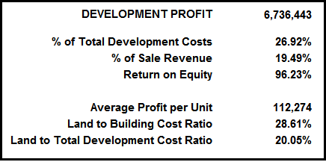

Q6.
On the flip side is an example of a bid proposal for a low risk development.
Flip side
True Case Study

Prime industrial land
The developer owns the land
Soils test, architectural and engineering design have been completed
Construction bids have been received, and the construction costs and time and financing costs are known.

The developer has been asked to submit a proposal to construct the building and sell it to a Triple A industrial tenant.

This is a low-risk development. The developer knows that there are other developers submitting a proposal.

Using the sale price that achieves a development profit of 25% of Total Development Costs would result in a high, non-competitive sale price.

Because of the low risk, the developer used a Development Profit of 12% of the Total Development Profit in structuring the deal.

END

Development analysis. Unit projects

Q1.
What are the building blocks for analyzing a unit development like a condominium development or land subdivision?
Flip side
The building blocks of development analysis for unit projects like a condominium development or land subdivision.
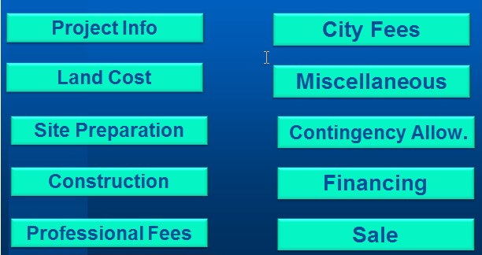

Q2.
What information is needed to analyze a unit development like a condominium development or a land subdivision?

Part 1 Development Cost and Unit Sales
Flip side

PROJECT INFORMATION
Basic information used to develop the development costs and sales revenue, such as the number of units or lots, building area, etc.

LAND COST
Cost of the land and acquisition costs such as legal and appraisal fees.

SITE PREPARATION
Clearing the land, removing buildings, trees, etc.

CONSTRUCTION
Cost to build the building, underground parking, landscaping, etc. All the costs to complete the development ready for sale.

PROFESSIONAL FEES
Architects, engineers, geoscientists, lawyers, appraisers, environmental engineers, building envelope specialists, mortgage brokers, etc.

CITY FEES
Application and processing fees, crossing permits. A significant cost is Development Cost Charges (DCC’s) or Impact fees.

Q3
What information is needed to analyze a unit development like a condominium development or a land subdivision?

Part 2. Timing
Flip side
TIMING

In order to calculate the interest costs, the following times are needed:

Time to get the required permits before construction can start.

Construction time.

Sales time. Time to sell the units or lots taking into account presales.

Q4.
Condominium Development. Sample inputs

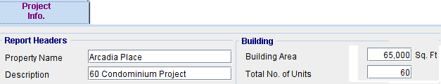
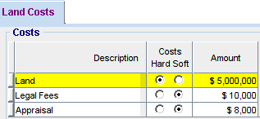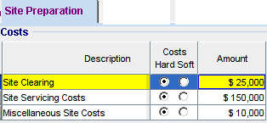

Flip side
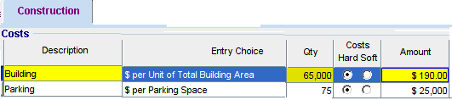
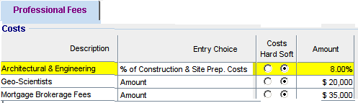

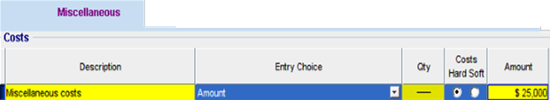

Q5.
Condominium Development. Inputs continued.
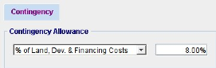

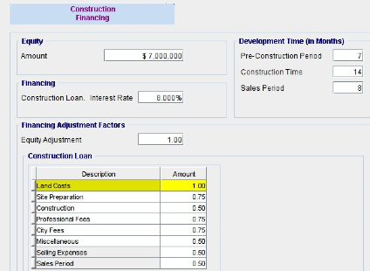

Flip side
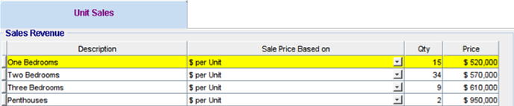

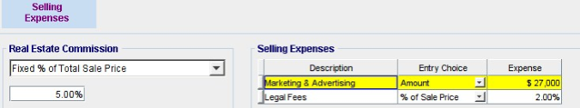

Q6.
What does the “Quick Proforma” development analysis look like for a condominium development?

Where we:

Buy the land
Construct the building
Sell the condominium units
Flipside
The development analysis indicates a development profit of $6,393,034, which is 25.54% of the “Total Development Costs” with a land price of $5,018,000.

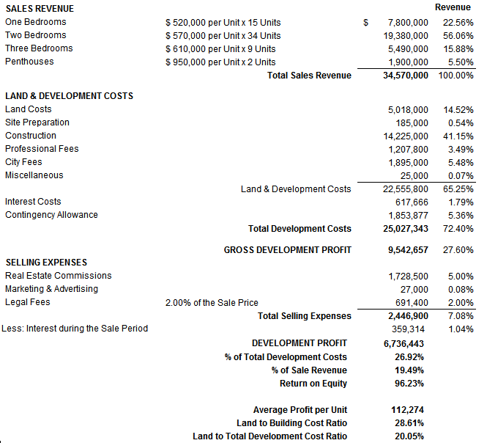

Q7.
What is “Goal Seeking” and how can it be used in analyzing the condominium development?
Your Answer
“Goal Seeking” can be used to establish the price to pay for the land to achieve the desired profit.

To achieve a development profit of 27% of Total Development Costs, the most we can pay for the land is $5,004,883

If we want a 100% Return on Equity (i.e., double our equity investment), the most we can pay for the land is $4,809,495

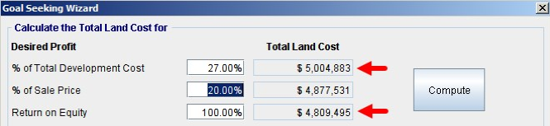

Q8.
What are “HARD COSTS” and “SOFT COSTS”?
Your Answer
Hard costs ____________________________________________

____________________________________________

Soft costs____________________________________________

____________________________________________

HARD COSTS Constructions cost directly related to the building, such as labor, materials, and equipment.

SOFT COSTS. Costs indirectly related to the development, such as professional fees for architects and engineers, surveyors, mortgage brokers, appraisers, insurance, lawyers, etc.

Q9.
Construction Cost Report. Hard and Soft Costs
Flip side
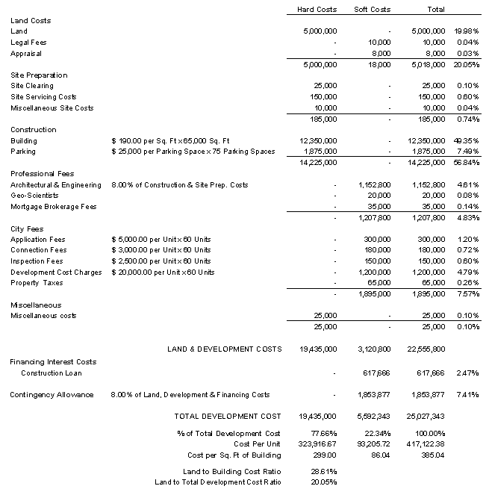

Q10.
How is the construction interests costs calculated?
Flip side
Calculating the total interest costs is tricky because the construction loan is a “Draw mortgage” and drawn down in stages. If the construction cost is $14,225,000, the lender advances funds as the construction proceeds based on the cost to complete as ascertained by an independent professional.

To adjust the interest costs, we use “Financing Adjustments Factors” to modify the interest calculations because the loan is drawn down in stages as the construction progresses.

In this example, the “Financing Adjustment Factor” for the construction portion of the loan is “0.5”.

Continued on the next flash card

Q11.
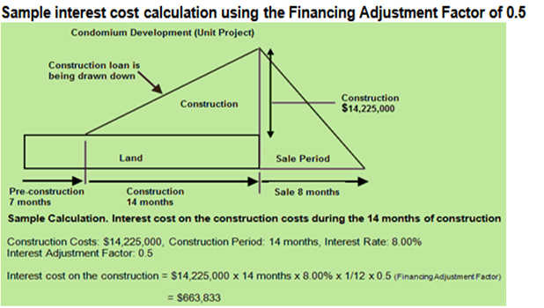

Flip side
Condominium development. Interest cost calculations
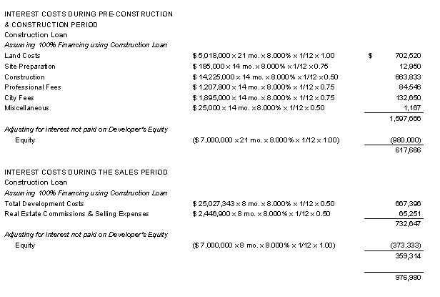

Q12.
What are the typical Financing Adjustment Factors used to calculate the development interest costs?
Flip side
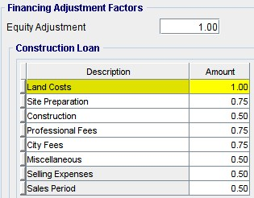

Some examples
Construction. FAF 0.5 because the construction portion of the loan is drawn down over the construction period.

Professional Fees and City Fees. FAF 0.75 because most of the fees are paid before the start of construction.

END

Development analysis. Income properties
Q1.
What’s the difference between analyzing unit developments like condominium and land subdivisions versus income property developments like an office building or a rental apartment building?
Your Answer
UNIT PROPERTY DEVELOPMENT (Condominiums, land subdivisions, etc.)
1. Buy the land and obtain the building permits 2. Build the building 3. Sell the units

Value. Based on the sales price per unit or price per lot, times the number of units or lots.

Lender requirement. A specified amount of presales before funding commences.

INCOME PROPERTY DEVELOPMENT (Offices, industrial, retail and rental apartments)

1. Buy the land and obtain the building permit 2. Build the building
3. Lease up space. This generates Income & Expenses during the lease-up period
4. Sales period. Time to find a buyer. Generates Income & Expenses during the sales period

Value. Based on the Cap Rate and the stabilized Income and Expenses

Lender requirement. A specified amount of preleasing before funding is advanced.

Q2.
When carrying out an analysis of an income property development, what questions do we want to answer?
Your Answer
- How much to pay for the land based on the desired profit?

- Based on the asking price for the land, is the development profit acceptable given the time involved and the development risks?

- How much equity does a buyer of the fully leased property need?.

- Is the amount of equity reasonable or too high?, making it hard to sell?

- How much equity does the developer need to hold the development as a long term investment?

- Should the developer hold as a long term investment or sell the fully leased building? This involves carrying out long term investment analysis?

Q3
What are the building blocks for analyzing income property developments like rental apartment buildings, office, industrial and retail developments?
Flip side
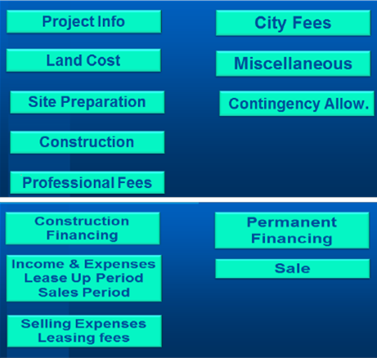

Q4.
What information is needed to analyze income property development such a rental apartments, office, industrial and retail developments?

Part 1 Development Phase

Flip side

SITE PREPARATION
Cost of clearing the land, removing buildings, trees, etc.

CONSTRUCTION.
Cost to build the building, underground parking, landscaping, etc. All the cost to complete the development ready for leasing.

PROFESSIONAL FEES.
Architects, engineers, geoscientists, lawyers, appraisers, environmental engineers, building envelope specialists, mortgage brokers, etc.

CITY FEES
Application and processing fees, crossing permits. A significant cost is Development Cost Charges (DCC’s) or Impact Fees.

Q5.
What information is needed to analyze income property developments such as rental apartments, office, industrial and retail properties?

Part 2 Leaseup and Sale Phase
Flip side
What are the Income and Expenses:
During the lease up period?
During the sales period based on the stabilized Income & Expenses?

The Cap Rate to use to determine the likely sale price.

What long term financing might be available?

Questions.
If the developer keeps the project, how much equity is needed?
Should the developer hold the project as a long term investment?

How much equity does a buyer need to purchase the property and is the equity amount realistic?

Q6.
What information is needed to analyze income property development such a rental apartments, office, industrial and retail?

Part 3. Timing
Flip side
In order to calculate the interest costs the following times are needed:

PRECONSTRUCTION TIME
Time to get the required permits before construction can start.

CONSTRUCTION TIME
The time from the start of construction until the building is ready for occupation.

LEASE UP TIME
Time to lease the building taking into account preleasing.

SALES TIME.
The time it will take to sell the property after it’s substantially leased.

Q7.
How do we determine the “Long Term Financing”
Flip side
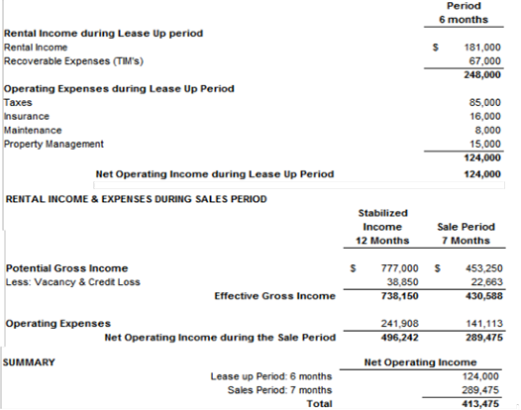

Q8.
Calculating the equity required by the buyer
Flip side
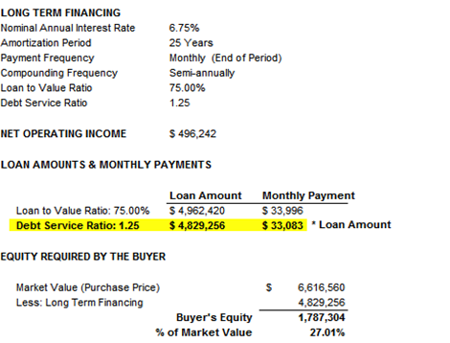

The equity required by the buyer is 27.01% which seems realistic.

If the answer had been say 51% equity, this would suggest that it would be hard to sell the completed development as it requires too much equity.

Q9.
How do we determine the equity required by the developer if the property is held as a long term investment?
Flip side
To calculate the long term financing and equity needed by the developer to keep the development as a long term investment, we need the following:

The total development cost to the end of the leaseup period which is when the long term financing kicks in.

The stabilize Net Operating Income

Long term financing information from the lender
Interest rate
Debt Service Coverage Ratio
Loan to Value Ratio

We then calculate the loan amount based on

Debt Service Coverage Ratio and Loan to Value Ratio

and choose the lower loan amount giving us the developer’s equity required to keep the development as a long term investment.

Q10.
How do we determine the equity required by the developer if the property is held as a long term investment?
Flip side
To calculate the long term financing and equity needed by the developer to keep the development as a long term investment, we need the following:

The total development cost to the end of the leaseup period which is when the long term financing kicks in.

The stabilize Net Operating Income

Long term financing information from the lender
Interest rate
Debt Service Coverage Ratio
Loan to Value Ratio

We then calculate the loan amount based on:
Debt Service Coverage Ratio
Loan to Value Ratio

and choose the lower loan amount giving us the developer’s equity required to keep the development as a long term investment.

Q11.
How do we determine the equity required by the developer if the property is held as a long term investment?

Sample calculation on the flip side.
Flip side
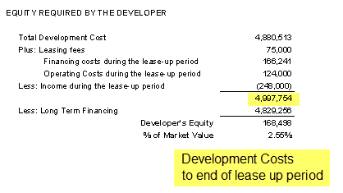

Q12.
What does the “Quick Proforma.” development
look like for a retail store development?

Income Property Development

Buy the land
Construct the building
Lease
Sell or keep the development?

Flip side
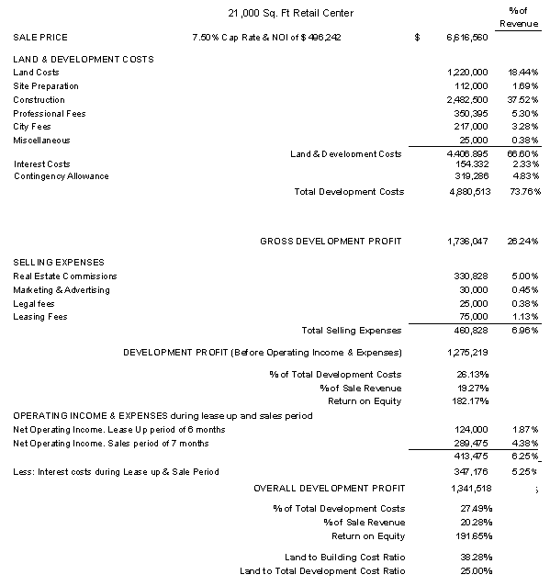

Q13.
How does the developer decide whether to keep the development as a long term investment?
Flip side
The developer carries out long term real estate investment analysis making the following assumptions.

Example.

Developer holds the property for 5 years and sells based on a 5% Cap Rate

Leases are renewed after three years based on a 5% increase in rent.

The investment is the development cost to the end of the leaseup period

The mortgage is $4,400,000
Loan to Value Ratio: 63%
Debt Coverage Ratio: 1.62

The resulting Net Cash Flow and financial returns are shown on the next flash card.

Q14.
The Internal Rate of Return (IRR) is 66.57%

Why is the Internal Rate of Return (IRR) so high at 66.57%?
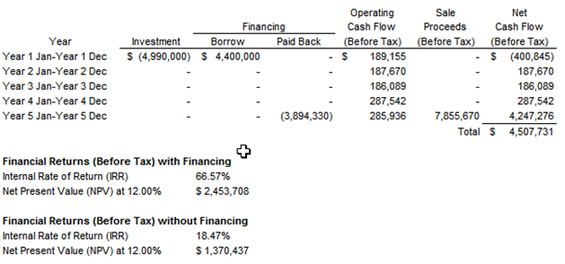

Slip side
There are several reasons:

1. The developer is getting the income property at the cost of $4,990,000. If instead, he bought the completed project at a 5% Cap Rate, he would have to pay $9,924,840

2. Impact of Financial Leverage. The amount of the equity of $590,000 is low for an investment of $4,990,000 which significantly increases the Internal Rate of Return (IRR)

Q15.
What is ”Mortgaging Out”?
Your Answer

It occurs when a developer of an income property can arrange a long term mortgage that is equal to or greater than the development cost and has little or no money invested in the property. He might even take money out when the long term financing kicks in.

How is this possible? There are several reasons:

The land was purchased many years ago and has gone up a lot in value.

The land has been rezoned to a higher density, increasing the land value.

The developer was a shrewd negotiator and got the land at a really good price.

Very good at controlling the development cost and acted as the general contractor, which results in savings by avoiding paying the contractor’s profit.

Q16.
Is it possible to mortgage out?
Your Answer
To ”mortgage out” means that when the long term financing is placed on the property, the developer (investor) requires zero equity and may even receive cash when the long term financing kicks in.

There are several reasons:

1. The developer is getting the income property at the cost of $4,990,000. If instead, he bought the completed project at a 5% Cap Rate, he would have to pay $9,924,840

2. Impact of Financial Leverage. The amount of the equity of $590,000 is low for an investment of $4,990,000 which significantly increases the Internal Rate of Return (IRR)

Over the years, the lender’s underwriting has become more restrictive. It’s very unlikely that that a lender would allow a developer to mortgage out.

They will require the developer to contribute equity.

Q17.
What is the:

Development Spread Yield?

Development Pop?

Your Answer
The difference between the “Market Cap and the Yield or Cap Rate based on the development costs.

Example.

Market Cap Rate: 6%
Cap Rate based on development costs: 4%
Development Spread Yield: 2%

The greater the development spread yield, the more likely the development is financially attractive.

What if the Development Spread Yield is negative?

Example. Market Cap Rate 6%
Cap Rate based on development costs: 8%
Development Spread Yield: -2%

This negative yield indicates that the development is not financially feasible.

DEVELOPMENT POP
The value added by the developer, created by taking the development and leasing risks.

END

Development analysis. Monthly cash flow method

Q1.
There are two different approaches to development analysis.

What are they?
Flip side
The two approaches to development analysis

1.Quick Proforma. Approximates the interest cost.
Used to quickly assess the development opportunity, development profit, and land value.

Called the “Sniff test” or “Back of the envelope” approach

2.Detailed Monthly Cash Flow Analysis.

The development costs, draw mortgage, and revenues are entered every month

Time-consuming analysis
Provides accurate interest costs
Determines the maximum equity required upfront
Used for budgeting, submissions to lenders, JV partners, etc.

Q2.
Monthly Cash Flow Approach
Sample entries
Flip side
The development expenses, draw mortgages, revenues are entered monthly.

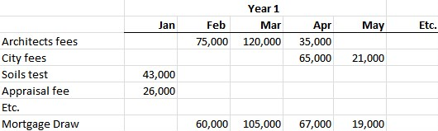

Q3
Monthly Cash Flow Report

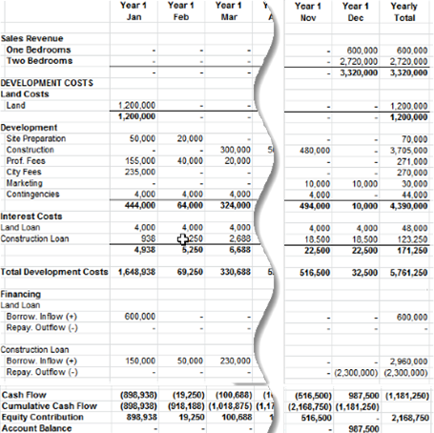

Flip side
Development Profit Report
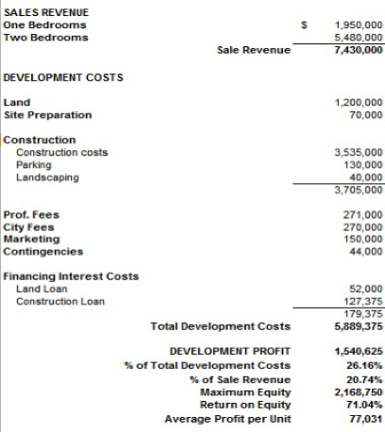

Q4.
How do you evaluate Phased Developments?
Flip side
Certain developments such as large scale housing or industrial subdivisions can be phased.

The advantages phased developments are:

Less capital is required than completing the development in one phase

The profits from the first phase a can be used to partially fund the next phase, reducing the construction, and interest costs

The development risk is reduced compared to completing the development in one go.

ANALYZING PHASED PROJECTS
Requires developing the monthly cash flows showing the monthly outflows like development costs, inflows from sales over time, and the development of the construction draw mortgages.

END

Analyzing “Mixed Use” developments

Q1.
What are “Mixed Use” Developments?
Your Answer
Mixed Use developments are developments that involve a combination of:

Unit Developments such as condominium and land subdivisions.

Income Property Developments such as rental apartment units, office, industrial and retail developments.

Q2.
What are some examples of “Mixed Use” developments?
Your Answer
Mixed use developments contain a mix of unit developments and income property developments.

Examples

Building consisting of retail on the ground floor and condominium units above.

A site development consisting of:
Rental townhouses (Income property development)
Single family lots (Unit development)
Small retail center (Income property development)

Q3
Why is it difficulty to analyze “Mixed Use” Projects using the “Quick Proforma approach?
Flip side
Analyzing mixed use projects is difficult because of how the revenue and profits are generated.

UNIT PROJECTS the revenue is generated by the sales of units such as the sale of condominium units or the sale of lots for the land subdivision project.

INCOME PROPERTIES the revenue is generated by:
Revenue and expenses during the leaseup period
Revenue and expenses generated during the time it takes to find a buyer
Revenue generated by the sale of the income property

It is very difficult to analyze these two very different types of development together using the ‘Quick Proforma” approach.

Q4.
Is there a way to analyze “Mixed Use” projects using the Quick Proforma approach?
Flip side
To analyze “Mixed Use” developments, analyze the Unit Project and the Income Property component separately, as follows:

- Allocate the land cost to:
a) Unit development
b) Income property development

- Analyze the Unit Development using the allocated land cost and calculate the development profit

- Analyze the Income Property Development using the allocated land cost and calculate the development profit

- Calculate the combined development profit

Q5.
Analyzing “Mixed Use” developments using the monthly cash flow projection approach
Flip side
The best way to analyze “Mixed Use” projects is to project the development costs and sales revenue sources on a monthly basis using a spreadsheet or Investit Pro real estate analysis software.

END

Sensitivity Analysis

Q1.
What is sensitivity analysis?
Your Answer
When carrying out investment, development, and lease analysis, it is important to establish which variables have the biggest impact on the financial results or property value.

You need to pay careful attention to the accuracy of these variable, such as the Cap rate, Rent Rate, etc.

Q2.
How can I carry out sensitivity analysis?
Your Answer

Simply change a variable by 10% and see how it affects the result.

Examples:

- The rent is $800 per month. If the rent is increased by 10%, what’s the financial impact?
- The mortgage interest rate is 5%. What happens if it is increased by 10% to 5.50%?
- If we paid 10% more for the property, how does that affect the Return on Investment (IRR)?
- If the Cap Rate changes by 10% from 6.00% to 6.60%, what’s the impact on the property value?

Q3
Show me an example of Sensitivity Analysis
Flip side
Sensitivity analysis. Example

If the Cap Rate changes from 8.00% to 9.00%, that doesn't seem like much, but it reduces the property value by 12.50%. The calculation is (9% - 8%) = 12.5%
8%
A small change in the Cap Rate creates a large change in value.

When valuing an income property using the Cap Rate approach, it is really important to get an accurate Cap Rate from comparables because the value of the property is highly sensitive to the Cap Rate.

Q4.
Be careful when using Cap Rates to determine the value of a property because the property value is very sensitive to the Cap Rate.

If the Cap Rate is 6% changes to 6.5% which doesn’t seem like much the property value will drop by 8.33%

See the example on the flipside

Flip side
Rental building. Net Operating Income (NOI): $230,000 per year
Asking price is $4,600,000 which is a 5% Cap Rate

What if the true Cap Rate from comparables is 5.5% instead of 5%?

Property value = $230,000/5.5% Cap Rate = $4,181,818 or $418,182 or 9.1% drop in value

The value of an income property is highly sensitive to the Cap Rate.

A small change in a Cap Rate creates large changes in the property value.

When valuing a property using the Cap Rate approach it is really important to get an accurate Cap Rate from comparables.

Q5
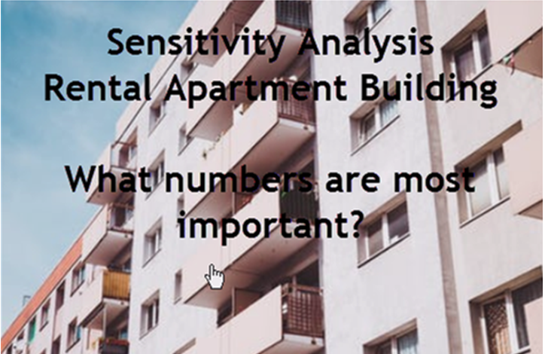
Flip side
The most important numbers when carrying out development analysis of a Rental Apartment Building, where you buy the land, build, and then sell the rented apartment building in order of importance are:

- The numbers that have the largest impact on the development profit is anything that affects the sale price such as:
Cap Rate
Rent per Unit
Number of units

Followed by:

- Construction costs

- Land cost

Q6

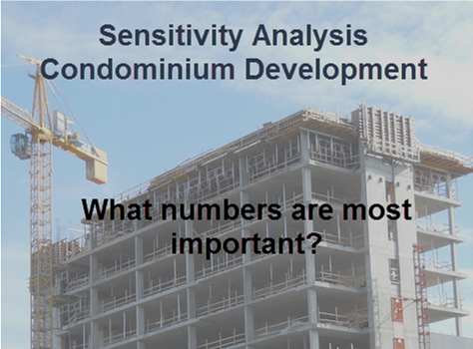
Flip side
The most important numbers when carrying out development analysis for a Condominium Building, where you buy the land, build, and then sell the units in order of importance are:

- The numbers that have the largest impact on the development profit is anything that affects the total sale price such as:
Price per Unit Number of Units

Followed by:

- Construction costs
- Land cost

Q7

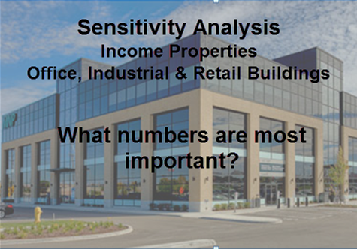

Flip side
The most important numbers when carrying out development analysis for commercial income properties such office, retail and industrial buildings, where you buy the land, build, and then sell the leased building in order of importance are:

- The numbers that have the largest impact on the development profit is anything that affects the sale price such as:
Cap Rate
Rent Rate
Rentable area

Followed by:

- Construction costs

- Land cost

Q8
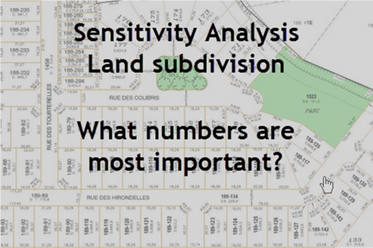

Flip side
The most important numbers when carrying out development analysis for a land subdivision, where you buy the land, develop and sell the lots, in order of importance are:

- The numbers that have the largest impact on the development profit is anything that affects the total sale price such as:
Price per Lot Number of lots

Followed by:

- Construction costs

- Land cost

Q9
What is “What if” analysis?
Your Answer
When carrying out development analysis to determine how much to pay for the land there are often numbers that that are not know accurately, such as the construction costs , sale price, rent rates, construction loan interest rate, etc.

Using “What If?” analysis we can test the impact of changing a number on the development profit and land value such as:

What If?
The Cap Rate is 6% not 5%?
The construction loan interest rate is 8% instead of 6.5%?
It takes 2.5 years to build instead of 2 years?
The City approves 130 units instead of 145 units?

END

Tips for creating an offer

Q1.
Creating an offer for a development site is very challenging. Why?
Think about the unknowns facing the developer

Your Answer
The developer is faced with a lot of unknowns when creating an offer for a development site, such as:

What will the City will approve?
How long will the approvals by the City take?
Is the development economically viable?
What are the soil conditions like?
Can the acceptable financing be arranged?
ETC.

Q2.
Make a list of the uncertainties facing a developer that have to be dealt with when creating an offer for a development site.

Think in terms of the development of an office building or condominium development.
Your Answer

How many units or square feet of office space will be approved?

How long will the approvals take to get a rezoning, development and building permit?

How long will it take for the architectural and engineering design to be completed?

Carry out a feasibility and development analysis to figure out how much to pay for the land?

How long will it take to obtain financing?
ETC.

Q3
Developing “Subject to” clauses

In developing the offer think in terms of “Unknowns” that will later become “Knowns”

Can you think of a way to handle the uncertainty of how many condominium units or square feet of office space will be approved by the City?
Your Answer
Condominium unit development
The offer is subject to obtaining a building permit for 35 one bedroom units by a specified date.

Office building development
The offer is subject to obtaining a building permit for a minimum of 35,00 Sq Ft office building by a specified date.

Q4.
Can you think of an objection that the seller might raise to the following “Subject to” clauses.
Condominium unit development

The offer is subject to obtaining a building permit for 35 one bedroom units by a specified date.
Office building development

The offer is subject to obtaining a building permit for a minimum of 35,000 Sq Ft office building by a specified date.
Your Answer
The seller may argue that the land is worth more if the building permit is approved for more than 35 condominium units or 35,000 Sq. ft of office space.

You can use the “Formula Approach” to establish the final price and handle these uncertainties.

Condominium development
The purchase price for the land is $3,000,000 plus $40,000 per one bedroom units for every unit approved over 35 units.

If 40 one bedroom units are approved the purchase price for the land is $3,000,000 + 5 x $40,000 = $3,200,000

Office development
The purchase price for the land is $3,000,000 plus $40 per sq ft of office space over 35,000 Sq Ft.

If 45,000 Sq. Ft of office space is approved the purchase price for the land is $3,000,000 + 10,000 Sq Ft x $40 = $3,400,000

Q5
There is very old office building on the site with tenants that the develop wants to demolish and build an office building.

What does the developer have to be concerned about?
Your Answer
That the tenants are on month by month lease and can be terminated on one months notice.

If long term leases are involved, that each lease contains an enforceable demolition clause that allows the developer to terminate the lease upon obtaining the specified development or building permit.

That all the leases are about to expire and revert to a month by month lease allowing the lease to be terminated by giving one months notice to the tenant.

Q6
Sellers are often concerned about the developer tying up the property and attempting to flip the property and making a quick profit.

How can you reduce the seller’s anxiety about dealing with a potential flipper?
Your Answer
Question. How can you reduce the seller’s anxiety about dealing with a potential flipper?

To ensure that you are dealing with a legitimate developer, not a flipper, put the onus on the developer to perform activities that are under the control of the developer by a certain date or time period.

Example
The developer must submit for a development permit by a specified date.

Upon receiving the development permit the developer must submit for a building permit within 4 months of receiving the development permit.

If there subject clauses are not met the contact to purchase become void.

This approach enables the seller to find out fairly quickly if the developers intent is to fie the property up and hopefully flip the property for a profit

Q7
In putting together an offer to purchase land that is going to be developed, why is it important to understand:

A) The City Hall approval process?
B) The architectural and engineering process?
Your Answer
Understanding the city approval and the architectural and engineering design process and the time involved, allows you to construct and offer that reflects the approval and design processes.

Q8
What are the architectural and engineering processes involved
in obtaining a building permit?
Your Answer
Architectural sketch plans which provide the developer an approximate idea of what can be built on the site. This enables the developer to carry out a development analysis to determine the value of the land.

Architectural plans are submitted for a development permit which are scale drawings that describe the site layout, floor plans, exterior design, building materials and landscape design.

Detailed working drawings and building specifications are prepared by architects and professional engineers are submitted to obtain a building permit.

Professionals involved include:
Registered architects who assumes the overall responsibility and engages:
Structural , electrical and civil engineers
Heating and air conditioning engineers
Geoscientist to carry out soil tests Building envelope engineers
Environmental engineers who deal with site contamination and remediation issues

Q9
How can you use a time line to help develop the subject removal dates.
Your Answer
The time line below a simple example of a development approval time line which can be used to set realistic subject removal dates.
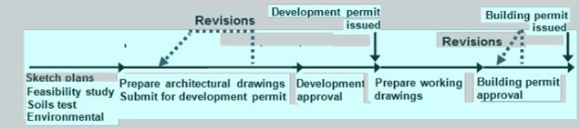

The time line above is a very simple example. The approval process can be far more complex and may involve:
Rezoning application
Public hearings
Approval from other agencies such the Department of Highways etc.

The city requests revision be made and the application resubmitted.

Make sure you allow plenty of time for the approvals. There can be a lot of setbacks that delay the approvals.

Q10
What the difference between an “Offer to Purchase” and an “Option”?
Your Answer
OFFER to PURCHASE
If the terms of the offer are met and the “subject to” clauses are removed. the purchaser has to buy the property for the agreed price.

OPTIONS
Provides the developer with exclusive rights to buy or not buy the property for the specified price by the specified date. The owner loses control of the property during the option period. During the option period the seller cannot sell the property. The option can be executed at any time.

The option gives the developer control over the property in order to carry out a feasibility study, obtain a building permit, line up financing or a joint venture partner or find a buyer or sell the option.

An option is easier to write than an offer to buy with a multitude of subject clauses. For the developer it’s simpler than an “Offer to Purchase” and provides a more flexibility. During the option period the seller cannot sell the property.

Q11
What are the pros and cons for an “Option to Buy” from the developers’ and seller’s perspective?
Your Answer
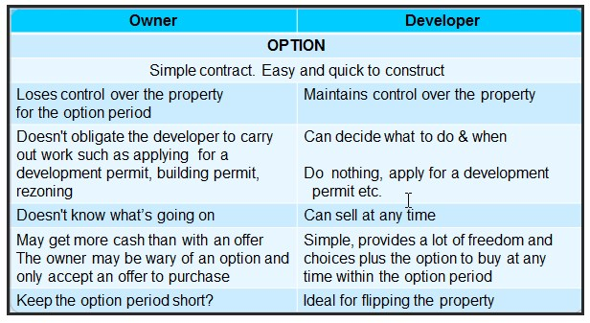

Q12
What are the pros and cons for an “Offer to Purchase” from the developers and seller’s perspective?
Your Answer
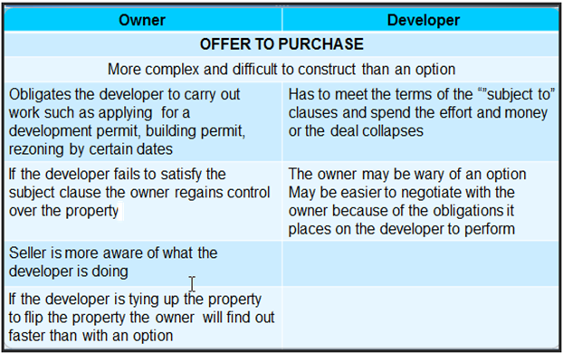

Q13
What are “Rights”?
How are “Rights” used by developers”
Your Answer
There are a number of activities that which occur during the soils test phase that the developer has to carry out prior to purchasing a development site that require temporary rights such as:

The right to enter the property to carry out soil tests or environmental studies.

The developer may be required to remedies for any damage
to the property

Obtain permission from the owner to apply for a rezoning, development or building permit. Approval by the owner may be required by the City before the City will process a development or rezoning application.

Q14
What are typical “subject to” clauses?
Your Answer
Typical sequential “subject to” clauses are:

Feasibility study
Soils test
Environmental clearance
Rezoning, development permit, building permit
Obtaining a permit for a specified building size
Approval by outside agencies if required

…obtaining the specified approval by a certain date

Q15
How are deposits and payment for options structured?
Your Answer
There are many ways to structure the deposits such as:

$1 for a two month option
$200,000 for a six month option
$10,000 per month for the option period
$10,000 for the first 3 months and then $20,000 per month until the end of the option period

The deposit can be applied or not applied to the purchase price

Q16
How are “Extensions” used?
Your Answer
Extensions
What if the developer, despite best efforts, can’t remove the subject to clause and needs more time?

The best approach is to build the extension clauses into the “Offer to purchase”or the option ahead of time.

As an example

“The subject to a rezoning permit can be extended for another 3 months upon payment of $25,000” which is non-refundable”

Q17
What are the issues related to the right to waive a subject clause from the seller’s and buyer’s perspective?
Your Answer
Extensions
What if the developer, despite best efforts, can’t remove the subject to clause and needs more time?

The best approach is to build the extension clauses into the “Offer to purchase”or the option ahead of time.

As an example

“The subject to a rezoning permit can be extended for another 3 months upon payment of $25,000” which is non-refundable”

Q18
How does a “Right to waiver” or a lack of “Right to waiver” impact the buyer or seller?
Your Answer
What if the subject to a development permit being issued by the City by <date> is not satisfied by the specified date…and the value of the property has gone up a lot?

The developer wants to waive this subject and buy the property even though the “Subject to” event hasn’t occurred.

The seller wants to escape from the deal and sell at the higher price. Maybe the seller has a backup offer?

The right to waive a subject clause, if appropriate, needs to be built into the offer.

Warning. This is a complex area of law and potential for litigation

Q19
When attempting to assemble several adjacent properties what “Subject to” clauses should be included in each offer?
Flip side
Site assemblies

When assembling a site the developer has to be able to assemble enough sites in a row in order to create a viable development and will make the offers contingent upon obtaining neighboring properties.

Q20
Creating the offer. Tips

- Become familiar with the city approval processes, the submission process and the work to be completed and times involved.
- There will be inevitable delays and setbacks that need to be taken into account when developing an offer
- Keep the number of “subject to” clauses to a minimum
- Make sure you allow plenty of time for the city approval processes
- Develop a time line that lays out the work to be done and the permit application process.

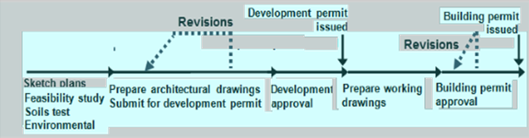
Flip side
Creating and Offer. Some tips continued.

Put the onus on the developer to perform activities that are under his control within a specified time period.
Example:

- The developer must submit for the “Building Permit” within four months of receiving the “Development Permit”
- Consider whether to use an “Offer” or an “Option”
- Effective subject clauses can be difficult to construct and enforce. Consider using a lawyer.
- The right to “waive” a subject clause needs to be specified into the offer

Q21

Offers on development sites tend to have the following characteristics:

- A long time frame
- Number of sequential subject clauses or options
- Subject clauses create uncertainty and anxiety for the seller
- Seller’s don’t like flippers
What strategies can be used to help keep an offer together?
Your Answer
Seller’s don’t like flippers.
Consider an anti-flipping clause or a clause where the seller shares a percentage in the flipper’s profit.

Potential price changes
Sometimes the land price is adjusted as the developer learns more about the building costs or the City reduces the size of the building.

Example:
The soils test found an unexpected soils problem which will increase the construction cost by $200,000.The developer wants to reduce the price by $200,000 or will collapse the deal.

Keep the seller involved and informed on a regular basis. Some suggestions
Give them a copy of the architectural drawings
Show them the scale model or send them a photograph on the scale model
Send them copies of the city permits as they are issued
Name the development after the family.

Q22
Strategies for keeping the offer together continued…
Flip side
When putting an offer together explain the costs that are being incurred by the developer
The costs can be extensive
E.g. Scale model $20,000
Architectural and engineering fees: 5% to 12% of the construction costs

Show the seller other projects completed by the developer

The idea is to reassure the seller that the developer is serious and not just tying up the property to flip and make a quick profit

Keeping the seller informed on a regular basis with progress reports in writing may make it easier to get an extension if this becomes necessary because of an unexpected delays in the development approval process.
END

Land assemblies
Q1
Make a list of:

FIXED BUILDING COSTS
Costs that don’t change with the size of the building

VARIABLE BUILDING COSTS
Costs that depend on the size of the building
Your Answer
FIXED BUILDING COSTS
Costs that don’t change with the size of the building
Two end walls, underground ramp
Site superintendent, construction trailer
Electrical and utility rooms. Elevator shaft and elevator
Stairwells
Some City fees

VARIABLE BUILDING COSTS
Costs that depend on the size of the building
Labour and materials
Cost of underground parking (Except the ramp)
Condominium development. Appliances, drapes, carpeting, etc.
Landscaping
Professional fees. Architects, engineers, etc.
Interest costs

Q2
Can you think of some development costs which are fixed to a certain point then increase at some point as the building size increases?

Called “Semi-variable” costs.
Your Answer
Cost that change at some point as the building size increases

Elevators.
Up to a certain size building, one elevator is adequate. As the building size increases, there will be a point where two or more elevators are required.

Q3
Explain “Economies of Scale” and how the concept applies to real estate development and land assemblies.
Your Answer

ECONOMIES OF SCALE
As the building size increases to building costs per square or per unit decreases.

WHY?

FIXED COSTS, such as the two end walls, the electrical room, underground ramp, site superintendent, etc.

Cost less per square foot of building for a large building compared to a smaller building.

BUYING POWER
The larger the building, the greater the buying power and the lower the unit cost.

Q4
How do “Fixed building costs” and “Economies of scale” influence land assemblies and acquisition strategies?
Your Answer
As the building size increases the building costs per square or per unit decreases.

WHY?

FIXED COSTS such as the two end walls, the electrical room, underground ramp, site superintendent cost less per square foot of building for a large building compared to smaller buildings.

BUYING POWER
The larger the building, the greater the buying power and the lower the unit cost.

Example
If a developer is buying 150 appliance sets they will get a much better price per set than buying 40 appliance sets.

Q5
A developer has acquired lots A and B and has had a preliminary design for a three floor condominium development.

The developer wants to include lot C in the development, but the owner of lot C wants a much higher price than lots A & B.

Questions.
Q1. How would you suggest the developer goes about analyzing whether to buy lot C?

Q2. Can you think of a way to encourage the owner of lot C to sell?
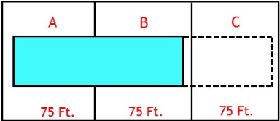
Your Answer
Q1. How to analyze buying lot C. The developer needs to:

1. Have the architect develop the layout for a building on lots A, B & C

2. Carry out a development analysis, taking into account economies of scale associated with the larger building to determine how much the developer can pay for lot C.

Q2. Can you think of a way to encourage the owner of lot C to sell?

If the owner of lot C doesn’t sell now, and a building is constructed on lots A & B, the value of lot C will drop significantly because the value will be based on developing a much smaller, more costly building on 75 ft. wide site.
Most developers are not keen to develop 75 foot wide sites if underground parking is required

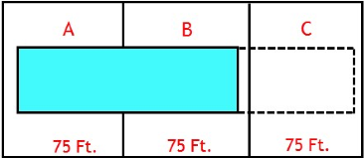
Once there is a building on lots A & B the owner of lot C will find it difficult to find a developer willing the buy a 75 foot wide site for a condominium development.

Q6
List the advantages of developing lots A,B & C compared:

Developing lots A & B

Developing lot C
Your Answer
Advantage of developing lots A, B & C compared to lots A & B

Economies of scale and lower building cost per unit.
Fixed costs. Two end walls, stairwell, elevator, site superintendent, underground ramp, etc.

Buying power. Buying larger quantities, usually results in lower unit cost for materials and shipping such as lumber, concrete, carpets, drapes. The larger the quantity the lower the unit and shipping costs for appliances , range hoods, etc.

A subtle advantage of developing lots A, B & C compared to lots A & B.
For development of lots A & B there is a side yard setback. Adding lot C adds a full site coverage for lot C as shown by the grey area on to C
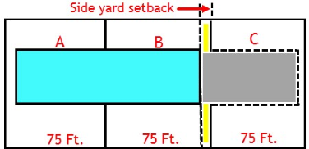

Q7
Exercise:
Eleven houses have the potential to be assembled by a developer to build a condominium project. Each home is worth $500,000.

You can afford to buy one of the homes for $500,000 and rent it out and hopefully sometime in the future sell it to a developer and make lots of money.

Zoning is Multi-family.

Which house would you buy to make the most money?
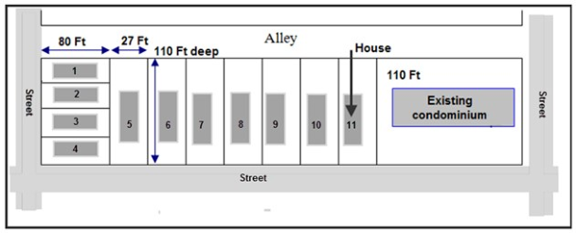
Your Answer
The best house to buy is one near the middle.

This is called a blocking strategy. For the development to proceed, the developer needs the middle lots.

If the developer can buy houses 5 to 10 he doesn’t need house 11.

Houses 1 to 4 on the end are a bad choice. Why? See the next flash card.

Q8
Land assembly. True case study.

The potential land assembly consisted eleven lots with a house on each lot. All the homes were listed for sale. The price for each home was around $500,000.

Do you think the developer should acquires lots 1, 2 3 & 4 as part of the land assembly?
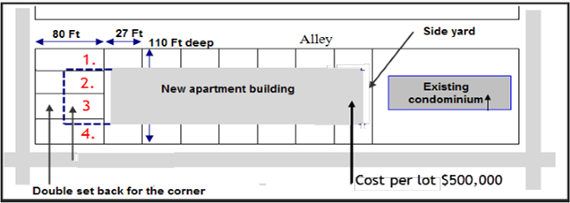

Your Answer
One approach is to get sketch plan for two developments.

1.Includinglots 1, 2, 3 & 4 the four end lots
2.Excluding lots 1, 2, 3 & 4 the four end lots
3. Carry out development analysis for the two options.

The result. The development profit dropped when the four end lots
were included despite the fact that it was a larger building.

WHY? See the next flash card

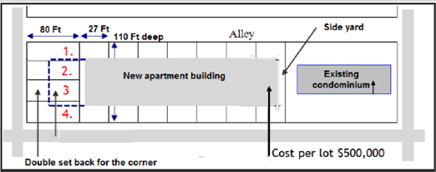

Q10
Why did the development profit drop when the four end lot were added to the assembly?
What did the developer decide?
Flip side
The developer decided not to buy the four end lots because the economics of adding the four end lots didn’t work.

Many years later the four end lots remain as houses.

The highest and best use for the four end lots is single family homes, even though the zoning is multifamily.
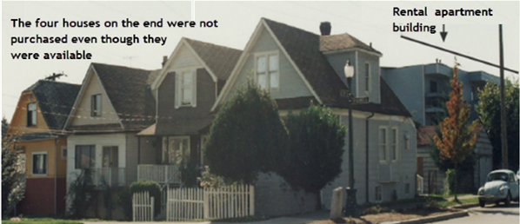

Q10
What’s a “Blocking” strategy?
Your Answer
Example of a “Blocking” strategy

A prominent shopping center developer is building a regional shopping center consisting of three major department stores and hundreds of smaller tenants.

The developer is aware the several miles away; there is a potential land assembly that is large enough to build a competing regional shopping center.

To prevent future competition, the developer buys several critical lots in the center of the potential assembly, preventing the development of a competing regional shopping center.

A clever strategy.

Q11
Be on the constant lookout for assembly potential. Why?
Your Answer
When looking at a site, or a site with an existing older building, look for site assembly potential by:

Looking at the properties on either side of the site and properties at the rear of the site.

Is there potential for a land assembly?

Enlarging the site through a land assembly will likely increase the value of the individual sites.

This only works if the zoning allows development on the assembled site. It wouldn’t work for residential single family residential zoning.

.

Q12
A realtor had a listing on a large site and wondered how to determine the value of the land. A consultant made the following observations upon visiting the site.

1. Zoning. Townhomes
2.Two large live Oak trees which had to be protected
3. Deep drainage ditch on the right side of the property. Suggests water problems and the need for a retention pond

Building around the two live oak trees and providing a retention pond
increases construction costs and significantly reduces the buildable area
and land value.

The consultant then looked to see if there was a land assembly potential by observing what was on either side of the property?

Flip side
Always look for development potential. What is beside and behind the site. Is there a potential land assembly?

Property to the left. Has an existing, relatively new, three story brick apartment building. No development potential.

Property to the right. There was a high fence surrounding the property. The site is large and has a cluster of small old cabins. Clearly not operating at the highest and best use.
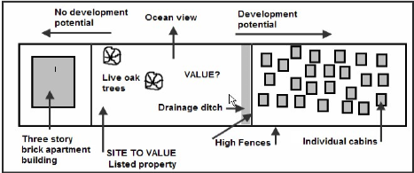

The consultant recommended finding out if the site on the right could be purchased.

Q13
How would you go about determining?

- The value of the site?
- The value of a land assembly created by acquiring the site on the right of the listed property
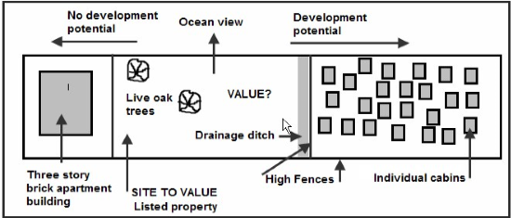
Your Answer

1. Get architectural sketch plans done to determine what can be built on the site for the:
a) listed site
b) listed site combined with the property to the right (Land assembly)

2. Carry out development analysis and determine the land value for:
a) The listed site
b) The listed site combined with the property to the right (Land assembly)?

Q14
When purchasing an older income property, should the buyer think about
long term assembly potential?
Flip side
When purchasing an older income property, should the buyer think about
long term assembly potential? YES

Which property is best to buy A, B, C and D?

Property A is a non conforming old rental apartment building. If it was destroyed it
would be difficult to replace. Current zoning would require underground parking,
front and side yard set back. There is no assembly potential because the building to
the left is a relatively new condominium building. A poor and risky investment.
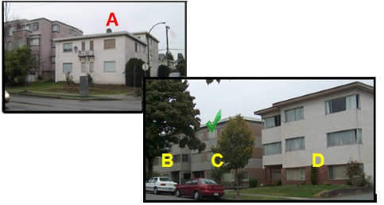

Properties B, C, and D all have long-term assembly potential. Assembling any two side-by-side buildings, B & C or C & D would provide a nice-sized condominium development.
The best choice would be C, the property.

Q15
Why is developing a land assembly challenging?
Your Answer
As an example, we will use assembling 10 single-family homes located in a multi-family zoning allowing the development of a four-floor condominium development with underground parking. Each lot is 34 feet wide by 125 feet deep. All the homes have for-sale signs.

Some of the owners will tend to value their home as being worth more than the other homes. Some will be keen to sell, while others will try to hold out for more money.

Before approaching the owners with an offer, you need to establish:

1. Which homes are critical to the development? Often it is the center properties. The first step is to get the essential properties under contract.

2. Figure out how many homes in a row do you need to create a viable development?

Generally, you need at least 100 feet wide property for a viable development. It’s too costly to develop 75 wide site if underground parking is required.

This suggests that the assembly needs at a minimum three homes providing 3 x 34 feet = 102 foot wide assembly.

3. Make each offer contingent upon purchasing the other homes.

Q16
What is the impact of land assemblies in property values?
Your Answer

Two plus two equals more than four

Developers encourage owners of contiguous homes to sell by offering a high price so that three or more lots can be assembled to build new condominiums.

If sold individually, these homes would fetch much less. When sold together, they become more than the sum of their parts.
Single family homes will often sell three to five times or more than their value as single-family homes when part of a land assembly to build condominiums.
For example, a house worth $1,000,000 could be worth $3,000,000 or more as part of a land assembly.

Q17
What strategies can you use for “Hold Outs”?
Your Answer
Holdouts are the property owners who want to sell but are asking an unrealistic price.

Q18
True case.
Strategy used to encourage a “holdout” to accept the developer’s offer
and be part of the assembly.
Flip side
The developer had the houses on lots 6 to 10 under contract
It was not economical to buy the four homes on the end. Why? See flashcard No.10
Lot 11 was not available. The owner had lived there all his life and didn’t want to sell
The “holdout” was lot 5, who want far too much money for his home.
The developer explained to the “holdout” that time was running out and that this
home is worth a lot more as part of the development. He didn’t budge.
When the surveyors were going out to survey the assembly, the developer asked them to exclude the “holdout’s” land from the survey using the survey stakes with red flags.
The next day the “holdout” turned up at the developer’s office and signed the offer.

The surveyor’s flag stake provided tangible evidence that the developer was prepared to proceed without the “holdovers” property.
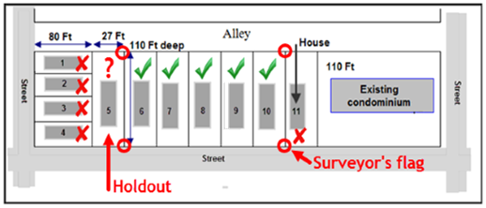

Q19
Some examples of what can happen to “Holdouts”
Flip side
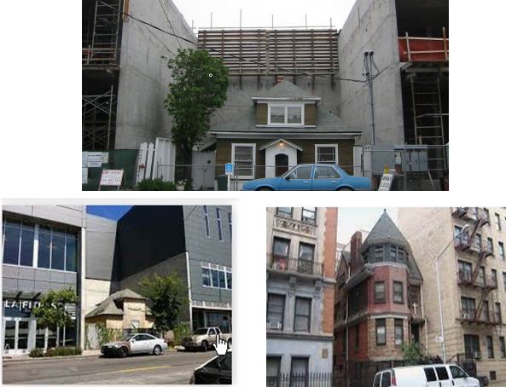

END

