Raising Your Commercial IQ
__________________________________________________________

203 Office, Industrial and Retail Leasing

In-house Training Program
Instructor Guide, Agenda and Timetable

Neil Osborne M.B.A.
DL. (604) 988-9964
nosborne@investitsoftware.com
Investit Software Inc.
Toll free 877-878-1828
North Vancouver BC
Canada V7R 3N4
investit@investitsoftware.com
www.investitacademy.com
www.investitpro.com
Copyright

Table of Contents

203. INSTRUCTOR GUIDE 3
LEARNING OBJECTIVES 5
Calculator 5
FORMULAS USED IN LEASE ANALYSIS 6
AGENDA TIME TABLE 7
203 FLASH CARDS. QUESTION & ANSWERS 10
Landlord and Tenant 10
The Leasing Process 14
Types of Leases 20
Types of Rent 24
Percentage Rents 26
Expense Caps and Stops 29
Lease Term, Option to Renew and Bumps and Steps 31
Assignment and Sub Leasing 35
How to define and measure space 37
Renting space for plans 41
Tenant Improvements (TI’s) 45
Missing the occupancy date 50
Operating and Recoverable Expenses 52
Renovating and Subdividing Space 55
Lease Comparison Analysis 58
Lease Negotiations. Landlord and Tenant trade offs 66
Valuing a Land Lease 69
Blending & Extending a Lease 71
Buy versus Leases Analysis 72
Tips for reading a lease 78
Demolition Clauses 81

203. INSTRUCTOR GUIDE

Class hours

Allow approximately 18 to 20 hours of class time. For example, five, four-hour sessions meeting once per week.

Content choices
In some cases, you may not want to present all the course material. For example, if the class consists of residential realtors or rookie commercial interested in learning more about commercial real estate, some topics may be too advanced. If this is the case, skip the topic.

Teaching process
The teaching process consists of alternating between playing the:

- micro videos
- flashcards, answering the flashcard questions, and class discussions

by following the “Agenda Time Table” below.

The micro videos provide an introduction to the topic. The flash cards actively involve the student in the learning process and reinforce the material presented in the micro videos.

Flash cards
A great way to learn the basics. The Participant Guide contains:

- Question
- Space for the participant to write the answer
- The answer is on the flip side of the flashcard.

Teaching using flashcards
Allow the participants time to complete the flashcard questions and then:

Review each flashcard question and answer and encourage questions and discussions. Enliven with your own experience and local examples.

This approach provides the opportunity for active class involvement.

- Questions, answers, and lively in-depth discussions
- Provides the instructor with an opportunity to provide local examples and personal experiences.

Example.
How leasing commissions are calculated varies widely depending on the state or province, local regional practices, and the type of real estate. Explain how leasing commissions are calculated in your area.

LEARNING OBJECTIVES
To provide a comprehensive understanding of,
- the leasing process
- the terms used in leasing
- how to read a lease and what to look for in a lease
- the differences between the different kinds of leasing markets
- how tenants go about choosing a location and space
- what question to ask the landlord and tenant
- some of the complex issues involved in a lease
- why leases are often complex, lengthy documents
- how to carry out a lease comparison analysis
- how leases impact the value of a property and the available financing
Enable you to deal confidently and knowledgeably with landlords, tenants and lawyers.
Help you decide if leasing is an attractive career choice.

Calculator
Your students will need to bring a calculator. In can be any kind of calculator. It doesn’t have to be a financial calculator.

FORMULAS USED IN LEASE ANALYSIS

Cap Rate (Capitalization Rate)

Net Effective Rent (NER)
Net Effective Rent (NER) = Net Present Value at X%
Rentable Area x No. of Years
Example:
Net Present Value at 10%: $4,500,000
Rentable Area: 20,000 Sq. Ft
Lease period: 10 years

Net Effective Rent (NER) = Net Present Value at 10%
Area x No. of Years

= $4,500,000
$20,000 x 10 years

= $22.50 per Sq. Ft per Yr at 10%

AGENDA TIME TABLE

Landlord & Tenants
Line  number | Play Micro Video | Manual  Page Number | Play Flash Card Set | Participant Package  Page number
1 | Types of Landlords and Tenants (13 min) | 6
2 | Leases and Property Types (14 min) | 7
3 | The leasing process (7 min) | 9
4 | Types of Leases (8 min) | 13
5 | Types of Rent (8 min) | 14
6 | Term of The Lease (7 min) | 25
7 | Assignment & Subletting (2 min) | 27
8 |  |  | Landlord and Tenants | 9
9 |  |  | The Leasing Process | 12
10 |  |  | Types of Leases | 16
11 |  |  | Types of Rent | 18
12 |  |  | Percentage Rent | 20
13 |  |  | Expense Cap & Stops | 22
14 |  |  | Lease Term, Option to Renew and Bumps and Steps | 23
15 |  |  | Assignment and Subleasing | 25
16 | Operating & Recoverable Expenses | 28
17 | Renovations. Structural considerations | 31

Line  number | Play Micro Video | Manual  Page Number | Play Flash Card Set | Participant Package  Page number
18 |  |  | How to define & measure space | 27
19 |  |  | Renting space from plans | 30
20 |  |  | Tenant Improvements (TI's) | 34
21 |  |  | Missing the occupancy date | 38
22 |  |  | Operating and Recoverable Expenses | 39
23 |  |  | Renovating and subdividing space | 42
24 | Analyzing leases (1 min) | 34
25 | Net Effective Rent (NER) (2 min) | 34
26 | Comparing Leases. Case study (5 min) | 35
27 | Lease negotiations.  The trade offs (4 min) | 41
28 | Lease negotiations. Case study (13) | 42
29 | Valuing Ground Lease (2 min) | 49
30 | Blending & Extending a Lease (8 min) | 51
31 | Lease. Impact on value & marketability (4 min) | 52
32 | Mutually exclusive investment analysis & Buy versus Lease Analysis (4 min) | 59
33 | Buying versus renting a home.  Case study (8 min) | 59
34 | Buy versus lease office space. Case study (9 min) | 61
35 | Analyzing a multi-lease proposal (  3 min) | 65
36 | Tips for reading a lease (3 min) | 54
37 | Demolition clauses (3 min) | 56
38 |  |  | Lease comparison analysis | 44
Line  number | Play Micro Video | Manual  Page Number | Play Flash Card Set | Participant Package  Page number
39 |  |  | Lease negotiations. Landlord and Tenant trade offs | 50
40 |  |  | Valuing a land lease | 52
41 |  |  | Blending & extending leases | 54
 |  |  | Buy versus Lease Analysis | 55
42 |  |  | Tips for reading a lease | 62
43 |  |  | Demolition clauses | 64

PRACTICE QUIZ and 203 COURSE EXAM
Suggest the participants take the 203 Practice Quiz to test their knowledge and measure their progress.
They can take the test many times, and the grade will be recorded and can be reviewed.
The quiz results are confidential and cannot be viewed by anyone else.

203. Course Exam.
Take the 203 course exam which is set up by a manager or office administrator.

203 FLASH CARDS. QUESTION & ANSWERS

Landlord and Tenant

Q1.
In legal terms the:

Landlord is called the ___________

Tenant is called the ___________

Your Answer
In legal terms the:

Landlord is called the “Lessor”

Tenant is called the “Lessee”

Q2.
Be very careful when working with inexperienced landlords, tenants or realtors because there is a potential for misunderstandings.

Write down some examples of potential misunderstanding between the landlord, tenant and inexperience realtor.
Your Answer
Example 1.
What three months “Free rent” means. A naïve tenant may assume that they will not have to pay any rent for three months. On the other hand, the landlord expects to be paid the “Additional Rent” for operating expenses such as “Taxes, Insurance & Maintenance (TIM’s) as spelled out in the lease.

Example 2.
In office building tenants can be confused as to what “Rentable” and “Usable” areas mean.

Q3.
Question
Write down some of the landlord’s major concerns when leasing space to a tenant.
Your Answer
The major concern is the rent rate because the rent rate influences the value of the property. The landlord will also be concerned about:
- Whether the tenant is compatible with the other tenants and enhances the property value
- Credit worthiness of the tenant
- Length of the lease.

These are just a few of the many concerns that a landlord may have. Can you add some more?

When leasing space it’s a good idea to find out ahead of time what the landlord’s main concerns are.

Q4.

List some of the concerns that a tenant may have when leasing space.
Your Answer

The “Your Answer” depends a lot on the type of tenant. Below are some examples. While the cost of renting is an important factor the tenant, depending on their business, will consider a lot of other factors such as:
- Moving cost
- Where their employees live
- Nearness to the airport or public transportation
- Cost of utilities, property taxes etc.
- Ability to sublease or terminate the lease
- The ability to rent more space in the building
- The nature of and compatibility with adjacent tenants
- Exposure, visibility and signage
- The cost of waste disposal
- Government incentives
ETC.

Q5.
Question
Landlords and Tenants are often concerned with “Tenant Mix & Compatibility” in property.

Provide an example of poor tenant mix for a small retail strip center with limited onsite parking for 6 cars. The adjacent street a parking is metered and it is often hard to find a parking spot.
Your Answer
Example of a poor tenant mix.

A retail strip consisting of:

7-11. Short term parking. In and out quickly

Doctor’s office. Ties up the parking space for long periods

Japanese restaurant. Ties up the parking

Baskin and Robins Ice cream parlor. Short term parking. In and out quickly

Given the limited parking the best retail tenants are ones where there customers are in and out quickly

Q6.

Explain ‘Synergy” as it relates to real estate and provide several examples.

Synergy means that the “whole” is greater than the sum of the individual “Parts” or 2+2 = 5 and has wide application for real estate establishments
Your Answer
Some examples of “Synergy”

Synergy. Gas station with an attached convenience store.
No synergy. Gas station with no convenience store with the convenience store located elsewhere.

The combined gas station and store will likely generate more revenue than if the gas station and convenience store are separate. Customers getting gas often purchase items after they gas up such as coffee, newspaper, soda and snacks. Gas stations with a convenience store can use the gas price as a loss leader to attract customers into the store. A gas station without a convenience store can’t do this.

Synergy. Shopping Mall with anchor tenants and many smaller stores and lots of parking.
No synergy. A standalone major department store with the smaller retail stores scattered in the neighbouring area.

Q7.
An industrial tenant with heavy equipment is considering renting 25,000 sq. Ft of industrial rent.

Besides the rent what are some features and building attributes that will be of concern to the industrial tenant?
Your Answer
The industrial tenant may have concerns about:

- Floor load capacity.
- Ceiling height
- Distance between columns
- A high voltage, 3 phase electrical system
- Ratio of office space to warehouse and manufacturing space
- Types of loading and unloading docks
ETC.
Note.
In the “Resources” section of the Investit Academy LMS there is an extensive ‘Industrial Real Estate Check List” Take a look.
END

The Leasing Process

Q1.
Is there a standard way to calculate a leasing fee?
Your Answer
Is there a standard way to calculate a leasing fee? The Your Answer is “NO”

There are many ways to calculate a leasing fee. The leasing fee calculation tends to depend on the local market and the type of real estate. As an example, how the leasing fee is calculated in California may be very different that the way it’s done in Florida and can vary by the type of real estate such as industrial versus office space.

If you’re new you need to find out what the local practice is for calculating the leasing commission for the different types of space such as office, industrial and retail space.

Q2.
What are some of the ways that leasing commissions are calculated?
Your Answer
What are some of the ways that leasing commissions are calculated?

While Leasing Commission rates vary by market, they’re generally quoted as a percentage of the total rent over the term of the lease (e.g. 6%).

Example. Lease term before the renewal date is 5 years. Leasing commissions is 5% of the first years rent plus 3% of 4 years which is 15% of the rent for the first year.

Calculated using $ per Sq. Ft of rentable area. E.g. the leasing commission is $1.00 per Sq. Ft of rentable area
Rentable area: 20,000 Sq. Ft. Leasing commission is $1.00 psf x 20,000 Sq. Ft = $20,000

Fixed fee. The leasing fee will be $15,000

Instructor Tip. Explain how leasing commissions are calculated in your area

Q3.
Leasing agreements often include the right for the tenant to renew the lease. Does the landlord have to pay a leasing fee on the renewal of the lease?
Your Answer
The Agreement to Lease between the landlord and the leasing agent will state:
- That the leasing fee is paid if the tenant renews the lease for another term
- Will specify that the leasing fee is only paid on the first term of the lease

Q4.
A “Triple Net Lease (NNN) consists of the “Base Rent” and the “Additional Rent” which is the payment of the landlord’s operating expenses such as “Taxes, Insurance & Maintenance” as spelled out in the lease.

Does the leasing commission calculation include the “Additional Rent”?
Your Answer

The landlord and the leasing agent can negotiate the leasing fee using any method that they agree upon.

Typically the leasing fee calculation does not include the “Additional Rent” but it certainly could be included in the calculation of the leasing commission.

Q5.
The “Commission Agreement” or “Authority to Lease” must include;
- How the leasing commission is calculated
- How it will be paid
- When will it be paid

Why is the third item “When will it be paid?” so important?
Your Answer
The Agreement to Lease form signed by the landlord and leasing agent will contain a trigger(s) as to when the leasing fee has to be paid. Care has to be taken to identify the payment triggers.

Example. The leasing fee is paid on the signing of the lease. What if the tenant moves in, pays the rent specified in the lease but the lease is never signed or isn’t signed for some time after the tenant has moved in.

Decent landlords would pay the leasing fee but there are some that wouldn’t pay because the lease has not been signed and the leasing fee is not due.

Solution
To make sure you get paid the leasing fee, identify multiple triggers such as:
- Signing of the offer to lease
- Signing of the lease
- Tenant moves in
- Issuance of an occupancy permit by the City
……..whichever occurs first.

Q6.
Is a leasing commission always paid as a single amount or can the fee payment be spread over time?
Your Answer
Generally the leasing fee is paid as a single amount but sometimes it may be spread over the term of the lease and paid monthly and may include a higher initial payment.

Examples. Leasing fee 6% of the rent for the first 5 year term excluding “Additional Rent”.
The total rent for the first five years is $1,000,000. Leasing fee = 6% x $1,000,000 = $60,000 paid as follows:

First payment: $20,000 with the remainder paid monthly at the beginning of the month for 4 years and 11 months which is ($60,000 -$20,000)/59 = $677.97 per month.

In other words, the landlord and the leasing agent can negotiate a plan for the payment of the leasing fee.

Q7.
What are the three main documents that are used when leasing space?
Your Answer

- The Letter of Intent (LOI)
- Offer to Lease
- The lease

Q8.
The ‘Letter of Intent (LOI)” is an enforceable contract

True or False

Circle Your Answer

Your Answer
False.
The Letter of Intent is a proposal from the landlord or tenant to rent the space and spells out the major terms and conditions to see if there is a general agreement before proceeding to the Offer to Lease and the Lease.

A “Letter of Intent” is not a binding contract.

Q9.
What’s the purpose of the “Offer to Lease” or “Agreement to Lease”?
Your Answer

The signed “Offer to Lease” is a contract between the landlord and the tenant which spells out the main terms and conditions of the lease. It is an interim step before signing the lease which is much more detailed and way more complex than the Offer to Lease.

The Offer to Lease may be a few pages where as a lease could be 70 pages long. A lengthy and complex document.

To be valid in law the Offer to Lease must have the essential terms required for an enforceable lease

Q10.
Is an accepted “Offer to Lease” a binding contract?
Your Answer
Yes as long as the Offer to Lease has the essential terms required for an enforceable lease.

Q11.
List some of the approvals that may be required by the City before the space can be occupied.
Your Answer
Leasing space requires many approvals from the City and other agencies including:

- Building permit for renovations and lease hold improvements
- Signage permit if appropriate
- Occupancy permit
- Fire and safety inspection
- Business licenses

In the case of restaurants, liquor stores, bars and pubs, marijuana outlets there will be a lot more applications and permits required which can many months even a year or more.

END

Types of Leases

Q1.
What is a “Gross Lease” and a “Full Service Lease”?
Write down Your Answer and check the Flip Side
Your Answer
The tenant pays a fixed amount of rent such as $3,000 per month
In most cases the tenant pays for their light and may or not pay for cost of heating their space.

With a “Gross Lease” the landlord pays for the operating costs such taxes, insurance and maintenance (TIM’s)

Often a “Full Service Lease” which is similar to a Gross Lease requires the tenant to be responsible for any increases in the buildings operating expenses as defined in the lease beyond the base year of the lease.

E.g. The operating expenses for the Base year (First year) were $75,000. The operating expenses for year two are $85,000. The tenant has to pay the increase in the operating expenses over the base year which is $10,000 ($85,000-75,000

Q2.
What’s the disadvantage of a Gross Lease from a landlord’s perspective?

Your Answer

Landlords don’t like Gross Leases because operating costs like property taxes cannot be passed to the tenant.

This means that the Net Operating Income (NOI) declines over time which may reduce the value of the building.

Q3
What’s a Modified Gross Lease?
Your Answer
It is a variation of the gross Lease where the tenant pays for some of the landlord’s operating expenses as spelled out in the lease. There are many variations of a modified gross lease.

Examples
- Tenant pays the gross rent plus the increase in property taxes, insurance and maintenance over the base year.

- Tenant pays the increase the property taxes over the base year plus snow removal.

Q4.
What is an Indexed Lease or a Gross lease with an escalation clause?
Your Answer
A gross lease where the base rent is increased each year by a specified percent as spelled out in the lease or increased by the change in the specified Consumer Price Index (CPI) to help offset the increase in the landlords operating expenses.

NOTE. There are many types of Consumer Price Indexes. The lease will specify the Consumer Price Increase (CPI) to be used in calculating the annual increase in rent.

Government’s often use a Gross Lease with some form of annual escalation when negotiating a lease. Also called an Indexed Lease.

Q5.
What’s a Triple Net Lease (NNN)? Also called a Net Lease.
Your Answer

A Triple Net Lease means a tenants pays their proportional share of the landlord’s operating expenses such as taxes, insurance and maintenance (TIM’s).

Triple Net Lease is a somewhat ambiguous term.

As an example, does the tenant pay their share of the Property Management fee? How about administrative costs? Or the depreciation of mechanical equipment?

To Your Answer these types of questions you need to read the lease which spells out what operating costs the tenant pays and what operating cost landlord pays.

Q6.
How clear and specific are terms like:
- Gross Lease
- Modified Gross Lease
- Indexed lease
- Full Service Lease
- Triple Net Lease (NNN)
Your Answer

It’s important to note that these terms aren’t clearly defined and standardized.

You need to READ THE LEASE to identify what operating expenses that are paid by the landlord and which are paid by the tenant.

Even the “Gross Lease” which is the simplest form of a lease can vary. Does the tenant pay for the internal light and heat? (Probably) but what about garbage collection. READ THE LEASE

Q7.

Are the different types of leases like “Full Service Lease” and “Triple Net” used consistently based on the type of real estate and are they independent of the geographic location of the real estate?

As an example, full service leases are often used for office buildings but is this consistent across the country?

How about rent rates such as $ per Sq. Ft per Yr versus $ per Sq. Ft per Mth?
Your Answer
The use of different types of leases like “Full Service Lease” and “Triple Net” varies across the country and depends on the location of the real estate and the types of real estate?

In some cities office leases will typically be “Full Service leases” but in other cities the office leases will be “Triple Net (NNN)” leases.

Quoting lease rates as $ per Sq. Ft per Yr versus $ per Sq. Ft per Mth also depends on location and sometimes the type of real estate.

Some regions use $ per Sq. Ft per Yr while others use $ per Sq. Ft per Mth. Some regions use $ per Sq. Ft per Yr for offices buildings and $ per Sq. Ft per Mth for industrial buildings.

TIP. You need to find out what types of leases and rent rates are commonly used in your market area for different types of real estate.

END

Types of Rent

Q1.
What is the Base Rent?
Your Answer

The “Base Rent” is the rent paid by the tenant to the landlord.

Commercial example:
Base Rent is $24 per Sq.Ft per year paid monthly at the beginning of the month

Note. In some states they use a monthly rate. E.G. $2 per Sq. Ft per Month

Q2.
What is the “Additional Rent”?
Your Answer

Payment by the tenant to the landlord under a “Triple Net(NNN)” arrangement for the landlord’s operating expenses as specified in the lease.

Also called:

Recoverable Expenses
Reimbursable Expenses
Pass Through
TIM’s (Taxes, Insurance & Maintenance
CAMs (Common Area Maintenance)

Q3
What is “Free Rent”?
Your Answer
Landlords often offer “Free Rent” as a tenant inducement to rent the space.

Example. Four months free rent where the tenant doesn’t pay the Base Rent for four months

Generally the free rent periods will be spread over several years to reduce the landlord’s risk if the tenant breaks the lease and leaves.

Example.
Four months free rent with one month of free rent occurring every year for four years
_____________________________________________________________________________________
Q4
Does “Free Rent” apply to “Additional Rent?”
Your Answer
Generally “Free Rent” only applies to the “Base Rent” not to the “Additional Rent”.

If the lease arrangement is “Triple Net” the landlord wants to get paid the “Additional Rent” as specified in the lease in order to recover the operating costs.

Percentage Rents

Q1.
Explain “Percentage Rent”
Your Answer

The tenant pays a “Base Rent” or the % Rent, whichever is the larger.
Often used when leasing retail space and by shopping center owners.

Example
Base Rent: $600,000 per year
% Rent: 5% of sales
Sales: $18,000,000 per Yr.

% Rent 5% x $18,000,000 = $900,000

Tenant pays the % Rent of $900,000 because it is larger than
the Base Rent of $600,000 per year

Q2.
Why do retail landlords use a “Percentage Rent”?

Your Answer
Percentage rents are used by large shopping center owners. The success of a shopping center and the tenant’s sales revenue depends in part on the tenant mix, appeal of the center and the landlord’s promotional activities to attract shoppers.

The shopping center owners like to participate in the tenant’s success and they do this by taking a percent of the tenant’s revenue which is called a ‘Percentage Rent”.

With a new shopping center it takes time for the traffic to build to an acceptable level where the tenant’s business is profitable. To offset this problem the landlord can offer a lower minimum base rent and benefits later as the tenant’s revenue grows by using a percentage rent.

Q3.
What types of retail establishments use a “Percentage Rent”?
Your Answer

Percentage rent is typically associated with retail leases and is used in neighborhood retail centers, regional and outlet mall shopping centers and smaller convenience retailers such as 7-11.

Percentage rents are not applicable to office and industrial tenancies.

Q4.
In calculating the “Percentage rent” what is the difference between the “Natural Break Point” and the “Artificial Breakpoint (Unnatural Breakpoint)”?
Your Answer

The Natural Breakpoint is the point where the base rent equals
the percentage rent.

The Natural Breakpoint = Base Rent = Base Rent $250,000 per Yr. = $5,000,000
% Rent % Rent 5%

Artificial Break Point.
The landlord and tenant agree upon the level of Gross business sales that allows the percentage rent to kick in. Example. When the annual gross business sales reach $4,000,000 the percentage rent of 4.50% kicks in.

Q5.
Based on the following information calculate:

1) The tenants annual rent

2) The “Natural Break Point”

Base Rent: $300,000 per year (Minimum rent)
Percentage Rent: 3.00%
Gross Business sales; $15,000,000
Your Answer
Percentage Rent 3.00% x $15,000,000 = $450,000
Base Rent: $300,000 per year (Minimum rent).

Tenant’s rent for the year is the Percentage Rent of $450,000
because it is higher than the Base Rent of $300,000 per year.

Natural Breakpoint = Minimum Rent = $300,000 = $10,000,000 per Year of Gross Business Sales
% Rent 3.00%

The % Rent kicks in once the gross business sales exceeds $10,000,000
_______________________________________________________________________________
END

Expense Caps and Stops

Q1.
What is an “Expense Stop”?
Your Answer
The landlord pays the operating costs such as Taxes, Insurance and Maintenance up the expense stop. Increases in operating expenses over the “Expense Stop” are paid by the tenant as additional rent.

Example
Expense Stop is $45,000. Operating costs for the year for Taxes, Insurance and Maintenance are $50,000. The landlord pays $45,000 and the tenant $5,000 ($50,000 – 45,000).

Q2.

Explain an Expense Stop coupled with “Base Year” operating expenses.
Your Answer
The tenant pays the increase in the operating expense(s) over the base year but not to exceed the “Expense Stop”.

The Expense Stop may be applied to a specific operating expense such as the property taxes or to all the operating expenses such as Taxes, Insurance and Maintenance.

Example
The property taxes, insurance and maintenance (TIMs) for the first year (base year) are $30,000 with an Expense stop of $40,000.

Next year if the TIM’s are $44,000 the tenant pays $40,000 - $30,000 which is $10,000

Q3.
Explain an Expense Cap and provide an example
Your Answer
A Rent Cap puts a limit on the operating expenses to be paid by the tenant to the landlord.

Examples

The tenant pays the operating expenses up to $60,000 per year. The landlord pays for the operating expenses over $60,000 per year.

END

Lease Term, Option to Renew and Bumps and Steps
Q1.
What is the “Lease Term”?
Your Answer

It is the time period that the tenant is allowed to legally occupy the space.

As an example 5 years commencing October 1, 2019

Q2.
What is a “Periodic Tenancy”?
Your Answer
A “Periodic Tenancy” is a “Month to Month Tenancy” where the landlord or the tenant can give one months notice.

Q3.
What is an “Option to Renew?” and how is the renewal rate determined?
Your Answer
At the end of the lease term the lease may have an “Option to Renew” for another term which allows the tenant to renew the lease and continue to legally occupy the space.

The “Option to Renew” clause will specify how the renewal rent will be determined such as:

- At fair market rates at the time of renewal
- Specified. E.g. The “Renewal Rate” will be $30.00 per Sq. Ft per Yr.
- Based on the change in a specified Consumer Price Increase (CPI) over the previous lease term.

Note: There are many Consumer Price Indexes. The lease will specify which Consumer Price Index (CPI) is to be used.

Q4.
A tenant is entering into a Five Year term lease that has a renewal option for another five years.
The renewal rate will be based on the “Fair Market” rent at that time.

The tenant is really concerned about how high the rent will be when the lease is renewed.

Can the renewal rent rate be limited?
Your Answer
Can the renewal rent rate be limited?

Yes. A “Rent Cap” can be used to limit the renewal rate increase.

Q5.
Show me an example of a Rent Cap in action.

Flip Side

The renewal rent rate will be based on the “Fair Market Rent” at that time but not to exceed the increase in the specified Consumer Price Index (CPI) over the previous lease term.

Example. Applying a “Rent Cap” to the renewal rent rate.
Lease Term: 5 years
Starting Lease Rate: $26.00 per Sq. Ft per Yr.
Fair Market Rent (FMR) in Five years later: $30 per Sq. Ft per Yr.
Renewal Rent Cap: Change in the specified CPI over the five years: 11.00%

Calculating the renewal rent rate five years later.
Rent Rate based on 11% change in the CPI $26.00 x 1.11 = $28.86 per Sq. Ft per Yr.
Fair Market Rent in Five years later: $30 per Sq. Ft per Yr.

The renewal rent rate will be based on the change in the CPI is $28.86 per Sq. Ft Per Yr. which is the “Rent Cap” and not the Fair Market Rent of $30.00 per Sq. Ft per Yr.

Q6.
What do lease “Bumps and Steps” refer to?
Your Answer
The lease may provide for periodic increases in the rent during the lease term which are called bumps or steps.

Example.1
Term: Three years

Rent. Year 1. $19 per Sq. Ft per Yr
2. $21
3. $24

Example 2.
The lease rate increases every year by 3% compounded annually

Q7.
How is the “Fair Market Rent” established?
Your Answer
The lease will specify which parties are responsible for establishing the “Fair Market Rent”

The most common method is that it is negotiated between the landlord and the tenant and is based on based on comparables. Establishing the Fair Market Rent can be very challenging because it’s difficult to find comparable space that has recently been rented and then finding the rent rate.

Invariably the landlord and the tenant will come up with different values for the Fair Market Rent and hopefully they can come to an agreement as to the value of the Free Market Rent.

If they can’t come to an agreement the lease will contain an arbitration clause which spells out how to determine the lease renewal rate such as:

The landlord provides a list of three commercial appraisals and the tenant selects one of them who then investigate the comparable rental market and determines the Far Market Value (FMV) rental rate.

Q8.
What if the landlord and the tenant can’t agree on the free market rent?
Your Answer
If they can’t come to an agreement the lease will contain an arbitration clause which spells out how to determine the lease renewal rate such as:

The landlord provides a list of three commercial appraisals and the tenant selects one of them who then investigates the comparable rental market and determines the Fair Market Value (FMV) rental rate.

END

Assignment and Sub Leasing

Q1.
What is an assignment of a lease?
Your Answer
The tenant vacates the space and transfers the tenants’ rights to the new tenant

The original tenant is still responsible for the rent payments and other obligations specified in the lease.

Q2.
What is a “Sublease”?
Your Answer
Sublease
A transfer of some of the tenant’s rights to a sub tenant such as renting a portion of the space to a sub tenant.

The landlord generally has the option to accept the sub lease.

The original tenant is still responsible for the rent payments and other obligations specified in the lease.

Q3.
Landlords hate this. A tenant profiting from a sublease.
Explain how a tenant can profit from a sublease.
Your Answer
Example showing how a tenant can profit by subleasing their space.

The tenant rented the space at $29 per Sq. Ft per Yr. and subleases at $34 per Sq. Ft per Yr.

If the rentable area was 10,000 Sq. Ft the annual sublease profit is ($34 -29) x 10,000 Sq. Ft = $50,000 per yr.

If there was three years left on the lease the sublease profit is 3 x $50,000 = $150,000

Q4.

How can the landlord profit from a tenant subleasing at a higher rent rate than the lease rate?
Your Answer

- The subleasing profit accrues to the landlord not to the tenant. Not a good solution because there is no incentive for the tenant to sublease at the market rent.

- The landlord and the tenant agree to split the sublease profit 50/50 after deducting the leasing commission and legal fees paid by the landlord and tenant.

Q5.
Can a tenant always “sublet” or “Assign” the lease to a third party?
Your Answer
The ability to assign or sublet is governed by the lease.

YOU NEED TO READ THE LEASE

END

How to define and measure space

Q1.
What are the Rentable Area and the Gross Leasable Area (GLA)?
Your Answer
The Rentable area is the area used to calculate the rent and varies by the type of real estate.

Industrial. The rentable area is generally the area occupied by the tenant

Retail space. Called the Gross Leasable Area (GLA). It’s the area occupied by the tenant

Office Space. See the next flash card

Q2.
How do you calculate the rentable area in an office building?
Your Answer
In an office building the landlord wants to get paid rent based on the area occupied by the tenant which is called the “Usable Area” plus the tenant’s share of the common areas such as the lobby, corridors etc.

Rentable Area = Usable Area x Load Factor or Common Area Factor

Various names are used to identify the Load Factor.
Load Factor, Common Area Factor
Add On Factor, R/U (Rentable Area/Usable Area)

Example: Usable Area: 9,000 Sq. Ft Load Factor or Common Area Factor: 14%

Rentable Area = 9,000 Sq. Ft plus 14% = 10,260 Sq. Ft

Q3.
Calculate the Base Rent per month for an office building using the following information:

Base Rent: $25 per Sq. Ft per Yr. based on the “Rentable Area”
Usable Area: 15,000 Sq. Ft. This is the area occupied by the tenant.
Add on Factor: 14%
Your Answer
Base Rent: $25 per Sq. Ft per Yr. based on the “Rentable Area”
Usable Area: 15,000 Sq. Ft. This is the area occupied by the tenant.
Add on Factor: 14%

Rentable Area = Usable Area plus the Add On Factor of 14%
= 15,000 Sq. Ft x 1.14
= 17,100 Sq. Ft

Monthly Base Rent = 17,100 Sq. Ft x $25 per Sq. Ft per Yr
12

= $35,625

Q4
What are the BOMA standards?
Your Answer
The BOMA (Building Owners and Manager Association) standards are widely used by landlords and tenants for measuring space in office, retail, industrial and flex buildings.

Q5.
When using the BOMA Standard to measure space in an office building the stair well and elevator shaft are included in calculating the tenant’s rentable area.

True or False
Circle Your Answer
Your Answer

False.
Using the BOMA Standards the stairwells and elevator shafts are excluded when calculating the rentable area.

Q6.
Using the BOMA Standards for office buildings how would you measure Tenants A’s space?

WALL A. Measure to Inside OR to the Outside of the wall
WALL B. Over 50% of the wall is glass. Measure to Inside OR the Outside of wall B or
to the inside of the glass line?
INTERIOR C. Measure to the Inside or Exterior of the interior wall?
DEMISING WALL. Measure to the Interior or the middle of the demising wall?
ELEVATOR WALLS. Measure to the Inside or Exterior of the elevator walls?

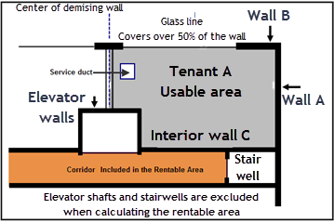

Your Answer
Using the BOMA standards how would you measure Tenant A space?

WALL A. Measure to the Outside of the wall
WALL B. Over 50% of the wall is glass. Measure to Inside of the glass line?
INTERIOR C. Measure to the inside of the interior wall?
DEMISING WALL. Measure to the middle of the demising wall?
ELEVATOR WALLS. Measure to the Inside of the elevator walls?

Q7.
What are the dangers associated with quoting rents as $ per Sq. Ft per Yr. or Month?
Your Answer
When calculating the rent the landlord and the tenant may use different areas to calculate the rent which can lease to misunderstandings as to the amount of the rent.

Example. Office building
Rentable Area: 10,000 Sq. Ft includes a portion of the common areas like corridors and the lobby.

Area occupied by the tenant: 9,000 Sq.Ft
Rent Rate: $30 per Sq. Ft per Yr

Tenant calculates the rent as 9,000 Sq.Ft x $30 = $270,000 per year
Landlord calculates the rent as 10,000 Sq.Ft x $30 = $300,000 per year.

This creates problems between the landlord and tenant.

Q8.
What’s the simple solution to the problems created by quoting rent as $ per sq. Ft per Yr. or Month
Your Answer

Quote the rent as an amount.
The rent is $120,000 per year paid monthly at the beginning of the month.
This simple approach avoids the problems of defining the rentable area and how the space will be measured avoiding potential misunderstanding between the landlord and the tenant.

END

Renting space for plans

Q1.
When leasing space from plans or in a building that’s under construction what are some of the “unknowns” that have to be dealt with in the “Offer to Lease or the Lease”
Your Answer

- The final area. The “Rentable Area” and “Usable Area” cannot be measured until the construction is complete

- When the construction will be complete and the Occupancy Permit issued by the City? Construction often gets delayed for many reasons such as delays created by bad weather, building materials not being available and not delivered on time etc.

- Delays in getting the building and occupancy permits the city

- Cost of leasehold improvements

Q2.
Since the rentable area is not known until the space is complete how can this uncertainty be handled in the “Offer to Lease”?
Your Answer.
Use a “Tolerance”

Example. Rentable Area was supposed to be 6,000 Sq.Ft. but because of construction issues a wall had to be moved over three feet and the final area was 7,500 Sq. Ft. Should the tenants rent be based on 6,000 or 7,500 Sq. Ft?

The Offer to Lease can handle this uncertainty by using a “Dimension Tolerance” As an example:

The area is the Usable area measured according to the BOMA standards
The Rentable Area as defined by BOMA will be 6,000 Sq. Ft ± 10%
Dimensions: Depth 60 feet ± 5%
Width 100 feet ± 5%

The lease should specify what happens if the tolerances are violated.

Q3.
A retailer who is considering renting space in a building that is under construction
requires a minimum of two aisles with a minimum width of 5 feet to accommodate two shopping carts side by side as illustrated below.
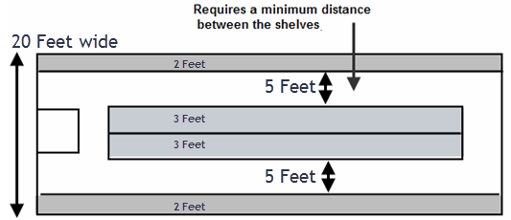

Since the final width cannot be determined until the construction is complete how would you specify the tenant’s requirements in the “Offer to Lease”?
Your Answer.

Use a “Tolerance” to specify the dimensions

Width. Has to be minimum of 20 feet and a maximum of 20 feet 6 inches. The tenant doesn’t want to pay rent for space that they can’t use.

Q4.
What’s the financial impact on the tenant if the tenant’s space ended up being 19 feet wide instead of the desired 20 feet?

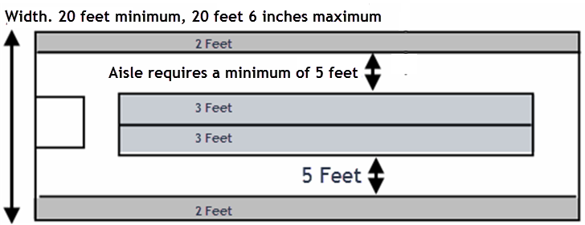

Flip Side
In retailing the amount of shelving is a major asset. Losing a row because the space ended up being 19 feet instead 20 feet is very costly to the tenant. Hopefully the Offer to Lease included a clause allowing the tenant to cancel the lease if the width is less than 20 feet such as the internal width of the store has to be 20 feet -0+2 inches. This example is based on a court case.

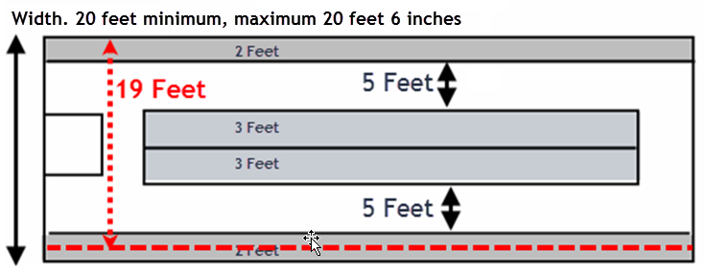

Q5.

The length or depth of the retail space can be very important. Case study.

A retailer has rented space from the plans. The display cases come in 10 feet modules. He needs 6 display cases which means the depth needs to be a minimum of sixty feet deep.

The space he rented was supposed to be 20 feet wide by a minimum of 60 feet deep.

Let’s see what happened when the space was finished and the tenant was ready to move it
Flip Side
Problems.
- Depth was 59 feet 6 inches which means the last display case doesn’t fit as 60 feet is needed
- A concrete column that wasn’t shown on the plans is protruding into the space.

The result is that the tenant has to get three display cases special made which was very costly.

The tenant sued the landlord for the extra display case costs.

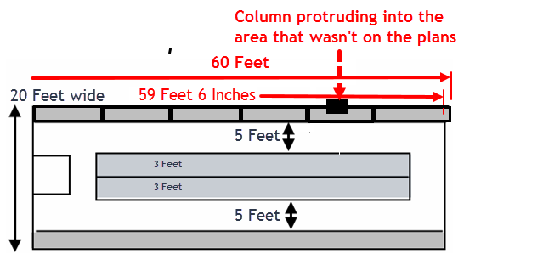

END

Tenant Improvements (TI’s)

Q1.
What are leasehold improvements?

Also called “Tenant Improvements (TI’s) or “Buildouts”

Your Answer
Leasehold Improvements or Tenant Improvements (TI’s) relate to changes to the interior space in order to customize it for the particular needs of a tenant. This can include interiors walls, offices, painting, installing partitions, changing the flooring or adding customized light fixtures based on the needs of the tenant. Normally furniture and fixtures would not be included as leasehold improvements.
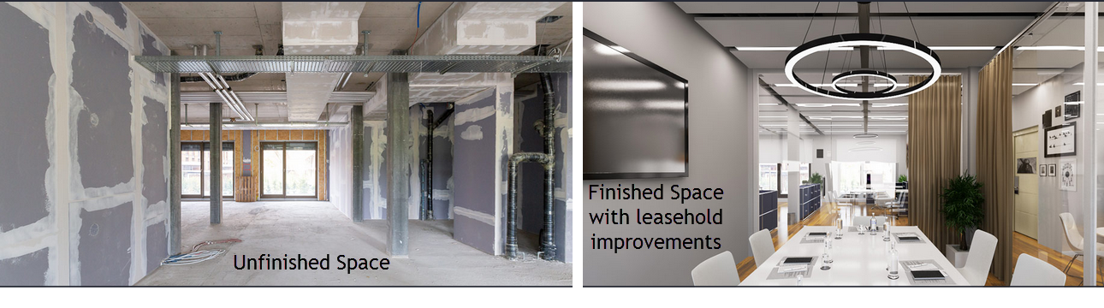

Q2.
Who builds the “Leasehold Improvements”?
Your Answer
Who builds the “Leasehold Improvements”?

The leasehold improvements can be completed by either the landlord or the tenant.

If the landlord builds the leasehold improvements the tenant will likely provide a detailed set of specifications, often prepared by an architect or designer, detailing the quality of the materials, finishing’s and fixtures to be used which is approved by the landlord.

If the tenant is providing all or some of the leasehold improvements the landlord will provide a set of specifications and standards and the tenant will agree to abide by the specifications.

In new shopping centers the landlord provides a comprehensive set of specifications consisting of hundreds of pages of detailed specifications and standards.

The various City departments such as the building, fire and safety departments will have to improve the leasehold improvements and will inspect the work before issuing an occupancy permit.

Q3.
What are leasehold specifications and plans?
Your Answer
Leasehold specifications are documents and specify in great detail the scope of the work, type of and quality of materials to be used such as carpets and underlay, tiles, paint, doors, HVAC interior distribution ducting and vents providing installation details and required workmanship etc. It will also specify and describe the type of equipment such as lighting fixtures, fans, fire alarm systems to be installed etc.

The specifications are often utilized in conjunction with leasehold improvement construction plans showing the space plans and layout.

Leasehold specifications are generally developed by architects, engineers and designers for either the landlord or the tenant and can consist of hundreds of pages.

Lawyers prepare the legal agreement for the leasehold improvements.

Q4
Why are “Leasehold Improvements” specifications and plans so important?
Your Answer

It’s very important for the tenant and the landlord to develop detailed specifications to avoid potential misunderstandings.

As an example, the landlord uses cheap carpet underlay which is uncomfortable to walk on which upsets the tenant. This problem would have been avoided if the quality of underfelt and method of installation was specified in the leasehold specification document.

Q5
Who pays for the “Leasehold Improvements”?

Your Answer
Leasehold improvement may be paid by the landlord or the tenant or they may share the cost of the leasehold improvements.

A common approach is that the landlord provides a “Leasehold Allowance”.

As an example $352,000. This amount is decided upon during lease negotiations.

In this case if the leasehold improvements cost more than $352,000 the tenant pays the difference.

Generally the tenant funds the leasehold improvements and the landlord reimburses the tenant once the leasehold improvements are complete.

Q6.
What is a “Shell Lease”?
Your Answer
A lease where the landlord provides the absolute minimum. Concrete floor, roof and outer wall. Utilities such as electric power, water and the HVAC system are brought to the premises but not into the tenant’s space.

Tenant is responsible for finishing the space and the leasehold improvements according to the landlord’s comprehensive and detailed set of specifications.

Sell leases are most often used by landlords of new shopping malls.

Q7.
What is a “Turnkey” lease?
Your Answer
The landlord provides all the leasehold improvements ready for the tenant to move in based on the agreed upon specifications.

It’s the opposite of a “Shell Lease”.

Q8.
What’s a Shell Lease with an allowance. Landlord builds?
Your Answer
The landlord builds the leasehold improvements based upon the agreed specifications.

The landlord will specify the costs. If the costs are exceeded the tenant pays the difference.

Example.
The leasehold allowance $350,000.

If the leasehold improvements come to $400,000 the tenant pays the cost overrun of $50,000 ($400,000 - $350,000)

Q9.
What’s a Shell Lease with an allowance. Tenant builds?
Your Answer
The tenant builds the leasehold improvements based on the agreed upon specifications and the landlord provides the tenant with a leasehold improvement allowance.

Example
The tenant carries out the leasehold improvements and the landlord provides $250,000 leasehold improvement allowance.

Q10.
Why is it important to have the landlord quote the leasehold improvement allowance as a dollar amount rather than a $ per Sq. Ft? E.g. $300,000 versus $150 per Sq. Ft
Your Answer
Using a $ per Sq. Ft requires defining the space and how the space will be measured. This can create the potential for misunderstanding between the landlord and tenant which can be avoided if the leasehold improvement allowance is quoted as an amount rather than a $ per sq. Ft.

Example: Leasehold Improvement allowance
$300,000
$150 per Sq. Ft

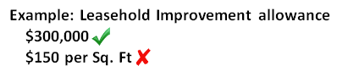

Q11.
What is a “Build to Suit” single tenancy building?
Your Answer
The landlord builds a building based on the tenant’s requirements.

Very common for industrial buildings as well as retail, restaurants where the tenants have very specific requirements in terms of layout, shape ,size, ceiling heights, relationship between office and warehouse space, parking requirements and want to create a certain image. Tenants such as Amazon, Walmart, Target, Sony etc. often enter into build to suit arrangements.

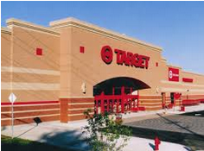

Q12.
With leasehold improvements being provided by the landlord or build to suit arrangements what do you think are the two major problems that need to be dealt with in the lease?
Your Answer
- Cost overruns
- Failing to meet the agreed upon completion and occupancy date.

Both of these issues need to be covered in the lease with a penalty clause for falling to meet the completion and occupancy date.

Q13.
The landlord agrees to build $400,000 worth of leasehold improvements based on the agreed upon detailed specifications prepared by the tenant’s engineers and architects.

During the construction the tenant decides to upgrade the carpets, add more costly lighting fixtures and two more offices adding $320,000 of additional costs.

How does the landlord get reimbursed for the additional leasehold improvement costs of $320,000?
Your Answer
There are several ways that the additional leasehold improvement costs can be recovered.
- The tenant pays the landlord $320,000 once the work is completed and accepted
- Instead of paying the landlord $320,000 the rent over the first term is increased to offset the cost overrun
- The landlord creates a loan to the tenant for the $320,000

Q14
What is “Force Majeure”?
Your Answer
Force Majeure is a provision found in leases that frees both parties from certain obligations if an extraordinary, unforeseeable or unavoidable event occurs that delays or prevents the obligation from being completed. Sometimes considered an act of god.

As an example, the landlord cannot get the space ready for occupancy by the agreed upon date because of a strike, or an earthquake, arson or an explosion in an adjacent building.

In this case, the landlord would not be subject to the tenant costs or a penalty clause because the tenant can’t move into the space on the agreed upon date.

END

Missing the occupancy date

Q1.
When leasing space from plans or in a partially constructed building the completion and occupancy date is not known for certain.

Can you come up with some examples of when a missed occupancy date would be very costly for the tenant in terms of lost revenue?

In other words, if the space is not ready to move in by the date specified in the lease the tenant would lose a lot of sales revenue
Your Answer
Any business that is seasonal particularly retail businesses.

Example No. 1
A retailer has rented space in a new retail center which is supposed to be ready by the end of November. The occupancy date specified in the lease was October 1. This date allowed the retailer to carryout leasehold improvements, fit out and stock the store, select and train staff ready for the Xmas rush.

Because of construction delays the occupancy permit wasn’t issued until December 3. This would be a financial disaster for the retailer as 65% of the retailer’s sales are done over the Xmas period.

Example No. 2 An accounting firm needs to move in to their new premises by February 1 in order to be ready for the busy tax season.

A well written lease will deal with these potential issues and the legal remedies.

Q2.
A tenant is moving into a new facility on July 1. The lease specified that the space would be ready June 1. The following has taken place

- The tenant has given notice to their landlord and has to move out by June 30.
- The landlord has rented the space commencing July 1

What happens if the new space is not available July 1?
Your Answer

This is a nightmare of the tenant, the landlord and the tenant moving into tenant’s old space.

What might happen?

The tenant may have to move into temporary premises which is very costly and disrupts the tenant’s business.

The tenant may “overhold” preventing the landlord’s new tenant from moving into the space

A well written lease will have contemplated these scenarios and built the legal remedies into the lease.
______________________________________________________________________
END

Operating and Recoverable Expenses

Q1.
If a lease uses the term “Recoverable Expenses” what are Recoverable Expenses?
Your Answer
Recoverable expenses are the operating expenses that a landlord can recover from the tenants such as taxes, insurance and maintenance (TIM’s) as spelled out in the lease.

Q2.
Which of the following would not be considered an operating expense and a recoverable expense?

Property taxes
Replacement of the boiler
Insurance
Cleaning services
Major upgrade to the elevator
Fee for leasing vacant space

Circle Your Answers
Your Answer

Operating expenses are expenses that occur on a regular basis, year after year such as taxes, insurance and maintenance.

Expenditures such as replacing the boiler are considered capital expenditures and provide benefits greater than one year.

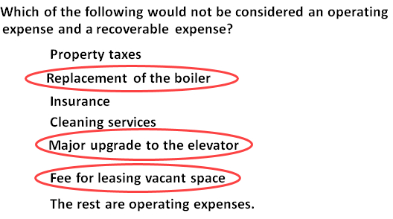

Q3.
What other names are used for “Recoverable Expenses”
Your Answer
Additional rent
Recoverable expenses can also be called:
TIM’s (taxes, Insurance and Maintenance) or TMI’s
Reimbursable expenses
Pass-throughs
CAM’s Common area maintenance

Q4.
A lease will often state the tenant is not responsible for structural repairs.
Write down two examples of structural repairs.
Your Answer
Examples of structural repairs are:

Repairs to columns and trusses
Major repairs or replacement of the roof

Q5.
What does “Grossing Up” of operating expenses mean?

Your Answer
Certain operating costs are variable such as janitorial costs, garbage collection, and utility cost that vary depending on the vacant space occupancy level.

The “gross up provision” stipulates that if a building has vacancies, the landlord can estimate what the variable operating expense would have been had the building been fully occupied, and charge the tenants their pro-rata share of that cost.

Q6.
Who pays the operating expenses on the vacant space?
Your Answer
From time to time the vacant space in the building fluctuates.

The question is “who pays for the operating costs associated with the vacant space? The landlord or the tenants or some shared arrangement?” The Grossing Up of Expenses allows the landlord to pass the variable operating costs associated with vacant space onto the tenants.

One approach is for the landlord to Gross Up the Expenses to reflect what the operating cost would be if the building is considered fully rented when 95% rented and then charging the tenants based on the estimated operating cost when 95% rented.

Grossing Up of Operating expenses is very common in office buildings.

Q7.
How does a lease handle the recoverable operating cost that is caused by a particular tenant who is receiving a specific benefit?
Provide an example.
Your Answer
The landlords can include in the lease that a tenant is responsible for costs that are created by a specific tenant or that the landlord reserves the right to allocate operating costs differently to the tenant’s pro-rata share of the total rentable area.

Example.
Ground level retail in a small mall with 6 retail tenants plus a Hot Yoga health studio.
Hot Yoga center. Installs 6 showers, two steam generators and installs 26 water fountains.
This increases the water costs for the building by 150%.

In this case the landlord would charge the Hot Yoga Studio for additional water costs beyond the normal use by the other tenants.

END

Renovating and Subdividing Space

Q1.
Vertical loads in a building can be broken down in two types of loads.
What are the names of the two types of vertical loads and provide an example of each?
Your Answer

- Dead loads. Example furniture, filing cabinets, the weight of the structure such as the roof and floor slabs. Dead loads are loads on the building structure that don’t move.

- Live loads. People, forklift trucks in a warehouse, rain on the roof. Live loads are loads that move and change.
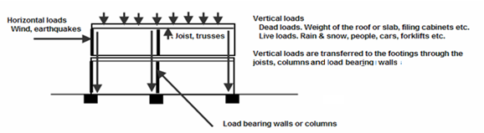

Q2.
Provide two examples of “Horizontal Loads” that can impact a building
Your Answer

- Wind blowing on a building

- Earthquakes

Q3.
What’s the purpose of the shear system in a building?
Give two examples of a “shear System” in a building
Your Answer
The shear system stabilizes the building and prevents it from being pushed over.

Give two examples of a “shear System” in a building
- Elevator shaft and concrete stairwell
- Cross bracing. See image below.

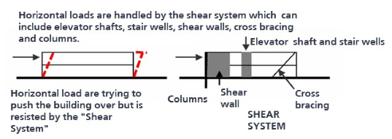

Q4.
Why should you never make statement that a wall can be removed even if the wall appears to be a non-load bearing wall?
Your Answer
A wall that appears to non-loading bearing can still be part of the shear system that stabilizes the building from wanting to tilt sideways during heavy winds and rain.

Removing a shear wall could influence the structural integrity of the building.

A structural engineer likely needs to be engaged to determine if the wall can be safely removed.

Q5.
If you are considering subdividing space why should you recommend to the landlord to check with an architect or the city before subdividing the space?
Your Answer
There are a lot of city regulations and by laws related to subdividing space. Subdividing space requires approval by the City.

Subdividing space can be complex in terms of meeting the various building codes and fire codes and should be done by an architect and perhaps involve professional engineers if walls are being removed or there are modifications to the HVAC system needed.

As an example the fire codes have a lot of regulations related to subdividing space such as:

- Space over a certain size must have two means of existing from the space

- The exiting doors must be within a specified minimum distance from the stairwells
.
END

Lease Comparison Analysis

Q1.
When carrying out lease comparison analysis why do we use discounted cash flow analysis and calculate the Net Present Value of the lease and the Net Effective Rent?
Your Answer
Lease proposals often involve different lease payments which vary over time resulting in different cash flows. To take into account the Time Value of Money when carrying out lease comparison analysis we use discounted cash flow analysis and calculate the Net Present Value (NPV) and Net Effective Rent (NER).

The next flash card shows an example of lease comparison analysis.

Q2.
A landlord has 10,000 Sq. Ft for rent and has received the following offers from Tenant A and Tenant B. Which one is the best deal based on the Net Effective Rent (NER) at 10%?

Tenant A. $20 per Sq. Ft per year for five years with free rent for the first five months of year 1. Tenant A has made this proposal because they want to reduce their expenses in the first year because it is a start-up business.

Tenant B. $20 per Sq. Ft per year for five years with one month of free rent every year for five years.

In both cases the tenant will pay the additional rent to cover the taxes, insurance and maintenance (TIM’s).

Your Answer
The following compares the cash flow the landlord will receive and the Net Effective Rent at 10%
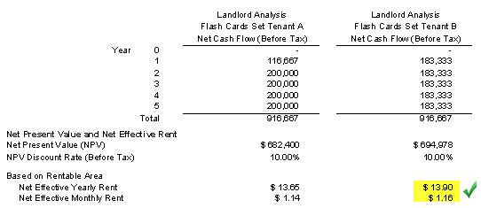

The best deal for the landlord is Tenant B’s proposal which has a Net Effective Rent at 10% of $13.90 per Sq. Ft per year compared to $13.65 per Sq. Ft per year for Tenant A even though the total amount received over the five years of $916,667 is the same for both proposals

Q3.
When comparing leases using the discounted cash flow approach why can’t you calculate the Internal Rate of Return (IRR)?
Your Answer
To calculate an Internal Rate of Return (IRR) an initial investment is required. Generally there are no significant investments for a lease except perhaps some lease hold improvements.

If there is no significant investment involved you cannot calculate the Internal Rate of Return (IRR)

If there is are major expenditures on leasehold improvement it might be possible to calculate the Internal Rate of Return (IRR)

Instead of the using the Internal Rate of Return (IRR) you use the Net Present Value and the Net Effective Rent (NER) when carrying out lease analysis.

Q4.

When carrying out lease comparison analysis why is important to compare the leases over the same time period?
Your Answer
As an example, a landlord has received a lease proposal from Tenant A for 5 years at $20 per Sq. Ft per Yr. and another from Tenant B for 7 years at $18 per Sq. Ft per Yr and wants to decide which is the best deal. Tenant B’s proposal includes an option to renew at the end of the first five years based on the change in a specified Consumer Price Index (CPI).

To compare these two leases requires that the annual lease payments for the 5 year lease proposal be projected to seven years in order to compare it with Tenant’s B’s 7 year lease proposal.

To do this you have to make assumptions as to what the lease rate will be when tenant’s A lease is renewed at the end of the five years based on your estimate of the increase in the specified Consumer Price Index (CPI).

Q5.
Calculate the Effective Rent (NER) using:

Net Present Value at 10%: $4,500,000
Rentable Area: 20,000 Sq. Ft
Lease period: 10 years
Your Answer
Net Present Value at 10%: $4,500,000
Rentable Area: 20,000 Sq. Ft
Lease period: 10 years

Net Effective Rent (NER) = Net Present Value at 10%
Area x No. of Years

= $4,500,000
$20,000 x 10 years

= $22.50 per Sq. Ft per Yr at 10%

Q6.
Is the Net Effective Rent (NER) helpful when analyzing a single lease or only useful when comparing two or more lease proposals from either a landlord or tenant perspective?
Your Answer

The Your Answer depends on several factors.

- Generally the Net Effective Rent is used to compare several lease proposals. Effective Rent. If you are told that the Net Effective Rent is $24 at 10% it is meaningless unless there is something to measure it against.

- Large landlords and REIT’s can provide you with the discount rate that they use to calculate the Net Effective Rent such as 9% and can tell you their desired Net Effective Rent for the space. As an example, we need a minimum Net Effective Rent of $19 per Sq. Ft per Year using a discount rate of 9.00%

Q7
When comparing leases using the Net Present Value (NPV) and the Net Effective Rent (NER) how important is the selection of the “Discount Rate”?
Your Answer
You can use any discount rate like 7% or 10% because you are using the discount rate to level the playing field when there are two or more lease proposals with different cash flows being compared.

Q8.
You are considering renting space in an office building and there are two buildings with space available in the location you desire. The rent rates are:

Space A. Usable area: 1,500 Sq. Ft. Base Rent Rate: $25 per Sq. Ft per Yr of rentable area
Space B. Usable area: 1,500 Sq. Ft. Base Rent Rate: $27 per Sq. Ft per Yr of rentable area

Why is it incorrect to select Space A as the best deal because it has the lowest rent?
Your Answer

It’s incorrect to choose to rent based simply on the first year base rent rate as there are a lot of factors beyond the rent rate to consider such as different “Gross Up factors”, differences in the “Additional Rent” and parking expenses as illustrated below.
Example
 | Space A | Space B
Rent Rate using Rentable Area | $25 per Sq. Ft per Yr | $27 per Sq. Ft per Yr
Usable Area | 1,500 Sq. Ft | 1,500 Sq. Ft
Add on Factors Gross Up factor | 16% | 13%
Rentable Area | 1,740 Sq. Ft | 1,695 Sq. Ft
Term | Five years | Five years
Additional Rent | $9.00 per Sq. Ft per Yr | $6.00 per Sq. Ft per Yr
Parking. Seven cars | $75 per month per space | Free

To correctly compare these two leases from the tenant’s perspective you need to:
- Calculate the total annual leasing expenses for each of the five years
- Calculate and compare the Net Present Value and the Net Effective Rent over the five years
- See next flash card for results

Q9.
A tenant is considering two spaces for renting two different buildings. Which space is the best deal from the Tenant’s perspective?
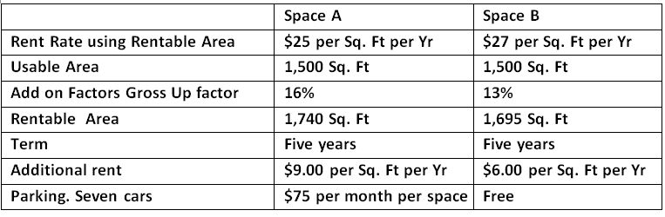

Your Answer
Even though the rent for Space A is $25 per sq. Ft per Yr which is less than Space B at $27 per Sq. Ft per Yr. Space B is the best deal when all the factors such as the Gross Up factors, differences in the “Additional Rent” and parking expenses are taken into account over the five years.

The Net Effective Rent (NER) at 10% is for Space A is $27.97 and $25.02 for Space B. From a financial viewpoint Space B with the higher base rent of $27 per Sq. Ft per Yr. compared to $25 for Space A is the best deal.

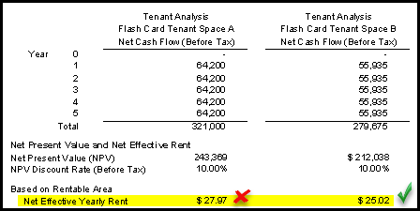

Q10

What information do you need to calculate the Net Effective Rent (NER) from a landlord and tenant perspective?
Your Answer

You need to develop the total yearly cash flow over the lease term to calculate the Net Present Value (NPV) and the Net Effective Rent (NER) from a landlord or tenant perspective using:
- Rentable area
- Lease term in years
- Discount rate to be used to calculate the Net Effective Rent
For each year calculate the cash flow taking into account:
- Tenant inducements such as free rent, leasehold improvements and other financial incentives
- Rent paid each year
- Additional rent (TIM’s)

Calculate the Net Present Value

The calculations will depend on whether you’re analyzing from the landlord or tenant’s perspective

Net Effective Rent (NER) = Net Present Value at “X”%
Area x No. of Years

END

Lease Negotiations. Landlord and Tenant trade offs

Q1.
When negotiating a lease there are a number of trade-offs that can be made between the landlord and tenant.

List as many of the trade-offs as you can.
Your Answer
Some of the many trade-offs that can be made between the landlord and the tenant when negotiating a lease.

Base Rent and the timing of future rent escalations
How future rent escalations and renewal rates are determined
Payment of “Recoverable Expenses”. What expenses are included and what are excluded
Free Rent periods and the timing of the free rent
Leasehold improvements funded by the landlord
Leasehold improvement loan from the landlord to the tenant
Cash payments from the landlord to the tenant for moving costs etc.
Cost of parking including free parking
Lease term

Q2.
Provide a simple example of a trade-off that can be made between the landlord and the tenant so that the Net Effective Rent (NER) remains the same.
Your Answer
Landlord charges a higher Base Rent but provides very generous tenant inducements such as free rent periods and provides free leasehold improvements in a way that maintains the same Net Effective Rent for the tenant.

Q3.
List two of the primary goals of the landlord when negotiating a lease.
Your Answer
- High Lease Rate

The landlord’s primary goal is to have the lease rate (called the face rate) as high as possible because the lease rate is a major factor in determining the property value. The face lease rate is what an appraiser will focus on when determining the value. The fact that the landlord gave free rent and other tenant inducements will not be taken into account when the appraiser determines the property value.

- Reliable Tenant
Losing a tenant is very costly. There is lost rent and additional rent, legal fees and leasing commissions to be paid when the space is re-rented as well as the costs of tenant inducements such as free rent periods, contributions to the tenant’s leasehold improvements etc.

Q4.
Why is maintaining the rent as high as possible so important to the Landlord?

If the landlord can increase from $21 to $23 per Sq. Ft per Yr how much will the value increase if the Cap Rate is 5.00% and the rentable area is 25,000 Sq. Ft?
Your Answer
Because the lease rate is one of the main factors in determining the property value.

Value at $21 per Sq. Ft per Yr 25,000 Sq. Ft x $21 per Sq. Ft Per Yr = $10,500,000
5.00% Cap Rate

Value at $23 per Sq. Ft per Yr 25,000 Sq. Ft x $23 per Sq. Ft Per Yr = $11,500,000
5.00% Cap Rate

Increasing the rent from $21 to $23 per Sq. Ft per Yr increases the value by $1,000,000

A small increase in rents creates a large increase in value. This is why landlords negotiate hard and offer generous free rent and other tenant inducements to keep the rent as high as possible.

END

Valuing a Land Lease

Q1.
Question
What is a ground Lease and provide an example?
Your Answer
A ground lease is a legal arrangement in which the land is leased to a developer who builds and owns the building.

When the land lease expires the land owner obtains ownership of the building.

Q2.
With a ground lease does the building developer end up owning the land at the end of the land lease?

Yes or No
Circle Your Answer
Your Answer
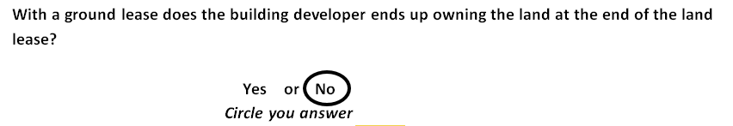
When the ground lease expires the building becomes the property of the land owner

Q3.
Can a ground or land leases be bought and sold?
Your Answer
Yes ground land leases can be bought and sold. The buyer is buying a cash flow until the land lease ends.

The next Flash Card shows an example on how to value a ground or land lease.

Q4.
How do you go about valuing a ground or land lease?
Your Answer
Both the Cap Rate and the Net Present Value (NPV) can be used to determine the value of a land lease.

The Net Present Value (NPV) is the better approach because it takes into account uneven cash flows and the impact of the time value of money on the value of the land lease.

Q5.
Example. Calculating the value of a ground or land lease

An investor is considering buying a land lease and wants a 10% return.

The land lease is $200,000 per year for 75 years. The yearly lease payments are made at the beginning of each year.

How much should the investor pay for the land lease?
Your Answer
The Net Present Value (NPV) $200,000 per year for 75 years at 10% discount rate is $2,198,270 with the annuals lease payment being made at the beginning of the year.

The value of the ground lease at 10% is $2,198,270

If an investor bought the ground lease for $2,198,270 the return (IRR) would be 10%

END

Blending & Extending a Lease

Q1.
Explain “Blending & Extending” a lease
Your Answer
Blending and Extending a lease tends to happen when times are tough or circumstances change. It’s an adjustment to the lease because of market changes and can benefit both the landlord and the tenant.

The tenant is facing declining revenue and perhaps experiencing losses and the landlord doesn’t want to lose the tenant and the tenant doesn’t want to move. In addition there is a lot of vacant space in the area and market lease rates have experienced major decline.

Blending and extending a lease is an agreement between the landlord and the tenant to renegotiate the lease and involves:
- Lowering the lease rate E.g. For $25 per Sq. Ft per Yr to $21
- Extending the term of the lease E.g. The remaining terms of 2 year and 3 months is extended to 5 years

Q2.
Provide an example of blending and extending a lease.
Your Answer
Times are tough. A serious recession has occurred and the tenant’s sales have dropped dramatically. The tenant is struggling to make the monthly rent payment but doesn’t want move. They have been in the space for a long time and have a good relationship with the landlord. The landlord doesn’t want to lose this good tenant and knows that if the space becomes vacant it could take a long time to re-rent.
The tenant has been paying $28 a Sq. Ft per Yr to lease space. There is two years left on the lease, but over time the average effective market rate for that area has dropped to $20 a square foot.
The landlord and tenant renegotiate the lease early. The tenant commits to an additional five more years and the lease rate is reduced from $28 per Sq. Ft per Yr to $20 per Sq. Ft per Yr. and the term is extended for five years.

Used during tough economic times for the landlord and the tenant.

END

Buy versus Leases Analysis

Q1
What are “Mutually Exclusive Investments”
Your Answer
Mutually exclusive investments are investment where the investor has several options and can only choose one of the options.

I can buy a house or I can rent a house, but I can’t do both.

Examples of mutually exclusive investments.

Buy versus leasing commercial space
Buy versus renting a home.
Hold versus Selling a building

Q2.
How do you carry out “Buy versus Lease Analysis”?
Your Answer
To carry out “Buy versus Lease Analysis:

- Develop the “Net cash flow” for the “Buy” option (After tax)

- Develop the “Net cash flow” for the “Lease” Option (After tax)

- Calculate “Net Cash Flow Buy – Net Cash Flow Lease” (After tax)

- Calculate the Internal Rate of Return (IRR) and Net Present Value (NPV) after tax

- Is the Return on Investment (IRR) of buying compared to leasing acceptable? If not consider leasing.

This is called the “Differential” or ‘Incremental Cash Flow” analysis and is a very important concept for analyzing mutually exclusive investments such as “Buy versus Lease”

Q3.
Why should Buy versus Lease analysis be done after tax?
Your Answer

Buy versus Lease analysis should always be done after tax because the tax calculations for “Buy” are different from “Lease”

BUY. Tax implications
Acquisition. The purchase price is broken down into “Land” and “Improvements” The improvements are generally expensed through depreciation claims.
Operating Expenses are expensed in the year that they occur.
Financing costs. Interest expenses are expensed. Principle payments aren’t expensed.
Sale. A sale creates a Capital Gains tax and possibly a Depreciation Recapture tax.

LEASE. Tax implications
Lease payments are expensed.
Leasehold Improvements are generally amortized of the term of the lease.

Q4.
Show me an example of “Buy versus Lease Analysis”
Flip Side
Take the after tax Cash Flow of buying subtract the after tax cash flow of leasing to get the differential cash flow of Buy versus Lease. Calculate the “Buy versus Lease” Internal Rate of Return (IRR) and Net Present Value using the investor’s discount rate.

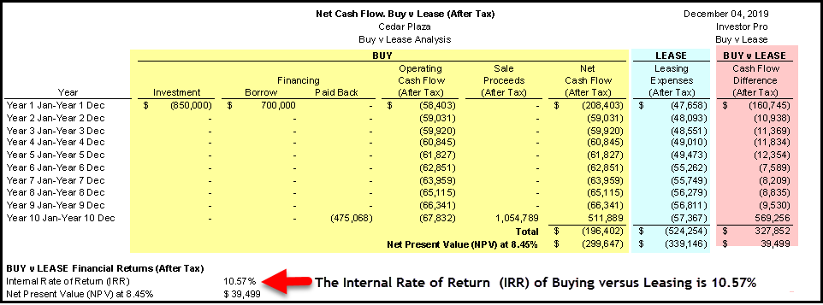

Q5.
How is the “Return on Investment (IRR)” or the “Discount Rate” determined when carrying out Buy versus Lease analysis?
Your Answer

In order to consider Buy versus Leasing the company has to have enough capital for the down payment of the property. If they don’t have sufficient funds they won’t be able to purchase a property and their only option is to lease or continue to lease.

Example. A company is leasing space and the lease is about to be renewed and they have $900,000 cash to use to purchase a property worth $2,000,000 using a $1,100,000 mortgage and $900,000 equity.

The question is what is an acceptable Return on Investment (IRR) to use when carrying out buy versus lease analysis.

It depend on how else can they use the $900,000 cash. Some options are:
Investit in the stock market. Assume they can make 3.5% after tax
Use the $900,000 to expand their business. Expected return 7.00% after tax

In this case if the Buy versus Lease analysis indicated a return of higher than 7.00% they should consider buying instead of leasing. If not, they should consider leasing.

Q6.
How do you evaluate the Return on Investment of buy versus lease using the Internal Rate of Return (IRR) and Net Present Value (NPV)?
Your Answer
An engineering firm is considering buying property instead of leasing space and would purchase a building instead of leasing if the Internal Rate of Return after taxes was 8% or higher.

In other words their discount rate is 8.00% after taxes.

Results of the Buy versus Lease after tax analysis
Internal Rate of Return (IRR): 12%. Consider buying instead of leasing
Internal Rate of Return (IRR): 7%. Consider leasing instead of buying

Net Present Value (NPV) at 8.00% Positive. Consider buying instead of leasing
Net Present Value (NPV) at 8.00% Negative. Consider leasing instead of buying

Q7.
What’s the Buy versus Lease crossover graph?
Flip Side
Shows the cut-off point between buying and leasing.

As an example, if the company can invest their money at more than 10.40% they should consider leasing. If not, they should consider buying.
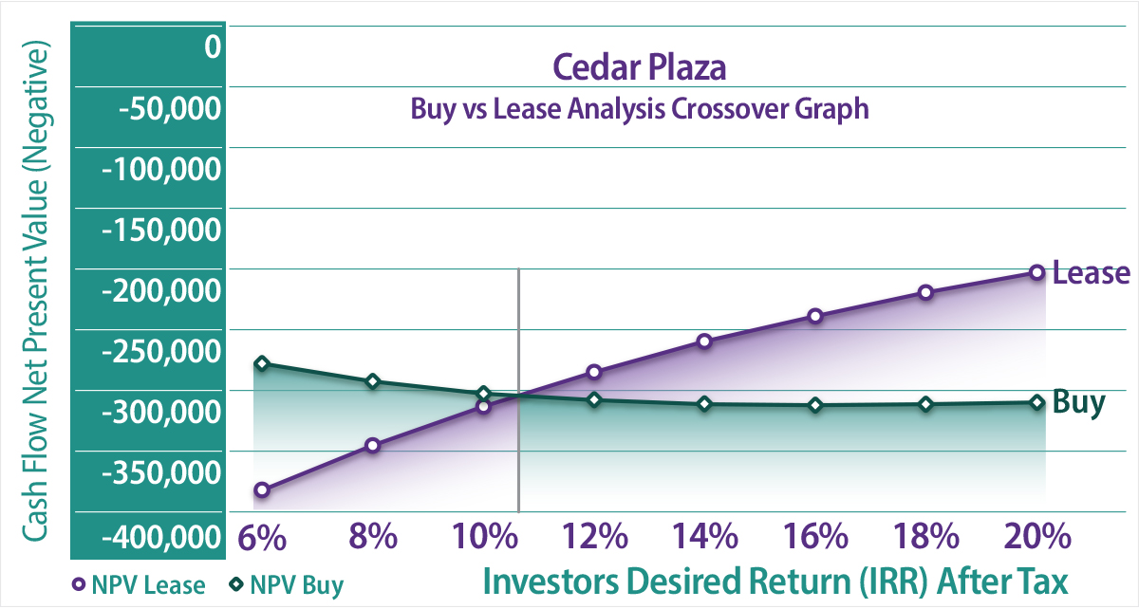

Q8.
How do I interpret the Buy versus Lease crossover graph?
Flip Side
The trick to reading the crossover graph is to recognize that the vertical axis shows the negative Net Present Value for “Buy” and for “Lease” because the cash flows for buying and for leasing are both negative.
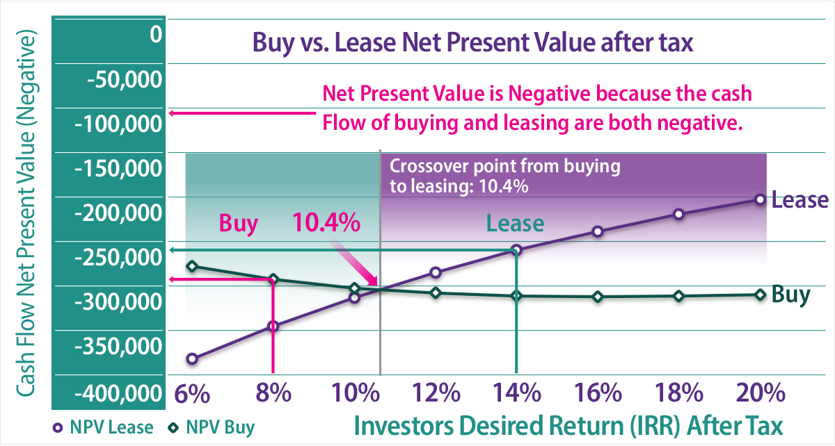

Q9.
A retailer is considering buying a property instead of renewing the lease. His “Desired Return (IRR)” is 12% after tax. If he can’t get at least an 12% after tax he feels he would be better off using the money to expand his business.

A consultant developed the ‘Buy versus Lease Crossover graph. Should he buy or lease?

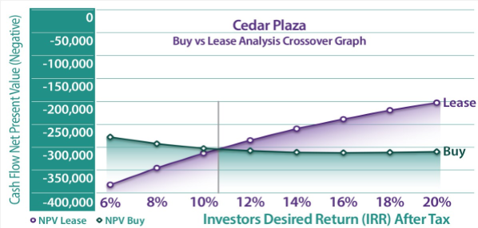
Your Answer
He should continue to lease and use his funds to expand his business where he can earn 13% after tax instead of buying a building.
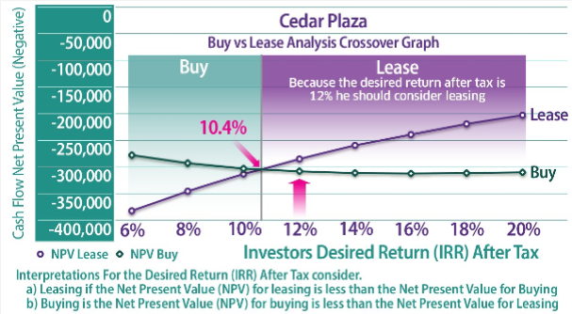

Q10.
The incorrect way to analyze whether to buy or rent a home or commercial building.
Flip Side
A common but incorrect approach is to look at the home as an investment and calculate the Return on Investment (IRR) of owning a home and decide if the return is acceptable.

This approach is completely wrong because it is ignoring the savings in the rent payments.

This is a case study summary of comparing the financial results of treating the home as an investment compared to carrying out buy versus lease analysis.

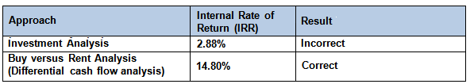

END

Tips for reading a lease

Q1.
Why is it so important to read a lease very carefully?
Your Answer
The lease governs the contractual relationship between landlord and the tenant.
The lease has a major impact on the value of the property.
Very important clauses are often buried in the middle of the lease where the reader is skimming through quickly and not paying attention, missing really important clauses.
Every lease is different because the lease is the result of the negotiations between the landlord and the tenant and the crafting of the lease by the lawyer.

Q2.
How do you determine what expenses are paid by the landlord, and by the tenant?
Your Answer
Be careful of the term Triple Net (NNN) it can highly ambiguous and misleading.

READ THE LEASE which will define who pays what.

Every lease is different because the lease is the result of the negotiations between the landlord and the tenant.

Q3.
What is a Demolition Clause?
Your Answer
A Demolition Clause is the landlord’s right to terminate the tenancy on the issuance of a rezoning, development or building permit from the City.

Tenants don’t like Demolition Clauses because it is very costly to move to another space and disrupts the tenant’s business.

On the other hand if a developer is buying an old tenanted building to demolish and build a new building they need to check to see if there is a demolition clause otherwise they may have to wait until all the leases expire before the building can be demolished.

Q4.

Tips for reading a lease

Flip Side

Read the lease several times. Leases are complex legal documents and need to be read carefully.

Ask a question and go looking for your answer in the lease. Read with a purpose. Have a question in mind.

Examples

Is there a “Demolition Clause?

When is the next rent increase and how is it calculated?

What operating expenses does the tenant pay?

ETC.

Q5.

How are the renewal rates in a lease determined?

Also called “Rent Steps” or “Rent bumps”

Your Answer

The lease will specify the date of the rent increase and how the new rent will be determined?

There are a variety of ways to specify how the rent will increase.

Examples

The lease may specify the new rate. The rent increases to $27 per Sq. Ft April 1 2021

The renewal rate will be based on market rents at the time of renewal

Based on the change in the specified Consumer Price Index (CPI)

Escalating or indexed lease.

The lease increases every year by 3% or the lease increases every year based on the change in the specified Consumer Price Index (CPI)

END

Demolition Clauses

Q1.
What is a “Demolition Clause?”
Your Answer
A “Demolition Clause” is a clause in the commercial lease that allows a landlord to terminate a tenancy upon receiving a specified approval from the city to demolish the building and construct a new building.

The demolition clause will specify the specific approval that will allow the landlord to terminate the lease such as a demolition permit, development or building permit or rezoning permit.

Q2.
Why would a landlord include a “Demolition Clause” in a lease?
Your Answer
If the landlord owns an aging building and the site is ripe for redevelopment the landlord will include a demolition clause which allows the landlord terminate of the lease. Once the tenants have vacated their space the building can be demolished.

Without a demolition clause in the lease the landlord has to wait until all the leases expire which could take a number of years. The other option is that the landlord could buy out the existing leases but that could be a very expensive proposition and some tenants may not agree to a buyout delaying the redevelopment of the site.

Q3.
From the landlord’s perspective what is the disadvantage of a “Demolition Clause” in the lease?
Your Answer
Demolition clauses often make it more difficult to rent space.

Tenants do not like demolition clauses because of the uncertainty as to when they may be forced to vacate. For many tenants such restaurant owners, night clubs or any venture that requires a large capital expenditure the organization needs a long term lease and won’t rent space if the landlord wants a demolition clause in the lease.

Starbucks had a very popular location for many years frequented by tourists and locals. When the lease came up for renewal Starbucks vacated the premises because the landlord insisted on a demolition clause in the new lease.

Q4.
What types of properties often have a “Demolition Clause” in all the leases in the building?
Your Answers
Generally old, obsolete buildings where the site is ripe for redevelopment such as the one below.
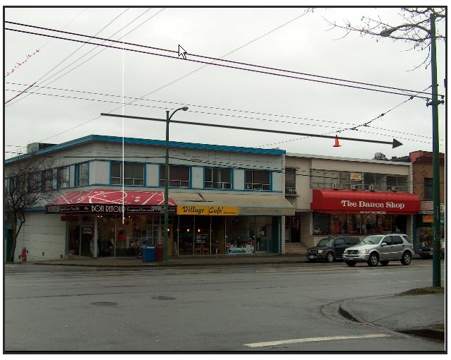
These two buildings are tear downs and would be replaced by a high rise mixed use building consisting of street level retail space and office space or condominiums. The landlord would insist on a demolition clause in the leases.

The other option is that the tenants are on a month to month lease and can be terminated on one months’ notice.

Q5.
If a landlord insists on a demolition clause and the tenant really wants to rent the space because of its location how can you modify the demolition clause so that it helps the tenant financially?
Your Answers
One approach is that the landlord pays the tenant’s estimated cost associated with relocating to new premises.

Examples
- If the landlord executes the demolition clause the landlord has to pay the tenant $100,000
- Negotiate a requirement for a long notice period such as 6 months
- Introducing a blackout period ensures that the landlord cannot exercise its redevelopment right until a certain amount of time has passed – often, this can be as much as ten years.

Q6.
If an investor or developer is looking at buying an older building which has 5 tenancies what’s one of the first things the investor should look for in the lease?
Your Answers
That all 5 leases have a demolition clause that allows the owner to terminate the leases when the site is redeveloped or that the tenancies are in month to month leases.

Q7.
Does a demolition clause affect the value of older commercial properties and make it easier or harder to sell?
Your Answers
Older buildings often have the potential to be rezoned and developed to a higher and better use.

When an investor or developer is looking and buying an older building they will check the leases for a demolition clause.

If the leases are long and there are no demolitions clauses they won’t buy the building.

The lack of a demolition clause reduces the number of buyers and the property value and makes it harder to sell the property.

___________________________________________________
END

