Raising Your Commercial IQ
______________________________________________________________________________________________________________________________

102. Real Estate Investment Analysis

______________________________________________________________________________________________________________________________

Neil Osborne M.B.A.
DL. (604) 988-9964
nosborne@investitsoftware.com
Investit Software Inc.
Toll-free 877-878-1828
North Vancouver BC
Canada
www.investitacademy.com
investit@investitsoftware.com
www.investitpro.com
N Osborne Copyright
All rights reserved
Table of Contents

Objectives 3
Valuing commercial properties 4
Apparent Cap Rate versus the True Cap Rate 4
Factors that distort the Cap Rate. Examples 4
Long Term Real Estate Investment Analysis Introduction 7
Choosing between two investments 7
Calculating the Net Cash Flows before Tax 8
Financial Returns that incorporate the Time Value of Money 10
The Internal Rate of Return (IRR) 10
Relationship between the Internal Rate of Return (IRR) and Compound Interest 12
Why we use the Internal Rate of Return (IRR) 12
Financial Calculators 13
Net Present Value (NPV) 13
Determining the Discount Rate or Desired Return (IRR) 14
Modified Internal Rate of Return (MIRR) 15
The building blocks of Real Estate Investment Analysis 16
Real Estate Investment Analysis. Case Study 17
Common real estate investment analysis reports 19
Goal Seeking 20
Appraiser’s Approach to Present Value 26
Determining the optimum holding period 28
Summary. The building blocks of investment analysis 33
Cash Flows. Timing and Sign Conventions 34
Timing and Sign Conventions. Summary 38
Cap Rate versus Internal Rate of Return (IRR) 39
Cap Rate and the Internal Rate of Return (IRR) Case Study 42
When does the Cap Rate equal the Internal Rate of Return? 44
Cap Rate versus Internal Rate of Return (IRR). Summary 45
What does the term “Return” mean? 46
Real Estate Taxation. Overview 47
Capital Gains Tax 48
Depreciation Claims 49
Amortization 49
Recaptured Depreciation Tax 50
Calculating Recaptured Depreciation 52
Properties that may be hard to sell because of tax implications 53
Properties that may be hard to sell because of mortgage restrictions 54
Introductory Case Study. Real Estate Investment Analysis 55
The Impact of Financial Leverage. Case study 56
Accumulated Wealth 60
Appendices 61
Information Sources and web sites 61

Objectives

This Video assumes that those attending understand the basics of commercial real estate or have participated in the Video “How to Value Income Properties”.

The overall objective of the Video is to provide an understanding of how to carry out in-depth real estate analysis investment and lease analysis and how to apply investment analysis techniques to different types of real estate decisions to help you list, sell or lease real estate during these challenging times.

Topics

- The significant weaknesses in using Cap Rates to make real estate investment decisions compared to the discounted cash flow approach. Examples illustrating the weakness of the Cap Rate approach to establishing the value

- Time value of money concepts. The Internal Rate of Return (IRR) and Net Present Value financial measures

- Real estate investment and discounted cash flow analysis

- Risk assessment

- The importance of financial leverage on the return on investment

NOTE: USA versus Canadian calculations

The examples provided in the manual are for the USA, where the default mortgage setting for the “Compounding Period” is monthly.

For Canada, the entries are the same except for mortgages, where the “Compounding Period” is semi-annually and the tax inputs and calculations are different.

The differences between the USA & Canadian tax calculations will be briefly explained.

Valuing commercial properties
Introduction
Using the sale price and the Net Operating Income to calculate the Cap Rate can result in an incorrect Cap Rate because of factors that you were not aware of that influenced the price.

Apparent Cap Rate versus the True Cap Rate
The “Cap Rate” is just the tip of the iceberg

Factors that distort the Cap Rate. Examples

The impact of “urgent major repairs” on the Sale Price

Sale Price: $3,200,000 Net Operating Income: $275,000 per year

“Apparent Cap Rate” = $275,000 x100 = 8.59%
$3,200,000

BUT… the buyer deducted $425,000 because the roof had to be replaced, the elevator upgraded
Sale Price based on “Normal” building = $3,200,000 + $425,000 = $3,625,000

“True Cap Rate” = $275,000 x100 = 7.59%
$3,625,000

True Cap Rate is 7.59% Apparent Cap Rate” of 8.59% A 12.00% difference
Impact of the timing of lease renewal on cash flows and the property value

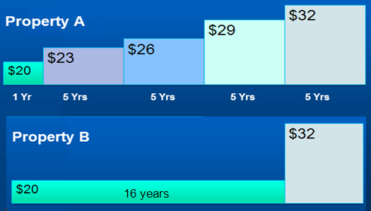

Question: What is the difference in value between Property A and Property B?

The rentable area is 20,000 Sq. Ft

Present Value Property A at 13.00% is $3,514,593
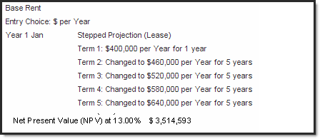

Present Value Property B at 13.00% is $2,960,062
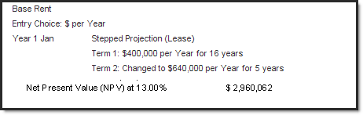
NPV at a 13% Discount Rate Property A: $3,514,593
NPV at a 13% Discount Rate Property B: 2,960,062
Difference $ 554,531 (16%)
Cap Rates. Summary

Using a Cap Rate to determine the value of an income property is a very simplistic approach fraught with difficulties.

A more realistic approach is “Discounted Cash Flow Analysis” which projects the cash flow over time and takes into account the “Time Value of Money”

Comparing Case A with Case B above was an example of “Discounted Cash Flow Analysis” and the use of Net Present Value

Long Term Real Estate Investment Analysis Introduction

Projects the cash flows over time and takes onto account “The Time Value of Money” Called Discounted Cash Flow Analysis.

I’m going to borrow $10,000 from you and offer you the following two repayment plans. The annual payment is at the end of each year. Which would you prefer as the lender Plan A or Plan B?

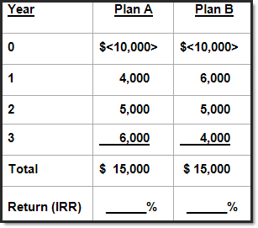

Which would you prefer? Plan _______

Why: _________________________

_________________________

You have intuitively applied “Discounted Cash Flow Analysis” and taken

into account the “Time Value of Money”

Always balance “Risk” and “Reward”

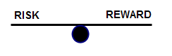

Which is more Risky? Plan A or B ________________________

Choosing between two investments

You have a choice to invest in either Property A and B. Each property will generate the following net cash flows. Which one would provide you with the best overall financial return?

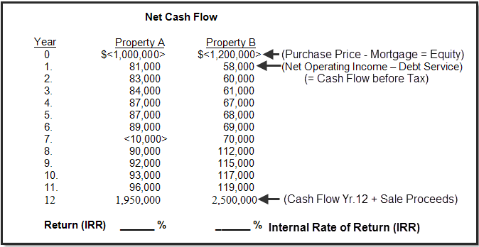

Calculating the Net Cash Flows before Tax

Analysis Time Period

In the example above the “Analysis Period” or the “Holding Period” is 12 years. The property will be sold at the end of the “Analysis Period”.

Acquisition (Net Cash Flow)

The purchase is made at “Time Period Zero” and the Net Cash Flow is:

Purchase Price

Less: Mortgage

Equity (Net Cash Flow. Time Period zero)

Note that the Net Cash Flow or Equity which is the cash invested is shown as a negative. For Property A it is minus $1,000,000 because this is an outflow of cash. In contrast, revenue would be shown as a positive number because revenue is an inflow of cash.

Yearly Cash Flows

The calculation of the yearly cash flow is:

Potential Gross Income

Less: Vacancy Loss

Effective Gross Income

Less: Operating Expenses

Net Operating Income

Less: Debt Service (Principal & Interest Payments)

Cash Flow before tax

Cash Flow in the Last Year

At the end of the last year of the “Analysis Period” the building is sold and we calculate the “Sale Proceeds” as follows:

Sale Price

Less: Real Estate & legal fees

Repayment of the outstanding mortgage balance

Sale Proceeds

The Net Cash Flow in the last year is:

Net Cash Flow = Operating Cash Flow + Sale Proceeds

Financial Returns that incorporate the Time Value of Money

We need tools to calculate the financial returns which take into account the "Time Value of Money" to:
- Calculate the financial return on the money invested. Is the financial return acceptable given the degree of risk and the financial returns available from other investment opportunities of similar risk?

- Compare alternate investment opportunities.

The financial tools used are the:

Internal Rate of Return (IRR)

Net Present Value (NPV)

Modified Internal Rate of Return (MIRR).
Also called the “Financial Management Rate of Return (FMRR)

The Internal Rate of Return (IRR)

The IRR is the annual compounding return on investment

Why is it called the Internal Rate of Return (IRR)?

Because of the Reinvestment Assumption

If the IRR is 13% this assumes that:

- Excess funds are reinvested at 13%

E.g. In Year 4 if the cash flow is +$30,000 it will in reinvested at 13%

- If there is an operating loss, funds are borrowed at 13%

E.g. In Year 6 if there is a negative cash flow of -$30,000 it will be borrowed at 13%

The reinvestment assumption can cause the Internal Rate of Return (IRR) to be overstated

Think Compound Interest

An Investor has $300,000 to invest. They can:

a) invest $300,000 in a building and achieve an Internal Rate of Return (IRR) of 9.00%

b) loan $300,000 as a second mortgage at an Interest Rate of 9.00%

From a financial perspective, the financial returns are the same. Both provide a 9.00% interest rate on the money invested.

Always balance Risk and Rewards

Which is more risky?

Buying a building with a down payment of $300,000

Loan $300,000 as a second mortgage

________________________________________________

Investing versus Lending

Invest in Real Estate | Second Mortgage  Conservative lender
Return is unknown  Could lose or make money | Return is known  The interest rate
Cash flow and return is uncertain  Based on assumptions and projections | Payment of principal and interest is known
More things can go wrong  E.g. Major tenant moves out  Building develops toxic mold | Very little can go wrong
Higher risk  Requires a higher return  Potential for a large capital gain | Less risky than real estate investing

Relationship between the Internal Rate of Return (IRR) and Compound Interest

If you invest $400,000 and get back the following cash flow per year at the end of each year, what is your annual return?

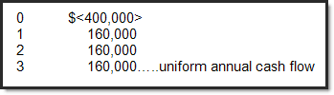

Because there is a uniform annual cash flow, any mortgage calculator can calculate the annual compound interest rate for the above cash flow.

Present Value: <400,000>
Future value: 0
Payment: $160,000 per year.
Payment: At end of year.
Compounding Frequency: Annual

Calculate the Interest Rate

Answer: Interest Rate is 9.70%

If you put the cash flow into a calculator that has an IRR and NPV function

The Internal Rate of Return (IRR) will be 9.70% which is the same as the interest rate of 9.70%.

Why we use the Internal Rate of Return (IRR)

If you invest $400,000 and get back the following cash flow per year at the end of each year.

What is your annual return?

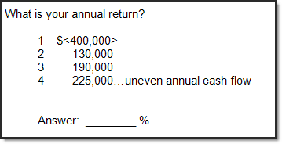

A standard mortgage calculator can’t calculate the annual interest rate because there is an uneven cash flow. You need a financial calculator with IRR and NPV features.

Financial Calculators

The easiest Financial Calculator to use is the Texas Instrument BAII Plus and BAII Plus Professional.

Another popular calculator is the HP-10B but it is a more difficult calculator to use, particularly in Canada where mortgages are compounded semi-annually.

Net Present Value (NPV)

The value today of the cash flow when taking into account the “Time Value of Money”

Net Present Value of the cash flow is calculated using the Investor’s “Desired Return”, “Discount Rate” or “Opportunity Cost”

If the Net Present Value is positive:

The return is greater than the Investor’s desired return or discount rate

If the Net Present Value is negative:

The return is less than the Investor’s desired return or discount rate

The Net Present Value (NPV) tells you how much you can pay for the property to get your desired return.

Following are the results of the analysis of an apartment building

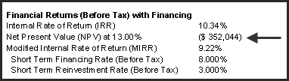

The Net Present Value at 13.00% is <$352,044>

To achieve a return of 13.00%, the purchase price has to be reduced by $352,044

If the priced is dropped by $352,044 the Internal Rate of Return (IRR) will be exactly 13.00%

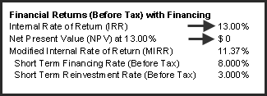

Determining the Discount Rate or Desired Return (IRR)

We try to find published information about returns with similar risk

Government Bond Rate. Not useful because of the very low risk

A useful comparison is the second mortgage rate for the property under consideration

Example: The second mortgage rate is 8.50%

Investor’s viewpoint.

If I can’t get an Internal Rate of Return (IRR) higher than 8.50% then I’d be better off being a second mortgage lender

For most real estate investments, we need to add 1.00% to 5.00% depending on the risk to the second mortgage rate to take into account the additional risks of buying a property compared to being a conservative second mortgage lender.

Discount Rate or Desired Return. 9.00% up to 15.00% or higher depending on risk.

A typical figure for a medium risk investment is around 13.00% IRR before tax

Exception.
Prime rental apartments with very low Cap Rates (4.00% to 5.00%) because of the low vacancy risk and potential for strong capital appreciation

For a Cap Rate of 4.50%, the IRR is around 6.50%

Note: You cannot easily compare a Cap Rate with an Internal Rate of Return (IRR)

To compare the Cap Rate with the Internal Rate of Return IRR) you need to carry out a cash flow analysis on a specific property.

Modified Internal Rate of Return (MIRR)

The Internal Rate of Return (IRR) reinvestment assumption may cause an overstatement of the Internal Rate of Return (IRR). As an example:

Internal Rate of Return (IRR) is 13.32%

Positive cash flows will be reinvested at 13.32%
Negative cash flows or losses will be borrowed at 13.32%

An alternate to the Internal Rate of Return (IRR) is the Modified Internal Rate of Return (MIRR)

The Modified Internal Rate of Return (MIRR) uses a short term:

Financing Rate. Example 7.50%

Reinvestment Rate. Example 1.50%

Example. The financial results of a rental apartment building cash flow analysis

Internal Rate of Return (Before Tax): 13.32%

Modified Internal Rate of Return (MIRR): 11.45%
Short Term Financing Rate (Before Tax): 7.50%
Short Term Borrowing Rate (Before Tax): 1.50%

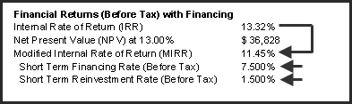

The building blocks of Real Estate Investment Analysis

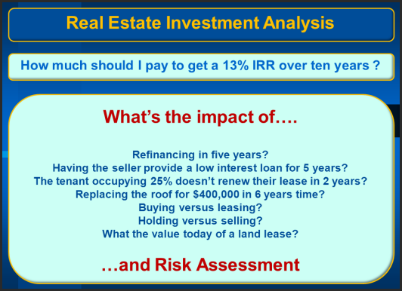

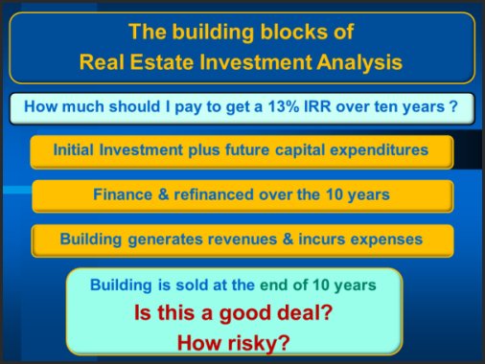

The best way to analyze long term real estate investments is to develop the Net Cash Flow. Cap Rates are far too simplistic for properly evaluating a real estate investment.

The result is the Net Cash Flow Report. The financial measures we use are the Internal Rate of Return (IRR), Net Present Value (NPV) and Modified Internal Rate of Return (MIRR)

Real Estate Investment Analysis. Case Study

Mixed-Use Building
One Bedroom Units: 20
Two-bedroom Units: 9
Retail space: 5,000 Sq. Ft
Parking: 40 spaces

Analysis Period: 10 years

Investment (Asking Price) $3,000,000 (Land: $1,000,000 Building: $2,000,000)

Financing

Option A. Conventional first mortgage with 60% Loan to Value Ratio
First Mortgage: $1,800,000 Interest 6.00% 25 Amortization: 25 years
Loan to Value Ratio: 60%
Equity: $1,200,000 (40%)

Option B. Seller provides a second mortgage for 5 years
To reduce the buyer’s equity from 40% to 25% the seller provides a second mortgage of $450,000 for five years.

First Mortgage: $1,800,000, Interest Rate: 6.00%, 25 Amortization for 5 years
Loan to Value Ratio: 60%

Second mortgage: $450,000 interest only mortgage at 8.00% for 5 years

Equity: $750,000 (25%)

At the end of the first 5 years:

- The outstanding balance of the first mortgage and the second mortgage of $450,000 is paid off.

- A new first mortgage is placed on the property beginning of Year 6 January using a 1.25 Debt Service Coverage Ratio for $2,500,000 at 6% interest, 25 year amortization.

Revenues & Expense Projections

REVENUE | Number | First Year | Increase per Yr. | Vacancy
One Bedroom Units | 20 Units | $900 per mos. | 3% per year compounding | 3%
Two-bedroom Units | 9 Units | $1,100 per mos. | 4% per year compounding | 3%
Laundry | 29 Units | $15 per mos. | 5% per year compounding | 3%
Retail Space | 5,000 Sq. Ft
Base Rent | $15 per Sq. Ft per yr for 3 years then $16.39 for 5 years  then $19.47 per Sq. Ft per yr. |  |  | Zero
Additional Rent (TIM’s) | $3.00 per Sq. Ft per year increasing at 3.50% compounding per year
Parking | 40 spaces | $45 per month | 5% per year compounding | Zero
EXPENSES

Property Taxes | - | $90,000 per Yr. | 5% for the next two years then 4% per year compounding
Insurance | - | $45,000 per Yr. | 5% per year compounding
Maintenance. Rental Units | 29 Units | $400 per Yr. | 4% per year compounding
Maintenance. Retail Space | - | $700 per mos. | 3% per year compounding
Resident Caretaker | - | $3,000 per mos. | 4% per year compounding
Property Manager | - | 4% of Effective Gross Income
Other Expenses | - | 3% of Potential Gross Income

Sale at the end of the 10 year Analysis Period

Sale Price. Based on a 7.00% Cap Rate using the Net Operating Income for the year following the sale

Real Estate Fees: 4.00% of the Sale Price
Selling Expenses: $6,000
Legal Fees: $5,000

Questions

- How much to pay for the property to get a 13% return (Internal Rate of Return) before tax?

- How does the return (Internal Rate of Return) change if the seller carries a second mortgage for $450,000 interest only loan at 8% for five years? The property will be refinanced at the end of the fifth year using a Debt Service Coverage Ratio (DSCR) of 1.25

- How much money does the investor receive when the property is refinanced at the end of the first five years?

Common real estate investment analysis reports

Option A. Conventional first mortgage with 60% Loan to Value Ratio

Net Cash Flow Report (Money Tree Diagram)
Provides a broad overview of the investment over the ten year period.

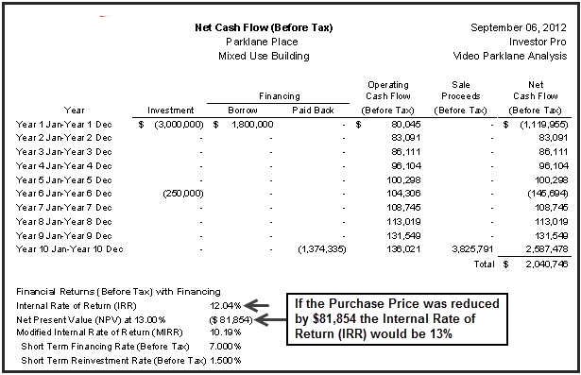

Question

- How much to pay for the property to get a 13% return (Internal Rate of Return) before tax?

Answer: $3,000,000 – 81,854 (NPV at 13%) = $2,918,146

Purchase Price versus the Desired Return

Example: If we wanted a 13% Return (IRR) the most we can pay for the property is just under $3,000,000
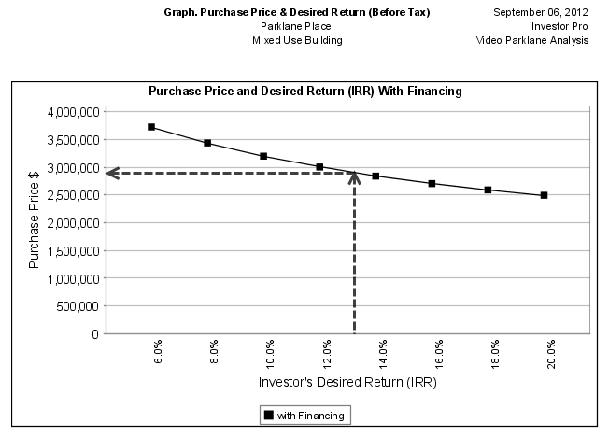

Goal Seeking

How much to pay for the property to get the desired return of 13%?.

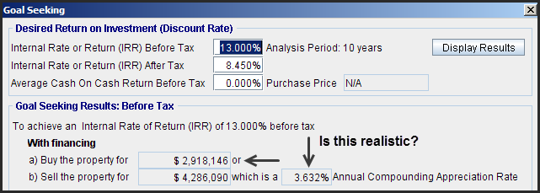

Overall Operating Cash Flow Report

Show all the inflows and outflows and the financial results over the analysis period of ten years.

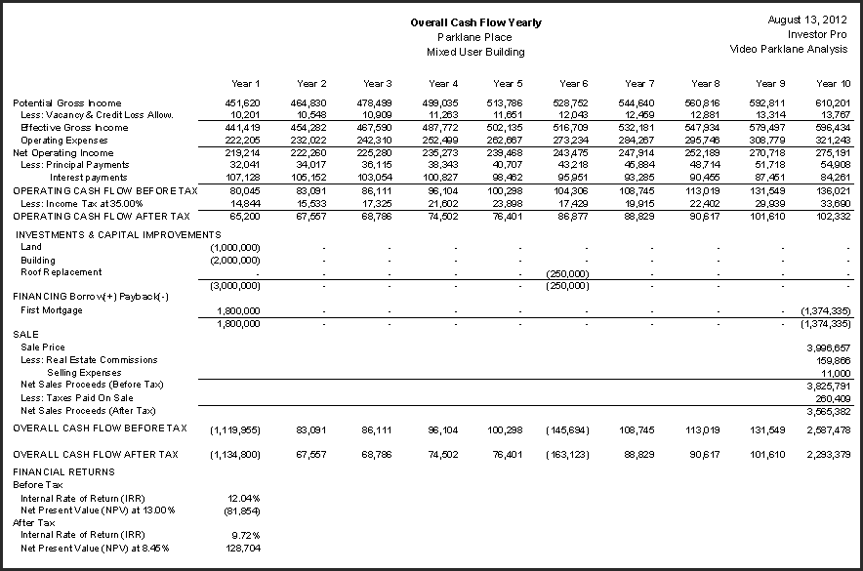
Operating Cash Flow Report

Shows the before and after tax cash flows from operations over the analysis period of ten years.

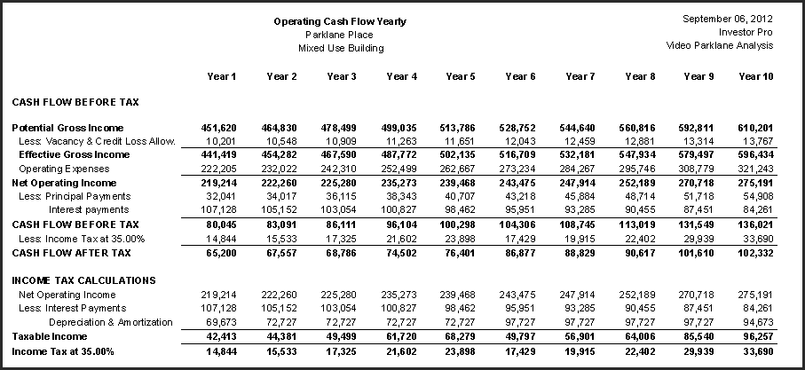

Income & Expense Statement

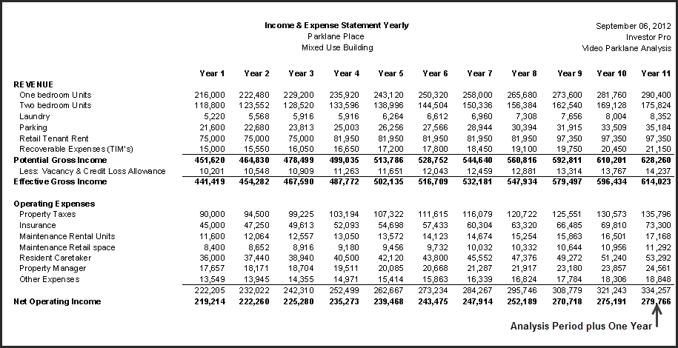
Cash Flow Projection Graph
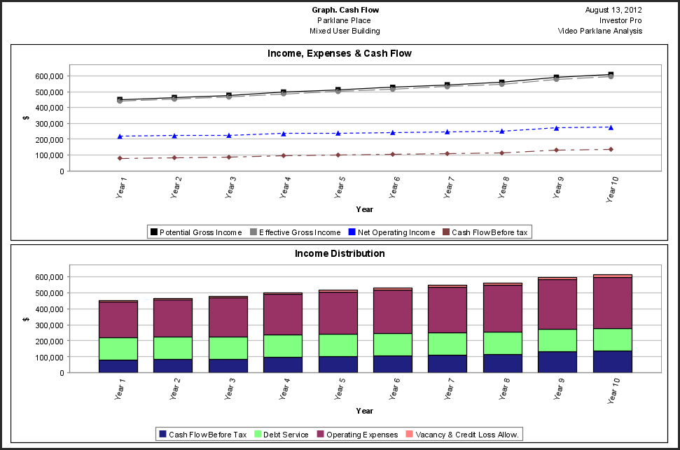

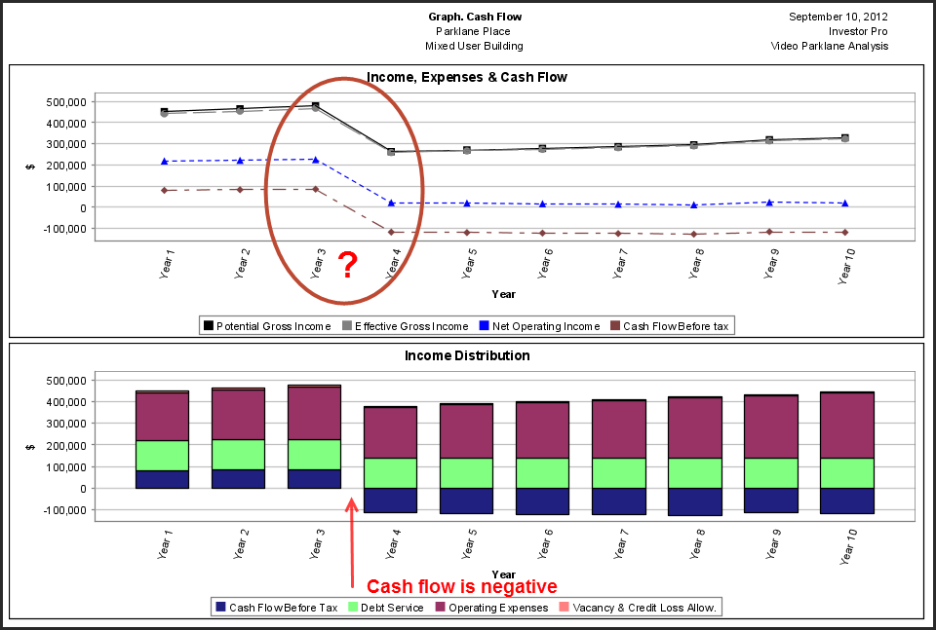
Cash Flow from Sale

Shows the cash flow from sale (before and after tax) when the property is sold in ten years' time.

Sometimes called the Reversionary Value

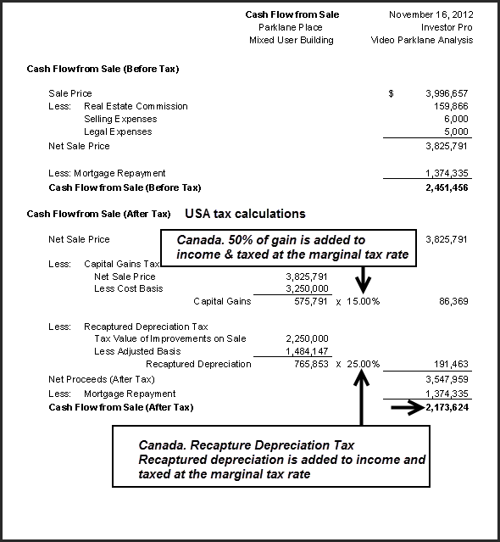
Financial Measures. Financing Potential & Risk Assessment

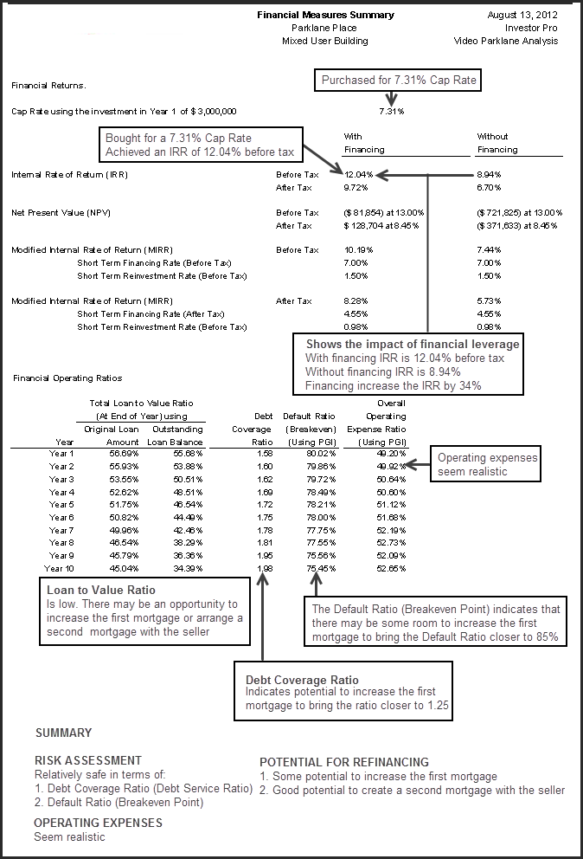

Appraiser’s Approach to Present Value

Appraisers like to examine:

How much of the Present Value is generated by:

- Net Operating Income

- Capital Appreciation and sales proceeds (Called the Reversionary Value)

This analysis is done without financing and before tax.

This approach can identify if there is too much reliance on “Capital Appreciation” instead of the “Net Operating Income” in determining the value

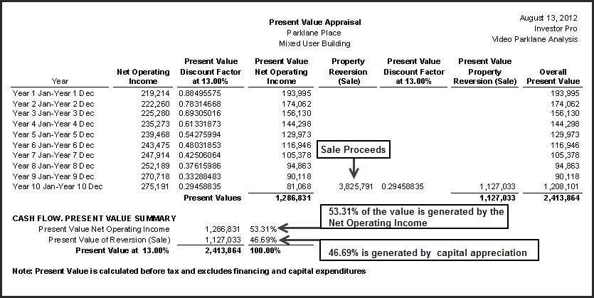
Revenue & Expense Projections

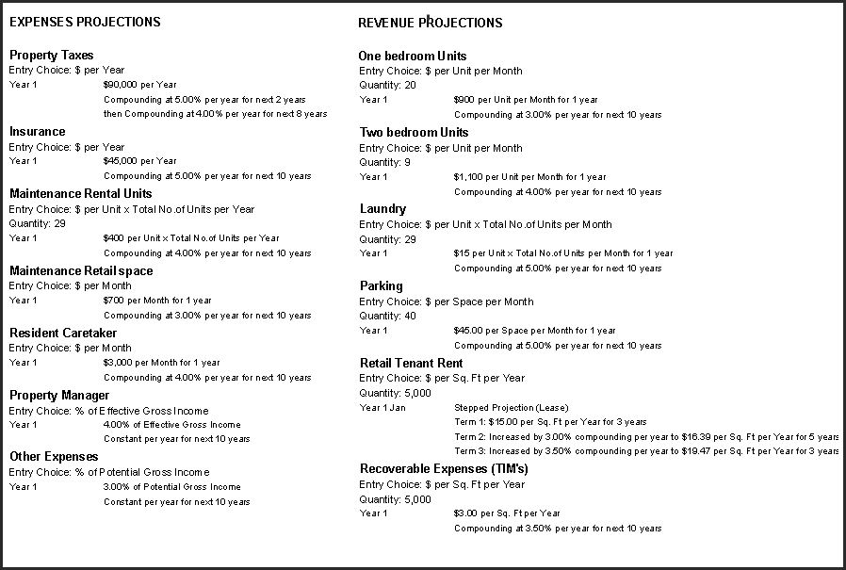

Determining the optimum holding period

Assumes the building is sold at the end of each year.

In this example, the maximum Internal Rate of Return (IRR) is 15.56% before suggesting the best time to sell the building is at the end of year 3

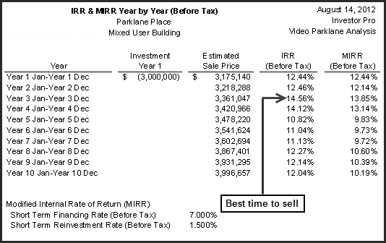
Investment Analysis. Option B. Seller provides a second mortgage for 5 years

To reduce the buyer’s equity from 40% to 25% the seller provides a second mortgage of $450,000 for five years.

First Mortgage: $1,800,000, Interest Rate: 6.00%, 25 Amortization for 5 years
Loan to Value Ratio: 60%

Second mortgage: $450,000 interest only mortgage at 8.00% for 5 years

Equity: $750,000 (25%)

At the end of the first 5 years:

- The outstanding balance of the first mortgage and the second mortgage of $450,000 is paid off.

- A new first mortgage is placed on the property beginning of Year 6 January using a 1.25 Debt Service Coverage Ratio for $2,500,000 at 6% interest, 25 year amortization.

Question:
How does the return (Internal Rate of Return) change if the seller carries a second mortgage for $450,000 interest only loan at 8% for five years? The property will be refinanced at the end of the fifth year using a Debt Service Coverage Ratio (DSCR) of 1.25

Net Cash Flow Report Option B with Seller Financing

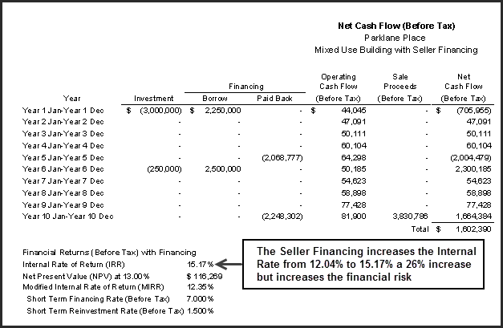

Financial Impact with Seller’s second mortgage

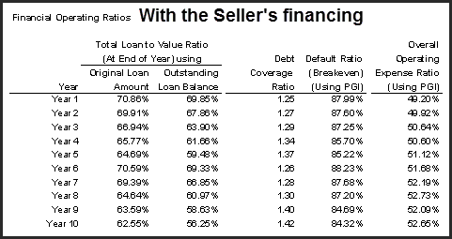
Comparison Report

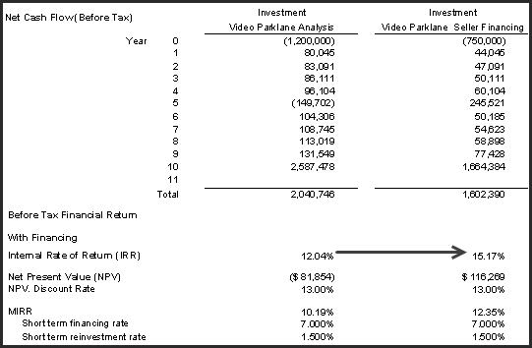

What happens when the building is refinanced in 5 years?

Create a new first mortgage $2,500,000
Pay off OSB First Mortgage 1,608,777
Pay off OSB Second Mortgage 450,000
New owner gets $ 431,223

When the new mortgage is put in place at the end of the first five years the funds will be used to pay off the outstanding balance of the existing first mortgage of $1,608,777 and the second mortgage of $450,000 with the investor receiving cash of $431,223.

Summary from the Buyer’s and Seller’s perspective

It is helpful to summarize the advantages and disadvantages from the buyer’s and seller’s perspective

Summary from the buyer’s perspective

The challenge
For the buyer to get a 13% IRR before tax the price has to drop from $3,000,000 by $81,854 to $2,918,146. The challenge is that the buyer has to come up with 40% equity which is a lot of money. This will make it hard to put the deal together.

The good news
The analysis indicates that there is plenty of room to have the seller provide a second mortgage for five years.

The solution
Explore a second mortgage with the seller
$450,000 Interest only at 8.00% for five years
Refinance the first mortgage at the end of 5 years

Financial impact of the buyer
The seller’s second mortgage increases the return (IRR) from 12.04% to 15.27%
Reduces the buyer’s equity from 40% to 25%
Refinancing at the end of five years the buyer (investor) receives $431,223 cash

Risk
Default or Breakeven Point goes for 80% to 88% which is a little high
Debt Service Ratio goes from 1.58 to 1.25
Carrying the seller’s second mortgage increases the risk but the investment is relatively safe with a 1.25 Debt Service Ratio.

Summary from the seller’s perspective
Agreeing to the second mortgage arrangement makes the property much easier to sell

There are many more buyers if the equity is 25% compared to 40% equity

Recommendations

- Check that the current first mortgage allows a second mortgage to be placed on the property
- Find out if the first mortgage can be paid off in five years’ time
- Consult with an accountant to establish the tax consequences of selling the property and carrying a second mortgage
- If cleared by your legal and tax advisors offer the second mortgage but consider increasing the price above $3,000,000 because the second mortgage increases the buyer’s return from 12.04% to 15.20% and the buyer’s desired return is 13%
Recap

We started by asking the following questions:

- How much to pay for the property to get the investor’s desired return of 13% before tax?
- Is there potential for increasing the financing now or in the future?
- How risky is the investment?
- What is the financial impact on having the seller carry a second mortgage at 8.00% for five years?

We then carried out real estate investment analysis to answer these questions and developed recommendations from the buyer’s and seller’s perspective.

Summary. The building blocks of investment analysis

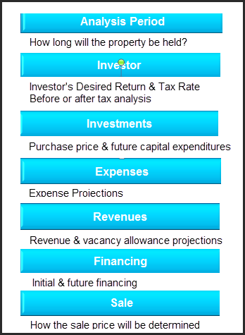

Cash Flows. Timing and Sign Conventions

Introduction
When carrying out discounted cash flow analysis and calculating the Internal Rate of Return (IRR) and the Net Present Value (NPV) we follow the industry standard timing and sign convention.

The reason we use a timing convention is that we are discounting the cash flow back to time period zero or the beginning of the first year to calculate the Internal Rate of Return and Net Present value

Time period zero. This is when the initial investment is made. The beginning of the first year

Cash flows. Occur at either the beginning or end of the year even if they occur during the year
Examples: Investments are assumed to be made at the beginning of the year
Revenues occur at the end of the year

Sign convention. The best way to decide whether a cash flow is “Positive” or “Negative” is from the investor’s viewpoint and their bank account.

Money coming into the investor’s bank account is positive such as:
Rent and other revenues, sale of the building at the end of the analysis period
Creation of a mortgage

Money going out of the investor’s bank account is negative such as:
Initial investment and future capital expenditures
Expenses, principal, and interest payments. Repayment of a mortgage

Investment and Future Capital Expenditures

We can analyze an investment using either “Before” or “After” tax analysis.

Before Tax Analysis. The investment or purchase price can be a single number. E.g. $3,000,000

After Tax Analysis. To set up the depreciation we break the purchase into "Land" and "Improvements". Land is not depreciable but the improvements are.

Land $ 1,000,000 Non depreciable
Improvements 2,000,000 Depreciable asset
Purchase Price $ 3,000,000

Investments and Future Capital Expenditures. Timing and sign convention

 | Timing | Sign Convention
Purchase (Investment) | Beginning of year | Negative $3,000,000 (Outflow)
Future capital expenditures  Roof replacement. Year 6 | Beginning of year | Negative <$250,000 per mos.> (Outflow)

Example. If the roof was replaced in August of Year six for <$250,000> the expenditure is assumed to be made at the beginning of year 6 (or the end of year 5) for discounting purposes

Financing & Refinancing

Creation of a mortgage
For discounting purposes, the creation of a mortgage is assumed to occur at the beginning of the year even if the funds were received during the year.

If the mortgage was arranged when the property was purchased the funds are assumed to be received at the beginning of the year which is time period zero.

Strange as it may seem, funds flowing from the creation of a mortgage are “Positive” because they are a cash inflow from the investor’s perspective.

Repayment of a mortgage

A mortgage may be repaid at any time during the analysis or holding period>. The outstanding mortgage balances at the end of the ‘Analysis Period” are always repaid when the property is sold.

For discounting purposes, the repayment of a mortgage is assumed to occur at the end of the year even if the mortgage was repaid much earlier in the year.

Principal and Interest Payments
Generally paid monthly but are assumed to be paid at the end of the year when discounting the cash flows to calculate the Internal Rate of Return (IRR) and Net Present Value (NPV)

Principal and interest payments are negative because they are a cash outflow.

Financing. Timing and sign convention summary

 | Timing | Sign Convention
Creation of the mortgage | Beginning of year | Positive $1,800,000 (Outflow)
Repayment of the mortgage | End of year | Negative <$1,374,333> (Outflow)
Payments of Principal & Interest | End of year | Negative <$11,597 per mos.> (Outflow)

Revenues, Expenses & Vacancy Allowances

In developing the cash flows we project the revenues, vacancies and expenses out over the analysis or holding period plus one year.

As an example, if the analysis period was 10 years we would project the revenues, vacancies and expenses over 11 years even though the property is being sold at the end of the tenth year.

The reason we project one year past the analysis period is that we want to develop the Net Operating Income for the year following the sale. Investors and appraisers, while interested in past performance, are most focused on future incomes and expenses.

The traditional way to calculate the sale price at the end of the analysis period is to use the "Net Operating Income" for the year following the sale and the appropriate Cap Rate.

Timing
Revenues and expenses are assumed to occur at the end of the year even though the rents may be received monthly. Most expenses are paid monthly. Some expenses such as property taxes and insurance may be paid yearly.

As an example, if the rent is $12,000 per month and received at the beginning of the month, the rent for the year is $144,000 and is assumed to be received at the end of the year when discounting to calculate the Internal Rate of Return (IRR) and Net Present Value (NPV)

Sign Convention

Revenues are cash inflows and are positive.

Expenses are cash outflows and are negative

Revenues & Expenses. Timing and sign convention summary

 | Timing | Sign Convention
Revenues. Rent Year 1 | End of year | Positive +$46,000 (Inflow)
Expenses. Property Taxes | End of year | Negative <26,000> (Outflow)

Sale and Selling Expenses

At the end of the analysis period, the property is assumed to be sold.

There are a variety of ways to calculate the value of the property at the end of the analysis period but the most common method is to use the Net Operating Income for the year following the sale and a Cap Rate.

We also have to estimate the real estate and legal fees and associated closing costs

Timing

The sale proceeds are assumed to occur at the end of the last year of the analysis period when discounting to calculate the Internal Rate of Return (IRR) and Net Present Value (NPV)

If the analysis period was 10 years the sale is assumed to occur at the end of the tenth year.

Selling expenses such as real estate and legal fees and associated closing costs are assumed to have occurred at the end of the analysis period for discounting purposes.

Sign Convention

The “Sale Price” is a positive number because the cash received from the sale is a cash inflow.

Selling expenses such as real estate and legal fees and other closing costs are negative because they are expenses or cash outflows.

Sale and Selling Expenses. Timing and sign convention summary

 | Timing | Sign Convention
Sale of the building | End of year | Positive +$3,612,335 (Inflow)
Closing costs RE & legal fees | End of year | Negative <$11,000> (Outflow)

Timing and Sign Conventions. Summary

This table summarizes the traditional timing and sign conventions used in real estate investment analysis when carrying out discounted cash flow analysis and calculating the “Internal Rate of Return (IRR)” and “Net Present Value (NPV)”.

 | Timing | Sign Convention
Purchase | Time period zero  Beginning of year 1 | Negative <$3,000,000> (Outflow)
Future capital expenditures  Roof replacement. Year 6 | Beginning of year | Negative <$250,000 per mos.> (Outflow)
Creation of the mortgage | Beginning of year | Positive +$1,800,000 (Inflow)
Repayment of the mortgage | End of year | Negative <$1,374,333> (Outflow)
Payments of Principal & Interest | End of year | Negative <$11,597 per mos.> (Outflow)
Revenues. Rent Unit A | End of year | Positive +$46,000 (Inflow)
Expenses. Utilities | End of year | Negative Utilities <$26,000> (Outflow)
Sale of the building | End of year | Positive +$3,612,335 (Inflow)
Closing Costs Selling & legal fees | End of year | Negative <$11,000> (Outflow)

Cap Rate versus Internal Rate of Return (IRR)

This table compares the difference between the Cap Rate and the Internal Rate of Return (IRR) in determining the value of an income property.

Cap Rate | Discounted Cash Flow Analysis & IRR
Only considers one year | Considers many years
Property is never sold | Property is sold at end of “Analysis Period”
Net Operating Income is constant  Year 1 $120,000 Yr. 2 120,000 forever | Income & Expenses change every year
Ignores future capital expenditures  Year 6. Replacing the roof for | Includes future capital expenditures
Excludes financing | Includes financing and refinancing
Simple and quick “Rule of Thumb” | Comprehensive analysis
Ignores the impact of taxes | Can be used for before & after tax analysis
How realistic? | More realistic. Much better assessment of the financial performance of the investment

Cap Rate vs. the Internal Rate of Return (IRR)

The Cap Rate and the IRR are two completely different financial measures or returns.

They cannot be compared. It’s like comparing apples and oranges

Let’s look at a very simple analysis using the “Cap Rate” method and the “Discounted Cash Flow Analysis” approach using the Internal Rate of Return (IRR).

Case Study.

Property Type. Income property
Analysis Period: 5 years
Asking Price: $1,000,000

Income & Expense Statement
Revenue $125,000 (After vacancy allowance) increasing at 2.5% per year compounding
Expenses (40%) 50,000
Net Operating Income 75,000

Financing
Loan Amount: $600,000 Loan to Value Ratio is 60% Interest Rate: 6.00% Amortization Period: 25 years

Sale Price: The sale price at the end of the five years is based on the Net Operating income in year 6 using a 7.50% Cap Rate

Cap Rate Approach

Cap Rate = Net Operating Income x 100 = 75,000 x 100 = 7.50%
Price 1,000,000

Discounted Cash Flow Analysis approach. Net Cash Flow Report

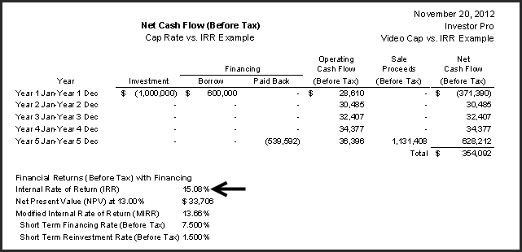

Results

The Cap Rate is 7.50% and the Internal Rate of Return is 15.08% which is closer to the true financial return.

The Internal Rate of Return (IRR) takes into account:

- Financial leverage which generally increases the return but increases the risk

- That rents increase each year

- That the property is sold at the end of the Analysis Period

- Take into account the Time Value of Money

The Cap Rate ignores these important factors and assumes the following:

- Net Operating Income is constant and goes on forever

Yr. 1 $75,000 Yr. 2 $75,000 etc.

- The property is never sold

- Ignores the time value of money

Cap Rate and the Internal Rate of Return (IRR) Case Study

Following is an analysis carried out to show the relationship between the Cap Rate on purchase and the Internal Rate of Return for a specific property using the following assumptions:

The analysis looked at holding the property for ten years then selling.

The sale price in ten years' time was calculated using the Net Operating Income (NOI) in the 11th year using the Cap Rate on purchase.

As an example, if the Cap Rate on purchase was 5.00%, the Cap Rate used to determine the sale price at the end of ten years was 5.00%.

Rental Apartment Building
Analysis Period: 10 years
Value in 10 year time is based on the NOI in the 11th year using the purchase Cap Rate
Rents. Increase at 3.00% per Yr compounding
Expenses. 43% Operating Expense Ratio
Debt Service Ratio maintained at 1.25
Cap Rate & IRR Analysis.

Results. Cap Rate versus the Internal Rate of Return

Example. If the Cap Rate on Purchase was 6.00% the Internal Rate of Return (IRR) is 10.29%

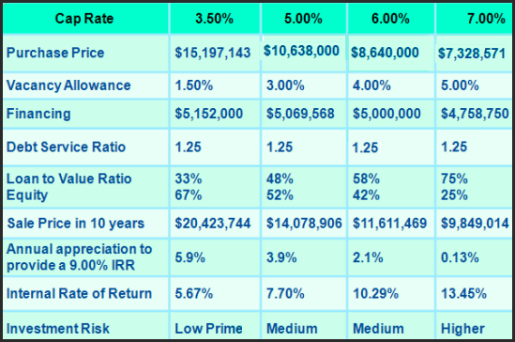

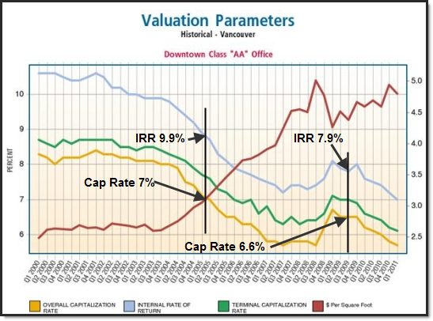
The relation between the Cap Rate and the Internal Rate of Return (IRR)
Vancouver Downtown office market Source: Altus Group. In Depth report June 2011

Conclusion: Relationship between the Cap Rate & the Internal Rate of Return (IRR)

The only way to connect a Cap Rate and the Internal Rate of Return is by analyzing a specific income property. We can, however, make the following observations:

- The Internal Rate of Return is generally higher than the Cap Rate under normal circumstances

- For a typical Cap Rate of 7% to 8%, the Internal Rate of Return before tax will be around 12% to 14%

- The lower the Cap Rate the lower the Internal Rate of Return (IRR) but also the lower the risk

- A good rule of thumb for the investor’s “Desired Return (IRR)” or “Discount Rate” is 12% to 14% before tax for Cap Rates around 7.5%

Caution
These are very general observations and may not always apply. Many factors influence the Internal Rate of Return and the investment risk such as:

- The financial leverage. Increasing the financings lowers the equity and increases the Internal rate of return but increases the risk which the example shows.
- The quality of the tenants. The poorer the quality of the tenant the higher the risk of defaulting on the rent or moving out prematurely
- Whether a major tenant will renew their lease when it expires
- Future major expenditures such as replacing the roof, a boiler or the HVAC system

All of these will influence the Internal Rate of Return and the relationship with the Cap Rate

When does the Cap Rate equal the Internal Rate of Return?

The Cap Rate and the Internal Rate of Return are nearly the same when:

- The income is constant and goes on for many years. At least 75 years
- There is no residual value such as the sale of the property or asset

Case Study

A farmer has leased a section of his farm to a wind farm operator for $100,000 for 40 years.

An investor is interested in buying the remaining income stream for $1,200,000. There are 25 years remaining on the lease.

Question: What is the Cap Rate and the Internal Rate of Return?

Cap Rate = $100,000 x 100 = 8.33%
$1,200,000

Internal Rate of Return
Investment <$1,200,000
Annual Cash Flow $100,000 per year for 25 years

Internal Rate of Return: 6.678%

The following table shows the Internal Rate of Return for different numbers of years

Number of Years  At $100,000 per year | Internal Rate of Return | Cap Rate | % Difference
25 | 6.678% | 8.33% | 25%
30 | 7.337% | 8.33% | 14%
40 | 7.941% | 8.33% | 4.89%
50 | 8.169% | 8.33% | 1.93%
75 | 8.312% | 8.33% | 0.22%
100 | 8.33% | 8.33% | 0.00%

Conclusion
For the Cap Rate and the Internal Rate of Return to be the same requires:

- A constant annual income. The example uses $100,000 per year
- There is no residual or reversionary value at the end of the time period
- Long the time period. Fifty years

Cap Rate versus Internal Rate of Return (IRR). Summary

The Cap Rate is a very simplistic, quick approach to valuing an income property and is based on the following assumptions:

- The Net Operating Income is constant and goes on forever
- The property is never sold

The Cap Rate approach ignores the time value of money and that cash flows change over time.

In contrast, the discounted cash flow approach which generates the Internal Rate of Return (IRR) takes into account the changing cash flows resulting from buying, financing, operating and selling the property over the ownership period.

The discounted cash flow analysis is a much more comprehensive and rigorous approach than the Cap Rate and is the best approach for analyzing complex real estate investments.

Relationship between the Cap Rate and the Internal Rate of Return (IRR)

The only way to connect the Cap Rate and the Internal Rate of Return (IRR) is to explore the relationship between the Cap Rate and the Internal Rate of Return (IRR) is by carrying out discounted cash flow analysis on a specific property and then varying the purchase Cap Rate to see the impact on the Internal Rate of Return (IRR)

Some general observations:

- The Internal Rate of Return is generally higher than the Cap Rate
- The lower the Cap Rate the lower the Internal Rate of Return (IRR) but also the lower the risk
- On a typical investment where the Cap Rate is around 7.5% the Internal Rate of Return (IRR) is around 12% to 14%

When does the Cap Rate equal the Internal Rate of Return (IRR)?
The Cap Rate and the Internal Rate of Return (IRR) are the same if the following conditions exist:

- A constant annual income. Example $100,000 per year for 50 years
- There is no residual or reversionary value at the end of the time period
- Long the time period is involved. A minimum of 50 years

What does the term “Return” mean?

There are various terms used to describe a “Return on investment”

If an investor asks what is the:
Return?
Yield?
Return on Investment?
ROI?
Bottom line?

…….you need to ask the investor to define what they mean by:

“Return”, “Yield”, “Return on Investment”, ”ROI” or the “Bottom Line”

The following are all financial returns on investment:

Cap Rate =Net Operating Income x 100
Price

Return on Equity. Also called “Cash on Cash” the “Equity Dividend Rate”

= (Net Operating Income – Debt Service) x 100
Equity

Internal Rate of Return (IRR)

Modified Internal Rate of Return (MIRR)
Also called the “Financial Management Rate of Return” or “FMRR”

Investor’s Discount Rate. The discount rate is equivalent to the Internal Rate of Return

Sometimes investors develop their own method of calculating a financial return that works for them.

As an example, an investor has developed her own method for calculating the “Return on Investment” and uses the following formulae:

Return on Investment (ROI) = Avg. yearly cash flow + (Sale Price – Purchase Price)/No. of Yrs
Initial Equity

Real Estate Taxation. Overview

The table shows the different kinds of real estate taxes and the difference between the USA and Canadian calculations. Both countries have:

Taxes on yearly operating profits
Mortgage interest is a deductible expense
Allow the depreciation of the improves but not the land
Capital gain tax
Recaptured depreciation tax which occurs if too much depreciation has been claimed

The major difference is how the taxes are calculated.

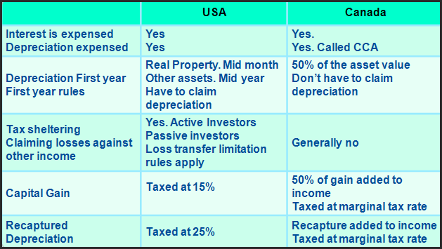

Capital Gains Tax

A capital gain is the difference between what you paid for an investment and what received when you sold that investment.

You have a capital gain when you sell or are considered to have sold, a capital property for more than the total of its cost basis, and the outlays and expenses incurred to sell the property.

Cost Basis

The “Cost Basis” is:

- Purchase price plus acquisition costs such a legal and appraisal fees, transfer costs etc.
- Plus “Capital Expenditures” such as replacing the roof, elevator, HVAC system etc.

Amount Realized or Proceeds of Sale on Disposition

The Sale Price less selling expenses such as legal, real estate fees, advertising costs, etc.

Capital Gain

Capital Gain = Amount Realized on Sale – Cost Basis

Capital Gains Tax

USA Generally 15% but different rates apply to low income earners

Canada. 50% of the gain is added to the individual or corporate income and taxed at the investor’s marginal tax rate

Depreciation Claims
Assets, such as real estate improvements have a useful life longer than one year and are expensed over time thoroughly yearly depreciation claims. The impact of the yearly depreciation claim is to increase the after tax cash flow because depreciation is a “non-cash “expense.
Each year the investor claims depreciation following the rules established by the tax department on the capital assets to reduce the taxable income as shown below and claims the depreciation as an operating expense. Land cannot be depreciated for tax purposes.

Note: In Canada depreciation for tax purposes is called “Capital Cost Allowance or CCA”

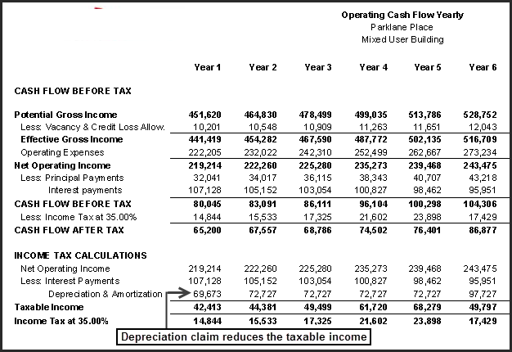

Amortization
Refers to spreading an intangible asset's cost over that asset's useful life.

For example, the cost of acquiring a lease by the landlord such as the leasing fee or cash payments to the tenant for leasehold improvements would likely be amortized over the term of the lease depending on the applicable tax rules.

Example: To acquire a lease with a five year term the landlord pays the leasing agent $40,000 and gives the tenant $80,000 cash for leasehold improvements. The total cost of acquiring the lease is $120,000 which would be amortized over the 5 year term at $120,000/5 at $24,000 per year. From the tenant’s perspective, the $80,000 cash inducement is treated as income.

Recaptured Depreciation Tax

When the property is sold, if the value of the improvement on sale is greater than the “Depreciated Balance” there will be recaptured depreciation tax.

Allocation of the purchase price between and improvements

When the property is sold, the buyer and seller will negotiate the allocation of the sale price between:

Land
Improvements

The Seller wants the value of the improvements to below to minimize or avoid depreciation tax

The buyer wants the value of the improvement to be high to maximize the yearly depreciation claims claim and minimize yearly income taxes

Recaptured depreciation on sale. USA Example

Capital Gain: Gain is taxed at 15.00%

Recaptured Depreciation: Taxed at 25.00%

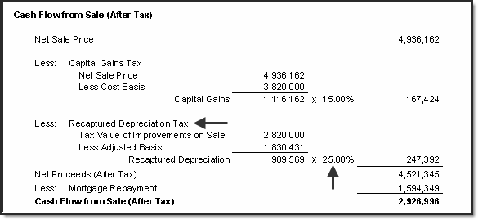

Recaptured depreciation on sale. Canadian Example

Capital Gain: 50% of the Gain is added to income & taxed at the Investor’s marginal tax rate

Recaptured Depreciation: Added to income and taxed at the Investor’s marginal tax rate

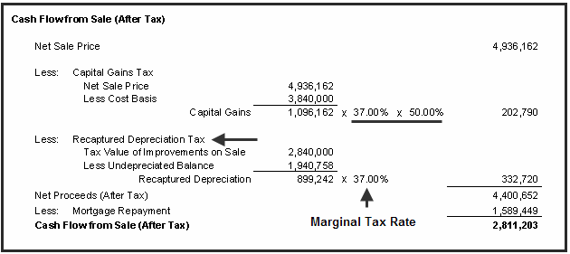

Calculating Recaptured Depreciation

The following table shows how the recaptured depreciation tax depends on the allocation of the purchase price between the “Land” and the “Improvements”. Recaptured depreciation tax can range from zero to a full recapture where all the depreciation claimed over the period of ownership is subject to recaptured depreciation tax.

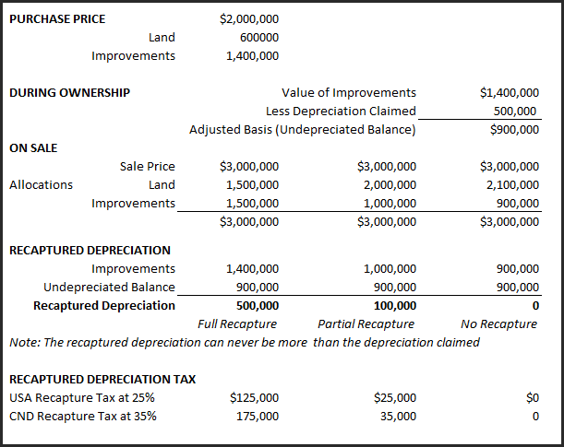

No recaptured depreciation tax
If the value of the improvements on sale is equal to (which means the improvements have been perfectly depreciated) or less than the undepreciated balance or adjusted basis the recaptured depreciation tax is zero.

Full recapture
A full recapture occurs when the value of the improvements on sale is greater than on acquisition which means the improvements have appreciated not depreciated in value. In this case, all the depreciation claimed is subject to recaptured depreciation tax

Note that recaptured depreciation cannot be more than the depreciation claimed.

Partial recapture
Occurs when the value of the improvements on sale is less than on acquisition but greater than the undepreciated balance or adjusted cost basis. The difference between the value of the improvement on sales and the undepreciated value or adjusted cost basis is subject to recaptured depreciation tax

Capital Gain. Appreciation is taxed as a capital gain. The increase in value of $1,000,000 is the purchase price of $3,000,000 minus the acquisition cost of $2,000,000 is taxed as a capital gain

Properties that may be hard to sell because of tax implications

Characteristics:

- Owned for a long period of time

- Gone up a lot in value

- Heavily depreciated

and there is a large mortgage on the property.

When the owner sells:

Large Capital Gain. USA 15% of the gain is added to income
Canada 50% of the gain is taxed at the marginal tax rate

Large Recaptured Depreciation Tax.

USA. Recaptured Depreciation is taxed at 25%

Canada. Recaptured Depreciation is added to income and taxed at the marginal tax rate

Large real estate fee and closing costs

…..and a large mortgage to pay off

The result. There is little money left from the sale

Seller Financing. Tax issues

Be careful about having the owner carrying financing without first checking with a tax accountant.

If the proceeds from the sale, after paying off the mortgage is small, there may not be enough money for the seller to pay the Capital Gains Tax and Recaptured Depreciation Tax as well as the real estate and legal fees.

Properties that may be hard to sell because of mortgage restrictions
Sometimes the mortgages registered on the property have restrictions that make it difficult to sell the property such as:

- The mortgage cannot be paid off until the end of the term
- The mortgage can be paid off but the penalty is very high making it difficult to pay off the mortgage
- The first mortgage may not allow a second mortgage to be placed on the property preventing the seller from offering a second mortgage to reduce the equity needed by the buyer

Example
A seller and a buyer have agreed upon a price of $4,850,000 for a prime mixed use building but unfortunately, the mortgage makes it difficult to complete the deal.

The details of the existing first mortgage are:

Loan Amount $2,750,000 Outstanding Balance: $2,319,000
Interest Rate: 6.50%
Monthly Payment: $17,000
Prepayment Period: The mortgage can’t be paid off for another 4 years
Restriction: A second mortgage cannot be placed on the property

The buyer can arrange a new first mortgage for 4.50% for $3,500,000 with a Loan to Value Ratio of 72%

Issues facing the buyer are:

Prepayment | Can’t pay off the first mortgage for 4 years
Equity | 48% or $2,531,000 versus 28% or $1,350,000 for the new mortgage
Interest Rate | 6.50% versus 4.50% current market interest rate
Future Rate | Will the interest rate be higher than 4.50% in 4 years’ time?
Leverage | The higher equity reduces the financial leverage
Return (IRR) | Unless the price is dropped significantly the IRR will be much lower
2nd Mortgage | Not allowed. Can’t set up a 2nd mortgage with the seller

Unless the seller is willing to drop the price significantly the first mortgage restrictions will prevent the sale of the property.

Introductory Case Study. Real Estate Investment Analysis

Showing the importance of financial leverage

The financial measures used to determine the loan amounts are:
      - Debt Service Ratio or Debt Coverage Ratio
      - Loan to Value Ratio. Sets the maximum loan amount

The lender calculates the loan amount using both measures and selects the method that yields the lowest loan amount. These lending criteria allow you to determine the potential for financing now and in the future.

Potential for financing now or in the future

Debt Service Ratio or Debt Coverage Ratio

= Net Operating Income = $240,000 per yr. = 1.33 Typical: 1,25

Debt Service $180,000

Note: Debt Service is the annual principal and interest payment

Loan to Value Ratio. Typical range 65% to 75%

Another useful measure for determining the financing now and in the future is the Default Ratio. Once the default ratio nears 85% there is little room to increase the first mortgage.

Default Ratio (Breakeven Point)

= (Operating Expenses + Debt Service) x 100

Potential Gross Income

= ($230,000 + 160,000) x 100 = 73%

$534,000

Risk assessment.

How risky is the investment?

The Default Ratio (Breakeven Point) and the Debt Service or Coverage Ratioare used to measure risk.

The example below shows the ratios for a moderate and high risk investment

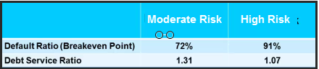

The Impact of Financial Leverage. Case study

Simple example illustrating financial leverage

An investor is considering buying a home to rent out and is considering two options:

1) Buy one home with cash for $300,000 and rent or

2) Buying 4 homes using 75% Loan to Value Ratio and rent

If the homes go up in value by 10%. The profit is:

- One home bought with cash. Profit is $300,000 x 10% = $30,000
- Buy 4 homes using 75% LTV Ratio. Profit is $300,000 x 10% x 4 = $120,000

Using financial leverage significantly increase the profit or return on investment

Case study. The impact of financial leverage

Office building

Capital Plaza

8,400 Sq. Ft of rentable space

Funds available to invest: $3,100,000

The case study explores the impact of the financing on the return on investment (Internal Rate of Return) using:

- Zero financing
- 45% LTV $1,395,000 25 years 4.50%
- 75% LTV $2,350,000 25 years 4.50%

Zero Financing

Without financing the Internal Rate of Return (IRR) before tax is 8.29%

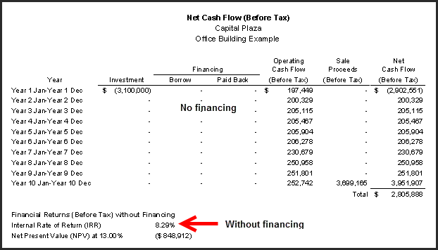

With Financing: 45% LTV $1,395,000 25 years 4.50% interest rate

Adding financing using a 45% loan to value ratio, 25 year amortization, and 4.50% interest rate changes the return from 8.29% without financing to 10.65% which is a 29% increase in the return.

Can the financing be increased?

In year 1 the Loan to Value Ratio is around 44%. The ceiling is generally around 75%

The Debt Service Ratio is 2.12. The Ratio can go down to 1.25 or lower.

Both measures suggest that the first mortgage can be increased.

How risky is the investment?

The two measures of risk are:

Debt Coverage Ratio 2.12 The Ratio can go down to 1.25 or lower

Default Ratio or the Breakeven Point 60.22%. Generally shouldn’t exceed 85%

The Debt Service Ratio and the Default Ratio suggest low risk.

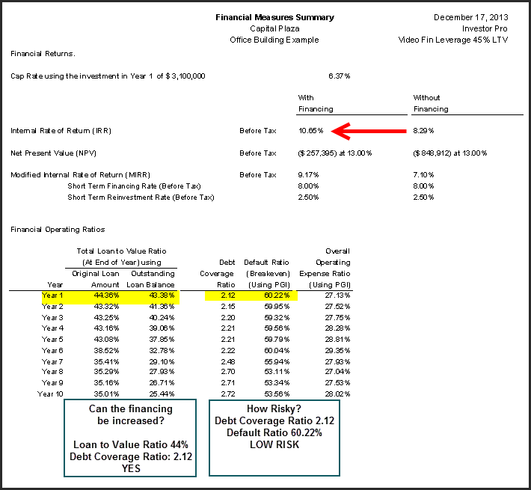.
With Financing: 75% LTV $2,350,000,000 25 years 4.50%

Adding financing using a 75% loan to value ratio, 25 year amortization, and 4.50% interest rate changes the return from 8.29% without financing to 15.24% which is an 84% increase.

Can the financing be increased?

In year 1 the Loan to Value Ratio is around 74%. The ceiling is generally around 75%

The Debt Coverage Ratio is 1.27. The Ratio can go down to 1.25 or lower.

Both measures suggest that there is little room to increase the first mortgage.

How risky is the investment?

The two measures of risk are:

Debt Service Ratio 1.27 The Ratio can go down to 1.25 or lower

Default Ratio or the Breakeven Point 82.28%. Generally shouldn’t exceed 85%

The Debt Service Ratio and the Default Ratio suggest moderate to higher risk

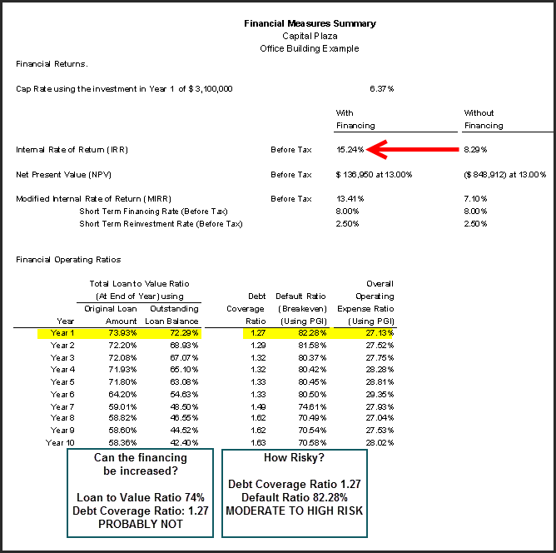

Summary. The impact of financial leverage

With no financing, the Internal Rate of Return (IRR) is 8.29%. If a mortgage is added using a 45% Loan to Value Ratio the Internal Rate of Return (IRR) changes from 8.29% without financing to 10.65% which is an increase of 29%.

If a mortgage is added using a 75% Loan to Value Ratio the Internal Rate of Return (IRR) changes from 8.29% without financing to 15.24% which is an increase of 84%.

The use of financial leverage generally increases the return (IRR) but it also increases the investment risk.

In this example, the Debt Coverage Ratio has gone from 2.12 with a 45% Loan to Value Ratio down to 1.27 using a 75% Loan to Value Ratio indicating increased investment risk.

The Default Ratio (Breakeven Point) has gone from 60.22% with a 45% Loan to Value Ratio up to 82.28% using a 75% Loan to Value Ratio.

A healthy balance is needed between the investment return and associated financing and risk.

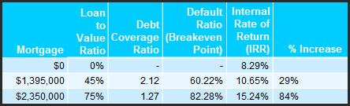

Accumulated Wealth

The above example illustrates how financial leverage increases the return on investment (IRR) but financial leverage also allows the investor to buy a much larger building and accumulate more wealth.

The funds that are available to invest are: $3,100,000.

Using a 75% Loan to Value Ratio allows the investor to buy a property that is four times larger than one purchased using an investment of $3,100,000 and no financing.

Using a 75% Loan to Value Ratio and buying the largest building possible the wealth accumulated over the ten year period is $7,581,239 compared with $2,805,888 for the all cash purchase.

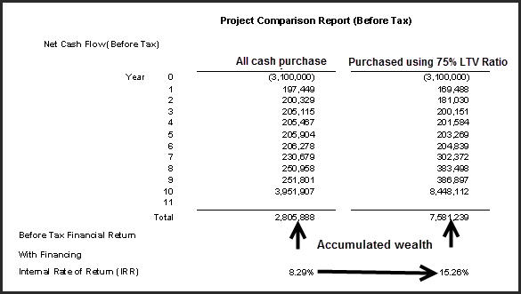

Conclusion

The use of financial leverage:

- Increases the Return on Investment (IRR) from 8.29% to 15.26%

- Allows the investor to buy a much larger property

$12,400,000 versus $3,100,000 for the all cash purchase

- Accumulate greater wealth over the holding period.

$8,851,239 versus $1,890,000 for the all cash purchase

- Increases the investment risk

If you own an income property always look for the potential to refinance

Sometimes the best strategy if you own a property there is to refinance the first mortgage and take the funds from refinancing and buy another property.

Appendices

Information Sources and web sites

www.investitpro.com Visit the Online Learning Center for educational resources, articles, etc.
www.investitacademy.com Commercial real estate education plus free resources and videos.

The following organizations provide information on income and operating expenses.

Institute of Real Estate Management (IREM)
www.irem.org
Tel: (312) 329-6000
Income/Expense Analysis. Office Buildings
Income/Expense Analysis. Shopping Centers
Income/Expense Analysis. Conventional Apartments
Income/Expense Analysis. Federally Assisted Apartments
Income/Expense Analysis. Condominiums, Co-ops & PUDs

Building Owners and Managers Assoc. (BOMA)
www.boma.orgTel: 1-800-426-6292 Office building expenses. Experience Exchange Report

International Council of Shopping Centers (ICSC) www.icsc.org
A variety of reports on sales, operating expenses, and the percentage by type of shopping center, location, etc.

National Apartment Owners Association www.naahq.org

Appraisal Institute www.appraisalinstitute.org
Excellent books on analyzing many kinds of properties including Hotel and Motels, Mobile Home & RV Parks, Apartment Buildings, Nursing Homes, Land Subdivisions, Golf Courses, Marinas, Convenience Stores & Retail Facilities, Shopping Centers, Religious Facilities, Rural Properties, Industrial Properties, etc.

www.loopnet.com USA & Canada

www.costar.com www.REISReport.com http://www.thenewsfunnel.com/
Excellent free newsletters and blogs on commercial real estate markets

www.iciworld.com Canada

CCIM Institute. www.CCIM.com or CCIM.NET CCIM.STDB (Site to do business)

Excellent site for USA and Canadian construction costs:
www.rsmeans.com

SnagIt Screen Capture program www.techsmith.com
Used to produce the screen captures used in this manual. Great productivity tool.

