Raising Your Commercial IQ

102 Real Estate Investment Analysis

In-House Program
Participant Package

Neil Osborne M.B.A.
DL. (604) 988-9964
nosborne@investitsoftware.com
Investit Software Inc.
Toll free 877-878-1828
North Vancouver BC
Canada V7R 3N4 Canada V7R 3N4
www.investitacademy.com
investit@investitsoftware.com
www.investitpro.com
Copyright

Table of Contents
LEARNING OBJECTIVES 3
AGENDA. TIME TABLE 4
PRACTICE QUIZ and 102 COURSE EXAM 6
FLASH CARD. QUESTIONS 7
Cap Rates. Issues 7
Intro. To Investment Analysis 10
IRR, NPV & MIRR Introduction 13
Cash Flow & Investment Analysis 22
Financial Leverage 33
Risk Analysis 37
Real estate taxation 43

+

LEARNING OBJECTIVES
The overall objective of the video is to provide an understanding of how to carry out in-depth real estate analysis investment and lease analysis, and how to apply investment analysis techniques to different types of properties or types of real estate decisions. How to use investment analysis to create deals.

Topics
- The significant weaknesses in using Cap Rates to make real estate investment decisions compared to the discounted cash flow approach. Examples illustrating the weakness of the Cap Rate approach to establishing value

- Time value of money concepts. The Internal Rate of Return (IRR) and Net Present Value financial measures
- Steps involved in carrying out long term real estate investment analysis and discounted cash flow analysis

- Real estate analysis. Tips and tricks

- The importance of financial leverage and accumulated wealth

- Real estate taxation

- Properties that are hard to sell because of taxes

- Seller financing. Tax issues

- Sale. Impact of mortgage restrictions

- How to use real estate analysis techniques to help list, sell or lease a property during challenging times

The knowledge and skills developed will improve your ability to value, list, sell or lease income properties and use investment analysis techniques to put deals together, make you money and help your client make wise financial decisions.

AGENDA. TIME TABLE

REAL ESTATE INVESTMENT & DISCOUNTED CASH FLOW ANALYSIS
Line  number | Play Micro Video | Manual  Page Number | Play Flash Card Set | Participant Package  Page number
1 | Apparent versus True Cap Rate (2 min) | 4
2 | Factors the effect Cap Rates (5 min) | 4
4 | Introduction to Discounted Cash Flow Analysis (7 min) | 7
5 | The Internal Rate of Return (IRR) (5 min) | 10
6 | Financial Calculators (2 min) Optional | 13
7 | The Net Present Value (NPV)  (6 min) | 13
8 | The Modified Internal Rate of Return (MIRR) (2min) | 15
9 |  |  | Cap Rate. Issues | 7
10 |  |  | Intro. Investment analysis | 10
11 |  |  | IRR, NPV & MIRR Intro | 13
12 | The Building Blocks of Investment Analysis (5 min) | 16
13 | Investment Analysis. Case study (47 min) | 17
14 | Review. Building blocks of Investment Analysis (2 min) | 33
15 | Cap Rate versus IRR (19 min) | 39
16 | Timing and Sign convention  (10 min)
17 | What does “Return” mean? (3 min) | 46
18 |  |  | Cash Flow and Investment Analysis | 22
19 |  |  | Financial leverage | 33
20 |  |  | Risk analysis | 37

Line  number | Play Micro Video | Manual  Page Number | Play Flash Card Set | Participant Package  Page number
21 | Real estate analysis. Tips and tricks (28 min) | 55
22 | The importance of Financial Leverage and Accumulated Wealth (22 min) | 56
23 | Real estate investment analysis. Summary (6 min)

SELLING A PROPERTY. & POTENTIAL CHALLENGES
Line  number | Play Micro Video | Manual  Page Number | Play Flash Card Set | Participant Package  Page number
24 | Real estate taxation (21 min) | 47
25 | Properties that are hard to sell because of taxes (4 min) | 53
26 | Seller financing. Tax issues (1 min) | 53
27 | Sale. Impact of mortgage restrictions (4 min) | 54
28 |  |  | Real Estate Taxation | 43

PRACTICE QUIZ and 102 COURSE EXAM
We recommend you take the 102 Practice Quiz to test your knowledge and measure your progress.

You can take the test many times, and the grade will be recorded and can be reviewed

Your quiz results are confidential and cannot be viewed by anyone else.

102. Course Exam.
Take the 102 course exam which is set up by a manager or office administrator.

FLASH CARD. QUESTIONS

Cap Rates. Issues
Q1.
The Cap Rate takes into account the "Time Value of Money"

True or False?
Circle your answer
Q2.
The "Internal Rate of Return (IRR)" takes into account
the time value of money.

True or False?
Circle your answer
Q3
The calculation of the Cap Rate assumes:

a) the property is never sold and

b) the Net Operating Income (NOI) is constant and goes on forever.

True or False?
Circle our answer

Q4.
Think of an example of when the Cap Rate approach to determining the value would not yield a good estimate of the value because of the way the cash flows change over time.

Flip to see an example
Your answer

Q5
Is the Cap Rate calculated using the:

Net Operating Income (NOI) and Sale Price
always correct?

Circle Your answer

Q6
Purchase Price: $3,000,000

Net Operating Income (NOI): $195,000
The Buyer deducted $450,000 for urgent major repairs to the roof and the boiler.

Calculate the "Apparent Cap Rate" and the "True Cap Rate”
Your answer

Q7
The "Apparent Cap Rate" ignores the hidden factors that may have influenced the price such as the buyer discovering that $350,000 has to be spent immediately on replacing the roof and major repairs to the HVAC system.
True or False
Circle your answer

Q8
If the Sale Price was $1,650,000 and the Net Operating Income $124,000 and the buyer deducted $300,000 for urgent major repairs.

Calculate the True Cap Rate.
Your answer

Q9
If the Cap Rate is calculated using the "Sale Price" and next years "Net Operating Income (NOI)" which one of the following statements is most correct?
- The calculation of the Cap Rate is always correct
b) The calculation of the Cap Rate is incorrect because the future value of the property has not been included

c) Using the Sale Price and the Net Operating Income (NOI) can result in an incorrect Cap Rate because of factors that you may not be aware of such as the cost of urgent major repairs that may have influenced the purchase price

a) b) c)

Circle your answer

END OF SET

Intro. To Investment Analysis
Q1.
Which would you rather have?

1) $1,000,000 today or

2) $1,000,000 in 10 years’ time?

Tick your answer

Q2.
You are going to loan me $10,000 and I’m offering the following two repayment plans. The annual payment is paid at the end of the year.

Which would you prefer as a lender Plan A or Plan B?

From your perspective as a lender which is the more risky option Plan A or Plan?
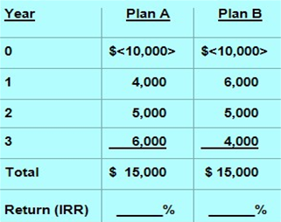

- Which would you prefer as a lender Plan A or Plan B
- From your perspective as a lender which is the more risky option Plan A or Plan?
Circle your answer your answers

Q3
What is the Internal Rate of Return (IRR)?
How do you calculate the Internal Rate of Return?

The answer
The Net Cash Flow report shows the cash flow from the time the property is acquired until it is sold allowing us to calculated the Internal Rate of Return (IRR)
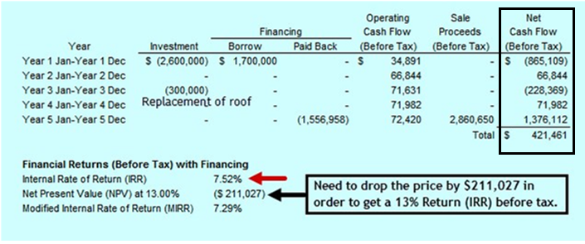

Q4.
What are the steps involved in carrying out real estate investment analysis?
The answer
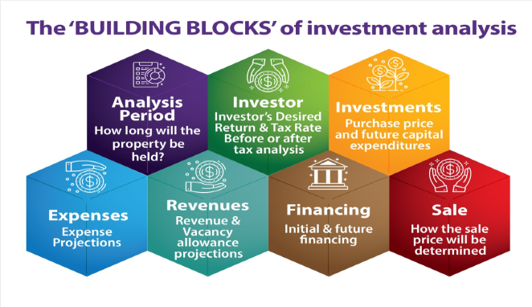

Q5
How to develop the Net Cash flows and Internal Rate of Return (IRR).

The answer
You have a choice to invest in either Property A and B. Each property will generate the following net cash flows. Which one would provide you with the best overall financial return?

Property A because the Internal Rate of Return (IRR) is 11.62% compared to 10.88% for Property B
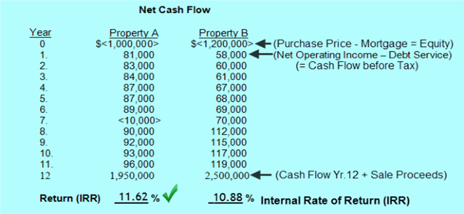

END OF SET

IRR, NPV & MIRR Introduction
Q1.
The IRR, NPV, MIRR, DCF and NCF are abbreviations for?
Your answer
IRR =

NPV =

MIRR =

DCF =

NCF = Net Cash Flow
Q2.
Which investment option would you rather have and which option is less risky?
a) $300,000 today
b) $300,000 in five years’ time
Circle your answer

Q3
Which of the following are true?

Discounted cash flow analysis considers the:
1) Time value of money

2) The impact of financial leverage

3) Changing revenues and expenses over time

4) Uses the IRR and NPV

5) The sale at the end of the Analysis Period

6) The above items are ignored when using the Cap Rate
Circle Your answer

Q4.
In carrying out long term real estate investment or discounted cash flow analysis the "Analysis Period" refers to:
Your answer

Q5
What is the generally recommended analysis period for:
a) Rental apartment buildings

b) Commercial buildings
Your answer
a) Rental apartment buildings _______ years

b) Commercial buildings _______ years
Q6
The Cap Rate and Internal Rate of Return (IRR) create the same estimate of value because they are both a 'Return on Investment"

True or False
Circle your answer
The Cap Rate approach is the best method for valuing an investment that has the following lease arrangement over the next 16 years.
Yr 1. $21 psf. per Yr.
Yrs 2- 6 $23 psf. per Yr.
Yrs 7-11 $26 psf. per Yr.
Yrs 12 -16 $29 psf. per Yr.

True or False

Circle your answer

Q8
Can you use a standard mortgage calculator to calculate the return on investment (the interest rate) for this cash flow?
Year 0. <$600,000>
Year 1. 200,000
Year 2. 250,000
Year 3. 310,000
Yes n No

Circle your answer

Q9
Which statement is correct?
a) If the Net Present Value (NPV) is positive the return is greater than the investment's discount rate or desired return
b) If the Net Present Value (NPV) is negative the return is greater than the investor's discount rate or desired return
Circle your answer

Q10
If the Net Present Value (NPV) at the Investor's discount rate or desired return is negative the return on investment (IRR) is:
a) greater than
b) less than
the Investor's desired return or discount rate.

Circle your answer

Q11
Which statement is correct?

The Investor's discount rate or desired return is used to calculate the:
a) Cap Rate
b) Internal Rate of Return (IRR)
c) Net Present Value (NPV)
d) Cash on Cash or Return on Equity
e) None of these
Circle your answer
Q12
When carrying out real estate investment analysis you look at the financial "Reward" such as the Internal Rate of Return (IRR) and the Net Present Value (NPV) PLUS......?
Your answer

Q13
If the investor's discount rate or desired return is 11% and the Net Present Value (NPV) is $<329,000> how much does the purchase price have to be reduced to get a return of 11%?
Your answer

Q14
Which items are not included when calculating the yearly cash flows from an investment in an income property?
a. Potential Gross Income
b. Vacancy Loss
c. Operating Expenses
d. Principal Payments
e. Interest Payments
f. Future Sale Price
g. Cap Rate
h. Major capital expenditures
Circle our answers

Q15
Which of the following financial measures does not take into account the "Time Value of Money"?
a) Debt Service Ratio
b) Cap Rate
c) Internal Rate of Return (IRR)
d) Return on Equity (Cash on Cash)
e) Net Present Value (NPV)
f) Modified Internal Rate of Return (MIRR)
Circle your answers

Q16
If the Investor's "discount rate" or "desired return on investment: is 13% and the Net Present Value (NPV) of a potential investment is $283,000 what does this tell you?

Your answer

Q17
What does the term "Capital Expenditure" mean?
Your answer

Q18
What does the 'Re-investment assumption" refer to when calculating the Internal Rate of Return (IRR)?
Your answer

Q19
If you received the following annual cash flow and calculated the Interest Rate the answer is 9.70%
Yr
0 <400,000
1 160,000
2.160,000
3.160,000
What is the Internal Rate of Return (IRR)?

Your answer
.

Q20
Can you calculate the return on investment or interest rate for the following investment using a standard mortgage calculator
Year
0 <730,000>
1 350,000
2 400,000
3 150,000...This is an uneven cash flow
Your answer

Q21
Which statement is correct?
a) If the Net Present Value (NPV) is positive the return is greater than the investment's discount rate or desired return
b) If the Net Present Value (NPV) is negative the return is greater than the investor's discount rate or desired return

Circle your answer

Q22
The Investor's discount rate is used to calculate the:
a) Cap Rate
b) Internal Rate of Return (IRR)
c) Net Present Value (NPV)
d) Cash on Cash or Return on Equity
e) None of these
Circle your answer

Q23
Which one of the following might be a good reference point in deciding on the "Discount Rate" or "Desired Return" when calculating the Net Present Value (NPV)?
a) A conservative second mortgage rate for the same kind of property
b) The Cap Rate from comparable properties
c) Government bond rate
d) The average return for a large REIT (Real Estate Investment Trust)
Circle your answer
We like to use a discount rate that:

Q24
The analysis of an investment property shows the following results:
Financial Returns (Before tax) with financing
Internal Rate of Return (IRR): 7.95%
Net Present Value (NPV) at 11%: $<319,118>
a) How much does the price have to be reduced to get the desired return of 11%?
b) If the price is reduced by this amount what is the IRR and the Net Present Value at 11%?
Your answers

Q25
The reinvestment assumption used when calculating the Internal Rate of Return (IRR)
a) Can cause the Internal Rate of Return (IRR) to be overstated

b) Has no impact on the Internal Rate of Return (IRR)
Circle your answer
.

Q26
If the Internal Rate of Return (IRR) is 16.17% when calculating the Internal Rate of Return (IRR) losses are borrowed at:
a) 0%
b) The interest rate used for the first mortgage
c) 16.17%
d) 15%
Circle your answer

Q27
The Cap Rate and the Internal Rate of Return (IRR) are similar measures and therefore can be compared.
True or False
Circle your answer

Q28
The Internal Rate of Return (IRR) is generally "Higher" or "Lower" than the Cap Rate?
Your answer

Q29
The results of an investment analysis of an office building are:
Internal Rate of Return (IRR): 8.27%
Net Present Value (NPV) at 13%: $<680,000>
If the purchase price is reduced by $680,000 the Internal Rate of Return (IRR) will change from 8.27% to _____% and the Net Present Value (NPV) will be $________?
Insert your answer

Q30
Under what conditions does the Cap Rate come close to being equal to the Internal Rate of Return (IRR)?
Your answer

END OF SET

Cash Flow & Investment Analysis
Q1.
What are the components of the

"Operating Cash Flow (Before tax)"?
The answer
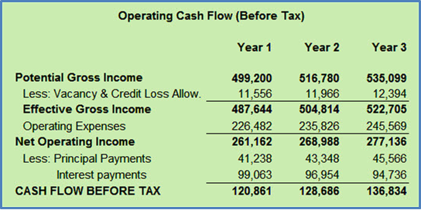

Q2.
How is the after tax cash flow calculated?
Your answer
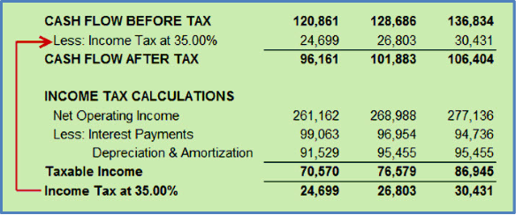

Q3
Investment analysis can be broken down into basic steps or building blocks.
The "Building Blocks of Investment Analysis" are shown on the flip side
Your answer
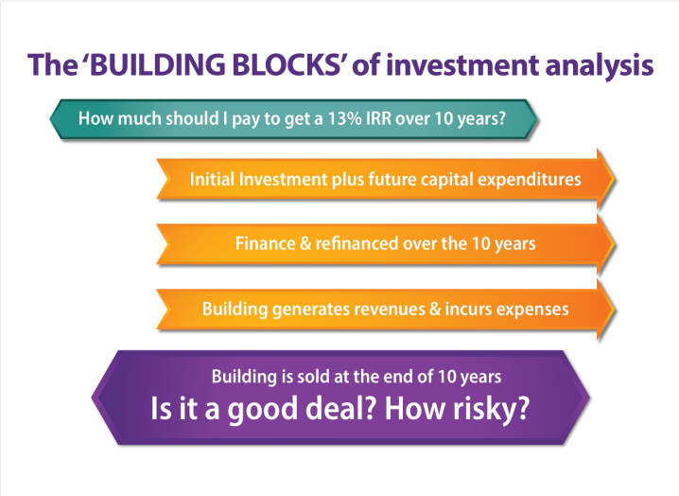

Q4.
A good starting point when carrying out investment analysis is to decide on the questions you want answered.

List some questions

Your answer

Q5
On the flip side is a summary of the steps involved in carrying out long term real estate investment analysis.
Also called "Discounted Cash Flow Analysis"
Your answer
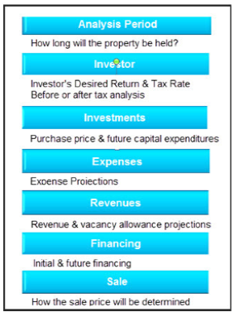

Q6
Capital Investment and capital expenditures refers to?
Your answer

Q7
What are "Operating Expenses?
Operating Expenses are regularly recurring expenses involved in maintaining and running the building.

Make a list of operating expenses
Your answer

Q8
What are "Non Recurring Expenses"?

List some non recurring expenses
Your answer

Q9
Non recurring expenses such as a leasing fee should never be included in the Net Operating Income (NOI) when using a Cap Rate to establish the value.

How do you show non-recurring expenses in an Income & Expense Statement?
Your answer

Q10.
What's the difference between:
1) Capital investment
2) Capital Expenditure or Capital Improvements
3) Expense
4) Non recurring expense
Your answer

Q11.
How do you calculate the "Cash Flow from Sale" before and after tax?
Your answer
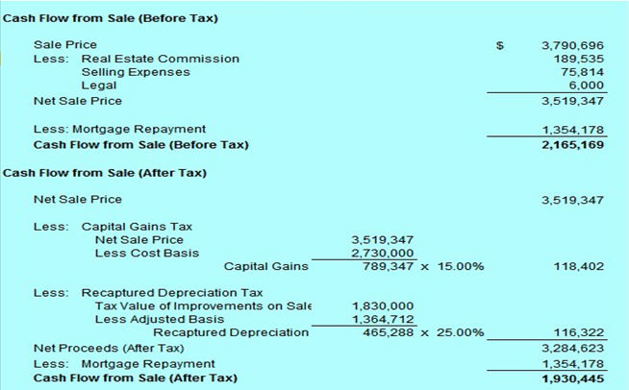

Q12.
What is the best investment analysis report that shows the big picture and the financial results and is easy to understand?
Your answer
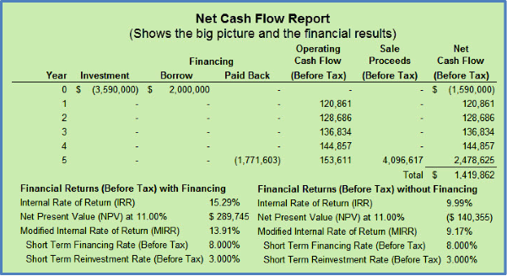

Q13.
The “Overall Cash Flow” report is an excellent report for seeing the "big picture" and the financial results all on one easy to understand report.

Your answer
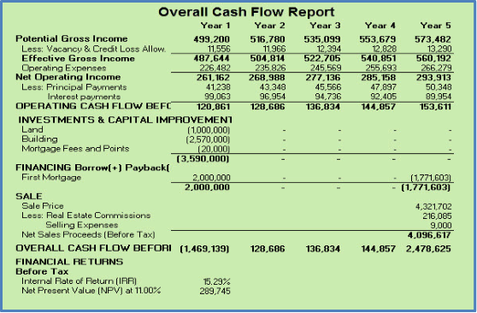

Q14.
What is 'Extra-ordinary Revenue" or "Non Recurring Revenue" and how do we treat them in cash flow analysis?
Your answer

Q15.
How would you show the following on an Income and Expense Statement?
Temporary sign rental $17,000 year 1

Leasing fee $30,000 & Minor building upgrades $21,000 both in year 2

Capital expenditure. Roof $450,000 year 3
Your answer
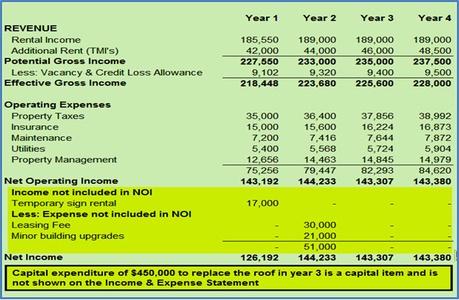

Q16.
How do you determine the Sale Price at the end of the "Analysis Period" (Also called the "Holding Period")?
Your answer

Q17.
In real estate investment analysis what does the "Analysis Period" or the "Holding Period" refer to?
Your answer

Q18.
Should the projection of revenues and expenses be done on a yearly or monthly basis?
Your answer

Q19.
What are the different ways for projecting revenues and expenses?
Your answer

Q20.
When carrying out investment analysis don't forget to consider...
Your answer
Future capital expenditures and major repairs

Potential for future refinancing

For new commercial tenants.
Free rent periods
Cost of tenant improvements (TI's) paid by the landlord Cost of tenant inducements, Leasing and legal fees.

If the tenant is vacating the space how long will it take to lease the space?

Q21.
An important aspect of real estate analysis is investigating the impact of financing on the financial return (IRR).

Financing generally increases the return (IRR) but increases the investment risk.

Always check to see if the financing can be increased now or some time in the future and if so, when?

See the impact of financial leverage on the flip side
Your answer
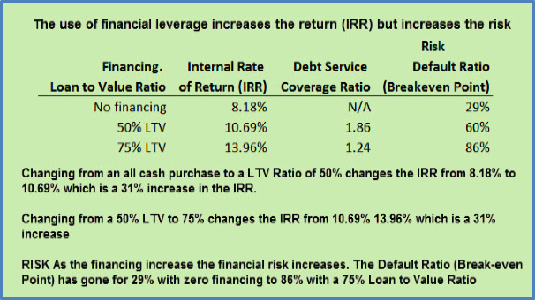

Q22.
When carrying investment analysis always check to see if the financing can be increased now or in the future and if so when?
The goal is to reduce the amount of equity required to buy the property and increase the return (IRR) through financial leverage balanced by risk considerations.

See examples showing how to determine if the financing can be increased on the flip side.
Your answer
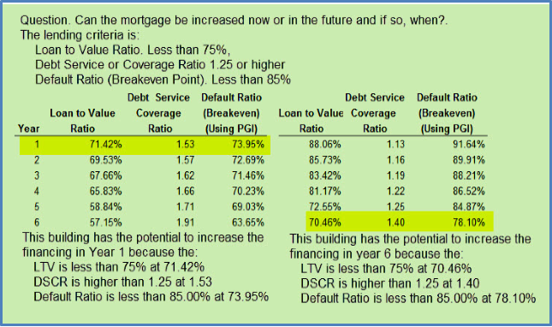

END OF SET

Financial Leverage
Q1.
What are the two financial measures commonly used by lenders to determine mortgage loan amounts.
Your answer

Q2.
Calculate the Debt Service or Coverage Ratio (DSCR) using the following information:
Net Operating Income (NOI): $200,000
Debt Service (p+i): $160,000
Note. Debt Service is the annual mortgage payment of principal and interest
Your answer

Q3
If the Debt Service or Coverage Ratio (DSCR) is 1.25 and the Loan to Value Ratio (LTV) is 75% determine the loan amount for the following mortgage:
Appraised value: $3,500,000
Net Operating Income (NOI): $245,000
Interest Rate: 5.00% compounded monthly.
Amortization: 25 years
Your answer

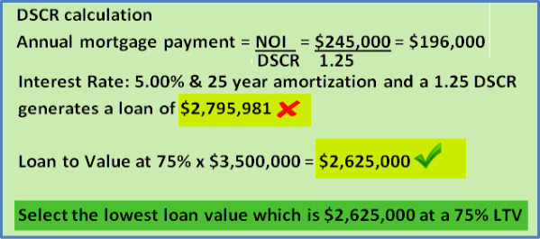

Q4.
If financing is increased from a 50% Loan to Value Ratio (LTV) to a 75% LTV what happens to the:

Return on Investment (IRR)?

Financial risk?
Your answer

Q5
In carrying out investment analysis always check to see if the financing can be increased "Now" or some time in the future and if so "When"

Flip side. If the lender is using a Debt Service or Coverage Ratio of 1.18 in what year could the building be refinanced and the mortgage increased?
Your answer
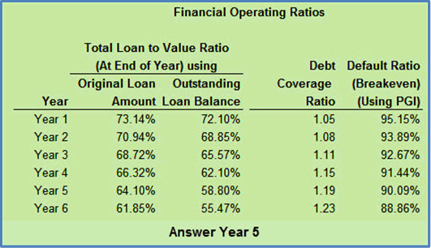

Q6
What does a Debt Service or Coverage Ratio (DSCR) of 1.25 mean from a lender's perspective
Your answer

Q7
Increasing the financing increases the return on investment (IRR) but increases the risk.

This is illustrated on the flip side which shows the return on investment (IRR) with and without financing and shows the impact on the DSCR and the Default Ratio (Breakeven Point)
Your answer
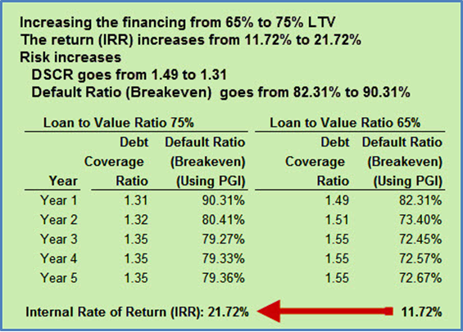

Q8
What is financial leverage?
Financial leverage refers to using finance or other people's money to purchase real estate.

Hopefully the use of financial leverage will increase the return on investment but it also increases the risk.
See example on the flip side.
Your answer

Q9
What might prevent you from increasing the first mortgage or arranging a second mortgage with the seller in order to reduce the amount of equity required to buy the property and increase the return on investment (IRR)?

Your answer

END OF SET

Risk Analysis
Q1.
The "Higher" the risk the "Higher" or "Lower" the desired return on investment?
Circle your answer

Q2.
What creates risk?
Identify some strategies that are used to reduce risk
Your answer
What create risk?

Some strategies for reducing risk

Q3
One way to identify risk is to look at the timing of the cash flows. The faster the money flows back the less risky the investment. Sooner is better than later.

This is illustrated on the flip side.
Your answer

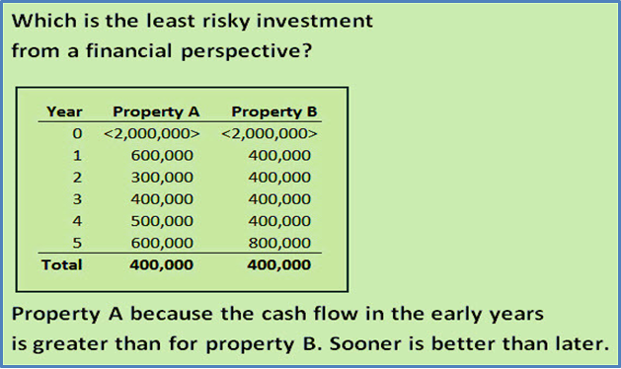

Q4.
When carrying out investment analysis which are the best financial measures for assessing the potential investment risk?
Your answer

Q5
One of the best measures for evaluating risk is the Debt Service or Coverage Ratio (DSCR)

Calculate the Debt Service or Coverage Ratio based on the following

Net Operating Income (NOI): $239,000

Debt Service (p+i): $190,000
Your answer

Q6
How can you use the Debt Service or Coverage Ratio (DSCR) to evaluate the financial risk?
Your answer
.

Q7
Another really good measure of financial risk is the “Default Ratio (Breakeven Point)” which is the point where the revenue covers the operating expenses and the mortgage payments.

Using the following information calculate the
Default Ratio (Breakeven Point)

Operating Expenses: $58,000

Debt Service (p+i): $180,538
Effective Gross Income (EGI): $292,230
Your answer

Q8
How can you use the Default Ratio (Breakeven Point) to evaluate the investment risk?
Your answer

Q9
Which investment would you consider to be less risky?
Investment A:
Default Ratio (Breakeven Point): 90%
Debt Service or Coverage Ratio: 1.13
Investment B
Default Ratio (Breakeven Point): 81%
Circle your answer

Q10
Increasing the financing on a building will increase the financial risk but will generally increase the return on investment or the Internal Rate of Return (IRR)
This is illustrated on the flip side where increasing the Loan to Value Ratio from 65% to 75% increases the Internal rate of Return(IRR) from 11.72% to 21.72% but increases the financial risk.
Your answer
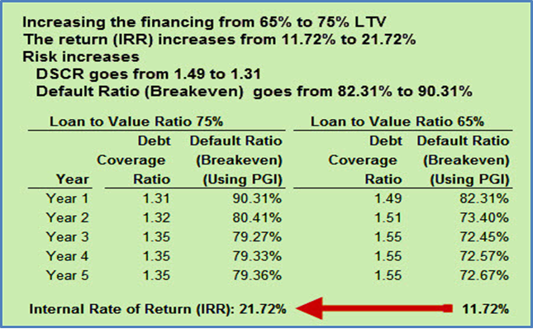

Q11
When using the Default Ratio (Breakeven Point) a high Default Ratio (Breakeven Point) such as 92% may indicate high risk but it depends on the predictability of the cash flows which may depend on the quality of the tenants.
The example on the flip side illustrates this.
Your answer
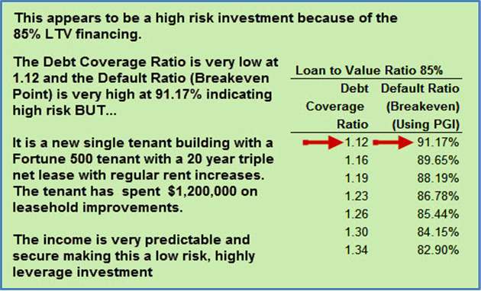

Q12
Increasing the financing generally increases the return on investment (IRR) but increases the risk.
The example on the flip side show the impact of using financial leverage.
Your answer
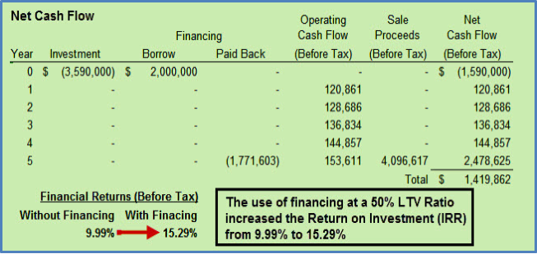

Q13
The example on the flip side shows prudent financial ratios for a safe versus a more risky investment.
Your answer
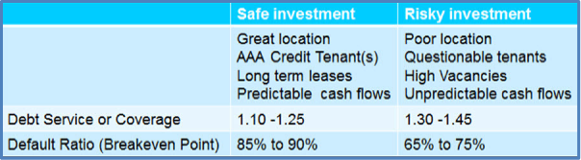

END

Real estate taxation
Q1.
When calculating taxes which of the following are “EXPENSED” and which are expensed by claiming “DEPRECIATION”?

Maintenance Expense Depreciate
Improvements Expense Depreciate
Utilities Expense Depreciate
Insurance Expense Depreciate
Roof replacement Expense Depreciate
Circle your answer

Q2.
When an investor buys a commercial property, the value of the land is claimed over time using depreciation.
True False
Circle your answer

Q3.
Recaptured depreciation tax paid by the seller because:

- The value of the improvements on sale is greater than on acquisition or..

- The value of the improvements on sale is less than on acquisition
Circle your answer

Q4.
When a property is sold, why is it important that the buyer and seller agree on the allocation of the purchase price between “Land” and “Improvements”?

BUYER
Wants the value of the improvements to be “HIGH” or “LOW”

SELLER
Wants the value of the improvements to be “HIGH” or “LOW”
Circle your answers

Q5.
What is a “Capital Gain”?
Your answer

Q6.
A “Capital Gain” is taxed at the Investor’s income tax rate.

True False
Circle your answer

Q7.
Your getting a listing to sell an income property.

The Investor has owned the property for many years, and it’s gone up a lot in value.

Why is it important for the Investor to check with her accountant before selling the property?
Your answer

Q8.
What are the characteristics of income properties that are hard to sell because of the impact of taxes?
Your answer

Q9.
Can a full depreciation claim be made in the year of acquisition?

Yes No

Circle your answer

Q10.
What is the difference between “Amortization” and “Depreciation”
Your answer

Q11.
When listing and selling a property, why is it important to review the mortgage document?
Your answer

Q12.
A CAUTION
Flip side
Taxation is complex and depends on the type of real estate and the legal entity used to own the real estate, such as a partnership or corporation and many other factors.

It is very important to get legal and accounting advice before acquiring or selling a property.

