Raising Your Commercial IQ
________________________________________________________________________________________________

103 Development Analysis and
Valuing land

In-house Training Program
Participant Package

Neil Osborne M.B.A.
DL. (604) 988-9964
nosborne@investitsoftware.com
Investit Software Inc.
Toll free 877-878-1828
North Vancouver BC
Canada V7R 3N4
investit@investitsoftware.com
www.investitacademy.com
www.investitpro.com
Copyright
LEARNING OBJECTIVES 3
Calculator 3
AGENDA TIME TABLE 4
PRACTICE QUIZ and 103 COURSE EXAM 8
FLASH CARDS. QUESTIONS 9
Introduction to development analysis and valuing land 9
Impact of soil conditions on development cost and land and value 15
Impact of excavation and foundation costs on land value 23
Impact of zoning regulations on land value 28
Market and design considerations 38
Construction financing 45
Profitability measures 53
Development analysis. Unit projects 57
Development analysis. Income properties 66
Development analysis. Monthly cash flow method 79
Analyzing “Mixed Use” developments 83
Sensitivity Analysis 85
Tips for creating an offer 91
Land assemblies 104

LEARNING OBJECTIVES
The overall objective of the video is to provide an understanding of:
- how to carry out development analysis to determine land values for unit projects such as land subdivisions and condominium projects, and for income properties such as office buildings
- the issues and difficulties associated with determining land value
Topics
- Issues related to using simplistic approaches, such as $ per Acre or Sq. Ft to value land
- The backdoor or land residual approach to valuing land
- Factors that affect land values. Examples are illustrated using photographs
- Soil conditions
- Architectural, design & zoning constraints
- Development Analysis Case Study. Condominium development
- Development Analysis Case Study. Retail center development
- Sensitivity & Risk analysis. What numbers have the biggest impact on the development profit?
- Analyzing a “Mixed” unit and income property development.
- Income property development. Sell or hold analysis
- Renovation analysis
- Profitability analysis and ratios & assessing the development risks
- Quick Proforma approach versus detailed monthly cash flow development analysis
- Construction loan requirements
- Offer to Purchase versus Options. Pros & cons.
- Tips for creating an offer
- Keeping the offer together
- Land assembly and analyzing sites with assembly potential

Skills and benefits obtained from the video
- How to analyze development sites and determine land values using the development analysis approach
- Appreciate the difficulties and uncertainties in determining land value
The knowledge and skills developed during the program will improve your ability to value, list and sell development sites or develop successful projects.

Calculator
You will need to bring a calculator. In can be any kind of calculator. It doesn’t have to be a financial calculator.

AGENDA TIME TABLE

Line  number | Play Micro Video | Manual  Page Number | Play Flash Card Set | Participant Guide  Page number
1 | Introduction to valuing land  \a(3 min) | 2
2 | Check for a demolition clause (2 min) | 4
3 | Two approaches to valuing land (4 min) | 4
4 | Land residual (11 min) | 5
5 | Total Development Cost  (2 min) | 9
6 |  |  | Introduction to development analysis and valuing land | 9

FACTORS THAT AFFECT LAND VALUE

Line  number | Play Micro Video | Manual  Page Number | Play Flash Card Set | Participant Guide  Page number
7 | Impact of soil conditions on land value (28 min) | 10
8 | Examples of factors that affect land values (5 min) | 24
9 |  |  | Impact of soil conditions on development costs and land and value | 15
10 |  |  | Impact of excavation and foundation costs on land value | 23
11 | Zoning regulations. Impact on land values (3min) | 27
12 | Building envelopes and light angles (6 min) | 28
13 | Be wary of long narrow sites (10 min) | 32
14 | Parking requirements (10 min) | 35
15 | Underground vs. surface parking. Case study (6 min) | 36
16 | Example. Highest and most stupid use (4 min) | 37
17 | Market and design considerations (6 min) | 39
18 | How to select an architect  (3 min) | 43
19 |  |  | Impact of zoning regulations on land value | 28
20 |  |  | Market and design considerations | 38

CONSTRUCTION FINANCING
Line number | Play Micro Video | Manual  Page Number | Play Flash Card Set | Participant Guide  Page number
21 |  |  | Construction financing | 45

CREATING AN OFFER
Line  number | Play Micro Video | Manual  Page Number | Play Flash Card Set | Participant Guide  Page number
22 | Tips for making an offer  (4 min) | 42
23 | Using development timelines (8 min) | 43
24 | Purchase versus an Option  (6 min) | 44
25 | Deposits and payments  (1 min) | 46
26 | Potential subject clauses  (1 min) | 46
27 | Built-in extensions (1 min) | 47
28 | Waiving “Subject to” clauses (1 min) | 47
29 | Offers on land assemblies  (1 min) | 47
30 | Tips for creating offers  (4 min) | 48
31 | Keeping an offer together  (6 min) | 49

DEVELOPMENT ANALYSIS and CASE STUDIES
Line number | Play Micro Video | Manual  Page Number | Play Flash Card Set | Participant Guide  Page number
32 | Introduction to development analysis and valuing land (9 min) | 51
33 |  |  | Profitability measures | 53
34 | Condominium development. Case study (35 min) | 54
35 | Condominium development. Sensitivity analysis (7 min) | 64
36 | Development Risks.  A story (11 min) | 65
37 | Determining the Sales Price. Challenges (1 min) | 66
38 | Realtors becoming developers. Beware (3 min) | 66
39 | Retail development. Case study (15 min) | 67
40 | Sensitivity analysis. Income property Development (13 min) | 79
41 |  |  | Development analysis. Unit projects | 57
42 |  |  | Development analysis. Income properties | 66
43 | Build and Sell or Keep  (15 min) | 83
44 | How to analyze “Mixed Use” developments  (3 min) | 89
45 | Two approaches to development analysis  (8 min) | 90
46 | Lender requirements  (3 min) | 93
47 | Renovation analysis  (1 min) | 94
48 |  |  | Development analysis. Monthly Cash Flow Method | 79
49 |  |  | Analyzing Mixed Use developments | 83
50 |  |  | Sensitivity analysis | 85

CREATING AN OFFER
Line  number | Play Micro Video | Manual  Page Number | Play Flash Card Set | Participant Guide  Page number
51 |  |  | Tips for creating an offer | 91

LAND ASSEMBLIES
Line  number | Play Micro Video | Manual  Page Number | Play Flash Card Set | Participant Guide  Page number
52 | Land assembly. Case study  (9 min) | 95
53 | Analyzing a potential land assembly (5 min) | 102
54 |  |  | Land assemblies | 104

PRACTICE QUIZ and 103 COURSE EXAM
We recommend you take the 103 Practice Quiz to test your knowledge and measure your progress.

You can take the test many times, and the grade will be recorded and can be reviewed

Your quiz results are confidential and cannot be viewed by anyone else.

103. Course Exam.
Take the 103 course exam which is set up by your manager or office administrator.

FLASH CARDS. QUESTIONS

Introduction to development analysis and valuing land
Q1.
How do you go about valuing land?
Your Answer

Q2.
How does the “Land Residual” of “Back Door” approach to valuing land work?
Flip side
Following is an example of the “Back Door” or “Land Residual” approach for valuing land where we work backward to calculate the land value.

We calculate the market value and then deduct all the development costs, real estate fees and closings costs, and the desired development profit to give us the land value.

Condominium Development Example
Market Value. 30 units x $350,000 $10,500,000

Less: Development Costs
Site clearing and preparation
Construction
Financing
Professional fees
City permits and fees
Miscellaneous 6,575,000

Real estate fees 25,000
Developer’s Profit 1,900,000
Land Value (The Land Residual) $1,500,000

Residual means “What’s left over”

Q3.
Why is it called the “Land Residual.”
Your Answer

Q4.
Can the “Land Residual” or “Back Door” approach to determining land value be used on a site where there’s an existing older building?
Your Answer

Q5.
How can we tell if a site with existing buildings has development potential?
Your Answer

Q6.
Does an old obsolete income property always have development potential?
Flip side
This property looks like it has development potential but does it?

It would be very difficult to redeveloped this site and build condominium or rental units because of the city regulations that would require:
1. Front yard and side yard set backs
2. Underground parking
This would be a risky investment. If the building burnt down it would be very difficult to replace the building because of the zoning and building codes. It’s called a non-conforming property.

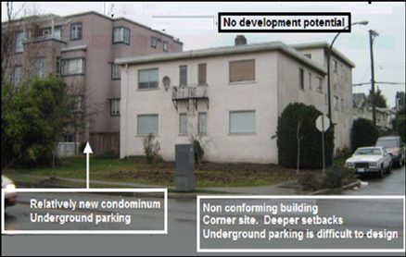

Q7..
The development potential of an old building on a narrow lot often depends on a land assembly.

It’s very difficult and costly to develop a building on a narrow site, 50 feet or less if underground parking is required.
Flip side
The area where buildings A, B, and C are located is zoned for hi-rise development with retail on the ground floor with offices and condominiums above, which will have a spectacular view of the mountains and downtown area.

On their own, it’s not possible to economically develop individually sites A, B, or C because they are narrow sites.

It requires and assembly of either buildings A & B or B & C or A, B, and C to effectively develop these obsolete rental properties.

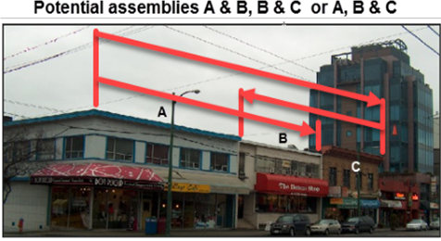

Q8..
Beware of long narrow sites. Why?
Your Answer

Q8.
A good starting point in carrying out development analysis to determine the land value is the have an architect develop sketch plans.
WHY?
Your Answer

Q10.
What do architectural sketch plans look like?
Flip side
Architectural sketch plans can be rough and simple or more detailed, as shown in the two examples below.
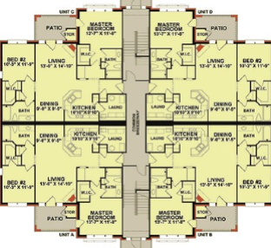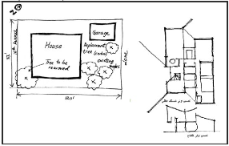

Q11.
How does a developer determine an acceptable development profit?
Your Answer

Q12.
.Are there circumstances where a developer might accept a lower development profit, such as 12% of Total Development Costs?
Your Answer

END
.

Impact of soil conditions on development cost and land and value

Q1.
It is very difficult to value land. WHY?
Your Answer

Q2.
Soil conditions can have major impact on foundation and construction costs.
Provide some examples of soil condition that would impact the value of land
Your Answer

.

Q3..
How are soil tests done?
Flip Side
Various soils test are conducted on-site and laboratory analysis caries out to decide the quality of soil for building construction purposes which help the architect and structural engineers design the building.

On-site drilling using a drilling rig, as shown in the photo, is a standard method for carrying out a soil test.

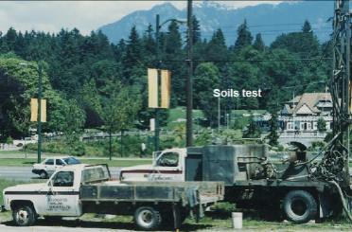
A soil test is carried out before the design of a condominium building with underground parking.

A wonderful location.

Q4.
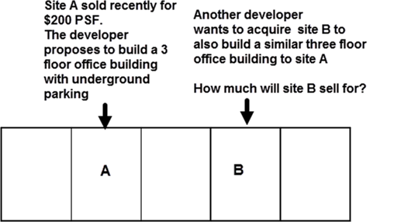

Your Answer

Q5.
What is expandable clay?
Your Answer

Q6.
On the flip side are some examples of the damage to buildings created by expandable clay.
Flip side
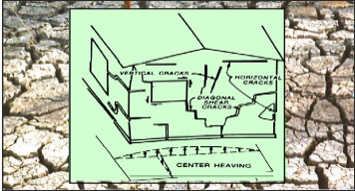

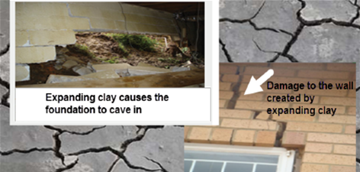

Q7..
What are some of the ways architects and engineers use to deal with expandable clay to prevent building damage?
Flip side
Techniques for dealing with expandable clay

Remove and replace the expandable soil with stable fill
Keep water away from the building
Slope the soil away from the building
Install a waterproof apron or moisture barrier around the building
Use pilings to support the structure
Design flexibility into the structure (See examples below)
Separate paved areas and slabs from the main structure
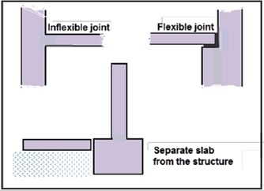
Examples of flexible versus inflexible structural design used to prevent building damage caused by expandable clay

Q8.
What is organic soil?
Your Answer

Q8.
For examples of organic soils see the flip side
Flip side
Examples of organic soil, buried materials and rubbish.
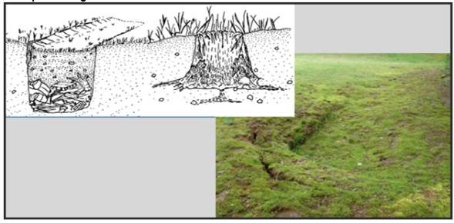

Q10.
What are sink holes, and how do sink holes develop?
Your Answer

Q11.
When I first got involved in development, I was looking for an industrial site to develop an industrial building. I found a large site where the price per acre seemed cheap compared to similar sites elsewhere.

Why was the price per acre so cheap?
Flip side
When I told the senior partner he replied: That’s on river road where:
a) A large amount of fill has to be bought in to bring the ground level with the road
b) The organic soil and peat moss has to be removed and replaced with compacted fill
c) Expensive pilings have to be used to support the foundation and structure

The cost to develop this industrial site is very high hence the low price per acre. Not such a great deal after all.

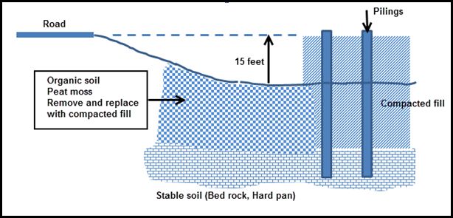
Q12.
Building on unstable soil may require pilings driven into the ground to support the foundation and building.

Pile driving is a costly and time-consuming process that lowers the land value.
Flip side

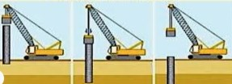

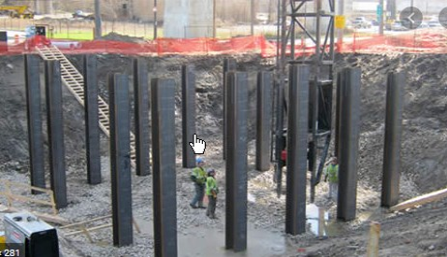

Q13.
What is “Pre-loading”?
Your Answer

Q14.
What is dynamic compaction?
Your Answer

Q15.
How does the developer reduce the risks associated with soil conditions on construction costs, development profit, and land value?
Your Answer

Q16.
Can the impact of soil conditions on construction costs kill a project?
Your Answer

_______________________________________________________________
Q17.

It looks like the “Geoscientist” and “Engineers” didn’t get it right.
Flip side

END

Impact of excavation and foundation costs on land value

Q1.
How do excavation and foundation costs impact land value?
Your Answer

Q2.
What is underpinning
Your Answer

Q3..
Show me an example of:
1. Underpinning
2. What can happen to adjacent buildings if not underpinned during excavation?
Flip side.
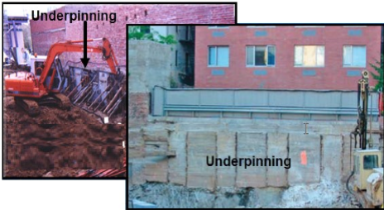

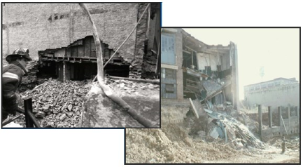
Failure caused by inadequate or no underpinning of the adjacent property

Q4.
What is “Shotcrete” or “Gunite?
Your Answer

Q5.
Example of protecting the building adjacent to the site being excavated to develop a hotel and condominium tower on the flip side.

Flip side
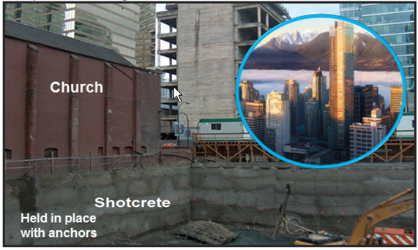

Q6.
A client had a piece of land in Brooklyn, NY, in a neighborhood that was being gentrified.

He proposed building a three storey condominium development.

The adjacent buildings bordered on the property line. I.e., there were no side yard setbacks.

He asked me what he had to look out for related to construction?

1. What questions would you ask him?

2. What should he worry about?

Your Answer

Q7..
True case.

When excavating against an existing building, even though the excavation is shallow, E.g., 3 to 4 feet, there will likely be a need to underpin to protect the adjacent building from damage.

What can happen if the foundation of the adjacent building is not underpinned?
Flip side
The structural engineer and the City required the developer of a warehouse facility to underpin the foundation of the adjacent warehouse.

The developer didn’t provide the specified underpinning to save money, and the side concrete block wall collapsed into the hole.

A very costly and dangerous decision, including a lawsuit and damages.
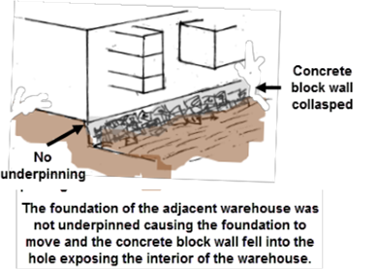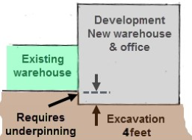

END

Impact of zoning regulations on land value

Q1.
A large number of architectural, design, and building code regulations reduce the buildable area, increase the construction cost, and reduce the land value.

Write down some examples.
Your Answer

Q2.
How is the maximum buildable area calculated?

What are some of the dangers of using the buildable area to determine what can be built on the site?
Flip side
You have found a site that is zoned for condominiums and want to determine how many one bedroom units can be built on the site.

Floor Area Ratio (FAR): 2.5 (specified in the zoning regulations)
Site Size: 125 feet x 120 feet

The objective is to build large one bedroom units for the first time home buyer market

Average Suite size: 800 Sq. feet
Common Area: 100 Sq. feet per unit
Gross Area: 900 Sq. feet

Buildable Area: FAR x Site Area = 2.5 x 125 x 120 = 37,500 Sq. Ft

Number of one bedroom units:
= Buildable area = 37,500 = 41 Units
Gross area per unit 900

This answer is nonsense. Why? See next flash card.

Q3..
Why is this calculation incorrect?

Number of one bedroom units

= Buildable Area
Gross Area per Unit

= 37,500 = 41 One bedroom units
900
This is Nonsense. Why?
Flip side
Why is this calculation nonsense?
Buildable Area: FAR x Site Area = 2.5 x 125 x 120 = 37,500 Sq. Ft

Number of one bedroom units:
= Buildable area = 37,500 = 41 Units
Gross Area per Unit 900

The calculation provides us the maximum buildable area.

There are many factors that reduce the maximum buildable area, including:

Zoning and building regulations such as building envelopes
Design & market considerations

Q4.
What are building envelopes?
Your Answer

Q5.
Provide some examples of vertical light angles
Your Answer

____________________________________________________________________

Q6.
Example. Fort Lauder beaches

Another example of using vertical light angles to allow sunlight into the street using vertical light angles.
Flip side
This example is located in Fort Lauder. Earlier buildings did not incorporate vertical light angles, which prevented sunlight from reaching the popular beach walk and shading a portion of the beach in the late afternoon.

The shading problem was solved by the City using vertical light angles to allow sunlight into the street.

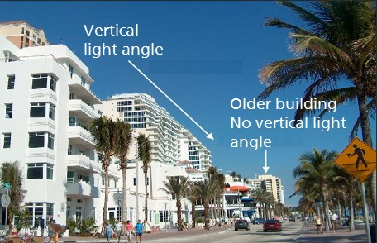

Q7..
An interesting and unusual example of shadow prevention.
Flip side
No building can cast a shadow on the Alamo.

Nearby downtown buildings are limited to 12 floors and can’t cast a shadow on the Alamo, a historical building in San Antonio, Texas.

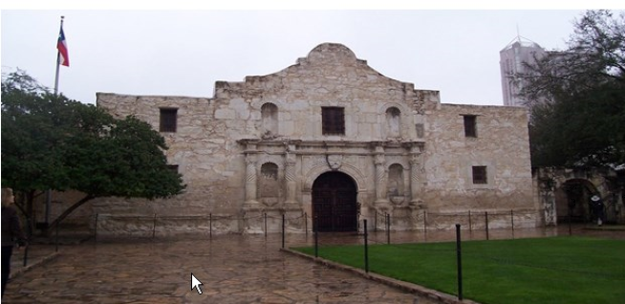

Q8..
What are “Horizontal Light Angles”?
Your Answer

Q8.
An example of the impact on a buildings shape created by horizontal light angles.
Flip side
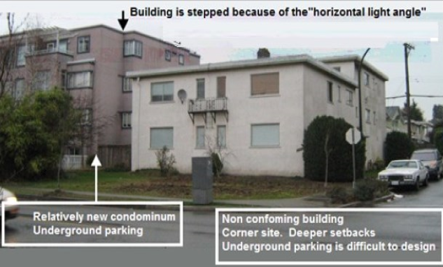

Q10.
What’s a “Traffic View Angle.
Your Answer

Q11.
What’s a corner or double set back?
Your Answer

Q12.
The size and the shape of the lot and the intended use influence the size and shape of the building and land value.
Flip side

Two industrial sites with the same area of 150,0000 Sq. Ft but different shapes.

Site a has a 38% site coverage. Site B is narrower but a longer site than Site B with a 19% site coverage. Provision has the be made for maneuvering the semi- trailers into the loading docks which requires 88 to120 feet.

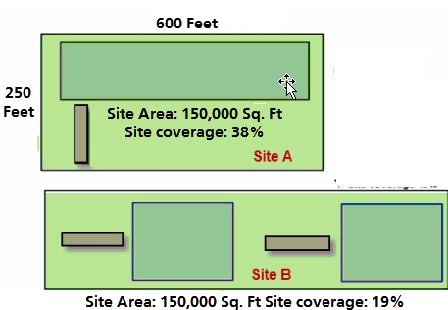

Q13.
If site A sold recently for $3,000,000 or $25 per Sq. Ft what will site B sell for?
Your Answer

Q14.
Underground parking design.

A site width of 50 feet versus 75 feet is more difficult to design efficient underground parking. Why?
Your Answer

Q15.
On the flip side is an example of the underground parking for a 45 foot wide site.
Flip side
This examples shows how difficult and costly it is to create underground parking on a narrow site.
The ramp to the underground parking is curved
There is only space for four cars after providing the stairwell and electrical room.

Very costly. The cost per parking space is very high.

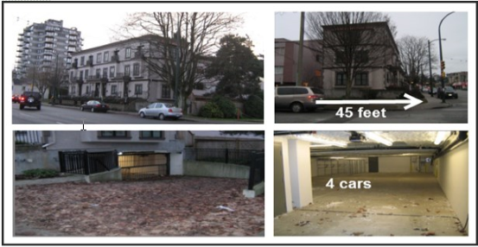

Q16.
An architectural engineering firm acquired a site to build a building where the firm would occupy around 3,000 Sq. Ft.
The zoning allows:
1. Wood frame. Three floors with surface parking at the rear and around 9,000 Sq.Ft
2. Wood frame. Three floors with one level of underground parking for 15,000 Sq. ft
3. Concrete building. Two floors of underground and five floors for 25,000 Sq. Ft

The question is “What should they build?
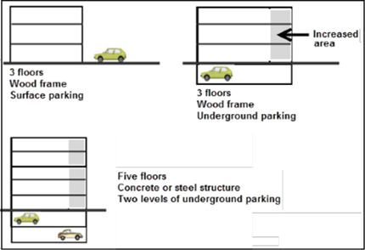
Flip side
The large concrete building with two levels of underground parking and five floors was quickly eliminated. The cost per Sq. Ft was much higher and couldn’t be supported by the local rent rates. The location was close to downtown but it was questionable if the area could absorb 25,000 Sq. Ft of office space. Required a lot of equity. High cost , high risk.

The three floor, wood-frame building with surface parking, was chosen as the safest investment for this local area. The economics of a three floor wood-frame building with underground parking couldn’t be justified.

The decision was made using development analysis to compare the three development options. The result was choosing the lowest cost, lowest risk option.

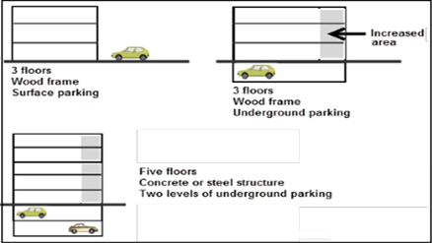
The building was completely leased before construction was completed to a government agency.

A photo of the completed building is on the next flash card

Q17.
On the flip side is a photo of the completed building.
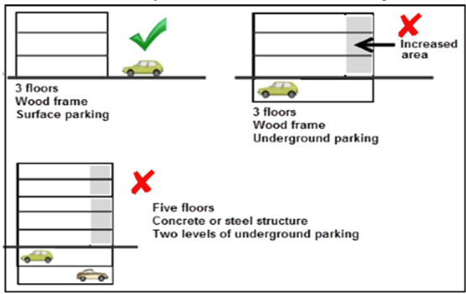
Flip side
The completed and fully rented three floor wood frame office building with surface parking at the rear of the building.

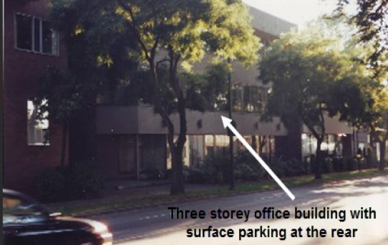

Q18.
What is the “Concept of highest and most stupid use.”?
Your Answer

Q19.
Can a developer always build one large building on the site?
Your Answer

Q20
What are retention ponds or storm water basins, and how do they impact land value?
Your Answer

END

Market and design considerations
Q1.
The last flash card set explored the impact of zoning and building regulations that reduces the buildable area and lowers the land value.

We will now explore the impact of design and market considerations on the buildable area and land value.

Example
A developer targeting the one bedroom room condominium market has instructed the architect to design the floor plans using only one bedroom units. Can this be done?

Building size: 150 feet x 54 feet deep.

Typical unit sizes
One bedroom units: 22 feet wide x 25 feet deep. 550 Sq. feet
Studio units: 18 feet wide x 25 feet deep. 450 Sq. Feet
Flip side
No. The architect cannot do a layout that has all one bedroom units.

The layout below shows why this is not possible

Each floor can have 12 one bedroom units and two studio units except for the ground floor because of the space taken up by the lobby.

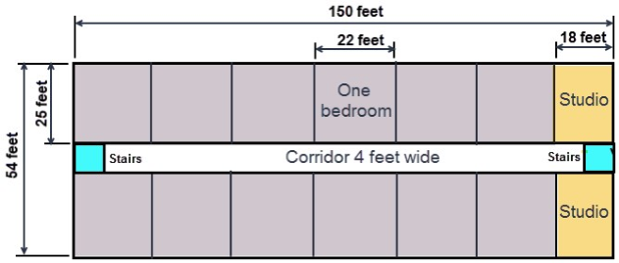

Q2.
The floor plan suite layout is much more complex than the previous flash card example.

In designing the floor plan, the architect has to include in the design:

- A firewall, which is located near the center of the building, which prevents fire from spreading from one side of the building to the other side.

- An elevator

- Laundry room

- A lobby on the ground floor

Flip side
The architect needs to provide the firewall in the center of the building plus an elevator and laundry rooms which complicates the floor layout.

The final result would be a combination studio and one bedroom units, possibly including some two bedroom units.

Achieving a floor plan with all one bedroom units is not be possible.

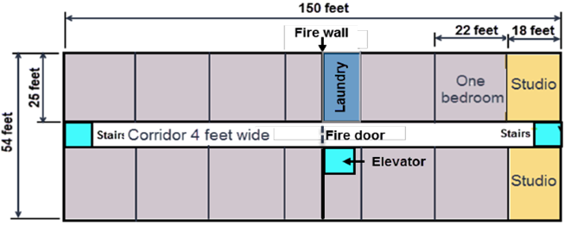

Q3..
Can you think of retail examples where you wouldn’t build the maximum space allowed for the site because of the tenant’s space needs?
Your Answer

Q4.
What are some of the design challenge facing architects when designing rental or condominium units?

Flip side
When laying out the units, the living room and bedrooms have to have windows, which complicate the layout.

The images below show the typical layout and dimensions for one and two bedroom units.
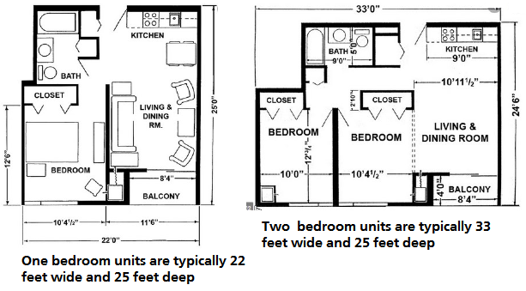

Q5.
Due to the Covid virus there may be less need for office space as more employees work from home.

What are the design and construction challenges in converting and office building to rental or condominium units?
Your Answer

Q6.
Beside market and design considerations can you think of other things and architect may have to consider when designing a building?
Your Answer

Q7..
A developer was considering buying an old retail property, demolishing the building and developing a three storey building with retail on the ground floor and offices on the second and third floor.

There was large cedar tree on the site which the City wanted protected because it was a neighborhood landmark.

Protecting the tree would result in less rentable area and reduce the value of the property.

Calculate the drop in value based on:

Lost rentable area: 25 feet x 25 feet x 3 floors = 1,875 Sq. Ft
Average rent rate: $27 psf per yr.
Cap Rate : 7.50%
Your Answer

Q8.
How can an industrial building be built on slopping land? and what’s the impact on the land value and development costs?
Your Answer

Q8.
If you are going to be involved in land sales you need to get to know some architects. WHY?
Your Answer

Q10.
True case
Having an architect develop sketch plans for free to market a potential development site.
Flip side
A realtor was aware of a large site that consisted of two side-by-side properties owned by the same owner, each with a different low-density zoning.

He asked an architect to develop some sketch plans for the site.

The architect suggested consolidating the two sites and then have the consolidated site rezoned for four storey condominium development.

The two properties had been on the market for some time at around $1,000,00 but had not sold.

The idea of consolidating the two properties and rezoning to a higher density was presented to a developer, and the site sold for around $1,300,000, which is $300,000 over the original asking price of $1,000,000.

END

Construction financing
Q1.
What the difference between a construction loan and a conventional mortgage?
Your Answer

Q2.
How does Construction or Draw Mortgages work?
Your Answer

Q3.
What does a construction draw schedule based on reaching specified milestones look like?

Develop an example.
Your Answer

Q4.
What is a “Builders Lien” or Lien Holdback?
Your Answer

Q5.
Assume you are a construction lender and offering the following construction loan on a condominium development:

Development cost: $5,000,000
Construction loan 75% of development costs: $3,750,000
Developer’s equity 25%: $1,250,000

What would be two important conditions of the loan agreement that reduce the risk for the lender?
Your Answer

Q6.
Assume you are a construction lender and offering the following construction loan on an income property such as an office building development.

Development cost: $7,000,000
Construction loan 75% of development costs: $5,250,000
Developer’s equity 25%: $1,750,000

What would be the three major conditions of the loan agreement to reduce the risk for the lender.
Your Answer

Q7..
What’s a “Construction to Permanent Loan”?
Your Answer

Q8..
Why might the developer of an office building not want to arrange the long-term loan as requested by the construction lender?

Is there another option that satisfies both the needs of the lender and the developer?
Your Answer

Q8.
What the difference between:

Recourse loan

Non recourse loan?

Your Answer

Q10.
What are” personal guarantees” and “limited personal guarantees”?
Your Answer

Q11.
What are “Limited Liability” Personal Guarantees?
Your Answer

Q12.
What’s an “Origination” Fee?
Your Answer

Q13.
What’s involved in applying for a construction loan?
Flip side
The amount of equity needed to fund a development project will depend on the type of development and the risks involved from the lenders perspective.

A good starting is that the developer’s equity is equal to the land value or higher.

In some cases, the lender maybe willing to fund a portion of the land value which reduces the developer’s equity.

If the lenders Loan/Cost Ratio is 75% then the developer’s equity will be 25% of the development costs.

Q14.
How does the construction loan application process and requirements affect the Offer to Purchase?
Your Answer

Q15.
How much equity does a developer need?

Any ideas?
Your Answer

Q16.
How does the lender secure the construction loan?

Can a second mortgage be placed on the land?
Your Answer

Q17.
If the landowner wants to be involved with the developer in developing the land and share in the profits, what are the benefits and risks for the landowner.
Your Answer
The landowner could end up with nothing or very little money for the land.

Q18.
A developer wants to acquire some land to rezone to multifamily, build a and sell a condominium project.

The developer has offered the landowner an opportunity to be involved in the development by contributing the land and sharing in the development profits.

The development steps are:

1. Rezone the land from single-family to multifamily zoning
2. Construct the condominium building
3. Sell the units

Can you think of a way to involve the landowner in profit sharing while avoiding the development risks and losing a lot of money if the development fails financially?
Your Answer
.

Q19.
Calculate
1. Rezoning profit
2. How much the landowner receives for the land

1. Value of the land before rezoning: $3,000,000
2. Value of the land after rezoning to multifamily use: $4,500,000
3. Cost of rezoning paid by the developer: $80,000
4. The cost of rezoning of $80,000 is deducted from the rezoning profit when calculating the profit
5. Rezoning profit sharing
Land owner: 40%
Developer: 60%

Your Answer

END

Profitability measures
Q1.
How do you determine if the development profit is realistic?
Flip side
A development analysis indicated a development profit of $6,400,000.

How do we know if this is a reasonable profit?

An acceptable development profit depends on the development time and the risks involved.

The higher the risk, the higher the development profit

For a typical moderate risk development taking two years, the development profit should be around 20% to 25% of “Total Development Costs.”

“Total Development Costs” are all the development costs to the point where leasing or renting commences or the sale of units or lots starts.

Q2.
How do you determine if the development profit is realistic?

As an example, if the development profit is $3,200,000

Is this a good deal?
Flip side
If the development profit is $3,200,000, we can’t tell if it’s a good deal.
Examples

If the development cost was $45,000,000, the profit of $3,200,000 is too low, given the amount of money involved and the development risk.

On the other hand, if the development profit is $3,200,000, and the development cost $21,000,000, this might be an acceptable profit.

To evaluate the development profit, we use several measures of profitability.

See the next flash card.
If the development profit is $3,200,000, we can’t tell if it’s a good deal.

See the next flash card.

Q3.
What are the measures of profitability?
Flip side
% of TOTAL DEVELOPMENT COSTS.
Typically 25% for a medium risk development taking several years and 15% for industrial developments.

% of SALES REVENUE
Not widely used because it is hard to predict the sales revenue or market value, which is several years away. It’s much easier to predict the “Total Development Cost” than the sales revenue or future market value.

RETURN ON EQUITY
Developers will often look for a Return on Equity greater than 100%, which means they want to more than double their equity or investment in the development. Useful ,but some what questionable measure as the Return on Equity is dependant on how much construction financing is involved.

Q4.
What are the Land & Development Cost Measures used to evaluate a development project?
Flip side
Land & Development Cost Measures
The following measures can be used to check if the building and development cost estimates are realistic for the City and the location?

1. Land to Building Cost Ratio
2. Land to Development Cost Ratio

These ratios depend on the City and the location. In areas where the land prices are very high, the land to Building cost and Development Cost Ratios will be high, and they will be much lower in areas where the land costs are low.

Developers familiar with the type of development and location usually have a good feel for the value of the ratios, and they use them to check the accuracy of the development analysis.

A high ratio requires a high sale price or high rents and a low cap rate to offset the high land cost.

These kinds of ratios can be helpful.
Development profit per unit, per square foot, and per lot, etc.

Q5.
On the flip side is an example using the Profitability Measures
Flip side
Condominium Development. Profitability measures
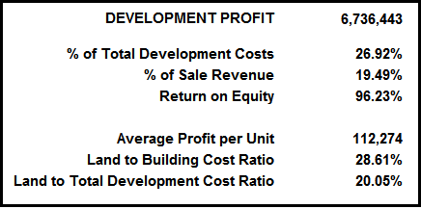

Q6.
On the flip side is an example of a bid proposal for a low risk development.
Flip side
True Case Study

Prime industrial land
The developer owns the land
Soils test, architectural and engineering design have been completed
Construction bids have been received, and the construction costs and time and financing costs are known.

The developer has been asked to submit a proposal to construct the building and sell it to a Triple A industrial tenant.

This is a low-risk development. The developer knows that there are other developers submitting a proposal.

Using the sale price that achieves a development profit of 25% of Total Development Costs would result in a high, non-competitive sale price.

Because of the low risk, the developer used a Development Profit of 12% of the Total Development Profit in structuring the deal.

END

Development analysis. Unit projects
Q1.
What are the building blocks for analyzing a unit development like a condominium development or land subdivision?
Flip side
The building blocks of development analysis for unit projects like a condominium development or land subdivision.
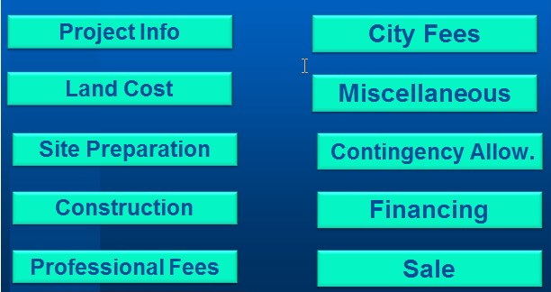

Q2.
What information is needed to analyze a unit development like a condominium development or a land subdivision?

Part 1 Development Cost and Unit Sales
Flip side
PROJECT INFORMATION
Basic information used to develop the development costs and sales revenue, such as the number of units or lots, building area, etc.

LAND COST.
Cost of the land and acquisition costs such as legal and appraisal fees.

SITE PREPARATION.
Clearing the land, removing buildings, trees, etc.

CONSTRUCTION.
Cost to build the building, underground parking, landscaping, etc. All the costs to complete the development ready for sale.

PROFESSIONAL FEES.
Architects, engineers, geoscientists, lawyers, appraisers, environmental engineers, building envelope specialists, mortgage brokers, etc.

CITY FEES
Application and processing fees, crossing permits. A significant cost is Development Cost Charges (DCC’s) or Impact fees.

Q3.
What information is needed to analyze a unit development like a condominium development or a land subdivision?

Part 2. Timing
Flip side
TIMING
In order to calculate the interest costs, the following times are needed:
Time to get the required permits before construction can start.
Construction time.
Sales time.Time to sell the units or lots taking into account presales.

Q4.
Condominium Development. Input example

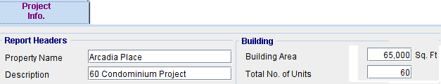
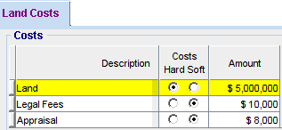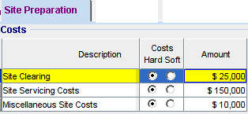

Flip side
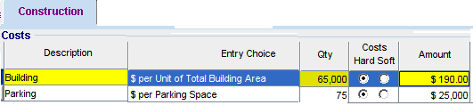
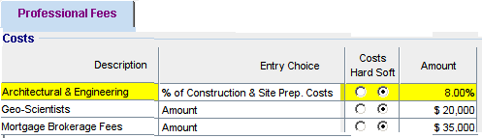

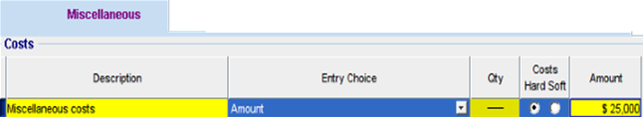

Q5.
Condominium Development. Inputs continued.
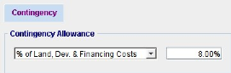

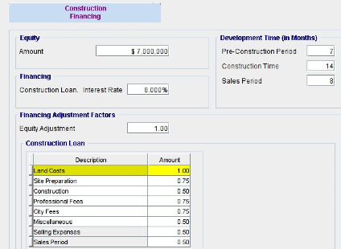

Flip side
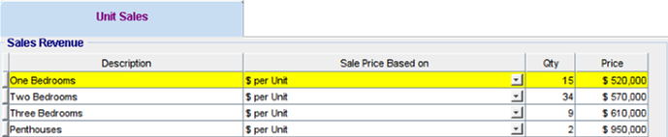

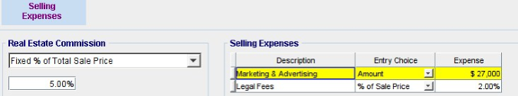

Q6.
What does the “Quick Proforma” development analysis look like for a condominium development?

Where we:

Buy the land
Construct the building
Sell the condominium units
Flipside
The development analysis indicates a development profit of $6,393,034, which is 25.54% of the “Total Development Costs” with a land price of $5,018,000.

 | 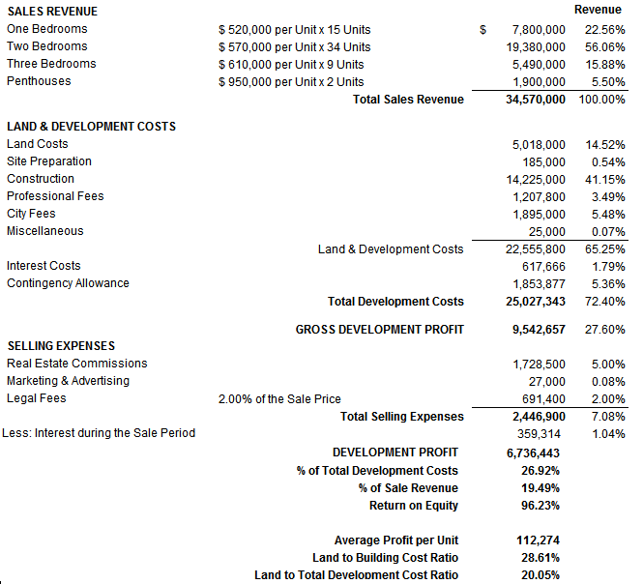 |  |  |  |  |  | % of

Q7.
What is “Goal Seeking” and how can it be used in analyzing the condominium development?
Flip side
“Goal Seeking” can be used to establish the price to pay for the land to achieve the desired profit.

To achieve a development profit of 27% of Total Development Costs, the most we can pay for the land is $5,004,883

If we want a 100% Return on Equity (i.e., double our equity investment), the most we can pay for the land is $4,809,495

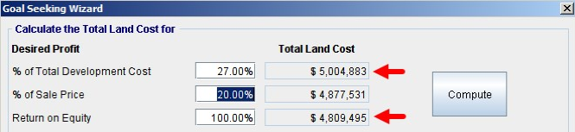

Q8.
What are “HARD COSTS” and “SOFT COSTS”?
Your Answer
Hard costs ____________________________________________
____________________________________________

Soft costs____________________________________________

____________________________________________

Q9.
Construction Cost Report. Hard and Soft Costs
Flip side
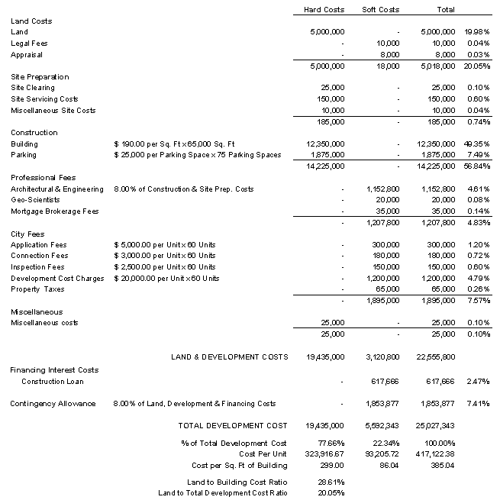

Q10.
How is the construction interests costs calculated?
Flip side
Calculating the total interest costs is tricky because the construction loan is a “Draw mortgage” and drawn down in stages. If the construction cost is $14,225,000, the lender advances funds as the construction proceeds based on the cost to complete as ascertained by an independent professional.

To adjust the interest costs, we use “Financing Adjustments Factors” to modify the interest calculations because the loan is drawn down in stages as the construction progresses.

In this example, the “Financing Adjustment Factor” for the construction portion of the loan is “0.5”.

Continued on the next flash card

Q11.
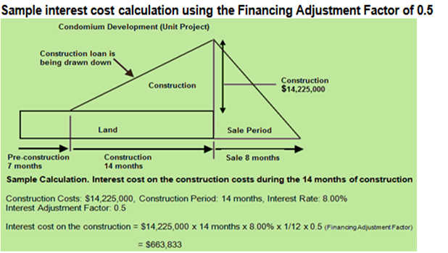

Flip side
Condominium development. Interest cost calculations
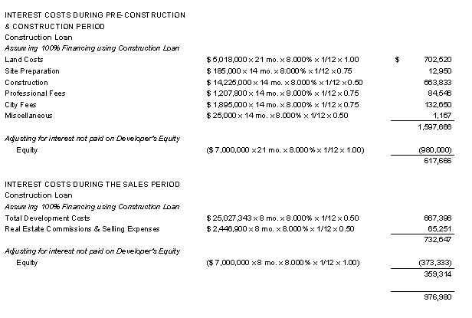

Q12.
What are the typical Financing Adjustment Factors used to calculate the development interest costs?
Flip side
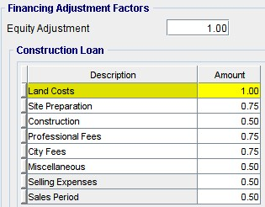
Some examples
Construction. FAF 0.5 because the construction portion of the loan is drawn down over the construction period.

Professional Fees and City Fees. FAF 0.75 because most of the fees are paid before the start of construction.
END

Development analysis. Income properties

Q1.
What’s the difference between analyzing unit developments like condominium and land subdivisions versus income property developments like an office building or a rental apartment building?
Flip side
UNIT PROPERTY DEVELOPMENT (Condominiums, land subdivisions, etc.)
1. Buy the land and obtain the building permits
2. Build the building
3. Sell the units

Value. Based on the sales price per unit or price per lot, times the number of units or lots.

Lender requirement. A specified amount of presales before funding commences.

INCOME PROPERTY DEVELOPMENT (Offices, industrial, retail and rental apartments)

1. Buy the land and obtain the building permit 2. Build the building
3. Lease up space. This generates Income & Expenses during the lease-up period
4. Sales period. Time to find a buyer. Generates Income & Expenses during the sales period

Value. Based on the Cap Rate and the stabilized Income and Expenses

Lender requirement. A specified amount of preleasing before funding is advanced.

Q2.
When carrying out an analysis of an income property development, what questions do we want to answer?
Your Answer

Q3.
What are the building blocks for analyzing income property developments like rental apartment buildings, office, industrial and retail developments?
Flip side
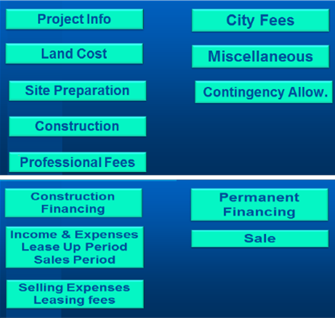
Q4.
What information is needed to analyze income property development such a rental apartments, office, industrial and retail developments?

Part 1 Development Phase
Flip side
SITE PREPARATION
Cost of clearing the land, removing buildings, trees, etc.

CONSTRUCTION.
Cost to build the building, underground parking, landscaping, etc. All the cost to complete the development ready for leasing.

PROFESSIONAL FEES.
Architects, engineers, geoscientists, lawyers, appraisers, environmental engineers, building envelope specialists, mortgage brokers, etc.

CITY FEES
Application and processing fees, crossing permits. A significant cost is Development Cost Charges (DCC’s) or Impact Fees.

Q5.
What information is needed to analyze income property developments such as rental apartments, office, industrial and retail properties?

Part 2 Leaseup and Sale Phase
Flip side
What are the Income and Expenses:
During the lease up period?
During the sales period based on the stabilized Income & Expenses?

The Cap Rate to use to determine the likely sale price.

What long term financing might be available?

Questions.
If the developer keeps the project, how much equity is needed?
Should the developer hold the project as a long term investment?

How much equity does a buyer need to purchase the property and is the equity amount realistic?

Q6.
What information is needed to analyze income property development such a rental apartments, office, industrial and retail?

Part 3. Timing
Flip side
In order to calculate the interest costs the following times are needed:

PRECONTRUCTION TIME
Time to get the required permits before construction can start.

CONSTRUCTION TIME
The time from the start of construction until the building is ready for occupation.

LEASE UP TIME
Time to lease the building taking into account preleasing.

SALES TIME.
The time it will take to sell the property after it’s substantially leased.

Q7.
How do we determine the “Long Term Financing”
Flip side
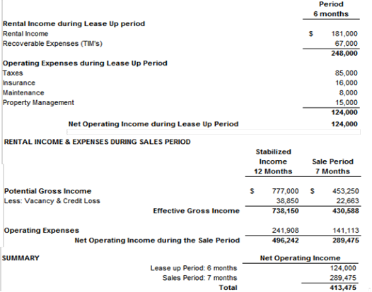

Q8.
Calculating the equity required by the buyer
Flip side
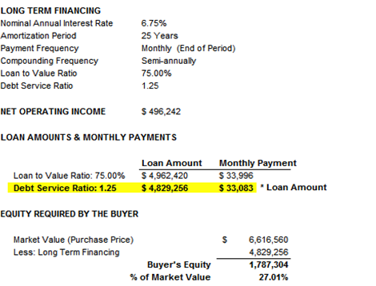

The equity required by the buyer is 27.01% which seems realistic.

If the answer had been say 51% equity, this would suggest that it would be hard to sell the completed development as it requires too much equity.

Q9.
How do we determine the equity required by the developer if the property is held as a long term investment?
Flip side
To calculate the long term financing and equity needed by the developer to keep the development as a long term investment, we need the following:

The total development cost to the end of the leaseup period which is when the long term financing kicks in.

The stabilize Net Operating Income

Long term financing information from the lender
Interest rate
Debt Service Coverage Ratio
Loan to Value Ratio

We then calculate the loan amount based on
Debt Service Coverage Ratio and Loan to Value Ratio
and choose the lower loan amount giving us the developer’s equity required to keep the development as a long term investment.

Q10.
How do we determine the equity required by the developer if the property is held as a long term investment?
Flip side
To calculate the long term financing and equity needed by the developer to keep the development as a long term investment, we need the following:

The total development cost to the end of the leaseup period which is when the long term financing kicks in.

The stabilize Net Operating Income
Long term financing information from the lender
Interest rate
Debt Service Coverage Ratio
Loan to Value Ratio
We then calculate the loan amount based on:
Debt Service Coverage Ratio
Loan to Value Ratio
and choose the lower loan amount giving us the developer’s equity required to keep the development as a long term investment.
Q11.
How do we determine the equity required by the developer if the property is held as a long term investment?

Sample calculation on the flip side.
Flip side
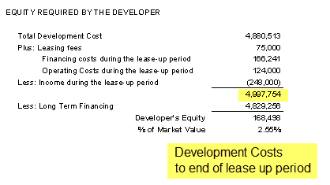

Q12.
What does the “Quick Proforma.” development
look like for a retail store development?

Income Property Development

Buy the land
Construct the building
Lease
Sell or keep the development?

Flip side
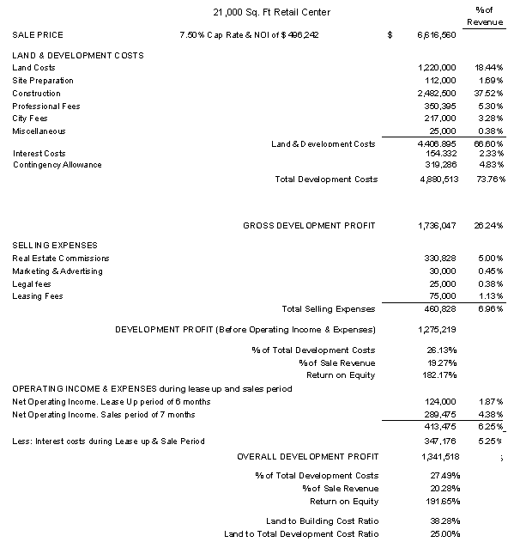

Q13.
How does the developer decide whether to keep the development as a long term investment?
Flip side
The developer carries out long term real estate investment analysis making the following assumptions.

Example.

Developer holds the property for 5 years and sells based on a 5% Cap Rate

Leases are renewed after three years based on a 5% increase in rent.

The investment is the development cost to the end of the leaseup period

The mortgage is $4,400,000
Loan to Value Ratio: 63%
Debt Coverage Ratio: 1.62

The resulting Net Cash Flow and financial returns are shown on the next flash card.

Q14.
The Internal Rate of Return (IRR) is 66.57%

Why is the Internal Rate of Return (IRR) so high at 66.57%?
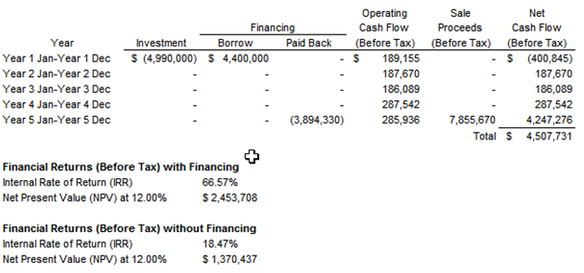

Flip side
There are several reasons:

1. The developer is getting the income property at the cost of $4,990,000. If instead, he bought the completed project at a 5% Cap Rate, he would have to pay $9,924,840

2. Impact of Financial Leverage. The amount of the equity of $590,000 is low for an investment of $4,990,000 which significantly increases the Internal Rate of Return (IRR)

Q15.
What is ”Mortgaging Out”?
Your Answer

Q16.
Is it possible to mortgage out?
Flip side
To ”mortgage out” means that when the long term financing is placed on the property, the developer (investor) requires zero equity and may even receive cash when the long term financing kicks in.

There are several reasons:

1. The developer is getting the income property at the cost of $4,990,000. If instead, he bought the completed project at a 5% Cap Rate, he would have to pay $9,924,840

2. Impact of Financial Leverage. The amount of the equity of $590,000 is low for an investment of $4,990,000 which significantly increases the Internal Rate of Return (IRR)

Over the years, the lender’s underwriting has become more restrictive. It’s very unlikely that that a lender would allow a developer to mortgage out.

They will require the developer to contribute equity.

Q17.
What is the:

Development Spread Yield?

Development Pop?

Flip side
The difference between the “Market Cap and the Yield or Cap Rate based on the development costs.

Example.
Market Cap Rate: 6%
Cap Rate based on development costs:4%
Development Spread Yield: 2%

The greater the development spread yield, the more likely the development is financially attractive.

What if the Development Spread Yield is negative?

Example.
Market Cap Rate : 6%
Cap Rate based on development costs: 8%
Development Spread Yield: -2%

This negative yield indicates that the development is not financially feasible.

DEVELOPMENT POP
The value added by the developer, created by taking the development and leasing risks.

END

Development analysis. Monthly cash flow method
Q1.
There are two different approaches to development analysis.

What are they?
Your Answer

Q2.
Monthly Cash Flow Approach
Sample entries
Flip side
The development expenses, draw mortgages, revenues are entered monthly.

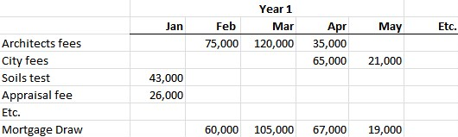

Q3.
Monthly Cash Flow Report

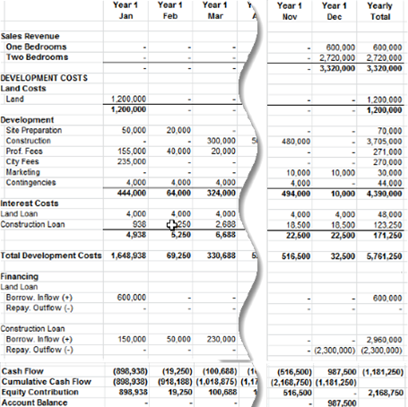

Flip side
Development Profit Report
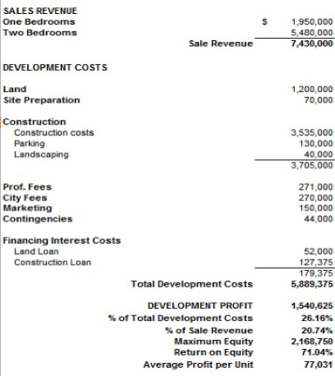

Q4.
How do you evaluate Phased Developments?
Flip side
Certain developments such as large scale housing or industrial subdivisions can be phased.

The advantages phased developments are:

Less capital is required than completing the development in one phase

The profits from the first phase a can be used to partially fund the next phase, reducing the construction, and interest costs

The development risk is reduced compared to completing the development in one go.

ANALYZING PHASED PROJECTS
Requires developing the monthly cash flows showing the monthly outflows like development costs, inflows from sales over time, and the development of the construction draw mortgages.

END

Analyzing “Mixed Use” developments
Q1.
What are “Mixed Use” Developments?
Flip side
Mixed Use developments are developments that involve a combination of:

Unit Developments such as condominium and land subdivisions.

Income Property Developments such as rental apartment units, office, industrial and retail developments.

Q2.
What are some examples of “Mixed Use” developments?
Your Answer

Q3.
Why is it difficulty to analyze “Mixed Use” Projects using the “Quick Proforma approach?
Your Answer

Q4.
Is there a way to analyze “Mixed Use” projects using the Quick Proforma approach?
Flip side
To analyze “Mixed Use” developments, analyze the Unit Project and the Income Property component separately, as follows:

- Allocate the land cost to:
a) Unit development
b) Income property development

- Analyze the Unit Development using the allocated land cost and calculate the development profit

- Analyze the Income Property Development using the allocated land cost and calculate the development profit

- Calculate the combined development profit

Q5.
Analyzing “Mixed Use” developments using the monthly cash flow projection approach
Flip side
The best way to analyze “Mixed Use” projects is to project the development costs and sales revenue sources on a monthly basis using a spreadsheet or Investit Pro real estate analysis software.

END

Sensitivity Analysis

Q1.
What is sensitivity analysis?
Your Answer

Q2.
How can I carry out sensitivity analysis?
Your Answer

Examples:

- The rent is $800 per month. If the rent is increased by 10%, what’s the financial impact?
- The mortgage interest rate is 5%. What happens if it is increased by 10% to 5.50%?
- If we paid 10% more for the property, how does that affect the Return on Investment (IRR)?
- If the Cap Rate changes by 10% from 6.00% to 6.60%, what’s the impact on the property value?

Q3.
Show me an example of Sensitivity Analysis
Flip side

Sensitivity analysis. Example

If the Cap Rate changes from 8.00% to 9.00%, that doesn't seem like much, but it reduces the property value by 12.50%. The calculation is (9% - 8%) = 12.5%
8%
A small change in the Cap Rate creates a large change in value.

When valuing an income property using the Cap Rate approach, it is really important to get an accurate Cap Rate from comparables because the value of the property is highly sensitive to the Cap Rate.

Q4.
Be careful when using Cap Rates to determine the value of a property because the property value is very sensitive to the Cap Rate.

If the Cap Rate is 6% changes to 6.5% which doesn’t seem like much the property value will drop by 8.33%

Flip side
Rental building. Net Operating Income (NOI): $230,000 per year
Asking price is $4,600,000 which is a 5% Cap Rate

What if the true Cap Rate from comparables is 5.5% instead of 5%?

Property value = $230,000/5.5% Cap Rate = $4,181,818 or $418,182 or 9.1% drop in value

The value of an income property is highly sensitive to the Cap Rate.

A small change in a Cap Rate creates large changes in the property value.

When valuing a property using the Cap Rate approach it is really important to get an accurate Cap Rate from comparables.

Q5.
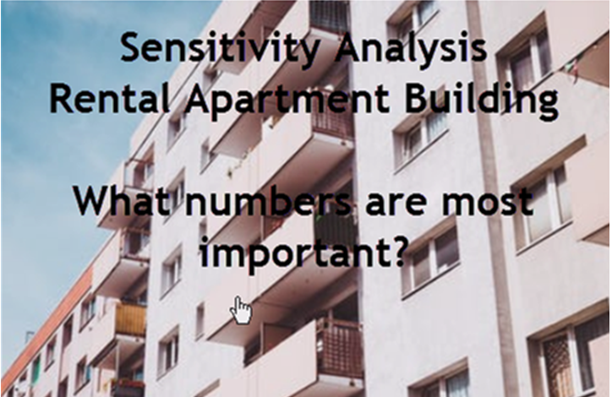
Your Answer

Q6.

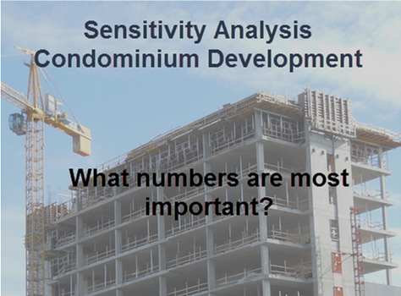

Your Answer

Q7.
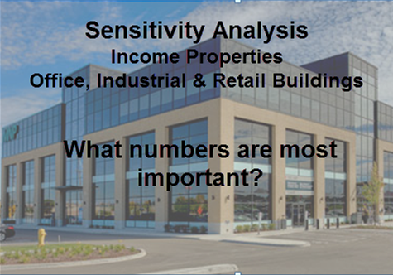

Your Answer

Q8.
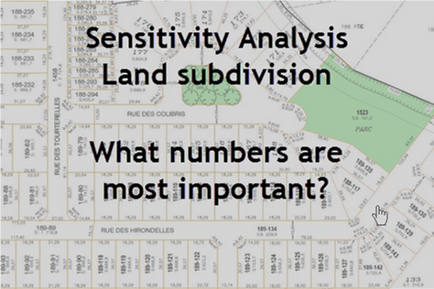

Your Answer

Q9.
What is “What if” analysis?
Your Answer

END

Tips for creating an offer
Q1.
Creating an offer for a development site is very challenging. Why?
Think about the unknowns facing the developer
Your Answer

Q2.
Make a list of the uncertainties facing a developer that have to be dealt with when creating an offer for a development site.

Think in terms of the development of an office building or condominium development.
Your Answer

ETC.

Q3.
Developing “Subject to” clauses

In developing the offer think in terms of “Unknowns” that will later become “Knowns”

Can you think of a way to handle the uncertainty of how many condominium units or square feet of office space will be approved by the City?
Your Answer

Q4.
Can you think of an objection that the seller might raise to the following “Subject to” clauses.

Condominium unit development
The offer is subject to obtaining a building permit for 35 one bedroom units by a specified date.
Office building development
The offer is subject to obtaining a building permit for a minimum of 35,000 Sq Ft office building by a specified date.
Your Answer

Q5.
There is very old office building on the site with tenants that the develop wants to demolish and build an office building.

What does the developer have to be concerned about?
Your Answer

Q6.
Seller are often concerned about the developer tying up the property and attempting to flip the property and making a quick profit.

How can you reduce the seller’s anxiety about dealing with a potential flipper?
Your Answer

Q7.
In putting together an offer to purchase land that is going to be developed, why is it important to understand:

A) The City Hall approval process?
B) The architectural and engineering process?
Your Answer

Q8.
What are the architectural and engineering processes involved
in obtaining a building permit?
Flip side
Architectural sketch plans which provide the developer an approximate idea of what can be built on the site. This enables the developer to carry out a development analysis to determine the value of the land.

Architectural plans are submitted for a development permit which are scale drawings that describe the site layout, floor plans, exterior design, building materials and landscape design.

Detailed working drawings and building specifications are prepared by architects and professional engineers are submitted to obtain a building permit.

Professionals involved include:
Registered architects who assumes the overall responsibility and engages:
Structural , electrical and civil engineers
Heating and air conditioning engineers
Geoscientist to carry out soil tests
Landscape architects
Building envelope engineers
Environmental engineers who deal with site contamination and remediation issues

Q9.
How can you use a time line to help develop the subject removal dates.
Flip side
The time line below a simple example of a development approval time line which can be used to set realistic subject removal dates.
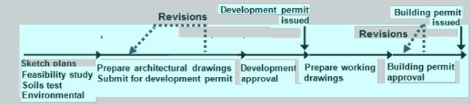

The time line above is a very simple example. The approval process can be far more complex and may involve:
Rezoning application
Public hearings
Approval from other agencies such the Department of Highways etc.

The city requests revision be made and the application resubmitted.

Make sure you allow plenty of time for the approvals. There can be a lot of setbacks that delay the approvals.

Q10.
What the difference between an “Offer to Purchase” and an “Option”?
Your Answer

Q11.
What are the pros and cons for an “Option to Buy” from the developers’ and seller’s perspective?
Flip side
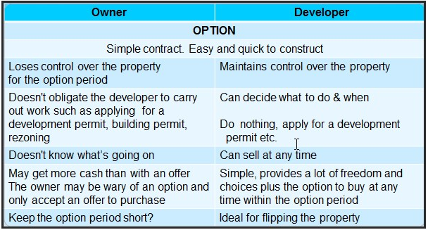

Q12.
What are the pros and cons for an “Offer to Purchase” from the developers and seller’s perspective?
Flip side
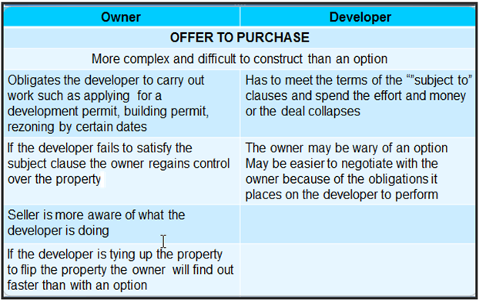

Q13.
What are “Rights”?
How are “Rights” used by developers”
Your Answer

Q14.
What are typical “subject to” clauses?
Your Answer

Q15.
How are deposits and payment for options structured?
Your Answer

Q16.
How are “Extensions” used?
Your Answer

Q17.
What are the issues related to the right to waive a subject clause from the seller’s and buyer’s perspective?
Flip side
Extensions
What if the developer, despite best efforts, can’t remove the subject to clause and needs more time?

The best approach is to build the extension clauses into the “Offer to purchase” or the option ahead of time.

As an example

“The subject to a rezoning permit can be extended for another 3 months upon payment of $25,000” which is non-refundable”

Q18.
How does a “Right to waiver” or a lack of “Right to waiver” impact the buyer or seller?
Flip side
What if the subject to a development permit being issued by the City by <date> is not satisfied by the specified date…and the value of the property has gone up a lot?

The developer wants to waive this subject and buy the property even though the “Subject to” event hasn’t occurred.

The seller wants to escape from the deal and sell at the higher price. Maybe the seller has a backup offer?

The right to waive a subject clause, if appropriate, needs to be built into the offer.

Warning. This is a complex area of law and potential for litigation

Q19.
When attempting to assemble several adjacent properties what “Subject to” clauses should be included in each offer?
Your answer

Q20.
Creating the offer. Tips

- Become familiar with the city approval processes, the submission process and the work to be completed and times involved.
- There will be inevitable delays and setbacks that need to be taken into account when developing an offer
- Keep the number of “subject to” clauses to a minimum
- Make sure you allow plenty of time for the city approval processes
- Develop a time line that lays out the work to be done and the permit application process.
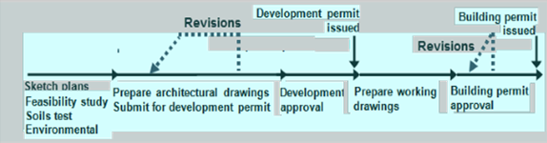
Flip side
Creating and Offer. Some tips continued.

Put the onus on the developer to perform activities that are under his control within a specified time period.
Example:

- The developer must submit for the “Building Permit” within four months of receiving the “Development Permit”
- Consider whether to use an “Offer” or an “Option”
- Effective subject clauses can be difficult to construct and enforce. Consider using a lawyer.
- The right to “waive” a subject clause needs to be specified into the offer

Q21.
Offers on development sites tend to have the following characteristics:

- A long time frame
- Number of sequential subject clauses or options
- Subject clauses create uncertainty and anxiety for the seller
- Seller’s don’t like flippers
What strategies can be used to help keep an offer together?
Flip side
Seller’s don’t like flippers.
Consider an anti-flipping clause or a clause where the seller shares a percentage in the flipper’s profit.

Potential price changes
Sometimes the land price is adjusted as the developer learns more about the building costs or the city reduces the size of the building.

Example:
The soils test found an unexpected soils problem which will increase the construction cost by $200,000.The developer wants to reduce the price by $200,000 or will collapse the deal.

Keep the seller involved and informed on a regular basis. Some suggestions
Give them a copy of the architectural drawings
Send them copies of the city permits as they are issued
Name the development after the family.

Continued on the next flash card.

Q22.
Strategies for keeping the offer together continued…
Flip side
When putting an offer together explain the costs that are being incurred by the developer
The costs can be extensive
E.g. Scale model $20,000
Architectural and engineering fees: 5% to 12% of the construction costs

Show the seller other projects completed by the developer

The idea is to reassure the seller that the developer is serious and not just tying up the property to flip and make a quick profit

Keeping the seller informed on a regular basis with progress reports in writing may make it easier to get an extension if this becomes necessary because of unexpected delays in the development approval process.

END

Land assemblies
Q1.
Make a list of:

FIXED BUILDING COSTS
Costs that don’t change with the size of the building

VARIABLE BUILDING COSTS
Costs that depend on the size of the building
Your Answer

FIXED BUILDING COSTS
Costs that don’t change with the size of the building

VARIABLE BUILDING COSTS
Costs that depend on the size of the building

Q2.
Can you think of some development costs which are fixed to a certain point then increase at some point as the building size increases?

Called “Semi-variable” costs.
Your Answer

Q3.
Explain “Economies of Scale” and how the concept applies to real estate development and land assemblies.
Your Answer

Q4.
How do “Fixed building costs” and “Economies of scale” influence land assemblies and acquisition strategies?
Your Answer

ECONOMIES OF SCALE

FIXED COSTS

Q5.
A developer has acquired lots A and B and has had a preliminary design for a three floor condominium development.

The developer wants to include lot C in the development, but the owner of lot C wants a much higher price than lots A & B.

Questions.
Q1. How would you suggest the developer goes about analyzing whether to buy lot C?

Q2. Can you think of a way to encourage the owner of lot C to sell?
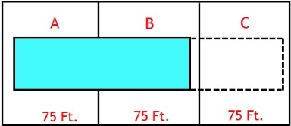
Your Answer
Q1. How to analyze buying lot C.

Q2. Can you think of a way to encourage the owner of lot C to sell?

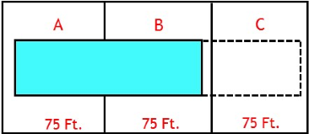

Q6.
List the advantages of developing lots A,B & C compared:

Developing lots A & B

Developing lot C
Your Answer

Q7.
Exercise:
Eleven houses have the potential to be assembled by a developer to build a condominium project. Each home is worth $500,000.

You can afford to buy one of the homes for $500,000 and rent it out and hopefully sometime in the future sell it to a developer and make lots of money.

Zoning is Multi-family.

Which house would you buy to make the most money?
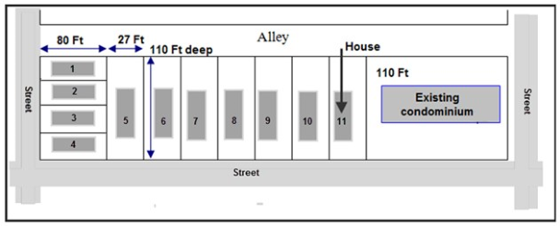
Your Answer

Q8.
Land assembly. True case study.

The potential land assembly consisted eleven lots with a house on each lot. All the homes were listed for sale. The price for each home was around $500,000.

Do you think the developer should acquires lots 1, 2 3 & 4 as part of the land assembly?
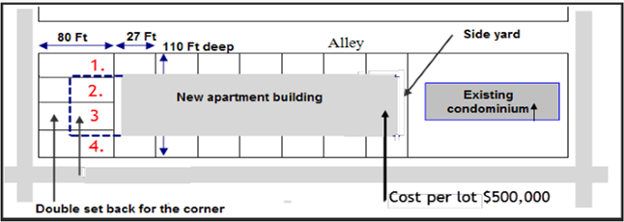

Your Answer
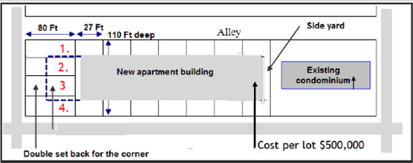

Q10.
Why did the development profit drop when the four end lot were added to the assembly.

What did the developer decide?

Flip side
The developer decided not to buy the four end lots because the economics of adding the four end lots didn’t work.

Many years later the four end lots remain as houses.

The highest and best use for the four end lots is single family homes, even though the zoning is multifamily.
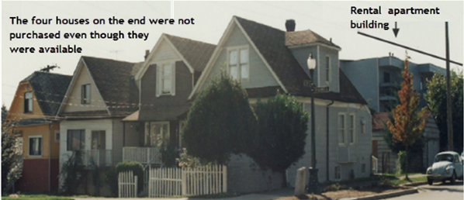

Q10.
What’s a “Blocking” strategy?
Your Answer

Q11.
TIP. Be on the constant lookout for assembly potential. Why?
Your Answer

.

Q12.
A realtor had a listing on a large site and wondered how to determine the value of the land. A consultant made the following observations upon visiting the site.

1. Zoning. Townhomes
2.Two large live Oak trees which had to be protected
3. Deep drainage ditch on the right side of the property. Suggests water problems and the need for a retention pond

Building around the two live oak trees and providing a retention pond
increases construction costs and significantly reduces the buildable area
and land value.

The consultant then looked to see if there was a land assembly potential by observing what was on either side of the property?

Flip side
Always look for development potential. What is beside and behind the site. Is there a potential land assembly?

Property to the left. Has an existing, relatively new, three story brick apartment building. No development potential.

Property to the right. There was a high fence surrounding the property. The site is large and has a cluster of small old cabins. Clearly not operating at the highest and best use.
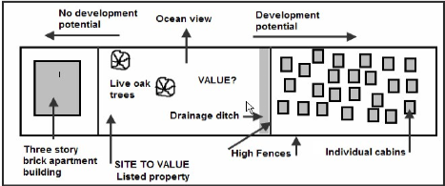

The consultant recommended finding out if the site on the right could be purchased.

Q13.
How would you go about determining:

- The value of the site?
- The value of a land assembly created by acquiring the site on the right of the listed property
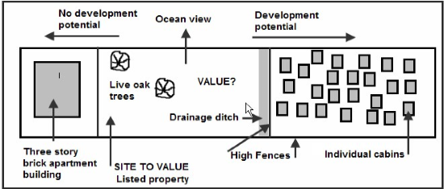
Your Answer

Q14.
When purchasing an older income property, should the buyer think about
long term assembly potential?
Flip side
When purchasing an older income property, should the buyer think about
long term assembly potential? YES

Which property is best to buy A, B, C and D?

Property A is a non conforming old rental apartment building. If it was destroyed it
would be difficult to replace. Current zoning would require underground parking,
front and side yard set back. There is no assembly potential because the building to
the left is a relatively new condominium building. A poor and risky investment.
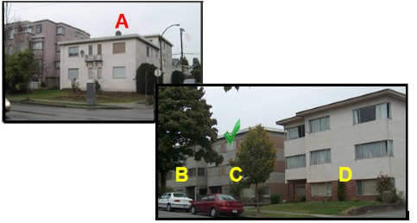
Properties B, C, and D all have long-term assembly potential. Assembling any two side-by-side buildings, B & C or C & D would provide a nice-sized condominium development.
The best choice would be C, the property.

Q15.
Why is developing a land assembly challenging?
Your Answer

Q16.
What is the impact of land assemblies on property values?
Your Answer

Q17.
What strategies can you use for “Hold Outs”?
Your Answer
Holdouts are the property owners who want to sell but are asking an unrealistic price.

Q18.
True case.
Strategy used to encourage a “holdout” to accept the developer’s offer
and be part of the assembly.

Flip side
The developer had the houses on lots 6 to 10 under contract
It was not economical to buy the four homes on the end. Why? See flashcard No.10
Lot 11 was not available. The owner had lived there all his life and didn’t want to sell
The “holdout” was lot 5, who want far too much money for his home.
The developer explained to the “holdout” that time was running out and that this
home is worth a lot more as part of the development. He didn’t budge.
When the surveyors were going out to survey the assembly, the developer asked them to exclude the “holdout’s” land from the survey using the survey stakes with red flags.
The next day the “holdout” turned up at the developer’s office and signed the offer.

The surveyor’s flag stake provided tangible evidence that the developer was prepared to proceed without the “holdovers” property.
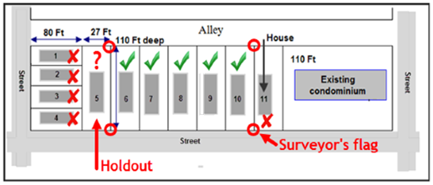

Q19.
Some examples of what can happen to “Holdouts”
Flip side
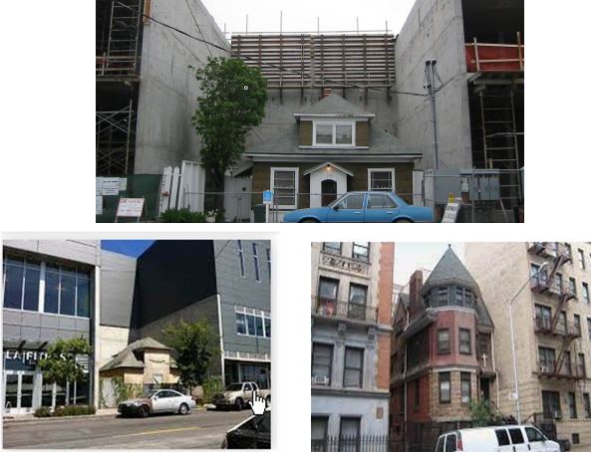

END

