Raising Your Commercial IQ
______________________________________________________________________

203 Office, Industrial and Retail Leasing

In-house Training Program
Participant Package

Neil Osborne M.B.A.
DL. (604) 988-9964
nosborne@investitsoftware.com
Investit Software Inc.
Toll free 877-878-1828
North Vancouver BC
Canada V7R 3N4
investit@investitsoftware.com
www.investitpro.com
Copyright

Table of Contents
Calculator 3
Skills and benefits obtained from the in-house sessions 3
FORMULAS USED IN LEASE ANALYSIS 5
AGENDA TIME TABLE 6
FLASH CARDS. QUESTIONS 9
Landlord and Tenant 9
The Leasing Process 12
Types of Leases 16
Types of Rent 18
Percentage Rents 20
Expense Caps and Stops 22
Lease Term, Option to Renew and Bumps and Steps 23
Assignment and Sub Leasing 25
How to define and measure Space 27
Renting Space from plans 30
Tenant Improvements (TI’s) 34
Missing the Occupancy Date 38
Operating and Recoverable Expenses 39
Renovating and Subdividing Space 42
Lease Comparison Analysis 44
Lease negotiations. Landlord Tenant Trade Offs 50
Valuing a Land Lease 52
Blending & Extending a Lease 54
Buy Versus Lease Analysis 55
Tip for reading a lease 62
Demolition Clauses 64

Calculator
You will need to bring a calculator. In can be any kind of calculator. It doesn’t have to be a financial calculator.

Skills and benefits obtained from the in-house sessions
To provide a comprehensive understanding of:
The leasing process and terms used in leasing
How to read a lease and what to look for in a lease
The differences between the different kinds of leasing markets
How tenants go about choosing a location and space
What question to ask the landlord and tenant
Some of the complex issues involved leases and lease negotiations
Why leases are often complex, lengthy documents
How to carry out lease comparison analysis from a landlord & tenant perspective
Topics

Following is a summary of topics that will be covered.
Overview of landlord and tenant leasing objectives
Tenant compatibility considerations and issues
Leasing characteristics by different types of properties
The leasing process and documents
Types of Leases
Gross & Modified Gross Leases, Indexed lease, Triple Net Lease Expense Caps and Stops and Rent Caps
Types of Rent
Base Rent & Additional Rent or Recoverable Expenses
Free Rent
Percentage Rent
Areas and Area Measurement
Rentable and Usable Areas and Load Factor
Space Measurements and the BOMA Standards
How to measure different types of properties
Issues related to measuring space
Leasing new space. Tenant Improvements and build outs.
Assignment & Subletting
Operating Expenses, Recoverable Expenses and related issues and considerations
Renovating and subdividing space including structural considerations
Lease Comparison Analysis and the Net Effective Rent from landlord & tenant perspective
Case Study. Comparing three different lease arrangements
Valuing ground leases.
Blending and extending a lease
Impact of leases on the property value and marketability
Tips for reading leases
Leasing as a career
Skills and benefits obtained from the video
Increased knowledge of lease terms and the leasing process
The differences involved in leasing office, industrial and retail space
A deeper understanding of the complex issues related to leasing
How to compare leases from a landlord or tenant perspective

The knowledge and skills developed during the video will improve your ability to negotiate and analyze leases and put leasing deal together from a tenant or landlord perspective.

FORMULAS USED IN LEASE ANALYSIS

Cap Rate (Capitalization Rate)
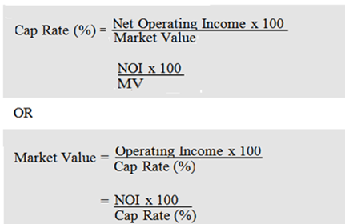

Net Effective Rent (NER)

Net Effective Rent (NER) = Net Present Value at X%
Area x No. of Years
Example:
Net Present Value at 10%: $4,500,000
Rentable Area: 20,000 Sq. Ft
Lease period: 10 years

Net Effective Rent (NER) = Net Present Value at 10%
Area x No. of Years

= $4,500,000
$20,000 x 10 years

= $22.50 per Sq. Ft per Yr at 10%

AGENDA TIME TABLE

Landlord & Tenants
Line  number | Play Micro Video | Manual  Page Number | Play Flash Card Set | Participant Package  Page number
1 | Types of Landlords and Tenants (13 min) | 6
2 | Leases and Property Types (14 min) | 7
3 | The leasing process (7 min) | 9
4 | Types of Leases (8 min) | 13
5 | Types of Rent (8 min) | 14
6 | Term of The Lease (7 min) | 25
7 | Assignment & Subletting  (2 min) | 27
8 |  |  | Landlord and Tenants | 9
9 |  |  | The Leasing Process | 12
10 |  |  | Types of Leases | 16
11 |  |  | Types of Rent | 18
12 |  |  | Percentage Rent | 20
13 |  |  | Expense Cap & Stops | 22
14 |  |  | Lease Term, Option to Renew and Bumps and Steps | 23
15 |  |  | Assignment and Subleasing | 25
16 | Operating & Recoverable Expenses | 28
17 | Renovations. Structural considerations | 31

Line  number | Play Micro Video | Manual  Page Number | Play Flash Card Set | Participant Package  Page number
18 |  |  | How to define & measure space | 27
19 |  |  | Renting space from plans | 30
20 |  |  | Tenant Improvements (TI's) | 34
21 |  |  | Missing the occupancy date | 38
22 |  |  | Operating and Recoverable Expenses | 39
23 |  |  | Renovating and subdividing space | 42
24 | Analyzing leases (1 min)
25 | Net Effective Rent (NER) (2 min)
26 | Comparing Leases. Case study (5 min)
27 | Lease negotiations.  The trade offs (4 min)
28 | Lease negotiations. Case study (13)
29 | Valuing Ground Lease (2 min)
30 | Blending & Extending a Lease (8 min)
31 | Lease. Impact on value & marketability (4 min)
32 | Mutually exclusive investment analysis & Buy versus Lease Analysis (4 min)
33 | Buying versus renting a home.  Case study (8 min)
34 | Buy versus lease office space. Case study (9 min)
35 | Analyzing a multi-lease proposal 3 min)
36 | Tips for reading a lease (3 min)
37 | Demolition clauses (3min)
38 |  |  | Lease comparison analysis | 44

Line  number | Play Micro Video | Manual  Page Number | Play Flash Card Set | Participant Package  Page number
39 |  |  | Lease negotiations. Landlord and Tenant trade offs | 50
40 |  |  | Valuing a land lease | 52 |  | Valuing a land lease
41 |  |  | Blending & extending leases | 54
42 |  |  | Buy versus Lease Analysis | 55
 |  |  | Tips for reading a lease | 62
44 |  |  | Demolition clauses | 64

PRACTICE QUIZ and 203 COURSE EXAM
Suggest the participants take the 203 Practice Quiz to test their knowledge and measure their progress.
They can take the test many times, and the grade will be recorded and can be reviewed.
The quiz results are confidential and cannot be viewed by anyone else.
203. Course Exam.
Take the 203 course exam which is set up by a manager or office administrator.

FLASH CARDS. QUESTIONS

Landlord and Tenant

Q1.
In legal terms the:

Landlord is called the ___________

Tenant is called the ___________

Q2.
Be very careful when working with inexperienced landlords, tenants or realtors because there is a potential for misunderstandings.

Write down some examples of potential misunderstanding between the landlord, tenant and inexperience realtor.
Your answer

Q3.
Write down some of the landlord’s major concerns when leasing space to a tenant.
Your answer

Q4.
List some of the concerns that a tenant may have when leasing space.
Your answer

Q5.
Landlords and Tenants are often concerned with “Tenant Mix & Compatibility” in property.

Provide an example of poor tenant mix for a small retail strip center with limited onsite parking for 6 cars. The adjacent street a parking is metered and it is often hard to find a parking spot.
Your answer

Q6.
Explain ‘Synergy” as it relates to real estate and provide several examples.

Synergy means that the “whole” is greater than the sum of the individual “Parts” or 2+2 = 5 and has wide application for real estate establishments.
Your answer

Q7.
An industrial tenant with heavy equipment is considering renting 25,000 sq. Ft of industrial rent.

Besides the rent what are some features and building attributes that will be of concern to the industrial tenant?
Your answer

Note. In the “Resources” section of the Investit Academy LMS there is an extensive ‘Industrial Real Estate Check List” Take a look.

END

The Leasing Process

Q1.
Is there a standard way to calculate a leasing fee?
Your answer

Q2.
What are some of the ways that leasing commissions are calculated?
Your answer

Q3.
Leasing agreements often include the right for the tenant to renew the lease. Does the landlord have to pay a leasing fee on the renewal of the lease?
Your answer

Q4.
A “Triple Net Lease (NNN) consists of the “Base Rent” and the “Additional Rent” which is the payment of the landlord’s operating expenses such as “Taxes, Insurance & Maintenance” as spelled out in the lease.

Does the leasing commission calculation include the “Additional Rent”?
Your answer

Q5.
The “Commission Agreement” or “Authority to Lease” must include;
- How the leasing commission is calculated
- How it will be paid
- When will it be paid

Why is the third item “When will it be paid?” so important?
Your answer

Q6.
Is a leasing commission always paid as a single amount or can the fee payment be spread over time?
Your answer

Q7.
What are the three main documents that are used when leasing space?
Your answer

Q8.
The ‘Letter of Intent (LOI)” is an enforceable contract

True or False

Circle your answer

Q9.
What’s the purpose of the “Offer to Lease” or “Agreement to Lease”?

Q10.
Is an accepted “Offer to Lease” a binding contract?

YES _____ NO _____

Q11.
List some of the approvals that may be required by the City before the space can be occupied.
Your answer

END

Types of Leases

Q1.
What is a “Gross Lease” and a “Full Service Lease”?
Your answer

Q2.
What’s the disadvantage of a Gross Lease from a landlord’s perspective?
Your answer

Q3
What’s a Modified Gross Lease?
Your answer

Q4.
What is an Indexed Lease or a Gross lease with an escalation clause?
Your answer

Q5.
What’s a Triple Net Lease (NNN)? Also called a Net Lease.
Your answer

Q6.
How clear and specific are terms like:
- Gross Lease
- Modified Gross Lease
- Indexed lease
- Full Service Lease
- Triple Net Lease (NNN)

Your answer

Q7.
Are the different types of leases like “Full Service Lease” and “Triple Net” used consistently based on the type of real estate and are they independent of the geographic location of the real estate?

As an example, full service leases are often used for office buildings but is this consistent across the country?

How about rent rates such as $ per Sq. Ft per Yr versus $ per Sq. Ft per Mth?
Your answer

END

Types of Rent

Q1.
What is the Base Rent?
Your answer

Q2.
What is the “Additional Rent”?
Your answer

Q3
What is “Free Rent”?
Your answer

Q4
Does “Free Rent” apply to “Additional Rent?”
Your answer

END

Percentage Rents
Q1.
Explain “Percentage Rent”
Your answer

Q2.
Why do retail landlords use a “Percentage Rent”?
Your answer

Q3.
What types of retail establishments use a “Percentage Rent”?
Your answer

Q4.
In calculating the “Percentage rent” what is the difference between the “Natural Break Point” and the “Artificial Breakpoint (Unnatural Breakpoint)”?
Your answer

Q5.
Based on the following information calculate:

1) The tenants annual rent

2) The “Natural Break Point”

Base Rent: $300,000 per year (Minimum rent)
Percentage Rent: 3.00%
Gross Business sales; $15,000,000
Your answer

- Annual rent calculation

- Natural Breakpoint

END

Expense Caps and Stops
Q1.
What is an “Expense Stop”?
Your answer

Q2.
Explain an Expense Stop coupled with “Base Year” operating expenses.
Your answer

Q3.
Explain an Expense Cap and provide an example
Your answer

END

Lease Term, Option to Renew and Bumps and Steps
Q1.
What is the “Lease Term”?
Your answer

Q2.
What is a “Periodic Tenancy”?
Your Answer

Q3.
What is an “Option to Renew?” and how is the renewal rate determined?
Your answer

Q4.
A tenant is entering into a Five Year term lease that has a renewal option for another five years.
The renewal rate will be based on the “Fair Market” rent at that time.

The tenant is really concerned about how high the rent will be when the lease is renewed.

Can the renewal rent rate be limited?
Your answer

Q5.
Show me an example of a Rent Cap in action.
Your answer

Q6.
What do lease “Bumps and Steps” refer to?
Your answer

Q7.
How is the “Fair Market Rent” established?
Your answer

Q8.
What if the landlord and the tenant can’t agree on the free market rent?
Your answer

END

Assignment and Sub Leasing

Q1.
What is an assignment of a lease?
Your answer

Q2.
What is a “Sublease”?
Your answer

Q3.
Landlords hate this. A tenant profiting from a sublease.

Explain how a tenant can profit from a sublease
Your answer

Q4.
How can the landlord profit from a tenant subleasing at a higher rent rate than the lease rate?
Your answer

Q5.
Can a tenant always “sublet” or “Assign” the lease to a third party?
Your answer

END

How to define and measure Space

Q1.
What are the Rentable Area and the Gross Leasable Area (GLA)?
Your answer

Q2.
How do you calculate the rentable area in an office building?
Your answer

Q3.
Calculate the Base Rent per month for an office building using the following information:

Base Rent: $25 per Sq. Ft per Yr. based on the “Rentable Area”
Usable Area: 15,000 Sq. Ft. This is the area occupied by the tenant.
Add on Factor: 14%
Your answer

Q4
What are the BOMA standards?
Your answer

Q5.
When using the BOMA Standard to measure space in an office building the stair well and elevator shaft are included in calculating the tenant’s rentable area.

True or False

Circle your answer

Q6.
Using the BOMA Standards for office buildings how would you measure Tenants A’s space?
Circle or tick your answers

WALL A. Measure to Inside OR to the Outside of the wall
WALL B. Over 50% of the wall is glass. Measure to Inside OR the Outside of wall B or to the Inside of the glass line?
INTERIOR C. Measure to the Inside or Exterior of the interior wall?
DEMISING WALL. Measure to the Interior or the Middle of the demising wall?
ELEVATOR WALLS. Measure to the Inside or Exterior of the elevator walls?

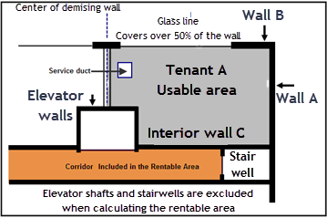

Q7.

What are the dangers associated with quoting rents as $ per Sq. Ft per Yr. or Month?
Your answer

Q8.
What’s the simple solution to the problems created by quoting rent as $ per sq. Ft per Yr. or Month
Your answer

END

Renting Space from plans
Q1.
When leasing space from plans or in a building that’s under construction what are some of the “unknowns” that have to be dealt with in the “Offer to Lease or the Lease”
Your answer

Q2.

Since the rentable area is not known until the space is complete how can this uncertainty be handled in the “Offer to Lease”
Your answer

Q3.
A retailer who is considering renting space in a building that is under construction
requires a minimum of two aisles with a minimum width of 5 feet to accommodate two shopping carts side by side as illustrated below.

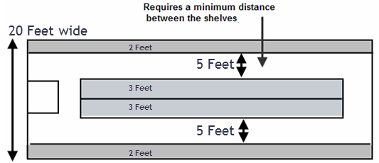

Since the final width cannot be determined until the construction is complete how would you specify the tenant’s requirements in the “Offer to Lease”?
Your answer

Q4.
What’s the financial impact on the tenant if the tenant’s space ended up being 19 feet wide instead of the desired 20 feet?

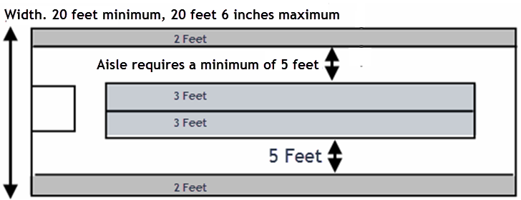

Your answer

Q5.

The length or depth of the retail space can be very important. Case study.

A retailer has rented space from the plans. The display cases come in 10 feet modules. He needs 6 display cases which means the depth needs to be a minimum of sixty feet deep.

The space he rented was supposed to be 20 feet wide by a minimum of 60 feet deep.

Let’s see what happened when the space was finished and the tenant was ready to move it
Flip side

Problems.
- Depth was 59 feet 6 inches which means the last display case doesn’t fit as 60 feet is needed
- A concrete column that wasn’t shown on the plans is protruding into the space.

The result is that the tenant has to get three display cases special made which was very costly.

The tenant sued the landlord for the extra display case costs.

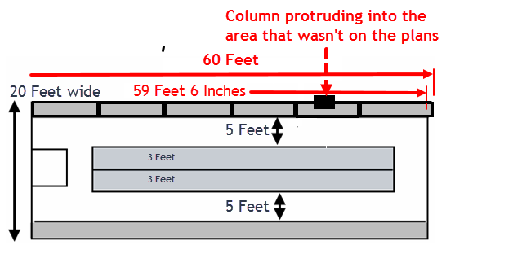

END

Tenant Improvements (TI’s)

Q1.
What are leasehold improvements?

Also called “Tenant Improvements (TI’s) or “Buildouts”
Your answer

Q2.
Who builds the “Leasehold Improvements”?
Your answer

Q3.
What are leasehold specifications and plans?

Your answer

Q4
Why are “Leasehold Improvements” specifications and plans so important?
Your answer

Q5
Who pays for the “Leasehold Improvements”?
Your answer

Q6.
What is a “Shell Lease”?
Your answer

Q7.
What is a “Turnkey” lease?
Your answer

Q8.
What’s a Shell Lease with an allowance. Landlord builds?
Your answer

Q9.
What’s a Shell Lease with an allowance. Tenant builds?
Your answer

Q10.
Why is it important to have the landlord quote the leasehold improvement allowance as a dollar amount rather than a $ per Sq. Ft? E.g. $300,000 versus $150 per Sq. Ft
Your answer

Q11.

What is a “Build to Suit” single tenancy building?
Your answer

Q12.
With leasehold improvements being provided by the landlord or build to suit arrangements what do you think are the two major problems that need to be dealt with in the lease?
Your answer

Q13.
The landlord agrees to build $400,000 worth of leasehold improvements based on the agreed upon detailed specifications prepared by the tenant’s engineers and architects.

During the construction the tenant decides to upgrade the carpets, add more costly lighting fixtures and two more offices adding $320,000 of additional costs.

How does the landlord get reimbursed for the additional leasehold improvement costs of $320,000?
Your answer

Q14
What is “Force Majeure”?
Your answer

END

Missing the Occupancy Date

Q1.
When leasing space from plans or in a partially constructed building the completion and occupancy date is not known for certain.

Can you come up with some examples of when a missed occupancy date would be very costly for the tenant in terms of lost revenue?

In other words if the space is not ready to move in by the date specified in the lease the tenant would lose a lot of sales revenue
Your Answer

Q2.
A tenant is moving into a new facility on July 1. The lease specified that the space would be ready June 1. The following has taken place

- The tenant has given notice to their landlord and has to move out by June 30.
- The landlord has rented the space commencing July 1

What happens if the new space is not available July 1?
Your Answer

END

Operating and Recoverable Expenses

Q1.
If a lease uses the term “Recoverable Expenses” what are Recoverable Expenses?
Your answer

Q2.
Which of the following would not be considered an operating expense and a recoverable expense?

Property taxes
Replacement of the boiler
Insurance
Cleaning services
Major upgrade to the elevator
Fee for leasing vacant space

Circle your answer

Q3.
What other names are used for “Recoverable Expenses”
Your answer

Q4.
A lease will often state the tenant is not responsible for structural repairs.
Write down two examples of structural repairs.
Your answer

Q5.
What does “Grossing Up” of operating expenses mean?
Your answer

Q6.
Who pays the operating expenses on the vacant space?
Your answer

Q7.
How does a lease handle the recoverable operating cost that is caused by a particular tenant who is receiving a specific benefit?

Provide an example.
Your answer

END

Renovating and Subdividing Space
Q1.

Vertical loads in a building can be broken down in two types of loads.
What are the names of the two types of vertical loads and provide an example of each?
Your answer

Q2.
Provide two examples of “Horizontal Loads” that can impact a building
Your answer

Q3.

What’s the purpose of the shear system in a building?

Give two examples of a “shear System” in a building
Your answer

Q4.
Why should you never make statement that a wall can be removed even if the wall appears to be a non-load bearing wall?
Your answer

Q5.
If you are considering subdividing space why should you recommend to the landlord to check with an architect or the city before subdividing the space?
Your answer

END

Lease Comparison Analysis

Q1.
When carrying out lease comparison analysis why do we use discounted cash flow analysis and calculate the Net Present Value of the lease and the Net Effective Rent?
Your answer

Q2.
A landlord has 10,000 Sq. Ft for rent and has received the following offers from Tenant A and Tenant B. Which one is the best deal based on the Net Effective Rent (NER) at 10%?

Tenant A. $20 per Sq. Ft per year for five years with free rent for the first five months of year 1. Tenant A has made this proposal because they want to reduce their expenses in the first year because it is a start-up business.

Tenant B. $20 per Sq. Ft per year for five years with one month of free rent every year for five years.

In both cases the tenant will pay the additional rent to cover the taxes, insurance and maintenance (TIM’s).

Flip Side
The following compares the cash flow the landlord will receive and the Net Effective Rent at 10%
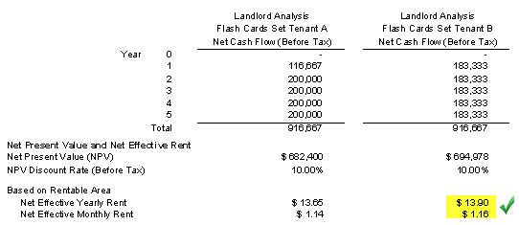

The best deal for the landlord is Tenant B’s proposal which has a Net Effective Rent at 10% of $113.90 per Sq. Ft per year compared to $13.65 per Sq. Ft per year for Tenant A even though the total amount received over the five years of $916,667 is the same for both proposals.

Q3.

When comparing leases using the discounted cash flow approach why can’t you calculate the Internal Rate of Return (IRR)?
Your answer

Q4.

When carrying out lease comparison analysis why is important to compare the leases over the same time period?
Your answer

Q5.

Calculate the Effective Rent (NER) using:

Net Present Value at 10%: $4,500,000
Rentable Area: 20,000 Sq. Ft
Lease period: 10 years
Your answer

Q6.
Is the Net Effective Rent (NER) helpful when analyzing one lease?
Your answer

Q7
When comparing leases using the Net Present Value (NPV) and the Net Effective Rent (NER) how important is the selection of the “Discount Rate”?
Your answer

Q8.
You are considering renting space in an office building and there are two buildings with space available in the location you desire. The rent rates are:

Space A. Usable area: 1,500 Sq. Ft. Base Rent Rate: $25 per Sq. Ft per Yr of rentable area
Space B. Usable area: 1,500 Sq. Ft. Base Rent Rate: $27 per Sq. Ft per Yr of rentable area

Why is it incorrect to select Space A as the best deal because it has the lowest rent?

Flip side

It’s incorrect to choose to rent based simply on the first year base rent rate as there are a lot of factors beyond the rent rate to consider such as different “Gross Up factors”, differences in the “Additional Rent” and parking expenses as illustrated below.

Example
 | Space A | Space B
Rent Rate using Rentable Area | $25 per Sq. Ft per Yr | $27 per Sq. Ft per Yr
Usable Area | 1,500 Sq. Ft | 1,500 Sq. Ft
Add on Factors Gross Up factor | 16% | 13%
Rentable Area | 1,740 Sq. Ft | 1,695 Sq. Ft
Term | Five years | Five years
Additional Rent | $9.00 per Sq. Ft per Yr | $6.00 per Sq. Ft per Yr
Parking. Seven cars | $75 per month per space | Free

To correctly compare these two leases from the tenant’s perspective you need to:
- Calculate the total annual leasing expenses for each of the five years
- Calculate and compare the Net Present Value and the Net Effective Rent over the five years
- See next flash card for results

Q9.
A tenant is considering two spaces for renting two different buildings.
Which space is the best deal from the Tenant’s perspective?
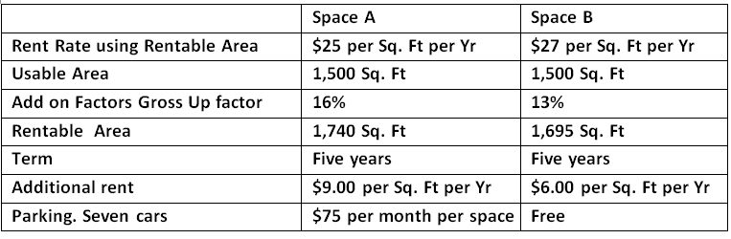

Flip side

Even though the rent for Space A is $25 per sq. Ft per Yr which is less than Space B at $27 per Sq. Ft per Yr. Space B is the best deal when all the factors such as the Gross Up factors, differences in the “Additional Rent” and parking expenses are taken into account over the five years.

The Net Effective Rent (NER) at 10% is for Space A is $27.97 and $25.02 for Space B. From a financial viewpoint Space B with the higher base rent of $27 per Sq. Ft per Yr. compared to $25 for Space A is the best deal.

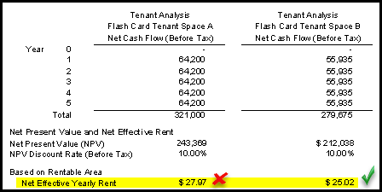

Q10

What information do you need to calculate the Net Effective Rent (NER) from a landlord and tenant perspective?
Your answer

END

Lease negotiations. Landlord Tenant Trade Offs
Q1.
When negotiating a lease there are a number of trade-offs that can be made between the landlord and tenant.

List as many of the trade-offs as you can.
Your answer

Q2.
Provide a simple example of a trade-off that can be made between the landlord and the tenant so that the Net Effective Rent (NER) remains the same.
Your answer

Q3.
List two of the primary goals of the landlord when negotiating a lease
Your answer

Q4.
Why is maintaining the rent as high as possible so important to the Landlord?

If the landlord can increase from $21 to $23 per Sq. Ft per Yr how much will the value increase if the Cap Rate is 5.00% and the rentable area is 25,000 Sq. Ft?
Your answer

END

Valuing a Land Lease

Q1.
What is a ground Lease and provide an example?
Your answer

Q2.
With a ground lease does the building developer end up owning the land at the end of the land lease?

Yes or No

Circle your answer

Q3.
Can a ground or land leases be bought and sold?

Yes or No

Circle your answer

Q4.
How do you go about valuing a ground or land lease?
Your answer

Q5.
Example. Calculating the value of a ground or land lease

An investor is considering buying a land lease and wants a 10% return.

The land lease is $200,000 per year for 75 years. The yearly lease payments are made at the beginning of each year.

How much should the investor pay for the land lease?

Flip side

The Net Present Value (NPV) $200,000 per year for 75 years at 10% discount rate is $2,198,270 with the annuals lease payment being made at the beginning of the year.

The value of the ground lease at 10% is $2,198,270

If an investor bought the ground lease for $2,198,270 the return (IRR) would be 10%

______________________________________________________________________
END

Blending & Extending a Lease
Q1.
Explain “Blending & Extending” a lease
Your answer

Q2.
Provide an example of blending and extending a lease.
Your Answer

END

Buy Versus Lease Analysis
Q1
What are “Mutually Exclusive Investments”
Your Answer

Q2.
How do you carry out “Buy versus Lease Analysis”?
Flip Side
To carry out “Buy versus Lease Analysis:

- Develop the “Net cash flow” for the “Buy” option (After tax)

- Develop the “Net cash flow” for the “Lease” Option (After tax)

- Calculate “Net Cash Flow Buy – Net Cash Flow Lease” (After tax)

- Calculate the Internal Rate of Return (IRR) and Net Present Value (NPV) after tax

- Is the Return on Investment (IRR) of buying compared to leasing acceptable? If not consider leasing.

This is called the “Differential” or ‘Incremental Cash Flow” analysis and is a very important concept for analyzing mutually exclusive investments such as “Buy versus Lease”

Q3.
Why should Buy versus Lease analysis be done after tax?
Your Answer

Q4.
Show me an example of “Buy versus Lease Analysis”
Flip Side
Take the after tax Cash Flow of buying subtract the after tax cash flow of leasing to get the differential cash flow of Buy versus Lease. Calculate the “Buy versus Lease” Internal Rate of Return (IRR) and Net Present Value using the investor’s discount rate.

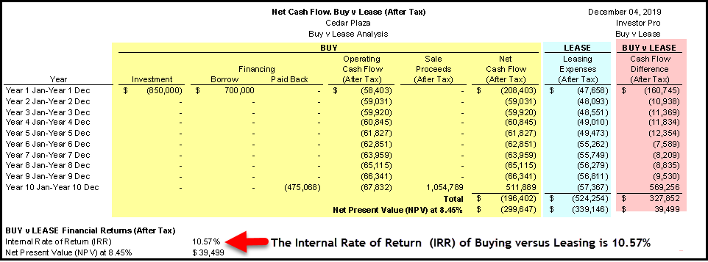

Q5.
How is the “Return on Investment (IRR)” or the “Discount Rate” determined when carrying out Buy versus Lease analysis?
Flip Side

In order to consider Buy versus Leasing the company has to have enough capital for the down payment of the property. If they don’t have sufficient funds they won’t be able to purchase a property and their only option is to lease or continue to lease.

Example. A company is leasing space and the lease is about to be renewed and they have $900,000 cash to use to purchase a property worth $2,000,000 using a $1,100,000 mortgage and $900,000 equity.

The question is what is an acceptable Return on Investment (IRR) to use when carrying out buy versus lease analysis.

It depend on how else can they use the $900,000 cash. Some options are:
Investit in the stock market. Assume they can make 3.5% after tax
Use the $900,000 to expand their business. Expected return 7.00% after tax

In this case if the Buy versus Lease analysis indicated a return of higher than 7.00% they should consider buying instead of leasing. If not, they should consider leasing.

Q6.
How do you evaluate the Return on Investment of buy versus lease using the Internal Rate of Return (IRR) and Net Present Value (NPV)?
Flip Side
An engineering firm is considering buying property instead of leasing space and would purchase a building instead of leasing if the Internal Rate of Return after taxes was 8% or higher.

In other words their discount rate is 8.00% after taxes.

Results of the Buy versus Lease after tax analysis
Internal Rate of Return (IRR): 12%. Consider buying instead of leasing
Internal Rate of Return (IRR): 7%. Consider leasing instead of buying

Net Present Value (NPV) at 8.00% Positive. Consider buying instead of leasing
Net Present Value (NPV) at 8.00% Negative. Consider leasing instead of buying

Q7.
What’s the Buy versus Lease crossover graph?
Flip Side
Shows the cut-off point between buying and leasing.

As an example, if the company can invest their money at more than 10.40% they should consider leasing. If not, they should consider buying.
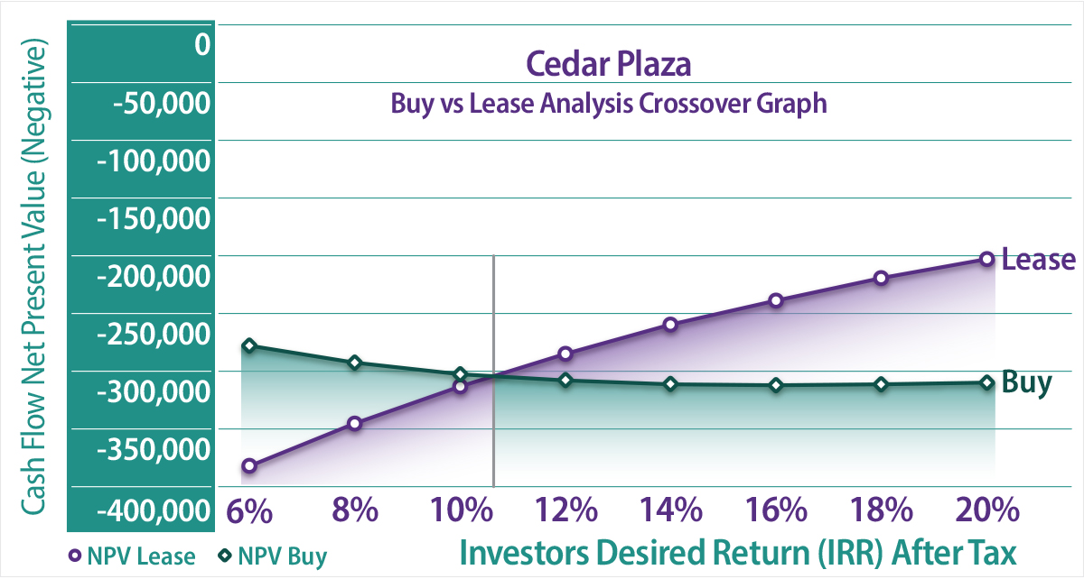

Q8.
How do I interpret the Buy versus Lease crossover graph?
Flip Side
The trick to reading the crossover graph is to recognize that the vertical axis shows the negative Net Present Value for “Buy” and for “Lease” because the cash flows for buying and for leasing are both negative.
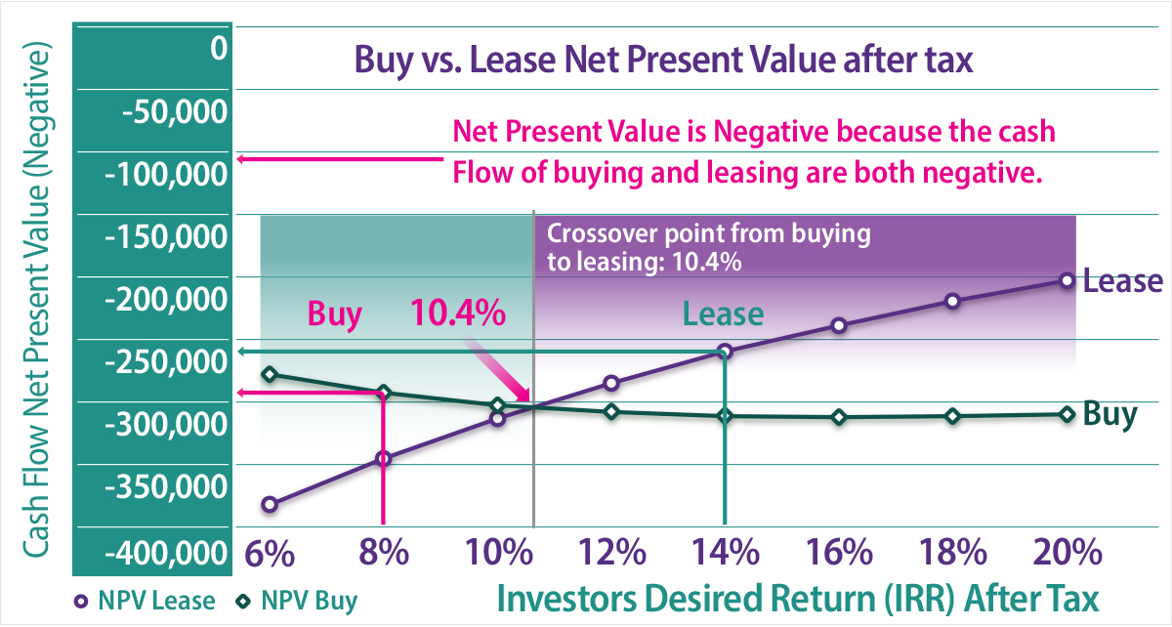

Q9.
A retailer is considering buying a property instead of renewing the lease. His “Desired Return (IRR)” is 12% after tax. If he can’t get at least an 12% after tax he feels he would be better off using the money to expand his business.

A consultant developed the ‘Buy versus Lease Crossover graph. Should he buy or lease?

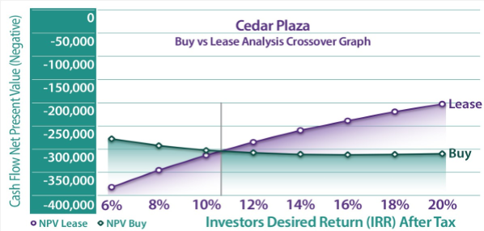
Your Answer

Q10.
The incorrect way to analyze whether to buy or rent a home or commercial building.
Flip Side
A common but incorrect approach is to look at the home as an investment and calculate the Return on Investment (IRR) of owning a home and decide if the return is acceptable.

This approach is completely wrong because it is ignoring the savings in the rent payments.

This is a case study summary of comparing the financial results of treating the home as an investment compared to carrying out buy versus lease analysis.

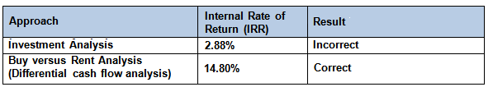

END

Tip for reading a lease
Q1. Why is it so important to read a lease very carefully?
Your answer

Q2.
How do you determine what expenses are paid by the landlord, and by the tenant?
Your answer

Q3.
What is a Demolition Clause?
Your answer

Q4.

Tips for reading a lease

Flip side

Read the lease several times. Leases are complex legal documents and need to be read carefully.

Ask a question and go looking for your answer in the lease. Read with a purpose. Have a question in mind.

Examples

Is there a “Demolition Clause?

When is the next rent increase and how is it calculated?

What operating expenses does the tenant pay?

ETC.
___________________________________________________________
Q5.

How are the renewal rates in a lease determined?

Also called “Rent Steps” or “Rent bumps”
Your answer

END

Demolition Clauses
Q1.
What is a “Demolition Clause?”
Your Answer

Q2.
Why would a landlord include a “Demolition Clause” in a lease?
Your Answer

Q3.
From the landlord’s perspective what is the disadvantage of a “Demolition Clause” in the lease?
Your Answer

__________________________________________________

Q4.
What types of properties often have a “Demolition Clause” in all the leases in the building?
Your answer

Q5.
If a landlord insists on a demolition clause and the tenant really wants to rent the space because of its location how can you modify the demolition clause so that it helps the tenant financially?
Your answer

Q6.
If an investor or developer is looking at buying an older building which has 5 tenancies what’s one of the first things the investor should look for in the lease?
Your answer

Q7.
Does a demolition clause affect the value of older commercial properties and make it easier or harder to sell?
Your answer

END

