Investit Academy Learning Management System
____________________________________________________________________________________________________________________

Curriculum and Instructors Guide

_________________________________________________________________________________________________________

Neil Osborne M.B.A.
DL. (604) 988-9964
nosborne@investitsoftware.com
Investit Software Inc.
Toll free 877-878-1828
North Vancouver BC
Canada V7P 2R5
investit@investitsoftware.com
www.investitpro.com
www.investitacademy.com
Copyright 2020 Neil Osborne

Table of Contents

Overview and Objectives 3
Educational Philosophy 3
Devices 4
Raising Your Commercial IQ Video Series 4
HOME PAGE and NAVIGATION 6
COURSE OUTLINES AND LEARNING OBJECTIVES 7
101. How to Analyze & Value Income Properties 7
102. Real Estate Investment & Lease Analysis 9
103. Development Analysis and Valuing Land 10
201. Applied Real Estate Investment & Lease Analysis 12
202. Creating & Profiting from Joint Ventures 14
203. Office, Retail and Industrial Leasing 15
PRACTICE QUIZZES 17
MICRO VIDEOS 17
FLASH CARDS 22
MASTERY CHALLENGES 25
RESOURCES. Informative articles, helpful checklists and short videos 26
Viewing grades and competency test results 27
Adding additional content 31
Branding 31

Overview and Objectives
The Investit Academy LMS enables organizations and educational institutions to offer comprehensive online courses in real estate investment, development, and leasing.

The objective of the “Curriculum and Instructors Guide” is to:

- Course planning. To help instructors put together and plan online courses in real estate investment, development, and leasing by providing a detailed view of the content of the courses, videos, micro-videos, flashcards, quizzes and exams

- To illustrate the depth and comprehensiveness of the Investit Academy Commercial Learning Management System

- Provide instructions for reviewing student grades and reviewing their progress

Educational Philosophy
Educational PhilosophyThe Investit Academy approach to education is built on four core principles that have been proven to make learning more effective and convenient – and increase retention and interest.

- On Demand
Investit Academy is the only fully online commercial real estate training and recruiting platform that allows teams to learn on demand. This on demand learning model makes training more convenient, flexible and effective. There are no classrooms, DVDs or downloads – everything is accessible anytime on any device.

- Learning Styles
We recognize everyone learns differently and has their own individual learning styles. To cater to all learning styles and preferences, Investit Academy offers a variety of engaging educational activities, including flash cards, micro videos, mastery challenges, practical exercises and case studies. Students have the flexibility to select the style that works best for them.

- Personalized
Investit Academy allows students to personalize their learning path based on their starting point and educational needs. If students are new to the industry, they can start with the basics and work their way up. For more experienced students, they can skip to more advanced activities to bypass what they already know.

- Collaborative
Investit Academy employs a collaborative approach to learning that identifies training needs and measures progress in real-time via consistent, two-way feedback. Student feedback helps instructors identify gaps in their learning progress that need to be filled. And instructor feedback helps them optimize their teaching method for the best results.

These principles are applied via two learning formats:
- Microlearning
Our microlearning approach delivers learning content in short, bite-sized learning nuggets that are easily digestible and enhance retention. Microlearning is ideal for adult learners because it is adaptive and well-suited to shorter attention spans and time constraints.
Microlearning is especially effective for teaching the basic terms, definitions, and calculations used in commercial real estate. Investit Academy utilizes microlearning in the form of micro videos, flash cards and short quizzes and mastery challenges to enhance retention and engagement.

- Traditional Learning
For the more complex commercial real estate topics, Investit Academy uses traditional learning concepts. This traditional learning method includes videos, manuals for analysis frameworks and illustrative case studies
Traditional learning techniques are used to cover advanced commercial real estate topics in the depth they require, such as long-term real estate investment, lease and development analysis.

Devices
The Investit LMS can be viewed on all the popular devices such as a PC, Laptops, Android tablets, Macs, IPads, iPhone, and Android smartphones.

In the case of the iPhone, an app must be downloaded from a link on the Home Page.

Raising Your Commercial IQ Video Series

The Investit Academy Commercial LMS consists of six introductory to advanced courses which are:

101. How to Analyze and Value Income Properties. (3-1/4 hours)
102. Real Estate Investment & Lease Analysis. (3-1/4 hours)
103.Development Analysis and Valuing Land. (4-3/4 hours)
201.Applied Real Estate Investment and Lease Analysis (4-1/2 hours)
202.Creating and Profiting from Joint Ventures (3-1/4 hours)
203. Office, Retail & Industrial Leasing (3 hours)

Everyone learns differently and at their own pace. Investit Academy offers refreshing learning flexibility. Videos and manuals, flash cards, micro videos, mastery challenges, practical exercises or case studies – how you learn is up to you.

HOME PAGE and NAVIGATION

The LMS is very easy to navigate and use.

There are two aspects to the Home page
- Links to the various learning activities such as viewing a course video or flashcard set
- Action menu for carrying out activities such as viewing a candidate’s grade

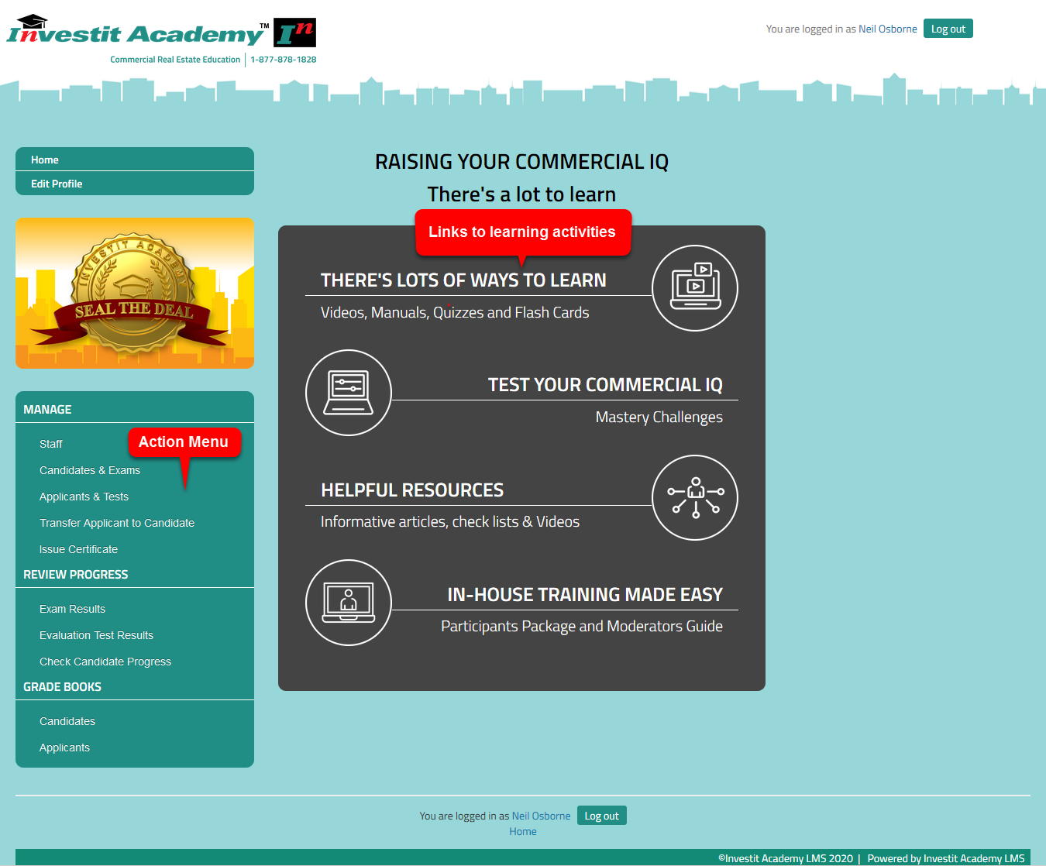

COURSE OUTLINES AND LEARNING OBJECTIVES

101. How to Analyze & Value Income Properties
Time: 3-1/4 hours
Learning objectives
This video introduces the fundamentals of real estate investment analysis and discusses the issues, complexities, and dangers involved in analyzing, purchasing, listing, and selling commercial properties.
Specific objectives are to:
- provide a good understanding of the basic financial measures used to evaluate and determine the value of rental apartment buildings and commercial properties.
- explore the advantages and disadvantages of the most used financial measures.
- demonstrate how to analyze and adjust Income & Expenses Statements and what expenses need to be included when using Cap Rates to determine the property value.
- provide an in-depth overview of the capitalization rate as it is used in commercial real estate, and to explain the factors that influence the Cap Rate
- show how to analyze apartment and commercial buildings and how to re-do the financial statements so that they more realistically reflect the financial performance of the buildings.
- provide an introduction to risk analysis and financial ratios for measuring risk
- show how to read a lease and discuss important terms /clauses in the lease that can affect the value of a commercial building
- provide an understanding of the weakness of using Cap Rates with a brief introduction to long term real estate investment analysis
- show how to identify properties that may be hard to sell because of income tax consequences
- show the importance of having a professional engineer assess the building on behalf of a buyer using real-world examples
Skills and benefits obtained from the video
- How to analyze and restructure “Income & Expense Statements” so that they more realistically represent the financial performance of the property
- How to use the various financial measures such as the Gross Income Multiplier, Cap Rate, etc., to value an income property and appreciate the limitations of these simplistic approaches
- Understand how important it is for the buyer of income properties to obtain professional engineering, tax, and legal advice
The knowledge and skills developed during the video will improve your ability to analyze and value income properties.

102. Real Estate Investment & Lease Analysis
Time: 3-1/4 hours
Learning objectives.
The overall objective of the video is to provide an understanding of how to carry out in-depth real estate analysis investment and lease analysis, and how to apply investment analysis techniques to different types of properties or types of real estate decisions.
How to use investment analysis to create deals.
Topics
- The significant weaknesses in using Cap Rates to make real estate investment decisions compared to the discounted cash flow approach. Examples illustrating the weakness of the Cap Rate approach to establishing the value
- Time value of money concepts. The Internal Rate of Return (IRR) and Net Present Value financial measures
- Steps involved in carrying out long term real estate investment analysis and discounted cash flow and risk analysis
- Lease analysis and lease comparisons from a landlord and tenant perspective
- Negotiating the financial aspects of a lease
- Lease negotiations. Case study
- Buy versus Lease analysis
- How to use real estate analysis techniques to help purchase, list, sell or lease a property during these challenging times
- A framework for exploring creative financing and case study
- Hold versus Sell analysis
- Valuing land leases
Skills and benefits obtained from the Video
How to:
- carry out and apply in-depth real estate analysis to different types of income properties
- determine the value of an income property using the discounted cash flow analysis approach

103. Development Analysis and Valuing Land
Time: 4-3/4 hours
Learning Objectives.
The overall objective of the video is to provide an understanding of:
- how to carry out development analysis to determine land values for unit projects such as land subdivisions and condominium projects, and income properties such as office buildings
- the issues and difficulties associated with determining land value
Topics
- Issues related to using simplistic approaches, such as $ per Acre or Sq. Ft to value land
- The backdoor or land residual approach to valuing land
- Factors that affect land values. Examples are illustrated using photographs
Soil conditions
Architectural, design & zoning constraints
- Development Analysis Case Study. Condominium development
- Development Analysis Case Study. Retail center development
- Sensitivity & Risk analysis. What numbers have the biggest impact on the development profit?
- Analyzing a “Mixed” unit and income property development. Case study3
- Income property development. Sell or hold analysis
- Renovation analysis
- Profitability analysis and ratios & assessing the development risks
- Quick Proforma approach versus detailed monthly cash flow development analysis
- Construction loan requirements
- Offer to Purchase versus Options. Pros & cons.
- Tips for creating an offer
- Keeping the offer together
- Land assembly and analyzing sites with assembly potential
Skills and benefits obtained from the video
- How to analyze development sites and determine land values using the development analysis approach
- Appreciate the difficulties and uncertainties in determining land value
The knowledge and skills developed during the video will improve your ability to value, purchase, list, and sell development sites or develop successful projects.

201. Applied Real Estate Investment & Lease Analysis
Time: 4-1/2 hours
Learning objectives.
The overall objective of the video is to provide an understanding of how to carry out in-depth real estate analysis investment and lease analysis, and how to apply investment analysis techniques to different types of properties or types of real estate decisions.
How to use investment analysis to create deals.
Topics
- Investment analysis. Getting started. Questions to ask.
- Applying the Internal Rate of Return (IRR), Net Present Value (NPV) and Modified Internal Rate of Return (MIRR) to real estate investment decisions
- Issues and challenges related to calculating the Internal Rate of Return (IRR)
- Exploring potential financing now and in the future
- Risk analysis and management
- Real estate analysis. Tips and tricks
- Lease analysis and lease comparisons from a landlord and tenant perspective
- Lease negotiations. Case study
- A framework for exploring creative financing and case study
- Buy versus Lease analysis. & Hold versus Sell case studies
- Valuing land leases
- Replacement reserve planning
Skills and benefits obtained from the Video
How to:
- carry out and apply in-depth real estate analysis to different types of income properties
- determine the value of an income property using the discounted cash flow analysis approach
- analyze and manage risk
- develop presentation packages and executive summaries
- financially structure a real estate transaction using creative financing
- perform lease comparison analysis from a landlord or tenant perspective
- make Buy versus Lease and Hold versus Sell decisions
- develop replacement reserve schedules
The knowledge and skills developed will improve your ability to value, list, sell or lease income properties and how to use investment analysis techniques to put deals together and make you money.
As an investor, how to determine the value based on your desired return and make wise investment decisions.

202. Creating & Profiting from Joint Ventures
Time: 3-1/4 hours
Learning objectives.
This Video assumes that those attending understand the basics of real estate investment analysis or have taken the Raising Your Commercial IQ Video “Real Estate Investment & Lease Analysis”.
The overall objective of the Video is to provide an understanding and a framework for analyzing and structuring joint ventures using case studies.
Topics
- Provide an introduction to the nature and characteristics of joint ventures
- Show how to use joint ventures to structure deals and earn commissions and/or profits
- Provide a universal framework for thinking about, analyzing and structuring joint ventures
- Demonstrate joint venture creation and analysis using case studies and solution guides
- How to analyze complex investments such as syndications, equity participation deal, and waterfall distributions
Skills and benefits obtained from the Video
The knowledge and skills developed will improve your ability to analyze and structure joint ventures by providing a framework for analyzing joint ventures and give you lots of ideas for putting joint ventures together.

203. Office, Retail and Industrial Leasing
Time: 3 hours

Learning Objectives.
To provide a comprehensive understanding of:
- The leasing process and terms used in leasing
- How to read a lease and what to look for in a lease
- The differences between the different kinds of leasing markets
- How tenants go about choosing a location and space
- What question to ask the landlord and tenant
- Some of the complex issues involved leases and lease negotiations
- Why leases are often complex, lengthy documents
- How to carry out lease comparison analysis from a landlord & tenant perspective
Topics
Following is a summary of topics that will be covered.
- Overview of landlord and tenant leasing objectives
- Tenant compatibility considerations and issues
- Leasing characteristics by different types of properties
- The leasing process and documents
- Types of Leases
Gross & Modified Gross Leases, Indexed lease, Triple Net Lease, Expense Caps and Stops and Rent Caps
- Types of Rent
- Base Rent & Additional Rent or Recoverable Expenses
- Free Rent
- Percentage Rent
- Areas and Area Measurement
- Rentable and Usable Areas and Load Factor
- Space Measurements and the BOMA Standards
- How to measure different types of properties
- Issues related to measuring space
- Leasing new space. Tenant Improvements and build-outs.
- Assignment & Subletting
- Operating Expenses, Recoverable Expenses, and related issues and considerations
- Renovating and subdividing space including structural considerations
- Lease Comparison Analysis and the Net Effective Rent from landlord & tenant perspective
- Case Study. Comparing three different lease arrangements
- Valuing ground leases.
- Blending and extending a lease
- Impact of leases on the property value and marketability
- Tips for reading leases
- Leasing as a career
Skills and benefits obtained from the video
- Increased knowledge of lease terms and the leasing process
- The differences involved in the leasing of office, industrial and retail space
- A deeper understanding of the complex issues related to leasing
- How to compare leases from a landlord or tenant perspective
The knowledge and skills developed during the video will improve your ability to negotiate and analyze leases from a tenant or landlord perspective.

PRACTICE QUIZZES
Practice exercises for each of the six courses allow the students to test their knowledge and measure their progress and prepare for the course exam. The quiz grade is recorded and can be viewed by the student but not by the instructor.

MICRO VIDEOS
Our unique micro-video program makes learning fast, convenient and effective. Learn exactly what you need to know in just minutes for each lesson, then measure your progress as you go. It’s a proven way to learn more effectively.
101. How to Analyze and Value Income Properties. Micro videos
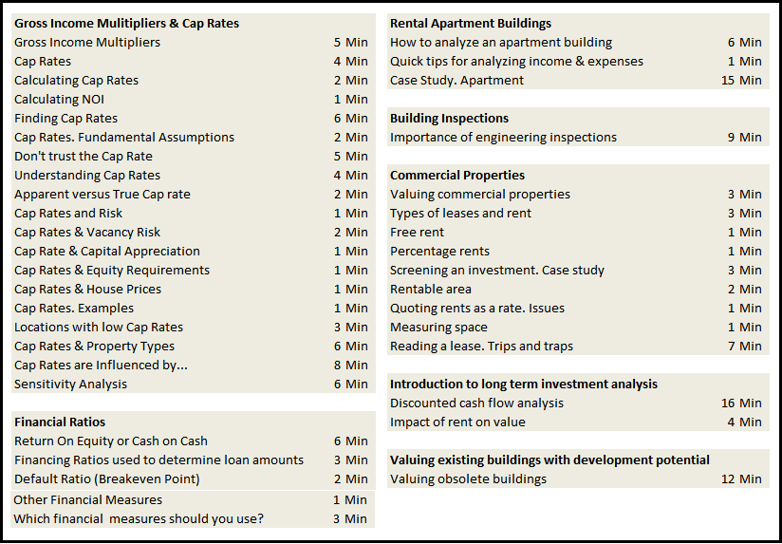

102. Real Estate Investment Analysis. Micro videos
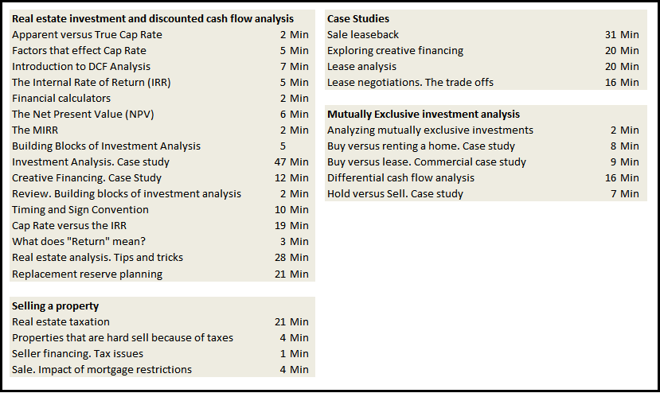

103. Development Analysis and Valuation of Land. Micro videos
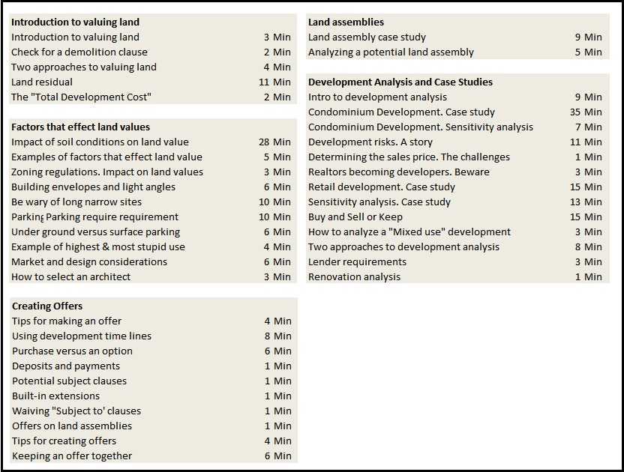

201. Applied Real Estate Investment and Lease Analysis. Micro videos
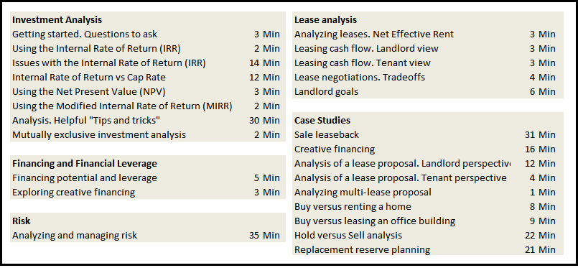

202. Creating and Profiting from Joint Ventures. Micro Videos
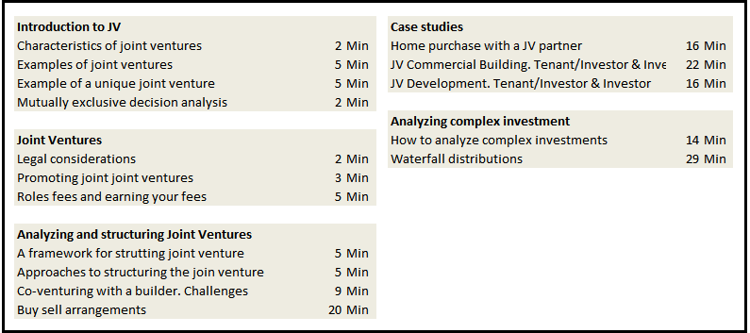

203. Office, Industrial and Retail Leasing. Micro videos
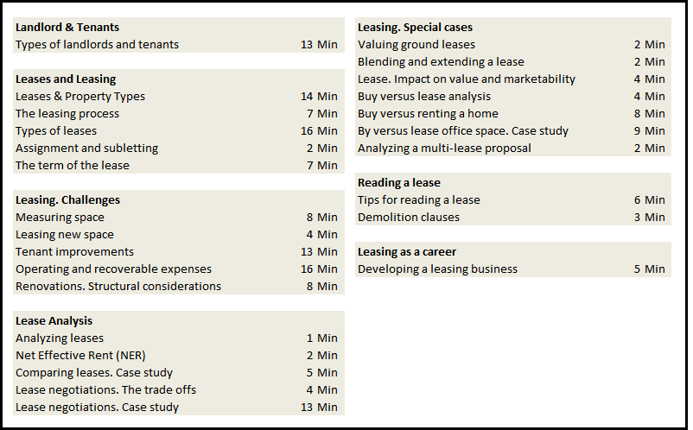

FLASH CARDS
Flash cards are a great way to learn the basic terms and calculations used in commercial real estate.

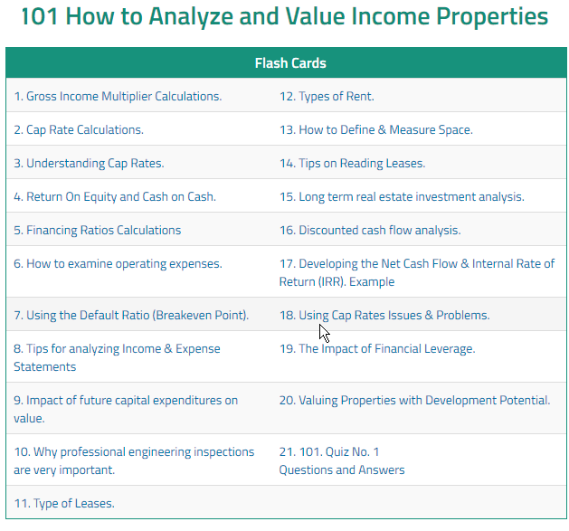

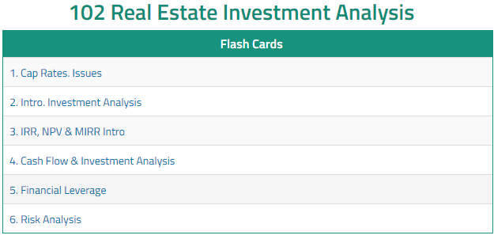

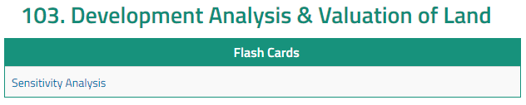

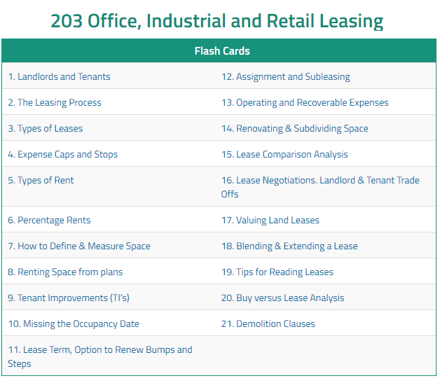

MASTERY CHALLENGES
Allows students to test their understanding of commercial real estate basics and evaluate their progress using real-time feedback.

Their grade is recorded and available for later reference. The instructor cannot view the mastery challenge grades.

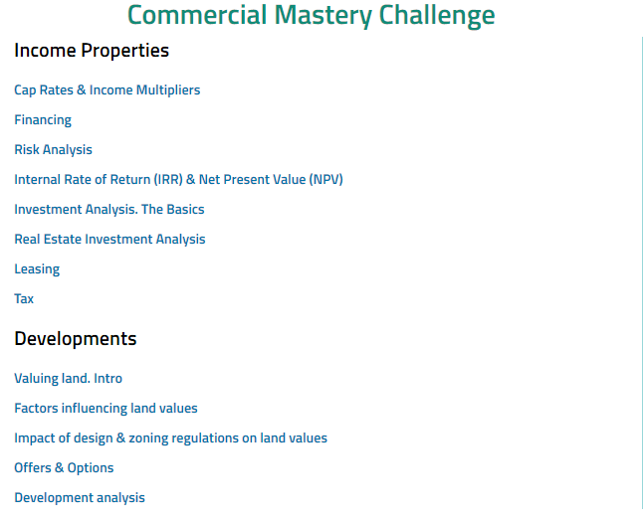

RESOURCES. Informative articles, helpful checklists and short videos

Informative Articles
- Commercial real estate formulas with sample calculations and practice exercises
- How to value income properties
- All about Cap Rate
- Commercial Leasing. Terms and Definitions
- 5 points an investor should consider when buying a property
Helpful Checklists
- Apartment buildings
- Industrial leasing
- Development checklist
Short Videos
- Buy Versus Lease
- Hold versus Sell
- Lease Analysis from a Landlord and Tenant perspective
- Development Analysis
- Replacement reserve planning
- Importance of financial leverage

Viewing grades and competency test results
As a manager or instructor, you can view candidates (students) results and measure their progress. Students can view their grades and progress using the Action Menu on the home page.

Competency Test.
The Competency test allows you to test the applicant or student's understanding of commercial real estate basic terms and calculations.

There are several ways to view grades. For illustration purposes, we will use “REVIEW PROGRESS” on the Home Page Action Menu.

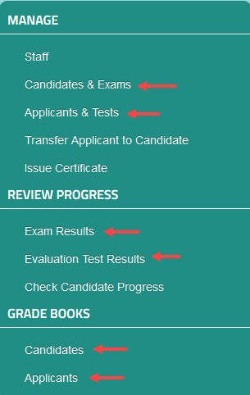

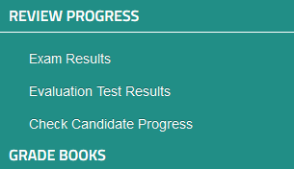

Exam Results
The first step are1) Select the course 2) Select the student 3) Show report
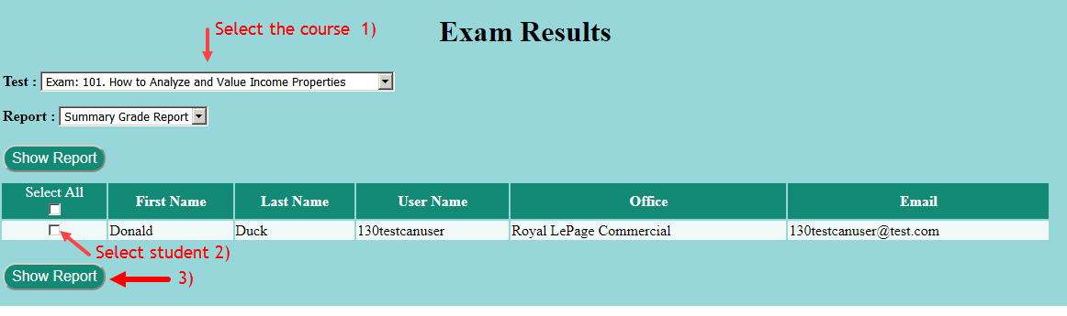
101. How to analyze and value income properties. Exam report example.

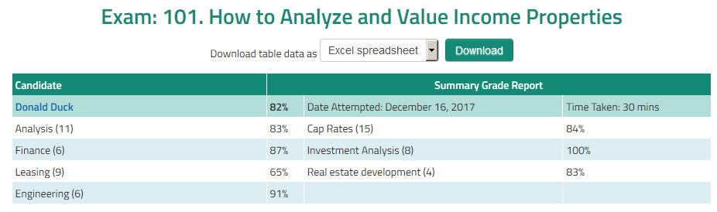

Evaluation Test Results (Competency Test)
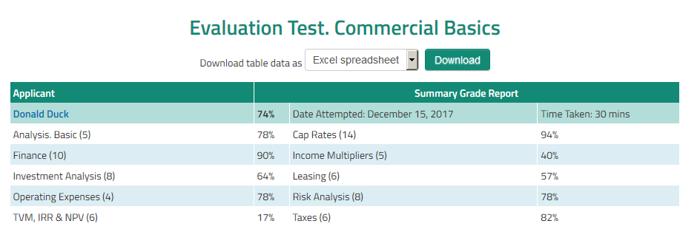

Check student progress
Allows you to view the student's grades and check their progress.

  - Select the student
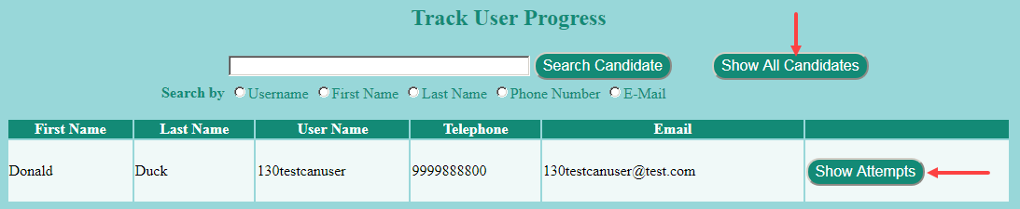

  - To review the course grades click on “Show Attempts”

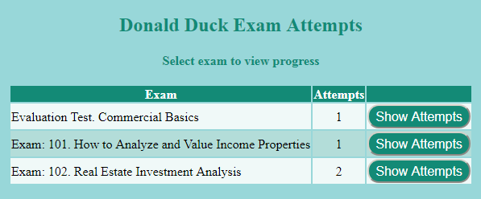

  - The course grade for each attempt is displayed allowing you to view the student progress

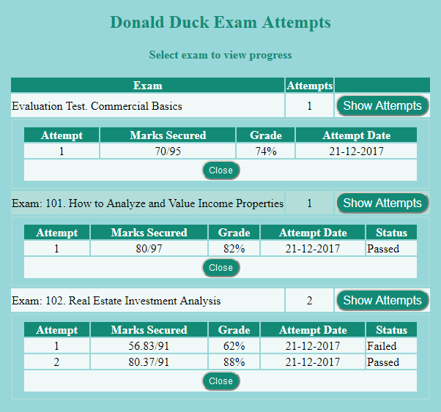

Adding additional content
Additional content such as videos, quizzes, articles, etc., that are unique to your teaching needs can be added to enhance the learning experience. To create additional content requires asking Investit to set up the “Additional Content” feature.

Branding
Adding logos and banners

When an organization is set up with the LMS we ask them for their logo. Two logos can be inserted in the header as shown below.

Also, the organization can add three banner ads or use the banner ad space to make announcements.

