Raising Your Commercial IQ. In-house program
____________________________________________________________________________________________________________________

Instructor Guide

__________________________________________________________________________________________________________________

Neil Osborne M.B.A.
DL. (604) 988-9964
nosborne@investitsoftware.com
Investit Software Inc.
Toll free 877-878-1828
North Vancouver BC
Canada V7P 2R5
www.investitacaademy.com
investit@investitsoftware.com
www.investitpro.com
www.investitacademy.com
Copyright Neil Osborne

Table of Contents

Investit Academy in-house commercial training program 3
Devices 3
Course set up 3
Instructor and Moderator (Assistant) 3
In-house courses 4
Class hours 4
Content choices 5
Teaching process 5
Competency Test 5
Practice Quizzes 11
Viewing grades and competency test results 11
Course outlines 15
101. How to Analyze & Value Income Properties 15
102. Real Estate Investment Analysis 16
103. Development Analysis and Valuing Land 17
203. Office, Retail and Industrial Leasing 19

Investit Academy in-house commercial training program

Devices
The Investit LMS can be viewed on all the popular devices such as a PC, Laptop, Android tablets, Macs, IPad, iPhone, and Android smartphones.

In the case of the iPhone, an app must be downloaded from a link on the Home Page.

Course set up
All participant need the be enrolled in the Investit Academy LMS as candidates which give them full access to all the Investit Academy learning activities including videos, micro videos, flash card sets, practice quizzes.

Instructor and Moderator (Assistant)
The instructor's major role occurs during the playing of the flash cards questions and answers. Providing explanations, encouraging discussion, answering questions, and providing local examples.

The moderator's role, which could be one of the participants, is to switch between playing the micro-videos and the flashcards. The instructor can act as the moderator.

Print and review the "Instructor Package and Agenda Time Table."

Participants
Prior to commencing the class, send the participants the following:
- Course manual
- Course Participant Package
- Information on:
Class dates, time, class hours, and to bring a calculator. It doesn't have to be a financial calculator.

The Course Manual and Participant Package can be downloaded from the Investit Academy LMS either as a Word or PDF document. Go to the Home page select "IN-HOUSE TRAINING MADE EASY."

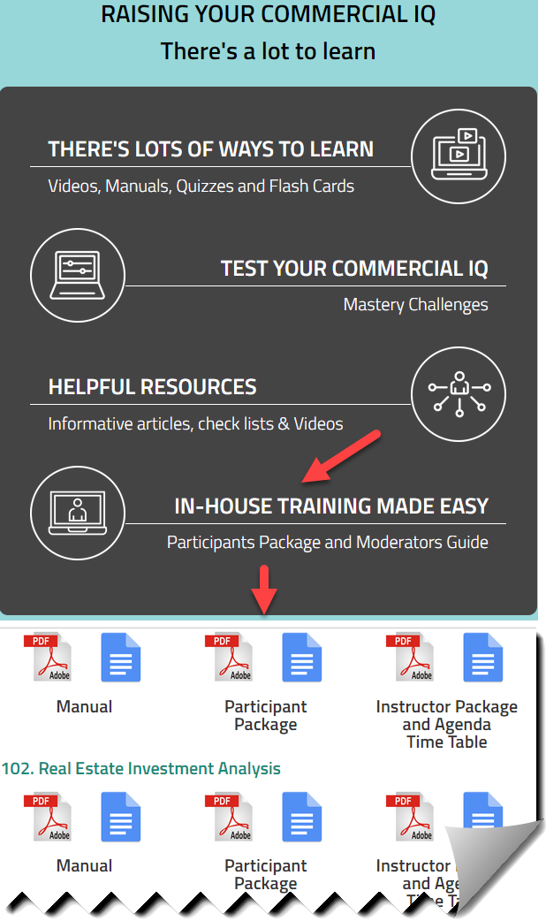

In-house courses
101. How to Analyze and Value Income Properties. Commercial Basics. 16 class hours.
102. Real Estate Investment Analysis. 16 class hours.
103. Development Analysis and Valuing Land. 18-20 class hours
203. Office, Retail & Industrial Leasing. 18-20 class hours

Class hours
Class meetings are flexible. For example, four-hour sessions meeting once per week for four weeks.

Content choices
In some cases, you may not want to present all the course material. For example, if the class consists of residential realtors or rookie commercial realtors interested in learning more about commercial real estate, some topics may be too advanced. If this is the case, skip the micro videos and flash Cards related to the topic.

Teaching process
The teaching process consists of alternating between playing the:

- Micro videos
- Flashcards, answering the flashcard questions, and class discussions

by following the "Agenda Time Table" See the example below.

The micro videos provide an introduction to the topic.

The flash cards actively involve the student in the learning process and reinforce the material presented in the micro videos.

Flash cards. A great way to learn the basics. The Participant Guide contains:

- Flash Card Question
- Space for the participant to write the answer in the participant Guide
- The answer is on the flip side of the flashcard.

Competency Test
We strongly recommend that participants take the "Competency Test." before commencing the 101 In-house course and then take the "Competency Test" again after completing the course to measure their progress.

The "Competency Test" measures their understanding of basic commercial real estate terms and calculations.

Prior to taking the 101 in-house course, the competency test grade is generally around 45% to 55%, indicating they have a lot to learn. The grade typically improves to 85% plus after taking the 101 in-house program.

Teaching using flashcards.
Allow the participants' time to complete the flashcard questions and then:

Review each flashcard question and answer and encourage questions and discussions. Enliven with your own experience and local examples.

This approach provides the opportunity for active class involvement.

- Questions, answers, and lively in-depth discussions

- Provides the instructor with an opportunity to provide local examples and personal experiences.

For example:

101 Course. How to analyze and value income properties (Commercial Basics)
Explain the Cap Rate for different types of income properties in your market area

103 Course Development analysis and valuing land
Soil conditions can impact the development costs and lower the land value. Explain the various types of soil in your area and how the soil affects the land value.

302 Course
Calculating leasing fees vary widely depending on the location and type of real estate. Explain how leasing fees are calculated in your area.

Course Agenda Time Table
The Instructor Guide for each course contains the Agenda and Time Table which shows:
- When to play the micro videos
- When to play the flash card set
- Shows the "Participant Package" page number and the "Course Manual "page number

This is a partial example for the 101 course "Agenda Time Table"

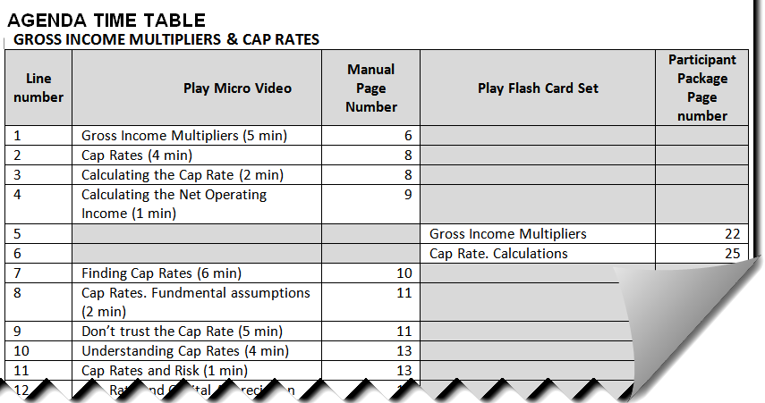

Micro Videos and Flash Cards
Are available on the LMS Home Page.

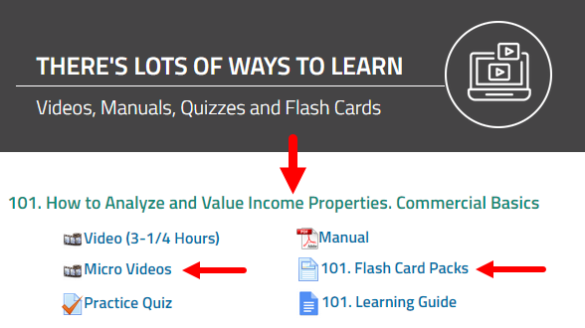

Micro Video Grid
At the start of the session, click on the "Display all Micro Videos" button to display all the micro videos for the course.

The micro videos can be expanded to "Full Screen."

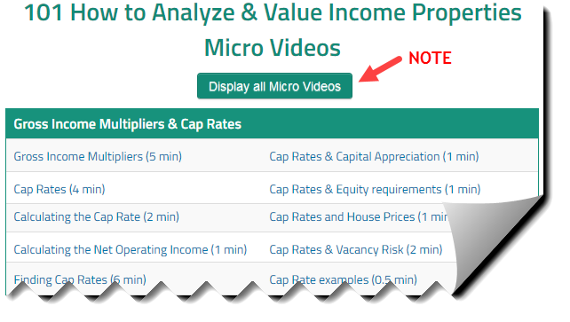

Flash Card
At the start of the session click, on the "Display all Flash Cards" button to display all the micro videos.

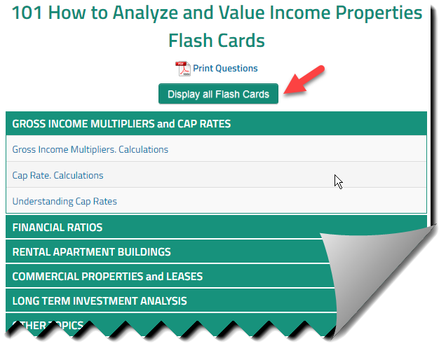

Expanding the flash card to "Full Screen"
Open the Flash Card set and click on the "Expand" button

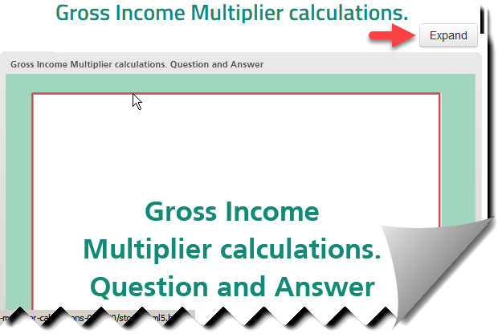

Home Page Navigation
The LMS Home Page is easy to navigate.

There are two aspects to the Home page
- Links to the various learning activities such as viewing a course video or flashcard set
- Action Menu for carrying out activities such as viewing a candidate's grade

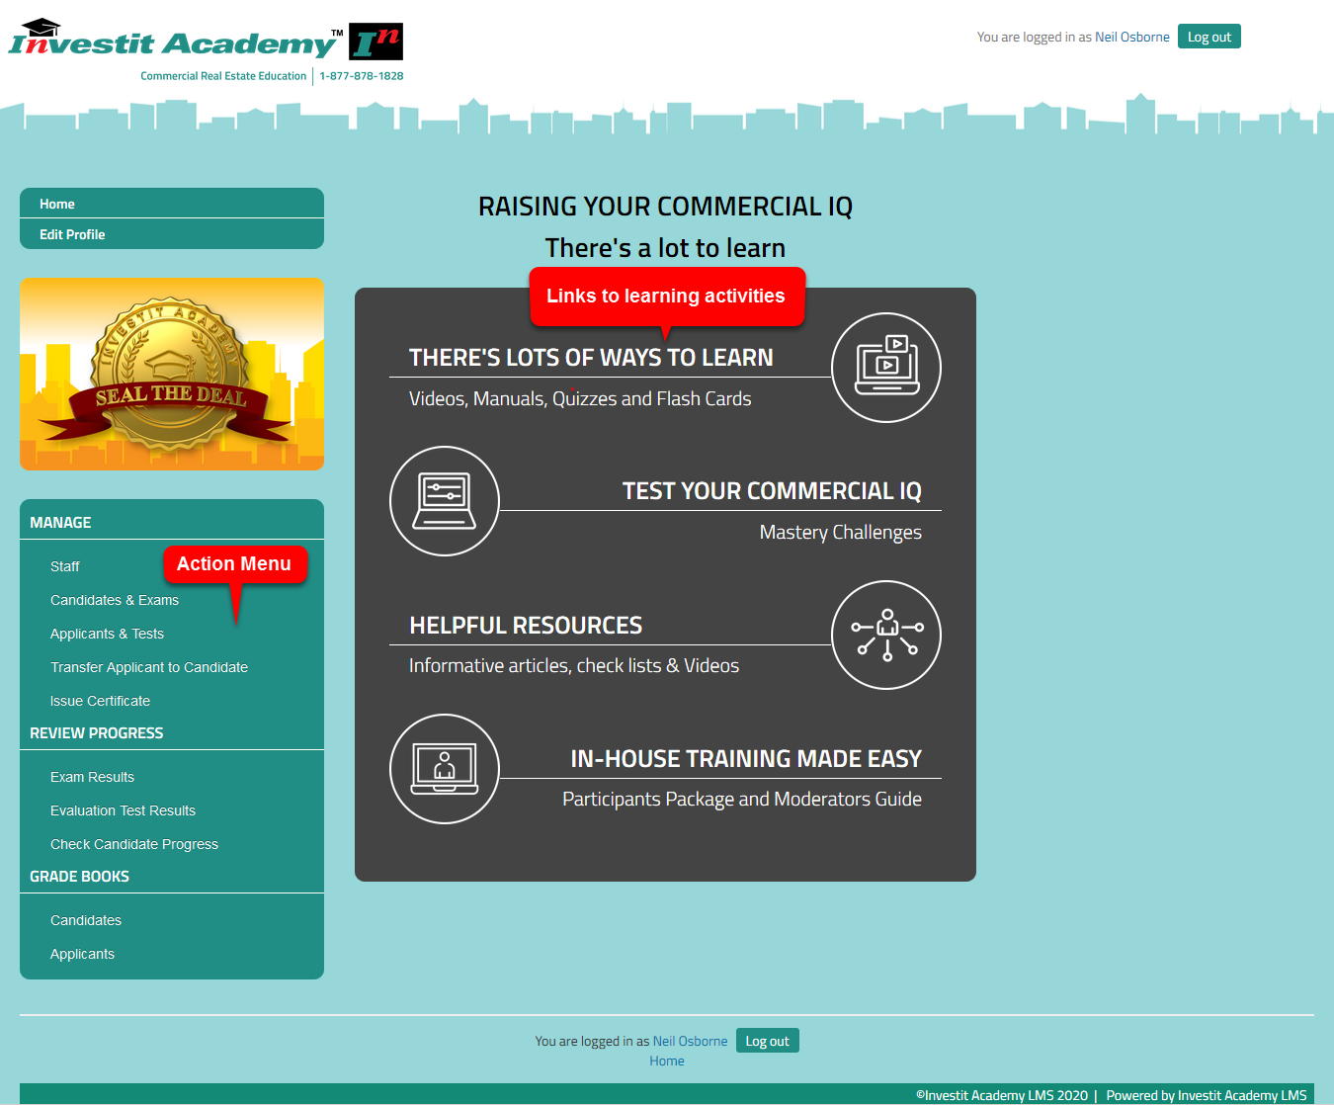

Practice Quizzes
Practice exercises for each of the four courses allow the students to test their knowledge and measure their progress and prepare for the course exam. The quiz grade is recorded and can be viewed by the student but not by the instructor.

Viewing grades and competency test results
As a manager or instructor, you can view candidates' (students) results and measure their progress. Students can view their grades and progress using the Action Menu on their home page.

Competency Test.
The Competency test allows you to test the applicant or student's understanding of commercial real estate basic terms and calculations.

There are several ways to view grades. For illustration purposes, we will use "REVIEW PROGRESS" on the Home Page Action Menu.

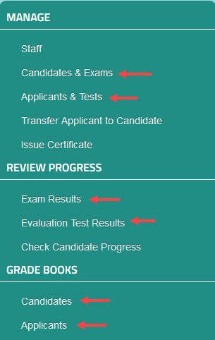

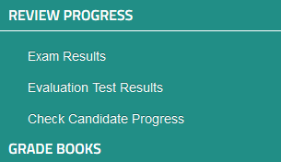

Exam Results
The first step are1) Select the course 2) Select the student 3) Show report
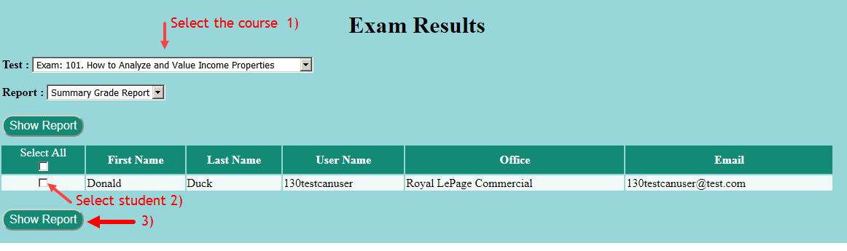

101. How to analyze and value income properties. Exam grade report example.

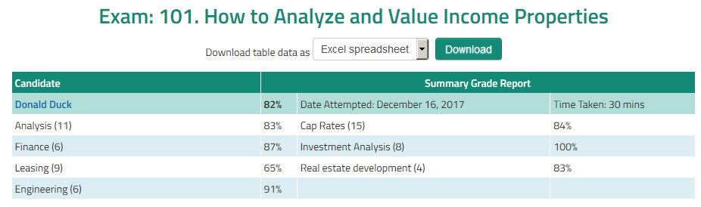

Evaluation Test Results (Competency Test)
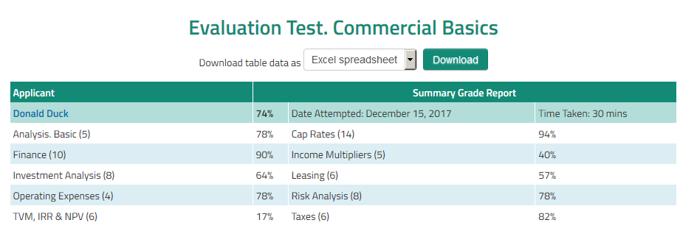

Check student progress
Allows you to view the student's grades and check their progress.

  - Select the student
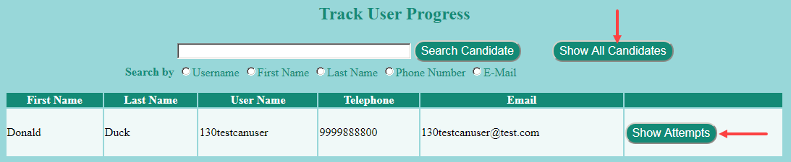

  - To review the course grades click on "Show Attempts"

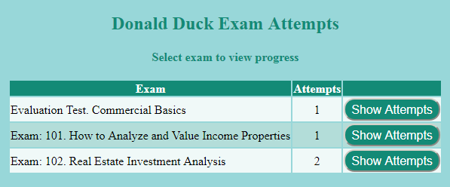

  - The course grade for each attempt is displayed allowing you to view the student progress

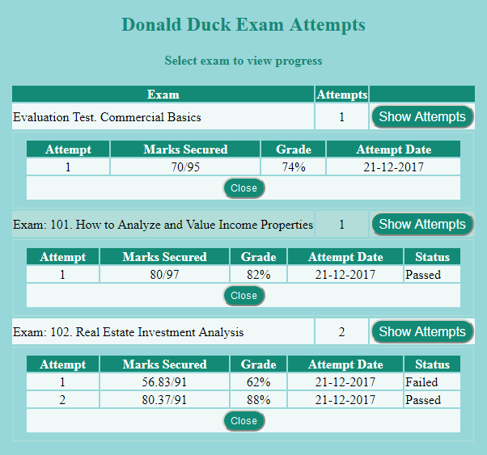

Course outlines

101. How to Analyze & Value Income Properties
Learning objectives
This video introduces the fundamentals of real estate investment analysis and discusses the issues, complexities and dangers involved in listing and selling commercial properties.
Specific objectives are to:
- provide a good understanding of the basic financial measures used to evaluate and determine the value of rental apartment buildings and commercial properties.
- explore the advantages and disadvantages of the most used financial measures.
- demonstrate how to analyze and adjust Income & Expenses Statements and what expenses need to be included when using Cap Rates to determine the property value.
- provide an in-depth overview of the capitalization rate as it is used in commercial real estate, and to explain the factors that influence the Cap Rate
- show how to analyze apartment and commercial buildings and how to re-do the financial statements so that they more realistically reflect the financial performance of the buildings.
- provide an introduction to risk analysis and financial ratios for measuring risk
- how to read a lease and discuss important terms and clauses in the lease that can affect the value of a commercial building
- provide an understanding of the weakness of using Cap Rates with a brief introduction to long term real estate investment analysis
- show how to identify properties that may be hard to sell because of income tax consequences
- show the importance of having a professional engineer assessment of the building on behalf of a buyer, by using real-world examples

Skills and benefits
How to analyze and restructure "Income & Expense Statements" so that they more realistically represent the financial performance of the property
- How to use the various financial measures such as the Gross Income Multiplier, Cap Rate, etc., to value an income property and appreciate the limitations of these simplistic approaches
- Understand how important it is for the buyer of income properties to obtain professional engineering, tax, and legal advice
The knowledge and skills developed during the in-house program will improve your ability to analyze and value income properties.

102. Real Estate Investment Analysis
Learning objectives.
The overall objective is to provide an understanding of how to carry out in-depth real estate analysis investment analysis and how to apply investment analysis techniques to different types of properties or types of real estate. How to use investment analysis to create deals.
Topics
- The significant weaknesses in using Cap Rates to make real estate investment decisions compared to the discounted cash flow approach. Examples illustrating the disadvantage of the Cap Rate approach to establishing value
- Time value of money concepts. The Internal Rate of Return (IRR) and Net Present Value financial measures and discounted cash flow analysis
- Steps involved in carrying out long term real estate investment analysis and discounted cash flow analysis
- Real estate taxation

- Impact of financial leverage on the investment return and investment risk

- A framework for exploring creative financing creative financing

- How to use real estate analysis techniques to help list, sell or lease or invest wisely

Skills and benefits
How to:
Carry out and apply in-depth real estate analysis to different types of income properties
Determine the value of an income property using the discounted cash flow analysis approach
Assess the investment risk
Financially structure a real estate transaction using creative financing
The knowledge and skills developed will improve your ability to value, list, sell or lease income properties and how to use investment analysis techniques to put deals together and make you money and make wise investment decisions.

103. Development Analysis and Valuing Land
Learning Objectives.
The overall objective of the video is to provide an understanding of:
- How to carry out development analysis to determine land values for unit projects such as land subdivisions and condominium projects and income properties such as office buildings
- The issues and difficulties associated with determining land value
Topics
- Issues related to using simplistic approaches, such as $ per Acre or Sq. Ft to value land
- The backdoor or land residual approach to valuing land
- Factors that affect land values. Examples are illustrated using photographs
Soil and site conditions
Architectural, design & zoning constraints
- Development Analysis Case Study. Condominium development
- Development Analysis Case Study. Retail center development
- Sensitivity & Risk analysis. What numbers have the biggest impact on the development profit?
- Analyzing a "Mixed" unit and income property development. Case study3
- Income property development. Sell or hold analysis
- Renovation analysis
- Profitability analysis and ratios & assessing the development risks
- Quick Proforma approach versus detailed monthly cash flow development analysis
- Construction loan requirements
- Offer to Purchase versus Options. Pros & cons.
- Tips for creating an offer & Keeping the offer together
- Keeping the offer together
- Land assembly and analyzing sites with assembly potential

Skills and benefits obtained from the video
- How to analyze development sites and determine land values using the development analysis approach
- Appreciate the difficulties and uncertainties in determining land value
The knowledge and skills developed during the video will improve your ability to value, list and sell development sites or develop successful projects.

203. Office, Retail and Industrial Leasing
Learning Objectives
To provide a comprehensive understanding of:
- The leasing process and terms used in leasing
- How to read a lease and what to look for in a lease
- The differences between the different kinds of leasing markets
- How tenants go about choosing a location and space
- What question to ask the landlord and tenant
- Some of the complex issues involved leases and lease negotiations
- Why leases are often complex, lengthy documents
- How to carry out lease comparison analysis from a landlord & tenant perspective
Topics
Following is a summary of topics that will be covered.
- Overview of landlord and tenant leasing objectives
- Tenant compatibility considerations and issues
- Leasing characteristics by different types of properties
- The leasing process and documents
- Types of Leases
- Types of Rent
- Base Rent & Additional Rent or Recoverable Expenses
- Free Rent
- Percentage Rent

- Areas and Area Measurement
- Rentable and Usable Areas and Load Factor
- Space Measurements and the BOMA Standards
- How to measure different types of properties
- Issues related to measuring space
- Leasing new space. Tenant Improvements and build-outs

- Assignment & Subletting
- Operating Expenses, Recoverable Expenses, and related issues and considerations
- Renovating and subdividing space, including structural considerations
- Lease Comparison Analysis and the Net Effective Rent from landlord & tenant perspective
- Case Study. Comparing three different lease arrangements
- Valuing ground leases.
- Blending and extending a lease
- Impact of leases on the property value and marketability
- Tips for reading leases

Skills and benefits obtained from the video
- Increased knowledge of lease terms and the leasing process
- The differences involved in leasing office, industrial and retail space
- A deeper understanding of the complex issues related to leasing
- How to compare leases from will improve your ability to negotiate and analyze leases from a tenant and landlord perspective.

