INVESTIT ACADEMY
IN-HOUSE Commercial Training & Mentoring Program
Moderators and Staff Guide
July 24, 2019

Investit Software Inc.
Neil Osborne
604-988-9964 Email: nosborne@investitsoftware.com
Copyright Neil Osborne July 24, 2019
All rights reserved

OBJECTIVES 3
IN-HOUSE PROGRAM 3
MODERATOR 4
Selecting the moderator. 4
COMPETENCY TEST 4
PREPARATION 5
Handouts 5
Printing the course manual 5
Printing the Formula Handout 5
Participant’s package 6
Getting started 6
RUNNING A SESSION 6
Overview of the Investit Online Commercial Education 6
AGENDA TIME TABLE 7
The Handy Table of Contents 11
HOW TO SET UP A COMPETENCY TEST 12

PURPOSE
The Investit commercial online educational program makes it easy for real estate offices and organizations to run an in-house commercial real estate training and mentoring program.

Provides real estate offices with a recruiting program by offering a commercial evaluation test and an in-house commercial training and mentoring program.

OBJECTIVES
To conduct an in-house commercial training and mentoring program to:

- Offer an in-house program to attract new agents
- Provide commercial training for:
- new recruits or residential realtors wishing to engage in commercial real estate
- existing commercial agents who wish to branch into new areas of commercial real estate
- training for administrative staff so that they have a better understanding of commercial real estate terminology

IN-HOUSE PROGRAM
The in-house program is based on the Investit 101 Course “How to Analyze and Value Income Properties” which covers the basic terms and calculations used in commercial real estate and covers rental apartment buildings, commercial buildings and leasing with an introduction the investment and land analysis. It provides the foundation for starting a career in commercial real estate.

Consists of three, three hour sessions consisting of:
- Video (3-1/4 hour) and a workshop manual for guided note taking
- Short “Question and Answer” sessions using the Investit Flash cards to reinforce learning
- Teaching Exercises where each participant explains to a partner an important concept. As an example “Explain the Cap Rate to an investor new to commercial real estate investment”
- Short Quiz at the end of the third session coupled with a solution handout

MODERATOR
The role of the moderator is to:
- Ensure that the sessions run smoothly
- Distribute the participants package
- Follow the Agenda Time Schedule (See page 7)
- Switch smoothly between the “Video” and “Flash Cards” (See page 10)
by following the Agenda Time Table (See page 7)
Distribute the class handouts at the appropriate time

Selecting the moderator.
The moderator does not have to have a background in commercial real estate. It can be:
- An office administrator or staff member
- One of the participants who is willing to act as the moderator supplemented by a staff member who prints the hand out materials, sends out emails, sets up the ‘Competency Test” etc.
- A manager or experienced commercial realtor responsible for recruiting, training and mentoring

COMPETENCY TEST
The “Competency Test” evaluates the recruits understanding of the basic terms and calculations used in commercial real estate.

It is highly recommended that each recruit take the “Competency Test” before the sessions start and again after the sessions have been completed.

This provides a base line and quickly identifies how much they know about commercial real estate and what they need to learn motivating then to learn more.

After completing the program and taking the competency test again they can measure their progress.

This is a sample of the competency for a recruit who had no background in commercial real estate who had joined a commercial real estate office and participated in the Investit Academy In-house commercial training program.

After taking the competency test and starting the program the recruit made the comment “there is a lot to learn”

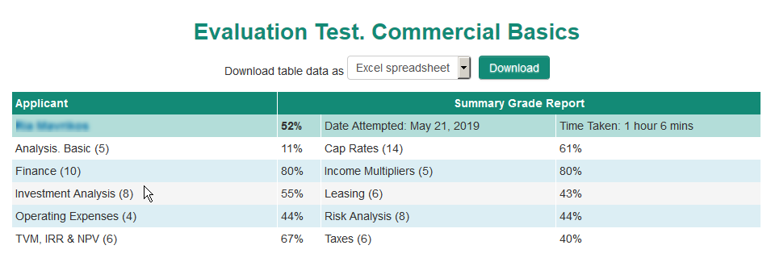
Setting up the Competency Tests see (See page 11)

PREPARATION

Handouts
The handouts consist of:
- Course 101 workshop manual
- Formulas with Sample calculations

Participant’s package consisting of:
- Flash Cards Question sheet showing the questions with space provided for the answer
- Teaching Exercise instructions

- Quiz handout. Conducted at the end of session 3
- Quiz Solution Guide. Handed out after the quiz has been completed

Printing the course manual
101. How to Analyze & Value Income Properties Course manual. Available on the Investit Academy LMS

HOME PAGE
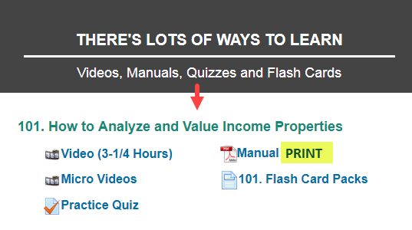

Printing the Formula Handout
Formulas with Sample Calculations. PRINT.
Available in the “Helpful Resources” section of the Investit LMS

HOME PAGE
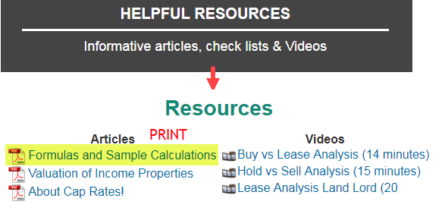

Participant’s package
Each participant receives a package consisting of:
- Flash Cards Question sheet showing the questions with space provided for the answer
- Teaching Exercise instructions
- Quiz

Getting started
Send out a welcome notice to each participant which includes:
- Session dates and start time
- To bring a calculator to each session. Any calculator will do. A financial calculator is not needed
- Conduct the competency test for each participant if appropriate

RUNNING A SESSION

Overview of the Investit Online Commercial Education
At the start of the first session provide brief overview showing each the learning activities:
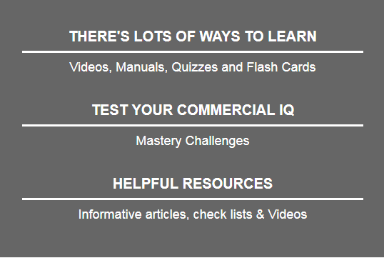

Each session consists of:

- Playing the video until reaching a specific point as specified in the “Agenda Time Table” below
- Playing a Flash Card Set. The question is displayed, participants write their answer in the Flash Card handout
After sufficient time to write the answer down the flip side of the Flash Card is displayed
- Process is repeated until the end of the 3 hour session
- Teaching Exercise. There are two teaching exercises per three hour session. See the Agenda Time Table for the timing (See page7).

AGENDA TIME TABLE
The moderator follows the following agenda which involve switching between the video segments, the 101 Flash cards and the teaching exercises.

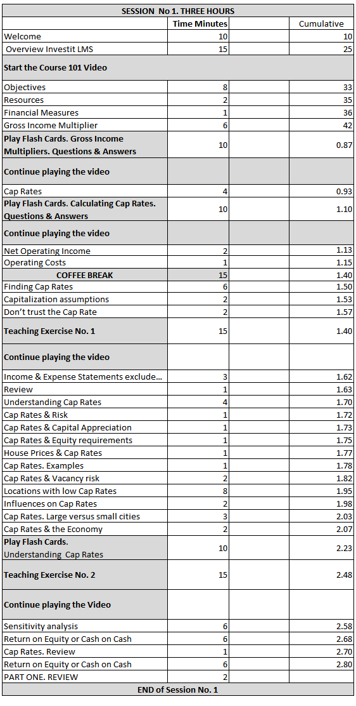

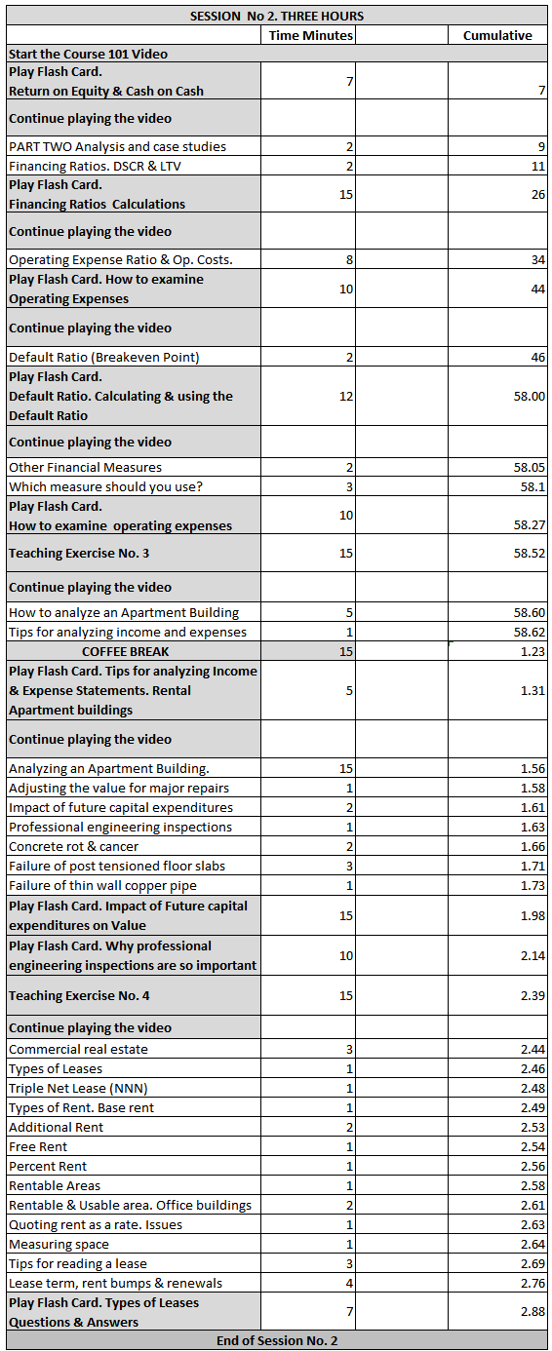
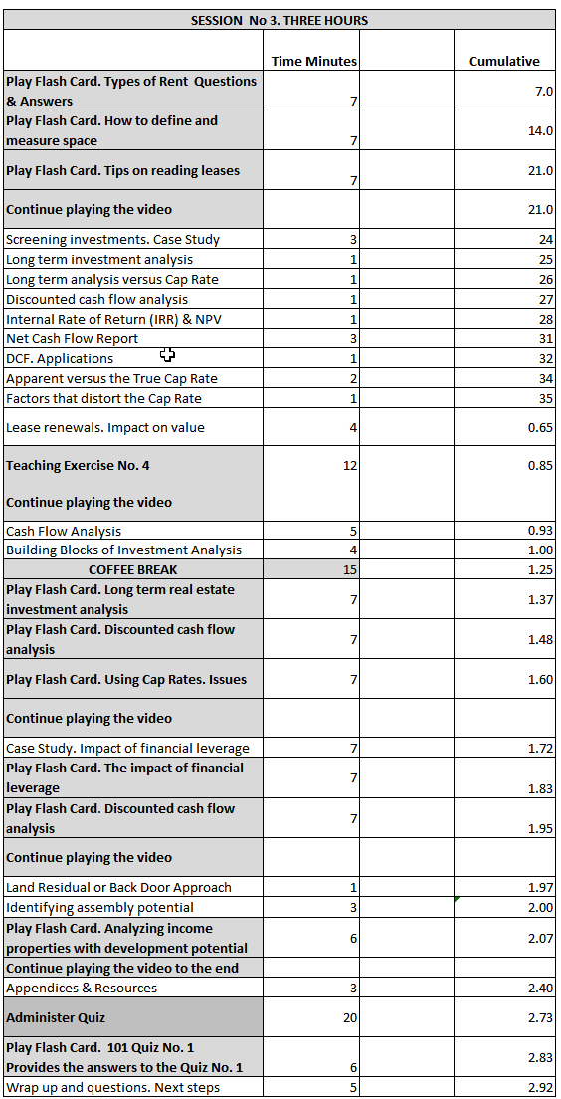

ALTERNATING BETWEEN PLAYING THE VIDEO AND FLASH CARDS

During the session there is a need to shift backwards and forwards effortlessly between the 101 video and the flash cards based on the Agenda Time table above.

Before starting a session set up the following….

On the Home Page select “Videos, Manuals, Quizzes and Flash Cards
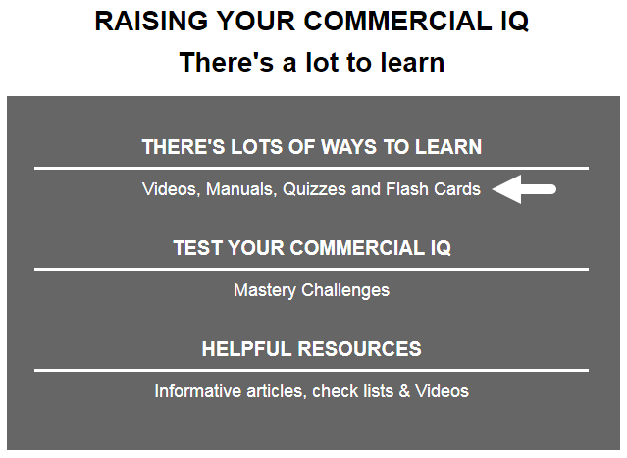

Hover the mouse over the video, click on the right mouse button and select “Open in New Window Tab”
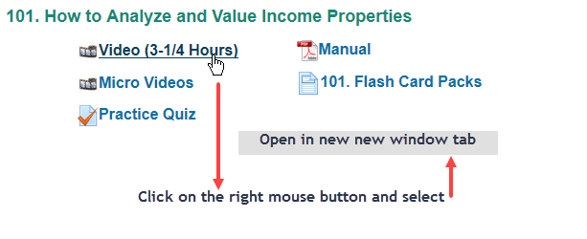
The window tab will show

Repeat for “101. Flash Cards Pack”
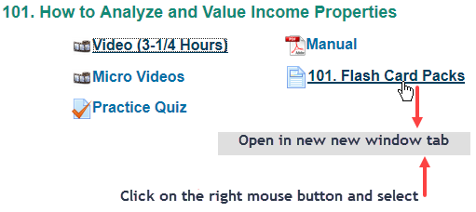
The windows tabs will show
You can now shit quickly between the “Video” and the “Flash Cards”
Video segments
The video is broken down into distinct segments or topics. At the end of each segment the video stops and offers two option buttons:
- Continue
- Replay
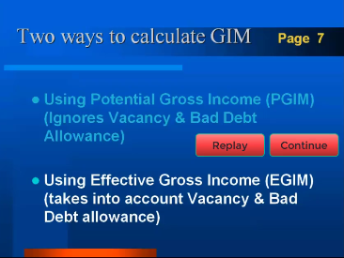

- The “Continue” button is pressed until the point is reached where you shift to the “Flash Cards”
- After the Flash Card Question and Answer period is completed continue the video

The Handy Table of Contents
From time to time it may be necessary to start the video mid-stream on a topic such as the start of the second and third session. To do the use the handy Table of Contents:
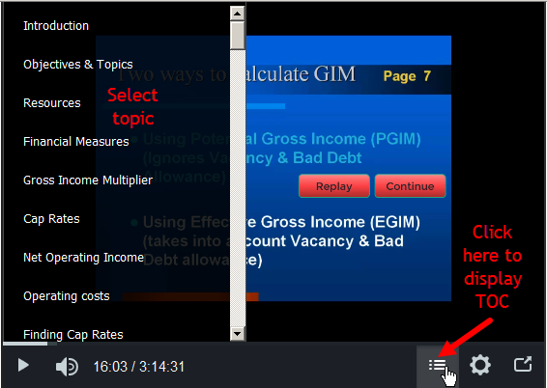

HOW TO SET UP A COMPETENCY TEST
Login as a manager or as a Proctor and select “Candidates & Exams”.
From the Candidates and Exams screen, find the appropriate candidate by searching for them specifically or by clicking Show all Candidates and picking the Candidate from the list. Click on the Candidates First or Last name.
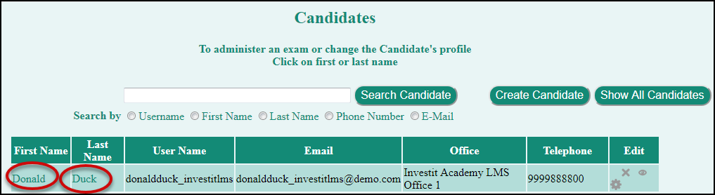

Click on Competency Test from the Candidate menu.

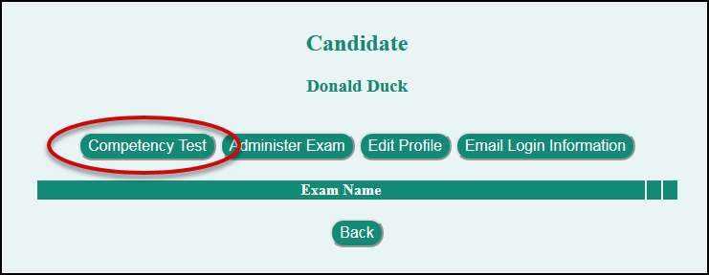

Select the test from the drop-down menu and click Submit.
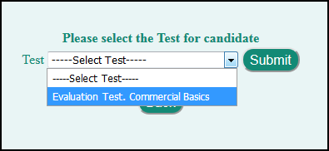

The chosen test with be displayed
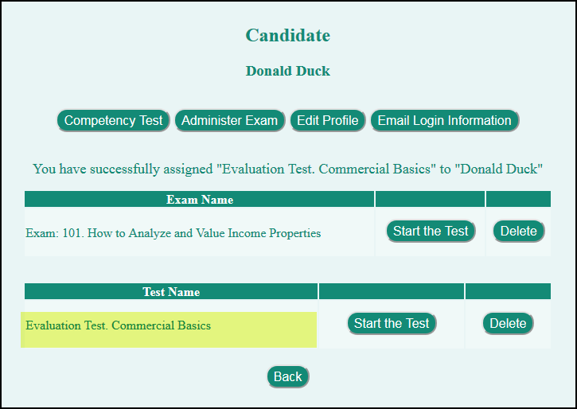

Starting a Test
There are two ways for a candidate to start a competency test.
The candidate can login to the Investit LMS using their Username and Password
The Proctor or Manager can click on Start the Test in Candidate menu next to the appropriate Exam.
.
