**Raising Your Commercial IQ**

______________________________________________________________________

**Investit In-House**

**Commercial Real Estate Education**

**Individual In-House Program**

**Participants Package**

**Investit Academy**

[**www.investit**](http://www.investit)**academy.com**

**Neil Osborne**

**604-988-9964**

**Email:nosborne@investitsoftware.com**

**Copyright August 8, 2019**

**All rights reserved**

**Table of Contents**

WELCOME 4

Learning Processes 4

Calculator 4

Remember the formulas 4

Skills and benefits obtained from the in-house sessions 5

Real Estate Investment Analysis Formulas 6

INCOME &EXPENSE STATEMENT 6

FINANCIAL MEASURES 6

Potential Gross Income Multiplier (PGIM) 6

Effective Gross Income Multiplier (EGIM) 7

Cap Rate 7

Return on Equity or Cash On Cash 8

Default Ratio or Break-even Point 8

Operating Expense Ratio 8

FINANCE MEASURES 9

Debt Service Ratio 9

GENERAL FINANCING MEASURES 9

Commercial Real Estate. Sample Calculations 10

FLASH CARD SETS. QUESTIONS & ANSWERS 18

Gross Income Multiplier calculations. 18

Understanding Cap Rates 24

Return on Equity and Cash on Cash calculations 26

Financing Ratios calculations 27

Examining Operating Expenses 30

Calculating and using the Default Ratio (Breakeven Point) 32

Impact of future capital expenditures on value 33

The importance of professional engineering inspections 35

Types of leases 36

How to define & measure space 38

Tips on how to read a lease 40

Introduction to long term real estate investment analysis 42

Discounted Cash Flow Analysis (DCF) 44

Using Cap Rates. Issues & problems 46

Developing the Net Cash Flow 48

CLASS EXERCISES 50

QUIZ 52

# WELCOME

Thanks for participating in the Investit Academy In-House commercial program.

Getting started in commercial real estate is a challenge as there is a **lot to learn**.

The in-house Investit Academy program introduces the fundamentals of real estate investment analysis and valuation and discusses the issues, complexities and dangers involved in listing and selling income properties fast tracking you to commercial success.

## Learning Processes

It is well known that we all have different ways we like to learn.

Recognizing this and to make the Investit Academy commercial in-house sessions interesting and to enhance the learning process the sessions consists of:

1. Video segments covering specific commercial topics
2. Flash cards sets which is a great way to learn basic terms and formulas
3. Quiz. At the end of the third session there is a short quiz to test your understanding of the most common terms and formulas used in commercial real estate
4. 101 How to Analyze and Value Income Properties manual which is ideal for taking notes and for a later reviews

## Calculator

You will need to bring a calculator. In can be any kind of calculator. It doesn’t have to be a financial calculator.

## Remember the formulas

There are a few really important financial measures such as the Cap Rate that you need to learn and can write down and apply without referring to your manual or notes. They are:

Gross Income Multipliers

Cap Rate

Calculation of the Net Operating Income

Return on Equity. Also called Cash on Cash Return and Equity Dividend Rate

Default Ratio or Break-even Point

Ratios used by lender to determine loan amounts.

Loan to Value Ratio (LTV)

Debt Service Coverage Ratio. Also called Debt Service Ratio

or Debt Coverage ratio

Operating Expenses Ratio

## Skills and benefits obtained from the in-house sessions

1. How to analyze and restructure “Income & Expense Statements” so that they more realistically represent the financial performance of the property
2. How to use the various financial measures such as the Gross Income Multiplier, Cap Rate, etc., to value an income property and appreciate the limitations of these simplistic approaches
3. Identify investment risks
4. Understand how important it is for the buyer of income properties to obtain professional engineering, tax and legal advice

The knowledge and skills developed during the in-house sessions will improve your ability to value, list and sell income properties and put deals together. Fast tracking you to success in commercial real estate.

# Real Estate Investment Analysis Formulas with sample calculations

# INCOME &EXPENSE STATEMENT

Income

Potential Gross Income (PG1) $__________

Less: Vacancy and Bad Debt Allowance __________

Equals: Effective Gross Income (EGI) $__________

Operating Expenses

Exclude: Depreciation

Mortgage Payments

Non-Operating Expenses

Capital Expenditures $__________

Net Operating Income (NO1) __________

Less: Debt Service (P + I) __________

Cash Flow Before Tax (CFBT) __________

Less: Income Taxes __________

Equals Cash Flow After Tax (CFAT) $__________

# FINANCIAL MEASURES

Used to determine the value of income properties

## Potential Gross Income Multiplier (PGIM)

Also called Potential Gross Rent Multiplier (PGRM)

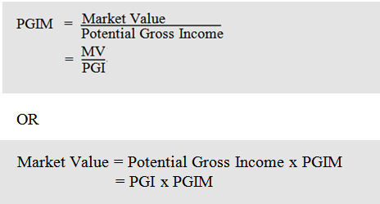

## Effective Gross Income Multiplier (EGIM)

Also called Effective Gross Rent Multiplier (EGRM)

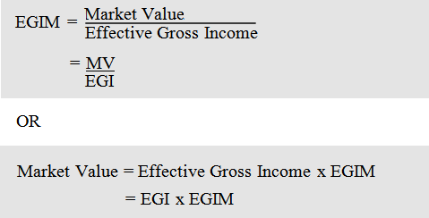

**Net Income Multiplier (NIM)**

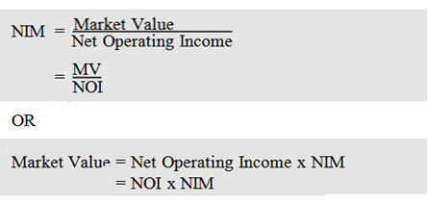

## Cap Rate

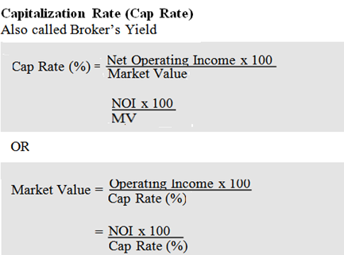

## Return on Equity or Cash On Cash

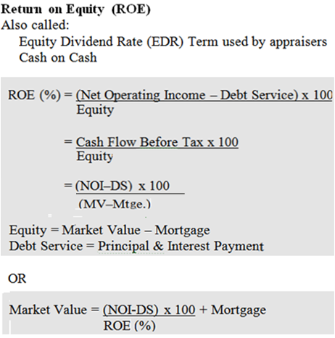

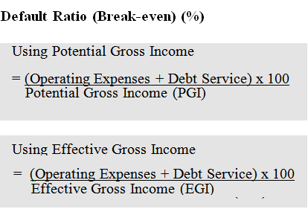**.**

## Operating Expense Ratio

= Operating Expense x100

Effective Gross Income

Used to check if the expenses are realistic

FINANCE MEASURES

Used by lenders to determine loan amounts for income properties.

Debt Service Ratio (DSR)

Also called Debt Coverage Ratio (DCR)

or Debt Service Coverage Ratio (DSCR)

## Debt Service Ratio

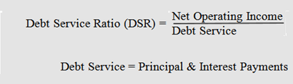

**Loan to Value Ratio**

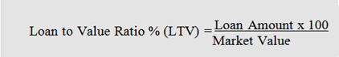

# GENERAL FINANCING MEASURES

**Rental Apartment Building Measures.**

1. Price per Unit

2. Price per Sq. Foot (Using Suite Areas)

3. Rents per Sq. Foot per month

4. Operating Costs

a. Operating Costs per Unit per Year

b. Operating Cost per Sq. Foot per Year

5. Operating Expense Ratio (OER) = Operating Expense x100

Effective Gross Income

Used to check if the expenses are realistic

## Commercial Real Estate. Sample Calculations

The following examples illustrate how to use the real estate formulas.

In Example No.1 the information is obtained for the property and the financial measures calculated.

In Example No. 2 the financial measures such as the Cap Rate are obtained for comparable sales and are used to calculate the Market Value for the subject property.

**Example No. 1**

Sale Price (Market Value): $3,165,000

Potential Gross Income: $306,000

Vacancy & Bad Debt Allowance: 4.5%

Operating Expenses: $58,000

Mortgage: $2,056,000

Mortgage Payment (P+i): $180,538

Number of Suites: 30

Total Rentable Area: 24,000 Square feet

Note: All figures are annual

Calculate: Potential Gross Income Multiplier (PGIM)

Effective Gross Income Multiplier (EGIM)

Net Income Multiplier (NIM)

Capitalization Rate (Cap Rate)

Return on Equity (ROE)

Default Ratio (Breakeven) based on:

Potential Gross Income

Effective Gross Income

Debt Service Ratio (DSR)

Loan to Value Ratio

Price per Suite

Price per Square Foot

Rent per Square Foot per Month

Operating Cost per Unit per Year

Operating Cost per Square Foot per Year

Operating Expense Ratio (OER) based on:

Potential Gross Income

Effective Gross Income

**1. Construct the Annual Income and Expense Statement**

Potential Gross Income $306,000

Less Vacancy & Bad Debt Allowance (4.5%) 13,770

Effective Gross Income $292,230

Operating Expenses 58,000

Net Operating Income $234,230

Less; Debt Service (P+i) 180,538

Cash Flow Before Tax $ 53,692

**2. Calculate the Financial Measures**

**Potential Gross Income Multiplier (PGIM):**

PGIM = MV = 3,165,000

PGI 306,000

= 10.34

**Effective Gross Income Multiplier (EGIM):**

EGIM = MV = 3,165,000

EGI 292,230

= 10.83

**Net Income Multiplier (NIM):**

NIM = MV = 3,165,000

NOI 234,230

= 13.51

**Capitalization Rate (Cap Rate):**

Cap Rate = NOI = 234,230 x 100

MV 3,165,000

= 7.40%

**Return on Equity (ROE) Cash on Cash on Cash**

ROE = (NOI – DS) x100 =

(MV – Mortgage)

= Cash Flow Before Tax x 100

Equity

= 53,692 x 100

(3,165,000 - 2,056,000)

= 4.84%

**Default Ratio (Breakeven)**

Based on Potential Gross Income:

Default Ratio = (Operating Expenses + Debt Service) x 100

Potential Gross Income

= (58,000 + 180,538) x 100

306,000

= 77.95%

**Default Ratio (Breakeven)**

Based on Effective Gross Income:

Default Ratio = (Operating Expenses + Debt Service) x 100

Effective Gross Income

= (58,000 + 180,538) x 100

292,230

= 81.63%

**Debt Service Ratio (DSR)**

Also called Debt Coverage Ratio (DCR)

Debt Service Coverage Ratio (DSCR)

Debt Service Ratio = Net Operating Income

Debt Service (P+i)

= 234,230

180,538

= 1.30

**Loan to Value Ratio %**

Loan to Value Ratio = Loan Amount x 100

Market Value

= 2,056,000 x 100

3,165,000

= 64.96%

**Price per Unit**

Price per Unit = 3,165,000

30

= $105,500

**Price per Square Foot**

Price per Sq. Ft = 3,165,000

24,000

= $131.88

**Rent per Sq. Foot per Mo.**

Rent per Sq. Ft = 306,000

24,000 x 12

**=** $1.06

**Operating Costs per Unit per Year**

Operating Costs per Unit = Operating Costs

No. of Units

= 58,000

30

= $1,933 per Unit

**Operating Cost per Square Foot per Year**

**O**perating Cost per Sq. Ft per Yr. = Operating Costs

Rentable Area

= 58,000

24,000

= $2.42 per Sq. Ft

**Operating Expense Ratio (OER)**

Based on Potential Gross Income:

Operating Expense Ratio = Operating Expenses x 100

Potential Gross Income

= 58,000 x 100

306,000

= 18.95%

Based on Effective Gross Income:

Operating Expense Ratio = Operating Expenses x 100

Effective Gross Income

= 58,000 x 100

292,230

= 19.85%

**Summary**

Potential Gross Income Multiplier (PGIM): 10.34

Potential Gross Income Multiplier (EGIM): 10.83

Net Income Multiplier (NIM): 13.51

Capitalization Rate (Cap Rate) 7.40%

Return on Equity (ROE) 4.84%

Default Ratio (Break even) based on:

Potential Gross Income 77.95%

Effective Gross Income 81.63%

Debt Service Ratio (DSR) 1.30

Loan to Value Ratio 64.96%

Price per Suite $105,000

Price per Square Foot $131.88

Rent per Square foot per month $1.06

Operating Cost per Suite per Year $1,933

Operating Cost per Square Foot per Year $2.42

Operating Expense Ratio (OER) based on:

Potential Gross Income 18.95%

Effective Gross Income 19.85%

**Example No 2.**

Potential Gross Income: $244,800

Vacancy & Bad Debt Allowance: 5.0%

Operating Expenses $49,300

Mortgage $1,685,000

Mortgage Payment (P+i) $147,500

Number of Suites 24

Total Rentable Area 18,720 Square feet

Note: All figures are annual

Calculate the Market Value using the following financial measures

Effective Gross Income Multiplier (EGIM): 9.30

Net Income Multiplier (NIM): 12.50

Capitalization Rate (Cap Rate): 8.00%

Return on Equity (ROE): 5.57%

**1. Start by constructing the Annual Income and Expense Statement**

Potential Gross Income $244,800

Less Vacancy & Bad Debt Allowance (5.0%) 12,240

Effective Gross Income $232,560

Operating Expenses 49,300

Net Operating Income $183,260

Less; Debt Service (P+i) 147,500

Cash Flow Before Tax $ 35,760

**2. Calculate the Market Value based on the:**

**Effective Gross Income Multiplier (EGIM):**

MV = Effective Gross Income x EGIM

= 232,560 x 9.30

= $2,162,808

**Net Income Multiplier (NIM):**

MV = Net Operating x NIM

= 183,260 x 12.50

= $2,290,750

.

**Capitalization Rate (Cap Rate):**

MV = Net Operating Income x 100

Cap Rate

= 183,260 x 100

8.0%

= $2,290,750

**Return on Equity (ROE):**

MV = (NOI - DS) x 100 + Mortgage

ROE (%)

= (183,260 - 147,500) x 100 + 1,685,000

5.57%

= $2,327,011

# FLASH CARD SETS. QUESTIONS & ANSWERS

## Gross Income Multiplier calculations.

Q1

There are two ways to calculate the Gross Income Multiplier.

What are they and what is the difference?

**Answer**

Q2

Write down the formulas for the:

Gross Income Multiplier (GIM)

**Effective Gross Income Multipliers (EGIM)**

**Answer**

Q3

If the Sale price of an income property is $1,000,000 and Potential Gross Income is $100,000 what is the Potential Gross Income Multiplier (PGIM**)?**

**Answer**

Q4

If the Sale price of an income property is $1,000,000 and Potential Gross Income is $100,000 and the Vacancy and Bad Debt Allowance is 10% what is the Effective Gross Income Multiplier (GIM)?

**Answer**

Q5

What are the formulas for calculating the potential selling price of an income property if you know the:

Potential Gross Income Multiplier (PGIM)

Effective Gross Income Multiplier (EGIM)

…from comparables?

How do you calculate the Effective Gross Income?

**Answer**

Q6

Based on the following information calculate the potential sales price using:

1. Potential Gross Income Multiplier (PGIM) of 11
2. Effective Gross Income Multiplier (EGIM) of 13

Potential Gross Income: $100,000

Vacancy and Bad Debt Allowance: 10%

**Answe**r

Q7

What does Bad Debt Allowance refer to?

Note. Also called “Credit Losses”

**Answer**

**.**

**END OF SET**

**Cap Rate calculations**

Q1

Write down the formulas for:

1. Calculating the Cap Rate
2. Determining the Sales Price using the Cap Rate from comparables

**______________________________________________________________________Answer**

Q2

How would you define the Operating Expenses?

When using a Cap Rate to determine the value of an income property what expenditures should be removed from an Income and Expense statement when calculating the Net Operating Income (NOI)

**Answer**

Q3

Which of the following expenses should be removed from the Income and Expense Statement when using the Net Operating Income (NOI) and the Cap Rate to calculate the value of the property?

Put an **“X”** against the expenses that should be removed.

Insurance

Property taxes

Upgrading the elevator

Elevator service contract

Landscaping service contract

Mortgage Interest costs

Repairs to a retaining wall

Security

Painting 40% of the building exterior

Property management

Q4

How do you calculate the Net Operating Income (NOI)?

**Answer**

Q5

Using the following information calculate the likely selling price using the Cap Rate approach to determine the value of the income property

Net Operating Income (NOI): $100,000

Cap Rate: 5% (from comparables)

**Answer**

 

Q6

Using the following information calculate the Cap Rate

Net Operating Income (NOI): $100,000

Sale Price: $2,000,000

**Answer**

**END OF SET**

## Understanding Cap Rates

Q1

The lower the Cap Rate the higher or lower the property value**?**

***Circle your selection***

Q2

Using an Net Operating Income (NOI) of $100,000

Calculate the property value using a:

1. 5% Cap Rate
2. 10% Cap Rate

**Answer**

Q3

From a BUYERS perspective which do they prefer? A higher or a lower Cap Rate?

From SELLERS perspective which to they prefer? A higher or a lower Cap Rate?

***Circle your selections***

Q4.

What are two fundamental assumptions that are made when using the Cap Rate to determine the value of an income property?

**Answer**

Q5

Why would aninvestor buy an income property at a 3.00% Cap Rate and finance with a first mortgage at 5.00%?

**Answer**

Q6

The higher the perceived risk the **HIGHE**R or **LOWER** the Cap Rate?

***Circle your selection***

Q7

The higher the anticipated **CAPITAL APPRECIATION** the **HIGHER** or **LOWER** the Cap Rate**?**

***Circle your selection***

Q8

**How does a HIGH Cap Rate effect the amount of EQUITY (Down Payment) needed by the investor?**

**Answer**

**END OF SET**

## Return on Equity and Cash on Cash calculations

Q1

The Return on Equity (ROE) goes under a number of different names.

Write them down.

**Answer**

Q2

Write down the formula for calculating Return on Equity (ROE) or Cash on Cash Return.

**Answer**

Q3

Calculate the Return on Equity (ROE) or Cash on Cash Return using the following information

Net Operating Income (NOI): $150,000 per year

Debt Service: $100,000 per year

Purchase Price: $1,500,000?

Mortgage: $1,000,000

**Answer**

**END OF SET**

## Financing Ratios calculations

Q1

Lenders use two ratios for determining the first mortgage amount

Write them down together with the formula and check your answers on the flip side

**Answer**

Q2

Using the following information calculate the:

1. Loan to Value Ratio(LTV)
2. Debt Service Coverage Ratio (DSCR)

Purchase Price: $3,300,000

First Mortgage: $2,300,000

Net Operating Income (NOI): $210,000 per Yr.

Debt Service: $165,000 per Yr. Annual (P +I) payment

**Answer**

Q3

How does the lender use the

Loan to Value Ratio (LTV)

Debt Service Coverage Ratio (DSCR)

to determine the loan amount of the first mortgage?

**Answer**

Q4

What are the common numbers that traditional first mortgage

lenders use for determining a loan amount for quality properties:

Loan to Value Ratio (LTV)

Debt Service Coverage Ratio (DSCR)

**Answer**

Q5

The Debt Service Coverage Ratio (DSCR) and the Loan to Value Ratio (LTV) are helpful in determining whether and when a property can be refinanced.

If the lender uses:

Loan to Value Ratio (LTV): 75% of appraised value

Debt Service Coverage Ratio (DSCR): 1.25

Which one of the following properties has the potential to be refinanced with a larger mortgage?

|  |  |  |  |
| --- | --- | --- | --- |
|  | **Property A** | **Property B** | **Property C** |
| **Loan to Value Ratio** | **77%** | **72%** | **69%** |
| **Debt Coverage Ratio** | **1.28** | **1.20** | **1.29** |

***Circle or tick your answer***

Q6

From the lender’s perspective what does a:

Loan to Value Ratio (LTV) of 75% of appraised value and a

Debt Service Coverage Ratio (DSCR) of 1.25 mean?

**Answer**

**END OF SET**

## Examining Operating Expenses

Q1

Write down the formula for the Operating Expenses Ratio (OER)

**Answer**

Q2

How do we use the Operating Expense Ratio (OER)?

**Answer**

Q3

Which is best method for checking expenses?

Using the:

1. Operating Expense Ratio (OER) based on the Potential Gross Income (PGI)?
2. Operating Expense Ratio (OER) based on the Effective Gross Income (EGI)?

***Tick or circle your answer***

Q4

Using the following information calculate the Operating Expenses Ratio (OER) using the Effective Gross income (EGI)

Potential Gross Income (PGI): $100,000 per Yr.

Vacancy: 5.00%

Operating Expenses: $35,000 per Yr.

**______________________________________________________________________**

**Answer**

Q5

What are typical Operating Expense Ratios for:

1. Rental apartment buildings
2. Commercial buildings. Office, Industrial and Retail

**Answer**

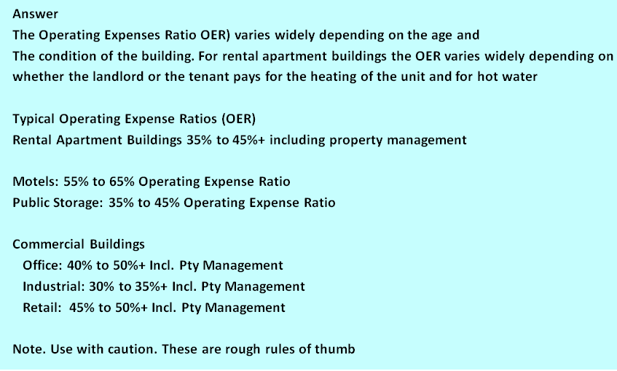

**END OF SET**

## Calculating and using the Default Ratio (Breakeven Point)

Q1

Write down the formula for calculating the Default Ratio (Breakeven Point)

**Answer**

Q2

**Answer**

Q3

How do we use the Default Ratio or Breakeven Point?

**Answer**

**END OF SET**

**FLASH CARD SET Quick Tips for analyzing Income & Expense Statements**

Q1

What is the best way to analyze individual revenue and expenses for a Rental Apartment Building?

**Answer**

Q2

List operating expenses which can be;

1. quickly verified
2. hard to verify

Answer

Operating expenses that can be quickly verified

Operating Expenses that can hard to verify

**END OF SET**

## Impact of future capital expenditures on value

Q1

Write down three examples of future capital expenditures that

might lower the price that a buyer is willing to offer the seller.

**Answer**

**1._____________________________**

**2._____________________________**

**3._____________________________**

Q2

Calculate the price that a buyer might offer using the following information

Net Operating Income $200,000

Market Cap Rate: 5.00% (From comparables)

As part of the diligence buyer engaged professional engineering

firm to assess the building

The engineers estimated that there is $700,000 of immediate and urgent repairs

Including replacing the roof and caulking the leaking windows

**Answe**r

**END OF FLASH CARD SET**

## 

## The importance of professional engineering inspections

Q1

Why is it important for a buyer to engage a professional

engineering firm to inspect a building?

**Answer**

Q2

What is concrete rot or cancer?

**Answer**

Q3

Post tension floor slab systems are widely used in concrete buildings.

1. Briefly describe the post tensioning system
2. In older buildings there have been many cases of the failure of post tensioned floor system failing. What causes the failure?

**Answer**

**END OF SET**

## Types of leases

Q1

What is a Gross Lease?

**________________________________________________________________**

**Answer**

Q2

What’s the disadvantage of a Gross Lease from a landlord’s perspective?

**Answer**

Q3

What’s a Modified Gross Lease or a Gross Lease with an escalation clause?

**Answer**

Q4

What’s a Triple net Lease (NNN)? Also called a Net Lease.

**Answer**

**END OF SET**

**FLASH CARD SET Types of rent**

Q1

What is the Base Rent?

**Answer**

Q2

What is the “Additional Rent”?

**Answer**

Q3

What is “Free Rent”?

**Answer**

Q4

Does “Free Rent” apply to “Additional Rent”?

**Answer**

Q5

Explain “Percentage Rent”

**Answer**

**END OF SET**

## How to define & measure space

Q1

What are the Rentable Area and the Gross Leasable Area (GLA)?

**Answer**

Q2

How do you calculate the rentable area in an office building?

**Answer**

Q3

Calculate the Base Rent per month for an office building using the following information:

Base Rent: $30 per Sq. Ft per Yr. based on the “Rentable Area”

Usable Area: 10,000 Sq. Ft. This is the area occupied by the tenant.

Add on Factor: 13%

**Answer**

Q4

What are the BOMA standards?

**Answer**

Q5

What are the dangers associated with quoting rents as $ per Sq. Ft per Yr. or Month?

**Answer**

Q6

What’s the simple solution to the problems created by quoting rent as $ per sq. Ft per Yr. or Month

**Answer**

**END OF SET**

## Tips on how to read a lease

Q1

Why is it so important to read a lease very carefully?

**________________________________________________________________Answer**

Q2

When reading a lease, ask who pays what?

**_______________________________________________________________**

**Recommendations**

Q3

What is a Demolition Clause?

Answer

Q4

Tips for reading a lease

**_______________________________________________________**

Recommendations

Read the lease several times. Leases are complex legal documents and need to be read carefully

Ask a question and go looking for the answer in the lease. Read with a purpose. Have a question in mind

Examples

Is there a “Demolition Clause?

When is the next rent increase and how is it calculated?

What operating expenses does the tenant pay?

Q5

How are the renewal rates in a lease determined?

Also called “Rent Steps” or “Rent bumps”

**Answer**

**END OF SET**

## Introduction to long term real estate investment analysis

Q1

What is long term real estate investment analysis?

**Answer**

Q2

Write down how to develop the cash flow before tax.

**Answer**

**Q3**

Show me an example of an operating cash flow Projection

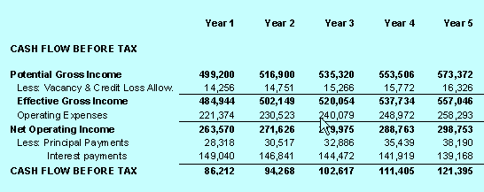

Q4

What’s the advantage and disadvantage of using cash flow analysis over using the Cap Rate approach to determine the value?

Answer

Q5

How long of a time period do you use when developing the yearly cash flows?

Answer

It depends on the type of building

Rental Apartment Buildings:

Five years is sufficient. Maybe 10 years

Office, Industrial & Retail properties

Ten years

With commercial buildings with leases it is best to analyze

over 10 years to take into account the impact of periodic increases

in rent on the long term value.

As an example Tenant A’s rent increases every 3 years

based on 2.5% compounding per year.

END OF SET

## Discounted Cash Flow Analysis (DCF)

Q1

Which would you rather have?

$1,000,000 today or $1,000,000 in 10 years’ time?

*Circle your selection*

Q2

You are going to loan me $10,000 and I’m offering you the following

two repayment plans. The annual payment is at the end of each year.

Which would you prefer as the lender Plan A or Plan B?

From your perspective which is the less risky option? Plan A or Plan B?

*Circle or tick your selection*

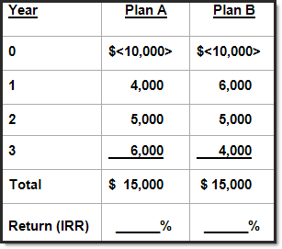

Q3

What is the Internal Rate of Return (IRR)?

How do you calculate the Internal Rate of Return?

What is a “Net Cash Flow” report?

The Net Cash Flow report shows the cash flow from the time the property

is acquired until it is sold and calculates the Internal Rate of Return (IRR)

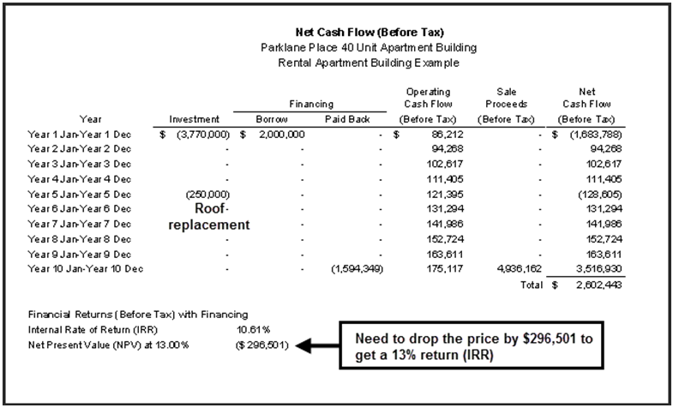

**END OF SET**

## Using Cap Rates. Issues & problems

Q1

Explain the Apparent Cap Rate versus the True Cap Rate

Answer

Q2

The impact of “urgent major repairs” on the purchase price. Example

The impact of “urgent major repairs” on the Sale Price

Sale Price: $3,200,000 Net Operating Income: $275,000 per year

“Apparent Cap Rate” = $275,000 x100 = 8.59%

$3,200,000

BUT… the buyer deducted $425,000 because the roof had to be replaced, the elevator upgraded

Sale Price based on “Normal” building = $3,200,000 + $425,000 = $3,625,000

“True Cap Rate” = $275,000 x100 = 7.59%

$3,625,000

Q3

Cap Rates can’t handle changing cash flows over time. Example.

The impact of the timing of a lease renewal on the cash flow and property value

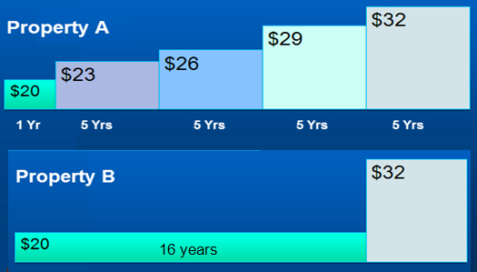

The Cap Rate approach doesn’t work very well when the cash flows change over time.

Clearly Property A is worth more than Property B.

To evaluate these two cash flows we would use discounted cash flow analysis and calculate the Net Present Value (NPV) using the investor’s discount rate

END OF SET

## Developing the Net Cash Flow

**Q1** What are the building blocks of investment analysis?

Following are the steps involved in carrying out long term investment analysis

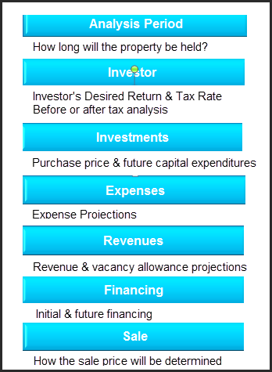

Q2

Developing the Net Cash flows. Example

You have a choice to invest in either Property A and B. Each property will generate the following net cash flows. Which one would provide you with the best overall financial return?

Property A because the Internal Rate of Return (IRR) is 11.62% compared to 10.88% for Property B

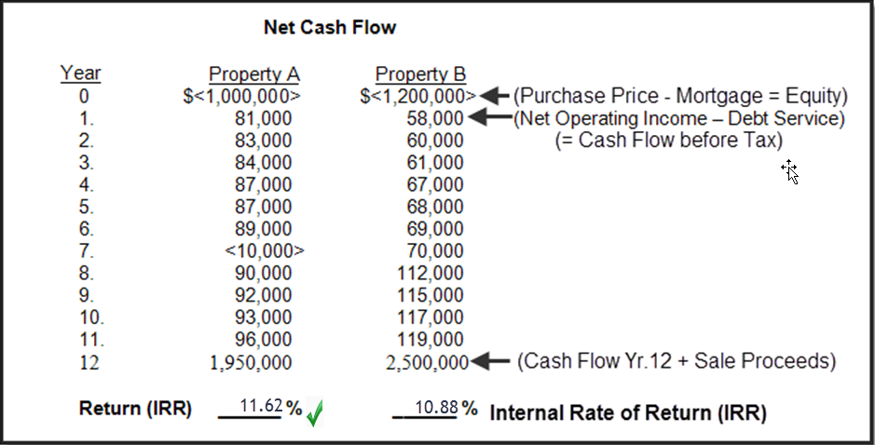

END OF SET

# CLASS EXERCISES

A great way to learn a concept or topic is to explain it another person.

Each session provides you with two opportunities to teach the topic to another class participant.

**Instructions**

Pair up with another person. One person is called “Partner A” and the other “Partner B”

“Partner A” teaches his/her assigned topic and the “Partner B” teaches his/her a assigned topic to “Partner A”

If the group consists of three people rather than two, “Partner C” listens and asks questions.

**Session No. 1**

**Teaching Exercise No. 1**

|  |  |
| --- | --- |
| **Participant A** | **Participant B** |
| **An investor has asked you what it is the “Cap Rate” and how it is used.**  **Explain your response to partner B** | **Explain to an investor the benefits and disadvantage of using a Cap Rate to determine the value of an income property**  **Explain your response to partner A** |

**Teaching Exercise No. 2**

|  |  |
| --- | --- |
| **Participant A** | **Participant B** |
| **Explain to Partner B which expense items should be excluded from an Income & Expense Statement when using a Cap Rate to determine the value of an income property.** | **Explain to Partner A the relationship between the Cap Rate and Risk.** |

**Session No. 2**

**Teaching Exercise No. 3**

|  |  |
| --- | --- |
| **Participant A** | **Participant B** |
| **Explain to Partner B which expense items should be excluded from an Income & Expense Statement when using a Cap Rate to determine the value of an income property.** | **Explain to Partner A the relationship between the Cap Rate and Risk.** |

**Teaching Exercise No. 4**

|  |  |
| --- | --- |
| **Participant A** | **Participant B** |
| **Explain to Partner B the two measures that a lender uses to determine the mortgage for and income property and how they select which method to use.** | **Explain to Partner A the Default Ratio or Breakeven Point and how it is used when evaluating an income property.** |

**Session No. 3**

**Teaching Exercise No. 5**

|  |  |
| --- | --- |
| **Participant A** | **Participant B** |
| **Explain to a Partner B? what a “Triple Net Lease” means.** | **Explain to Partner A the potential for misunderstanding between a landlord for an office building when quoting rents as $23 per Sq. Ft per Year.**  **What is the best way to describe the rent rate?** |

**Teaching Exercise No. 6**

|  |  |
| --- | --- |
| **Participant A** | **Participant B** |
| **Explain the Internal Rate of Return (IRR) to Partner B and the advantages of using the Internal Rate of Return IRR) compared to using the Cap Rate** | **Explain to Partner A what “Discounted Cash Flow Analysis” means.** |

**.**

**QUIZ**

Q1.

Using the following information calculate the Cap Rate

Net Operating Income (NOI): $200,000 per year

Sale Price: $4,000,000

*Start by writing down the formula for calculating the Cap Rate*

Answer

**Q2.**

Put an “X” against the expenses that should be removed from the Income & Expense Statement when using the Net Operating Income (NOI) and the Cap Rate to calculate the value of the property?

.

Insurance

Property taxes

Upgrading the elevator

Elevator service contract

Landscaping service contract

Mortgage Interest costs

Security services

Painting 40% of the building exterior

Property management

**Q3**

Calculate the Return on Equity (ROE) or Cash on Cash Return using the following information.

Net Operating Income (NOI): $125,000 per year

Debt Service: $75,000 per year

Purchase Price: $1,700,000?

Mortgage: $1,000,000

*Start by writing down the formula*

Answer:

**Q4.**

From a BUYERS perspective which do they prefer?

A higher or a lower Cap Rate?

***Circle your selection***

**Q5.**

Using the following information calculate the:

1. Loan to Value Ratio(LTV)
2. Debt Service Coverage Ratio (DSCR)

Purchase Price: $2,500,000

First Mortgage: $1,500,000

Net Operating Income (NOI): $130,000 per Yr.

Debt Service: $100,000 per Yr. Annual (P +I) payment

Sta*rt by writing down the formulas*

Answer

**Q6.**

Calculate the Base Rent per Sq. Ft per Yr. for an office building using the following information:

Base Rent: $200,000 per Yr. based on the “Rentable Area”

Usable Area: 9,000 Sq. Ft. This is the area occupied by the tenant.

Add on Factor or Gross up Factor: 15%

Answer

**Q7.**

The lower the Cap Rate **t**he **“higher”** or “**lower”** the property value?

***Circle your selection***

**Q8.**

The Cap Rate is an excellent approach to valuing Property A which has the following lease arrangement. True or False?

***Circle your selection***

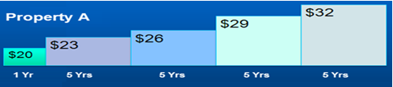

**Q9.**

A tenant is entering into a Triple Net Rent (NNN) and the landlord has offered the tenant three months free rent.

The tenant interprets this to mean that during the Free Rent period of three months that there are no payments made to the landlord.

Based on the typical arrangements for free rent is the tenant’s assumption correct?

Yes or No

***Circle your answer***

**Q10**  
When calculating the Cap Rate for a commercial building leasing fees should be excluded from the Income & Expenses statement when using the Cap Rate to determine the value.

True or False?

***Circle your answer***

**Q11**

You are considering buying a building which has a Net Operating Income (NOI) of $230,000.  
   
If you wish to buy the property for a 6.00% Cap Rate, how much would you pay for the property?

**Q12**The Loan to Value Ratio (LTV):

a) __ Always determines the loan amount

b) __ Determines the maximum loan subject to the Debt Service or Coverage Ratio

c) __ Is never used by a commercial lender because they always use the Debt Service or Coverage Ratio to determine the loan amount to determine the loan amount

***Tick your answer***

**Q13**Which Debt Service Coverage Ratio provides the highest loan amount?

a) 1.19

b) 1.25

c) 1.30

***Tick the correct answer*  a)__ b)__ c)__**

**Q14**

Which Debt Service Coverage Ratio potentially indicates the highest financial risk?

a) 1.31

b) 1.07

c) 1.15

d) 1.20

***Tick the correct answer* a)__ b)__ c)__ d)__**

**Q15**  
**A "Triple Net (NNN)" lease means that the tenant pays all of the landlords operating expenses.**

**True False**

***Circle your answer***

**Q16**

In a multi-tenant office building the landlord usually calculates the rent based on the Usable Area because this is the area occupied by the tenant.

True False

***Circle your answer***

**Q17**

How much would you pay for $130,000 per year forever if wanted a 10% return?

a) __ $1,300,000

b) __ $130,000

c) __ $13,000,000

d) __ None of these

e) __ $13,000

***Tick the correct answer***

**Q18**  
Which would you rather have?

a) Receive $750,000 today

b) Receive $750,000 in 5 years time

***Tick the correct answer* a)__ b)__**

**Q19**  
The diagram below shows the projected lease rates and renewals

for two comparable properties. Which is the most valuable property?

a) Property A

b) Property B

***Tick the correct answer***a)__ b)__



**Q20**  
From a financial perspective which investment provides the highest:

1. Return (IRR) Investment A or Investment B
2. Risk Investment A or Investment B

***Circle your answers***  
   
 

**Q21**  
How would you value this property?  
  
 

1. Use the income approach such as the Cap Rate or

Discounted Cash Flow Analysis approach

1. Use the "Development Analysis” or “Land Residual” approach

***Tick the correct answer* a)__ b)__**